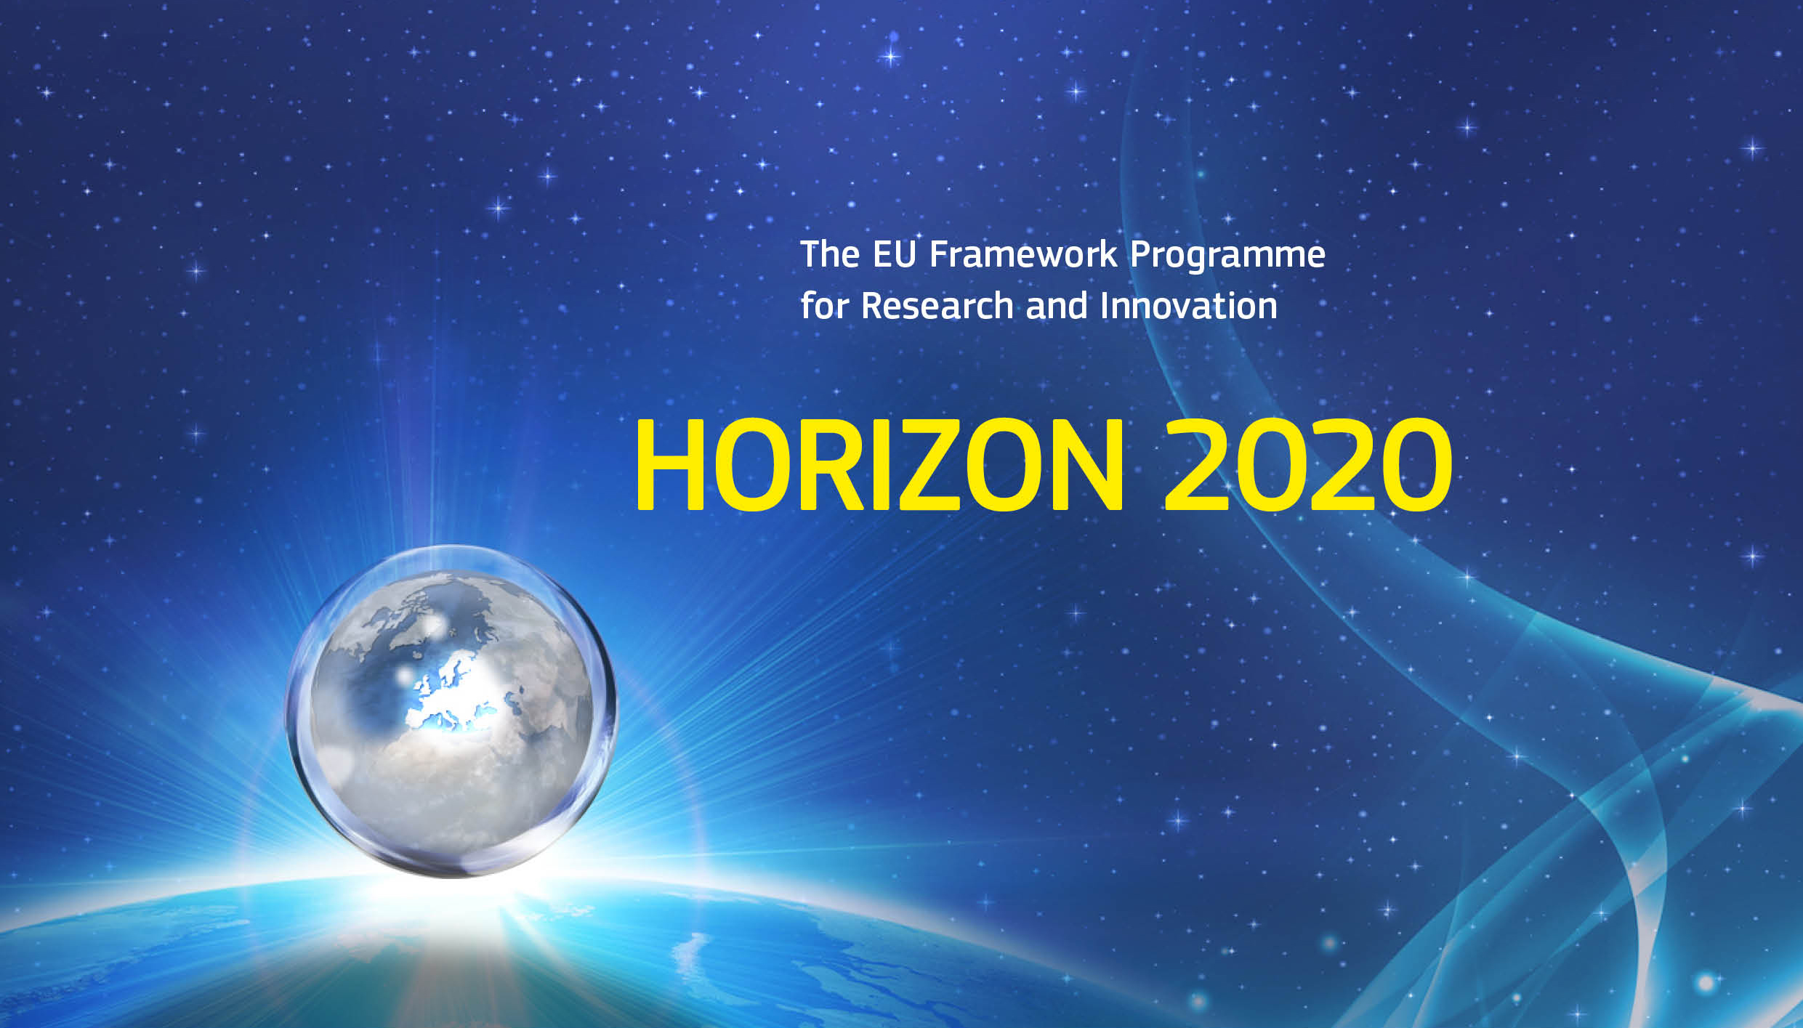

Flash information on the CALL results (flash call info)

Call for proposals: Smart and Sustainable Cities (H2020-SCC-2017)
Published: 14 October 2015
Deadline: 14 February 2017
Available budget:
Total budget: EUR 69,500,000
Budget per topic/type of action with separate ‘call-budget-split’:
- SCC-1-2016-2017: EUR 69,500,000

The Commission and INEA Agency have now completed the evaluation of the proposals submitted to the above-mentioned calls.
The results of the evaluation are as follows:
Topic SCC-1-2016-2017:
Number of proposals submitted (including proposals transferred from or to other calls): 17
Number of inadmissible proposals: 0
Number of ineligible proposals: 2
Number of above-threshold proposals: 3
Total budget requested for above-threshold proposals: EUR 53.362.959,68

We recently informed the applicants about the evaluation results for their proposals.
It is expected that the first grant agreements will be signed by 14 October at the latest.
Information on the selected projects will be published on CORDIS after that date.
Please note that the number of proposals that can finally be funded will depend on the finally available budget and the formal selection by the Commission/Agency.
For questions, please contact the Research Enquiry Service.

Available at http://cordis.europa.eu/projects/home_en.html
Available at http://ec.europa.eu/research/enquiries

