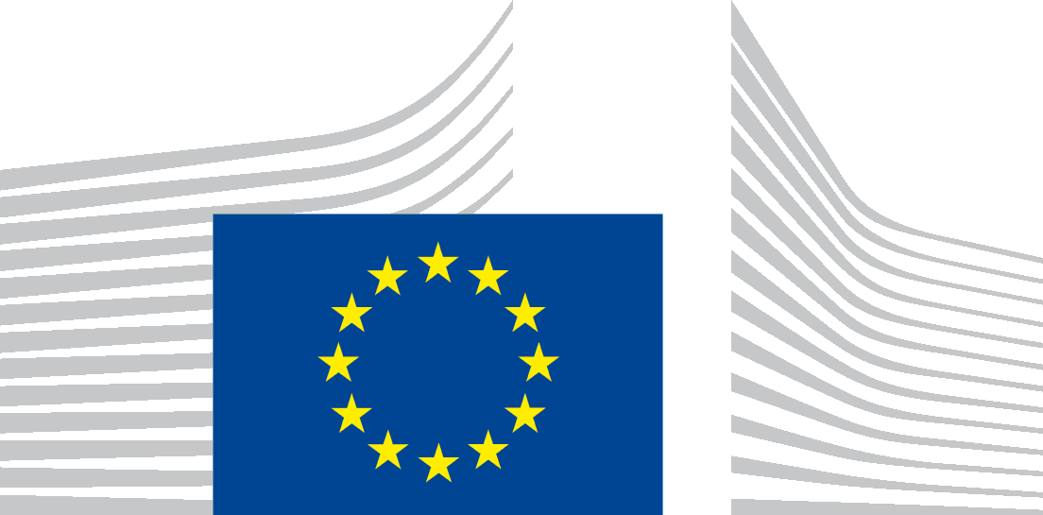 | EUROPEAN COMMISSION  DIRECTORATE-GENERAL  REGIONAL AND URBAN POLICY

PILOT ACTION ON INTERREGIONAL INNOVATION
CALL FOR EXPRESSION OF INTEREST FOR
COVID-19 RESPONSE AND RECOVERY PARTNERSHIPS

Annex 1: Application Form

Call for Expression of Interest for COVID-19 Response and Recovery
Interregional Innovation Partnerships

Please complete this form electronically and send it to:
REGIO-SMART-GROWTH@ec.europa.eu

1. Information about the Applicant
1.1. | Name of the lead body
1.2 | Contact Person for this application |  | Name, Last Name
 |  |  | Job title
Phone
(e.g. +32-00000000)
 |  |  | Email
1.3 | Thematic area of cooperation | COVID-19 innovation/Circular Economy/Tourism/ Hydrogen
1.4 | Leading Region, partner Regions and number of total EU countries represented
1.5 | Representatives of the quadruple helix within the partnership (name, country) | Academia/research centres: Industry sector: Governments/public institutions:  End-users' representatives from different countries:
1.6 | Is the partnership already a beneficiary of support from any of the three existing Thematic Smart Specialisation Platforms (if yes, please indicate the name of the partnership and the Thematic Area).
1.7 | Is the partnership already a beneficiary of support from the European Union budget (if yes, please indicate the programme/instrument)?

2. Rational and linkage with regional Smart specialisation strategies
Please provide a clear and justified explanation why support to your research and business collaboration activities at interregional level can add value to Smart specialisation strategies in the chosen Thematic Area. Explain how the commercialisation and scaling up of the partnership's activities will contribute to the creation or reshaping of a EU value chain?
(max 500 words)

3. Partnership maturity
Please explain the existing mechanisms for partnership coordination and the track-record of the partnership. Please explain the extent to which learning, connecting and demonstration activities have already been carried out as well as their main outcomes.

(max 500 words)

4. Identification of bottlenecks
Please explain which bottlenecks to commercialisation and scale-up have been identified and the possible solutions already identified by the partnership, where appropriate.
(max 500 words)

5. Potential synergies with other EU initiatives and projects
Please explain how other EU programmes and initiatives such as Horizon, INTERREG, EIT KICs, Joint Undertakings, European Innovation Partnerships and macro-regional strategies can be beneficial to your activities and how your potential involvement in these could be further exploited e.g. which projects you have already identified to establish synergies or what kind of results/deliverables can be helpful for your partnership?
(max 500 words)

6. Please use this space to provide any other relevant comments/ clarifications, if necessary

(max 500 words)

