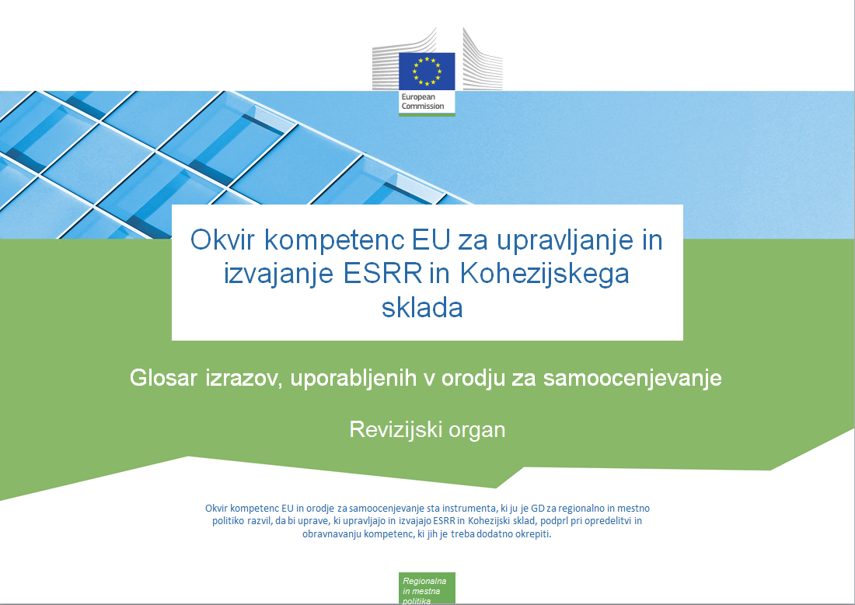

Različice dokumenta
Različica | Datum
V1 | 3. november 2017

Kazalo

1. Delovne vloge 4
2. Podopravila 5
3. Lestvica stopenj znanja 6
4. Operativne kompetence 8
5. Upravljavske kompetence 9
6. Strokovne kompetence 13

Delovne vloge
Angleščina |  | Slovenščina
Job Role | Description | Delovna vloga | Opis
Decision-making level | This is the head of the organization or persons that act on relatively high strategic management levels | Raven odločanja | To je vodja organizacije ali osebe, ki delujejo na razmeroma visokih ravneh strateškega upravljanja.
Supervisory level | This is the middle management level, responsible for a group of people and not directly involved in operational implementation of the programme, for instance heads of organizational units | Nadzorna raven | To je srednja vodstvena raven, zaposleni na tej ravni, kot so vodje organizacijskih enot, pa so odgovorni za skupino ljudi in niso neposredno vključeni v operativno izvajanje programa.
Operational level | These are the experts that are directly working on the different tasks and sub-tasks within the organization | Operativna raven | To so strokovnjaki, ki neposredno opravljajo različne naloge in podopravila v organizaciji.

Podopravila
Angleščina | Slovenščina
- Audit strategy preparation | - Priprava revizijske strategije
- Risk Assessment | - Ocena tveganja
- Planning of the Audit | - Načrtovanje revizije
- Carrying out audits on systems | - Izvajanje revizij sistemov
- Carrying out Accreditation audit | - Izvajanje revizije za akreditacijo
- Selection of sample of operations | - Izbira vzorca operacij
- Annual control reports and accreditation audit | - Letna poročila o nadzoru in revizija za akreditacijo
- Carrying out audits on operations | - Izvajanje revizij operacij
- Carrying out audits of the accounts certified by CA | - Izvajanje revizij računovodskih izkazov, ki jih je potrdil organ za potrjevanje
- Procurement of goods and services under Technical Assistance | - Javno naročanje blaga in storitev v okviru tehnične podpore

Lestvica stopenj znanja
Angleščina |  | Slovenščina
Scale | Description | Lestvica | Opis
N.A. - Not Applicable | The competency is not applicable to the job role. | n. r. – ni relevantno | Kompetenca ni relevantna za delovno vlogo.
Level 0 –  No knowledge | No knowledge of the competency or no ability to apply it in real situations. | Stopnja 0 –  neznanje | Zaposleni nima znanja, povezanega s kompetenco, ali ga ni sposoben uporabiti v dejanskih situacijah.
Level 1 –  Awareness | Basic knowledge of the competency (e.g. understands general concepts and processes, is familiar with related key terminology).  Ability to demonstrate this competency after being given specific instructions and guidance. | Stopnja 1 –  poznavanje | Osnovno znanje, povezano s kompetenco (na primer zaposleni razume splošne koncepte in postopke ter je seznanjen z zadevno ključno terminologijo).  Sposobnost dokazati to kompetenco po prejemu posebnih navodil in smernic.
Level 2 –  Trained | Good working knowledge of the competency. Ability to apply that knowledge in daily work.  Ability to perform standard activities with regards to this competency in an independent manner | Stopnja 2 –  usposobljenost | Aktivno znanje, povezano s kompetenco. Sposobnost uporabiti znanje pri vsakodnevnem delu.  Sposobnost neodvisno izvajati standardne dejavnosti v zvezi s to kompetenco.
Level 3 –  Intermediate | Broad and in-depth knowledge and skills with regards to the competency.  Ability to deal with a variety of exceptions and special cases related to the competency in an independent manner.  Ability to effectively share knowledge and experience with more junior profiles.  Confidence in serving as an advisor and is sought out to provide insight in the application of this competency.  Is capable of coaching others in the application of this competency by translating complex nuances and issues relating to this competency into easy to understand terms. | Stopnja 3 –  vmesna stopnja | Obsežno in poglobljeno znanje in spretnosti v zvezi s kompetenco.  Sposobnost neodvisno obravnavati različne izjeme in posebne primere, povezane s kompetenco.  Sposobnost učinkovite izmenjave znanja in izkušenj z zaposlenimi na nižjih stopnjah.  Zaposleni je samozavesten pri zagotavljanju nasvetov, drugi pa se nanj obračajo za vpoglede glede uporabe te kompetence.  Zaposleni lahko druge uči, kako uporabljati to kompetenco, pri čemer lahko zapletene vidike in vprašanja v zvezi s to kompetenco predstavi na preprosto razumljiv način.
Level 4 –  Expert | Extensive expert knowledge and skills with regards to the competency.  Ability to highlight the (dis)advantages of each of the processes related to the competency whilst linking them to the bigger picture.  Ability to provide tailored advice and to support the advice with relevant and context specific arguments when responding to internal and external queries.  Viewed by others as a role model who is capable of leading or teaching others in the area of the competency. | Stopnja 4 –  strokovna stopnja | Obsežno strokovno znanje in spretnosti v zvezi s kompetenco.  Sposobnost opredeliti prednosti (pomanjkljivosti) posameznih postopkov, povezanih s kompetenco, in jih povezati s širšim okvirom.  Sposobnost odzvati se na notranje in zunanje poizvedbe s prilagojenimi nasveti ter podpreti nasvete z ustreznimi in okoliščinam prilagojenimi argumenti.  Zaposlenega drugi vidijo kot zgled, ki je sposoben voditi ali učiti druge na področju kompetence.

Operativne kompetence
Angleščina |  | Slovenščina
Koda | Competency | Kompetenca
AA.O.C1 | Audit standards, procedures and methodologies | Revizijski standardi, postopki in metodologije
AA.O.C2 | Eligibility of expenditure | Upravičenost izdatkov
AA.O.C3 | Fraud risk management (incl. prevention, detection and mitigation measures) | Obvladovanje tveganja goljufije (vključno z ukrepi za preprečevanje, odkrivanje in zmanjšanje)
AA.O.C4 | Simplified Cost Options | Poenostavljene možnosti obračunavanja stroškov
AA.O.C5 | Financial instruments relevant for the function | Finančni instrumenti, ustrezni za funkcijo
AA.O.C6 | Horizontal issues | Horizontalna vprašanja
AA.O.C7 | Public procurement rules | Pravila o javnem naročanju
AA.O.C8 | State Aid | Državna pomoč
AA.O.C9 | Audit standards, procedures and methodologies | Revizijski standardi, postopki in metodologije
AA.O.C10 | IT Audit standards | Revizijski standardi IT
AA.O.C11 | Sampling and extrapolation methods | Metode vzorčenja in ekstrapolacije
AA.O.C12 | Funding gap and revenue generation | Vrzel v financiranju in ustvarjanje prihodka
AA.O.C13 | Major projects procedures / legislation | Postopki/zakonodaja v zvezi z velikimi projekti
AA.O.C14 | Territorial issues, such as ITI, CLLD, Sustainable urban development, macro/regional strategies and interregional cooperation planning | Teritorialna vprašanja, kot so celostne teritorialne naložbe, lokalni razvoj, ki ga vodi skupnost, trajnostni urbani razvoj, makro/regionalne strategije in načrtovanje medregionalnega sodelovanja
AA.O.C15 | Administrative procedures for procurement of goods and services from Technical Assistance | Upravni postopki za javno naročanje blaga in storitev v okviru tehnične podpore
AA.O.C16 | Input, output, results indicators | Kazalniki vložka, učinka, rezultatov
AA.O.C17 | Incentive effect | Spodbujevalni učinek
AA.O.C18 | Programme management and Project Cycle management | Upravljanje programa in upravljanje projektnega cikla

Upravljavske kompetence
 | Angleščina |  | Slovenščina
Koda | Competency | Description | Kompetenca | Opis
M.C1 | Developing others and people management | Demonstrating ability to provide timely, clear and specific guidance, feedback and support others in identifying development and training needs and opportunities, developing their knowledge, skills and abilities needed to accomplish the assigned tasks or solve issues, as well as demonstrating ability to manage work activities of employees, their development and performance in a manner to maximise the efficiency of human resources. | Razvoj drugih in upravljanje človeških virov | Dokazovanje sposobnosti zagotoviti pravočasna, jasna in konkretna navodila, povratne informacije in podporo drugim pri opredelitvi potreb po razvoju in usposabljanju ter priložnosti zanju, razvoju njihovega znanja, spretnosti in sposobnosti, potrebnih za opravljanje dodeljenih nalog ali reševanje težav, pa tudi dokazovanje sposobnosti upravljati delovne dejavnosti zaposlenih ter njihovega razvoja in uspešnosti tako, da se kar najbolj poveča učinkovitost človeških virov.
M.C2 | Decision making | Demonstrating ability to apply efficient approaches for drawing conclusions or developing solutions and take timely action that is consistent with the available data and facts received from different sources, limitations, and potential consequences. | Odločanje | Dokazovanje sposobnosti uporabljati učinkovite pristope za oblikovanje sklepov ali razvoj rešitev ter sprejemati pravočasne ukrepe v skladu z razpoložljivimi podatki in dejstvi, pridobljenimi iz različnih virov, omejitvami in morebitnimi posledicami.
M.C3 | Delegation | Demonstrating ability to allocate decision-making and/or task responsibility to others, to ensure clear communication about the allocation and completion of responsibilities, and to provide appropriate support in a manner to maximise the organisational and individuals effectiveness. | Prenos | Dokazovanje sposobnosti dodeliti odgovornost za odločanje in/ali nalogo drugim, zagotoviti jasno komunikacijo o dodelitvi in izvedbi odgovornosti ter zagotoviti ustrezno podporo tako, da se kar najbolj poveča uspešnost organizacije in posameznikov.
M.C4 | Facilitation and communication | Demonstrating ability to evoke engagement and creativity from others, use group capabilities to lead the group to consensus, effectively solve issues, accomplish tasks and mutual goals. | Olajševanje in komuniciranje | Dokazovanje sposobnosti spodbuditi sodelovanje in ustvarjalnost drugih, uporabiti zmogljivosti skupine za usmerjanje skupine k soglasju, učinkovitemu reševanju težav, izpolnjevanju nalog in skupnih ciljev.
M.C5 | Leadership | Demonstrating ability to energize and inspire individuals to strive towards the vision of the future, present clearly goals and objectives, create a sense of direction and purpose for employees and act as a catalyst for action. | Vodstvene sposobnosti | Dokazovanje sposobnosti motivirati in navdihniti posameznike k prizadevanju za uresničitev vizije za prihodnost, jasno predstaviti cilje, ustvariti občutek usmerjenosti in namena med zaposlenimi ter spodbujati ukrepanje.
M.C6 | Multi-level stakeholder management | Demonstrating ability to understand the goals and objectives of various stakeholders, ensure efficient cooperation and stakeholders engagement (incl. being open and stimulating exchange of good practices between different Member States). | Upravljanje zainteresiranih strani na več ravneh | Dokazovanje sposobnosti razumeti cilje različnih zainteresiranih strani, zagotoviti učinkovito sodelovanje in vključevanje zainteresiranih strani (vključno z dovzetnostjo in spodbujanjem izmenjave dobrih praks med različnimi državami članicami).
M.C7 | Negotiating | Demonstrating ability to effectively explore (facilitating discussion, asking questions, responding to objections, etc.) alternatives and positions of others to reach outcomes that are accepted by all parties (a win-win solution). | Pogajanje | Dokazovanje sposobnosti učinkovito proučiti (olajšati razpravo, spraševati, odzivati se na nasprotovanja itd.) alternativne možnosti in stališča drugih, da bi se dosegli rezultati, ki so sprejemljivi za vse strani (rešitev, ki koristi vsem).
M.C8 | Result orientation | Demonstrating ability to set challenging goals, maintain focus and persistence and constantly achieve goals or deliver required results even in the case of adversity. | Usmerjenost v rezultate | Dokazovanje sposobnosti določiti zahtevne cilje, ohraniti osredotočenost in vztrajnost ter stalno dosegati cilje ali zahtevane rezultate tudi v neugodnih okoliščinah.
M.C9 | Strategic management | Demonstrating ability to make decisions and take actions that lead to development and implementation of strategies aligned with the strategic direction of the organisation and achievement of objectives. | Strateško upravljanje | Dokazovanje sposobnosti sprejemati odločitve in ukrepe, ki vodijo v razvoj in izvedbo strategij, usklajenih s strateško usmerjenostjo organizacije, ter doseganje ciljev.
M.C10 | Risk management | Demonstrating ability to identify, analyse, assess and prioritize risks and to minimize, monitor, and control the probability and/or impact of unfortunate events or to maximize the realization of opportunities. | Obvladovanje tveganja | Dokazovanje sposobnosti opredeliti, analizirati, oceniti in prednostno razvrstiti tveganja ter kar najbolj zmanjšati, spremljati in nadzorovati verjetnost in/ali učinek neugodnih dogodkov ali kar najbolj povečati uresničevanje priložnosti.
M.C11 | Planning of resources | Demonstrating ability to manage organization's resources including but not limited to financial resources, inventory, human skills, production resources, information technology (IT) in an efficient and effective way. | Načrtovanje virov | Dokazovanje sposobnosti učinkovito in uspešno upravljati vire organizacije, med drugim finančne vire, inventar, človeško znanje in spretnosti, proizvodne vire, informacijsko tehnologijo (IT).
M.C12 | HR Strategy development and implementation | Demonstrating ability to make decisions and take actions that lead to development and implementation of HR strategies aligned with the strategic direction of the organisation and achievement of objectives. | Razvoj in izvajanje strategije človeških virov | Dokazovanje sposobnosti sprejemati odločitve in ukrepe, ki vodijo v razvoj in izvedbo strategij človeških virov, usklajenih s strateško usmerjenostjo organizacije, ter doseganje ciljev.

Strokovne kompetence
 | Angleščina |  | Slovenščina
Koda | Competency | Description | Kompetenca | Opis
P.C1 | Analytical skills | Building a logical approach to address complex problems or opportunities by splitting them into constituent parts to identify underlying issues, determine cause and effect relationships and arrive at conclusions or decisions. | Analitične spretnosti | Oblikovanje logičnega pristopa k obravnavanju zapletenih problemov ali priložnosti z njihovo razčlenitvijo na sestavne dele za opredelitev osnovnih vprašanj in vzročno-posledičnih zvez ter sprejemanje sklepov ali odločitev.
P.C2 | Communicating in writing | Demonstrating ability to present information and ideas in writing in a clear and convincing manner, selecting appropriate means of written communication and writing style to reach the audience, using correct spelling, grammar and punctuation, as well as demonstrating ability to communicate across cultures. | Pisno komuniciranje | Dokazovanje sposobnosti jasno in prepričljivo predstaviti informacije in zamisli v pisni obliki, izbrati ustrezna sredstva in slog pisnega komuniciranja za nagovarjanje občinstva, uporabiti pravilno črkovanje, slovnico in ločila ter dokazovanje sposobnosti komunicirati z različnimi kulturami.
P.C3 | Communicating verbally | Demonstrating ability to clearly express thoughts and ideas to individuals or groups using speech in a way that engages the audience, encourages two-way communication and helps them understand and retain the message, as well as demonstrating ability to communicate across cultures. | Govorno komuniciranje | Dokazovanje sposobnosti jasno ustno predstaviti misli in zamisli posameznikom ali skupinam na način, ki pritegne občinstvo, mu pomaga razumeti in si zapomniti sporočilo ter spodbudi dvosmerno komunikacijo, pa tudi dokazovanje sposobnosti komunicirati z različnimi kulturami.
P.C4 | Conflict handling | Demonstrating ability to deal effectively with others in an antagonistic situation by recognising different opinions, bringing them for open discussion and using appropriate interpersonal styles and techniques in order to find a win-win solution in a conflict between two or more people. | Obravnavanje sporov | Dokazovanje sposobnosti učinkovito ravnati z drugimi v primeru spora z upoštevanjem različnih mnenj, organiziranjem odprte razprave ter uporabo ustreznih medosebnih slogov in metod za tako rešitev spora med dvema ali več osebami, ki koristi vsem.
P.C5 | Flexibility and adaptability to change | Demonstrating ability to adjust and retain effectiveness when experiencing major changes in work tasks, work environment, organisational structure and culture, processes, requirements, and other work related aspects. | Prožnost in prilagodljivost spremembam | Dokazovanje sposobnosti prilagajanja in ohranjanja učinkovitosti v primeru velikih sprememb delovnih nalog, delovnega okolja, organizacijske strukture in kulture, postopkov, zahtev in drugih vidikov, povezanih z delom.
P.C6 | Problem solving | Demonstrating ability to identify problems by using logic, intuition, data, conducting appropriate analyses, searches and involving others (if needed) in order to arrive at solutions or decisions. | Reševanje problemov | Dokazovanje sposobnosti opredeliti probleme z uporabo logike, občutka, podatkov, izvajanjem ustreznih analiz in poizvedb ter (po potrebi) vključevanjem drugih za oblikovanje rešitev ali odločitev.
P.C7 | Team work | Demonstrating ability to work cooperatively and collaboratively with other colleagues from different structural units and ranks in order to accomplish collective goals. | Timsko delo | Dokazovanje sposobnosti sodelovati z drugimi sodelavci iz različnih strukturnih enot in položajev za izpolnjevanje skupnih ciljev.
P.C8 | Technological ability | Demonstrating ability to use appropriate personal computer software, information systems and other IT tools (e.g. Microsoft Office programs) that are required to accomplish work goals. | Tehnološka sposobnost | Dokazovanje sposobnosti uporabiti ustrezno programsko opremo za osebne računalnike, informacijske sisteme in druga orodja IT (na primer programe Microsoft Office), ki so potrebni za izpolnjevanje delovnih ciljev.
P.C9 | Usage of monitoring and information system | Demonstrating ability to use EU funds monitoring and information systems (both external and internal if available) in order to accomplish work goals. | Uporaba sistema spremljanja in obveščanja | Dokazovanje sposobnosti uporabiti sisteme spremljanja skladov EU in obveščanja (zunanjih in notranjih, če so na voljo) za izpolnjevanje delovnih ciljev.
P.C10 | Representation to the outside world | Demonstrating ability to act or speak for institution in an efficient way and appropriate manner. | Zunanje zastopanje | Dokazovanje sposobnosti učinkovito in ustrezno ravnati ali govoriti v imenu institucije.
P.C11 | Relevant language skills | Demonstrating ability to apply relevant foreign language skills in order to carry out the assigned functions and accomplish work goals. | Ustrezne jezikovne spretnosti in znanje | Dokazovanje sposobnosti uporabiti ustrezne jezikovne spretnosti in znanje tujih jezikov za izvajanje dodeljenih funkcij in doseganje delovnih ciljev.
P.C12 | Intercultural skills | Demonstrating ability to work in multi-cultural environment, efficiently dealing with stakeholders in EU institutions and other member states. | Medkulturna znanja in spretnosti | Dokazovanje sposobnosti delati v večkulturnem okolju ter učinkovito sodelovati z zainteresiranimi stranmi iz institucij EU in drugih držav članic.

