

**Study on the implementation of the EU Competency Framework for the management and implementation of the European Regional Development Fund and the Cohesion Fund**

Annex 3. 3 - Learning and Development Plan template

*Regional and Urban Policy*

**EU Competency Framework for the management and implementation of the ERDF and Cohesion Fund**

**Learning and Development Plan template**

*[Insert name of the administration]*

*Regional and Urban Policy*

Contents

1. Scope and methodology of the self-assessment 4

2. Institution level results of the competency assessment 5

2.1. Operational competencies 5

2.2. Management Competencies 6

2.3. Professional Competencies 7

3. Immediate actions to improve competencies 8

3.1. Selected actions 8

3.2. Learning methods 8

3.3. Recruitment 9

3.4. Outsourcing 9

3.5. Robotics process automation 9

3.6. Participation in learning networks 9

3.7. Good practices, exchanges and peer support 10

3.8. Considerations on the organizational structure 10

4. medium and long-term use of the Instrument 11

4.1. Medium Term actions 11

4.1.1. Responsibility 11

4.1.2. Procedures 11

4.1.3. Resources 11

4.2. Long Term actions 11

4.2.1. Competency-based HR Strategy 11

5. competency development roadmap 12

# Scope and methodology of the self-assessment

* Employees involved
* Timeline of assessment
* ……

# Institution level results of the competency assessment

* Overview of results for the groups of competencies
* ……………
* ……………

## Operational competencies

Overview of results

* ……………
* ……………
* ……………

Operational level employees

* ……………
* ……………
* ……………

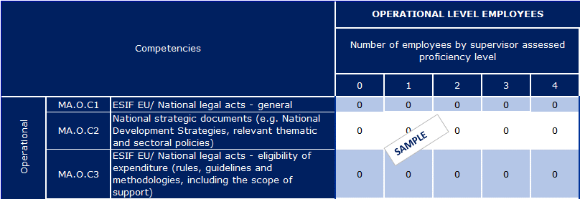

Supervisors and decision making employees

* ……………
* ……………
* ……………

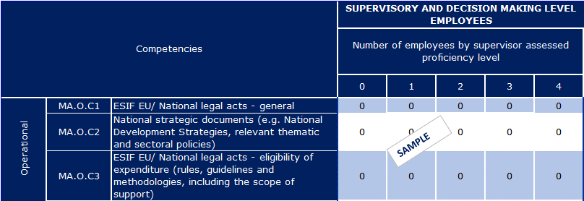

## Management Competencies

Overview of results

* ……………
* ……………
* ……………

Operational level employees

* ……………
* ……………
* ……………

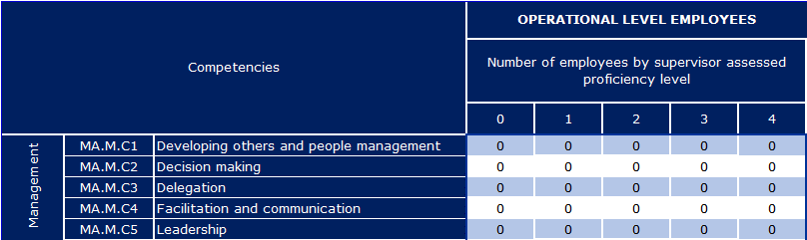

Supervisors and decision making employees

* ……………
* ……………
* ……………

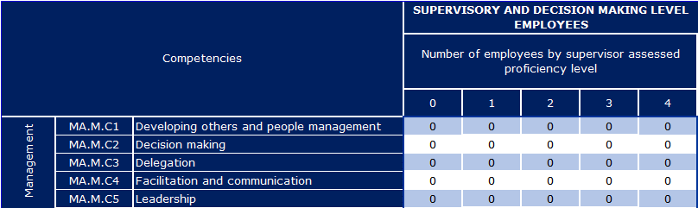

## 

## Professional Competencies

Overview of results

* ……………
* ……………
* ……………

Operational level employees

* ……………
* ……………
* ……………

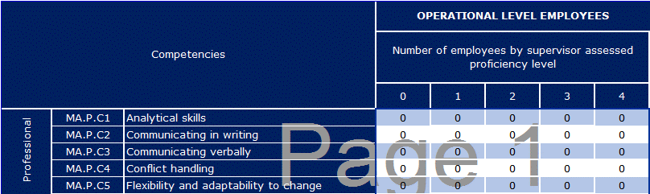

Supervisors and decision making employees

* ……………
* ……………
* ……………

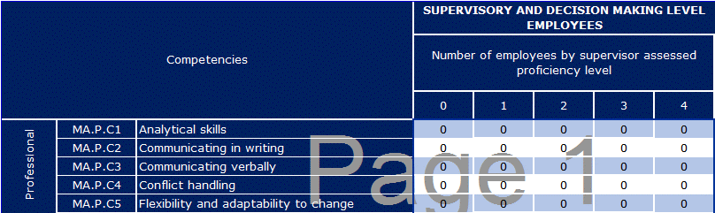

# Immediate actions to improve competencies

## Selected actions

* Overview on selected methods and actions for competency development
* Link to the Technical Assistance resources of the operational programme



## Learning methods

|  |  |  |  |  |  |  |  |  |  |
| --- | --- | --- | --- | --- | --- | --- | --- | --- | --- |
| Operational competencies | | |  | | |  | | |  |
| Competency | Course name | Brief course description | | Duration | Learning Method | | Desired level addressed | Tasks | Technical Assistance resources |
| XXXX |  |  | |  |  | |  |  |  |
|  |  |  | |  |  | |  |  |  |

|  |  |  |  |  |  |  |  |  |  |
| --- | --- | --- | --- | --- | --- | --- | --- | --- | --- |
| Professional competencies | | |  | | |  | | |  |
| Competency | Course name | Brief course description | | Duration | Learning Method | | Desired level addressed | Tasks | Technical Assistance resources |
| XXXX |  |  | |  |  | |  |  |  |
|  |  |  | |  |  | |  |  |  |

| Management competencies | | |  | | |  | | |  |  |  |
| --- | --- | --- | --- | --- | --- | --- | --- | --- | --- | --- | --- |
| Competency | Course name | Brief course description | | Duration | Learning Method | | Desired level addressed | Tasks |  | Technical Assistance resources |  |
| XXXX |  |  | |  |  | |  |  |  |  |  |
|  |  |  | |  |  | |  |  |  |  |  |

## Recruitment

|  |  |  |  |
| --- | --- | --- | --- |
| Job Role | Desired level | Competencies | Tasks related |
|  |  |  |  |
|  |  |  |  |

## Outsourcing

|  |  |  |  |
| --- | --- | --- | --- |
| Outsourced Tasks | Details | Competencies addressed | Technical Assistance resources |
|  |  |  |  |
|  |  |  |  |

## Robotics process automation

|  |  |  |  |
| --- | --- | --- | --- |
| Automated Tasks | Details | Competencies addressed | Technical Assistance resources |
|  |  |  |  |
|  |  |  |  |

## Participation in learning networks

|  |  |  |  |
| --- | --- | --- | --- |
| Network | Details | Competencies addressed | Tasks related |
|  |  |  |  |
|  |  |  |  |

## 

## Good practices, exchanges and peer support

|  |  |  |  |
| --- | --- | --- | --- |
| Good practice | Details | Competencies that will benefit | Tasks that will benefit |
|  |  |  |  |
|  |  |  |  |

|  |  |  |  |  |
| --- | --- | --- | --- | --- |
| Peer learning topic | Details about administration involved | Competencies that will benefit | Tasks that will benefit | TAIEX-REGIO Peer2Peer |
|  |  |  |  |  |
|  |  |  |  |  |

## Considerations on the organizational structure

* Considerations on organizational units and tasks / sub-tasks

# 

# medium and long-term use of the Instrument

## Medium Term actions

### Responsibility

### Procedures

### Resources

## Long Term actions

### Competency-based HR Strategy

# competency development roadmap

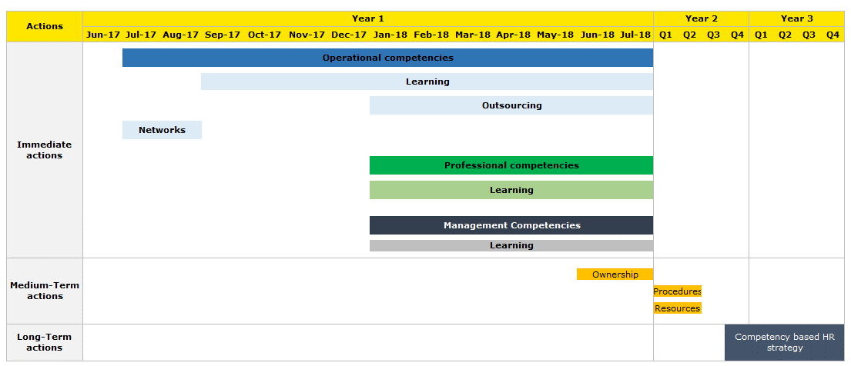

[Catalogue number]