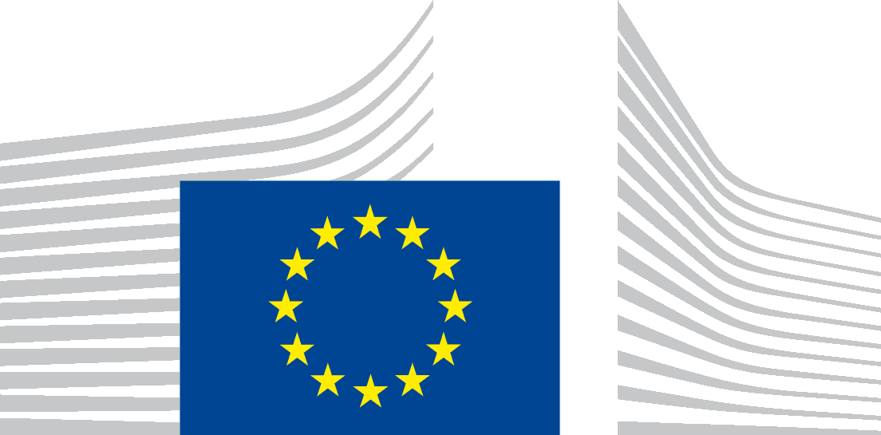 | EUROPEAN COMMISSION

Privacy Statement for Meetings and Events organised by the European Commission

PROTECTION OF YOUR PERSONAL DATA
Processing operation: 2021-2027 Technical seminars
Data Controller: European Commission, Directorate-General for Regional and Urban Policy, Coordination of programmes unit
Record reference: DPR-EC-1063

Table of Contents
- Introduction
- Why and how do we process your personal data?
- On what legal ground(s) do we process your personal data?
- Which personal data do we collect and further process?
- How long do we keep your personal data?
- How do we protect and safeguard your personal data?
- Who has access to your personal data and to whom is it disclosed?
- What are your rights and how can you exercise them?
- Contact information
- Where to find more detailed information?

1. Introduction
The European Commission is committed to protect your personal data and to respect your privacy. The Commission collects and further processes personal data pursuant to Regulation (EU) 2018/1725 of the European Parliament and of the Council on the protection of natural persons with regard to the processing of personal data by the Union institutions, bodies, offices and agencies and on the free movement of such data.
This privacy statement explains the reason for the processing of your personal data in the context of a (type of a) meeting or event, organised by the European Commission. It explains the way we collect, handle and ensure protection of all personal data provided, how that information is used and what rights you have in relation to your personal data. It also specifies the contact details of the responsible Data Controller with whom you may exercise your rights, the Data Protection Officer and the European Data Protection Supervisor.
The information in relation to the processing of personal data linked to meetings and events, organised by the services of the European Commission, is presented below.

2. Why and how do we process your personal data?
Purpose of the processing operation: the European Commission collects and further processes your personal data to provide you with information about the specific meeting or event (before, during and after) and to process your application for participation in that meeting or event.
Your personal data will not be used for any automated decision-making including profiling.
Live web-streaming and audio-visual recording at the event or meeting of the speakers, organisers and participants, as well as photographs of the speakers and panoramic photographs of participants and organisers will be taken and published in the context of the event or meeting at the 2021-2027 Technical seminars page. This page contains links to the European Commission webstreaming page containing the recordings of the mentioned seminars.
The audience or non-speaker participants are not photographed individually or in groups. They may however appear on panoramic photographs of the whole event/audience.
Participants that do not wish to be part of the above web-streaming and recording/publishing activities have the possibility to object to processing.
We organise the event via Webex. For more information on the processing of your personal data, you can consult the record DPR-EC-05006.1 in the Public Register of the Data Protection Officer via the following link: http://ec.europa.eu/dpo-register

3. On what legal ground(s) do we process your personal data?
The processing operations on personal data, linked to the organisation, management, follow-up and promotion of the meeting or event (including web-streaming, photos, audio-visual recording) are necessary for the management and functioning of the Commission, as mandated by the Treaties. Those provisions are in particular, Article 11 of the Treaty on European Union and Article 15 of the Treaty on the Functioning of the European Union.
Consequently, those processing operations are lawful under Article 5(1)(a) of Regulation (EU) 2018/1725 (processing is necessary for the performance of a task carried out in the public interest or in the exercise of official authority vested in the Union institution or body).
Your consent is required for the following actions during the meeting or event
- the processing of your personal data for sending to you a follow up email on the seminars (the email is sent after the seminar with information of the website, presentations and recordings available) inviting you to future events the data controller may organise;
If you opt-in, you are giving us your explicit consent under Article 5(1)(d) of Regulation (EU) 2018/1725 to process your personal data for those specific purposes. You can give your consent via a clear affirmative act by ticking the box on the online registration form.
Your consent for these services can be withdrawn at any time sending an email to REGIO-COORDINATION-OF-PROGRAMMES@ec.europa.eu .
4. Which personal data do we collect and further process?
The following personal data may be processed in the context of the meeting or event:
- contact details (function/title, first name, last name, name of organisation, city, country, e-mail address, telephone number);
5. How long do we keep your personal data?
The Data Controller only keeps your personal data for the time necessary to fulfil the purpose of collection or further processing.
For each of the categories of personal data that may be processed, please find below the retention details and the reference to the relevant record of processing processing:
- Personal data related to the organisation and management of the meeting or event (this includes the information given during the registration, before, during or after the event) will be kept for five years after the meeting or event.
- Recordings from the web-streamed meeting or event will be kept for 7 years before being deleted. More information is available in the Record of Processing DPR-EC-00306 (Web-streaming of Commission events). These specific 2021-2027 Technical seminars will be kept for 7 years, as they should be available throughout the programming period 2021-2027.
- Personal data shared with the controller for future mailing purposes (e.g., for receiving newsletters or invitations to similar events) are processed in line with the Record of Processing DPR-EC-03928 (Management of subscriptions to receive information) and the specific privacy statement prepared by the organising Commission service.

6. How do we protect and safeguard your personal data?
All personal data in electronic format (e-mails, documents, databases, uploaded batches of data, etc.) are stored on the servers of the European Commission. All processing operations are carried out pursuant to Commission Decision (EU, Euratom) 2017/46 of 10 January 2017 on the security of communication and information systems in the European Commission.
In order to protect your personal data, the Commission has put in place a number of technical and organisational measures. Technical measures include appropriate actions to address online security, risk of data loss, alteration of data or unauthorised access, taking into consideration the risk presented by the processing and the nature of the personal data being processed. Organisational measures include restricting access to the personal data solely to authorised persons with a legitimate need to know for the purposes of this processing operation.

7. Who has access to your personal data and to whom is it disclosed?
Access to your personal data is provided to the Commission staff responsible for carrying out this processing operation and to other authorised Commission staff according to the “need to know” principle. Such staff abide by statutory, and when required, additional confidentiality agreements.

8. What are your rights and how can you exercise them?
You have specific rights as a ‘data subject’ under Chapter III (Articles 14-25) of Regulation (EU) 2018/1725, in particular the right to access, your personal data and to rectify them in case your personal data are inaccurate or incomplete. Where applicable, you have the right to erase your personal data, to restrict the processing of your personal data, to object to the processing, and the right to data portability.

You have the right to object to the processing of your personal data, which is lawfully carried out pursuant to Article 5(1)(a) of Regulation (EU) 2018/1725 on grounds relating to your particular situation.

You have consented to provide your personal data to the data controller for the present processing operation. You can withdraw your consent at any time by notifying the data controller REGIO-COORDINATION-OF-PROGRAMMES@ec.europa.eu by email. The withdrawal of your consent will not affect the lawfulness of the processing carried out before you have withdrawn the consent.

You can exercise your rights by contacting the data controller, or in case of conflict the Data Protection Officer. If necessary, you can also address the European Data Protection Supervisor. Their contact information is given under Heading 9 below.
Where you wish to exercise your rights in the context of one or several specific processing operations, please provide their description (i.e. their Record reference(s) as specified under Heading 10 below) in your request.

9. Contact information
- The Data Controller
If you would like to exercise your rights under Regulation (EU) 2018/1725, or if you have comments, questions or concerns, or if you would like to submit a complaint regarding the collection and use of your personal data, please feel free to contact the Data Controller Coordination of programmes, DG REGIO, at REGIO-COORDINATION-OF-PROGRAMMES@ec.europa.eu .
- The Data Protection Officer (DPO) of the Commission
You may contact the Data Protection Officer (DATA-PROTECTION-OFFICER@ec.europa.eu) with regard to issues related to the processing of your personal data under Regulation (EU) 2018/1725.

- The European Data Protection Supervisor (EDPS)

You have the right to have recourse (i.e. you can lodge a complaint) to the European Data Protection Supervisor (edps@edps.europa.eu) if you consider that your rights under Regulation (EU) 2018/1725 have been infringed as a result of the processing of your personal data by the data controller.

10. Where to find more detailed information?
The Commission Data Protection Officer (DPO) publishes the register of all processing operations on personal data by the European Commission, which have been documented and notified to him. You may access the register via the following link: http://ec.europa.eu/dpo-register.
This specific processing operation has been included in the DPO’s public register with the following Record reference: DPR-EC-1063.

