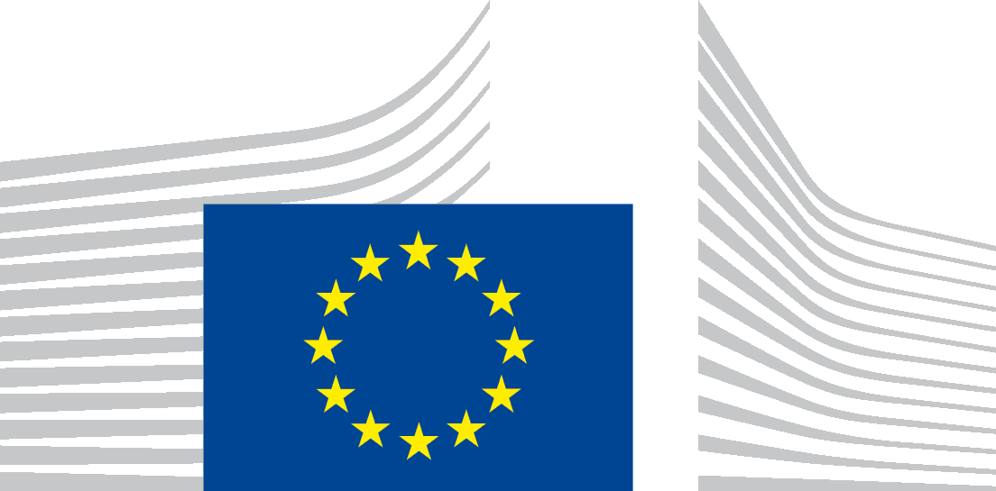 | EUROPEAN COMMISSION  DIRECTORATE-GENERAL FOR EMPLOYMENT, SOCIAL AFFAIRS AND INCLUSION  Skills  Skills and Qualifications

Minutes

Webinar: “Instructions for publishing learning opportunities on new Europass”
Date: Monday, 16 March 2020
Time: 10:00 – 12:00

Attendance:
67 Participants including DG EMPL and contractors

Meeting Agenda:
- Opening remarks and overview of the call by Koen NOMDEN;
- Context and overview presentation by Francesco LOSAPPIO (cf PPT);
- Learning Opportunities: Technical overview presentation by Honza FÖRSTER (cf PPT);
- Questions & Answers interactive session;
- Next Steps

Questions by MS representatives:
- How long will the legacy model be sustained? is it possible to extend this deadline to AFTER the end of 2020?
After the launch of Europass the legacy model for publishing data on learning opportunities will still be available. The legacy model will be phased out, but the timeline for doing so will still be fixed. Countries that use the legacy model ensure that they only publish up to date learning opportunities.
- We have only one option to work with a new database and do not wish to use the legacy one. I hope this can be facilitated.
The idea is that you use the new data model and move away from the legacy model which is there for those who cannot yet use the new model on Learning Opportunities. The legacy model does not benefit from all the features of QDR.
- Is it possible to publish LOpps if we do not have qualifications online yet?
Yes, this is possible. If qualifications and learning opportunities represent two different data sets, they can be published separately or be linked.
- With the new Learning Opportunities model, will there be an upload portal like with Qualifications or do we update LOpps the same way as before?
Under the new model QDR is used for uploading the LOpps and we hope that everyone could use the automated update option, while there is still the option of using the legacy model for those not ready yet.
- Will there be testing?
Yes, there will be testing. Testing can start already and all countries ready to do so are invited to start testing.
- Please send us which of the new required fields are the same with old ones of previous LO 0.510 protocol. In the instructions page 32-33 we have 15 fields but in pages 71-81 there are a lot more fields.
The difference is that the first pages (32-33) are required fields are aligned also with the legacy model while in the annex (71-81) these are the full data model with the optional fields. It depends how many of those fields you have in your own database, and if you have them it will be recommended to publish them.
- What’s the difference between field 3 (title) and 6 (title)? Also, what is the difference between 4 (provide by), 13 (organization) and 15 (legal name).
3 (title) refers to the title of the learning opportunity while 6 (title) refers to the title of the learning specification. These may be different or the same depending on the MS data model. 4 (provide by) is a link to the organisation from the learning opportunity, 13 (organization) is an indication that this class shall exist in the data and 15 (legal name) mean that the name of the organisation shall be indicated.
- I understand that some additional programming will be required. Will there be some additional funding available?
Further programming efforts will be needed, unless you continue working with the legacy model for now and continue publishing the data manually as it was done in LOQ platform. It also depends on how the exact programme implementation work as it depends on MS internal infrastructure.
Regarding the additional funding, the grants applicable to the Euroguidance and Europass are running until the end of 2020. There will be however new grants in 2021 which the European Commission will finalise their ToR, and then share them with you. As from 2021 grants for Euroguidance and Europass and other platforms in relation
- Can you send us the schema of the QMS and LOMS in an Excel format?
Yes, we will prepare them and send them out
- Is it possible to send us an example of a filled LO according to the new protocol. It would help to use it as a model.
There are already examples in the manual, namely the XML samples for LOpps.

Questions to participants:

When do you plan to connect your LOpps data to the Europass platform? Do you intend to use the LOMS or will you continue publishing through the legacy model? Please indicate to us until when you would need to stay on the legacy model?

The use of the legacy model was announced by DK, AT, PT, RO, RS;

The following countries confirmed their intention to use QDR-LOMS from the beginning: EL, IE, IS, NL, NO.

Next steps

- Testing to publish data before the soft launch of the Europass platform can already start. This has to be done in the acceptance environment of QDR;
- COM will follow up with each of the participating countries after this meeting to get an assessment on their readiness (and also when and how) to publish LOpps on Europass (the same will be done regarding information on qualifications). You will be contacted for this by Alla Aboudaka (alla.aboudaka.sa@everis.com);
- Technical support is available free of charge through the helpdesk: qualifications@ext-ec-europa.eu;
- Launch dates of Europass:
- 23 April: soft launch (LOQ + New Europass operate in parallel);
- 29 May: official launch (LOQ will be turned off);
- COM will prepare and send in Excel format the tables in PdF of the Manual;
- COM will edit the Manual where needed;
- COM will publish FAQ on the Manual;
- COM will share a recording of the meeting.

