Compilation of US and EU supply, use and input-output tables in the European classifications and comparison of the two economies

Remond-Tiedrez, Isabelle; Defense-Palojarv, Pille* (a)

(a) European Commission, Eurostat
E-mail: isabelle.remond-tiedrez@ec.europa.eu
Pille.palojarv@ec.europa.eu
In 2013, Eurostat, the Statistical Office of the European Union, compiled for the first time the supply and use tables for the United States of America in the new classification NACE Rev 2, based on ISIC 4 and CPA 2008. In December 2013, the Bureau of Economic Analyses (BEA), published the revised make and use tables based on the new benchmark tables of the year 2007. This paper will present the process of derivation of the US tables from the US official dissemination (BEA into the same classification used in the European Union and changes compared to the first version disseminated last year. It also presents updated comparison with German economy and the European Union for the years 2008 – 2010 and possible effects of switch to the ESA2010
Disclaimer: The views expressed in this paper are those of the authors and should not be attributed to the European Commission or its services.
* corresponding author
Keywords: national accounts, supply and use tables, classifications, European Union
Introduction
In October 2012, Eurostat has published for the first time European Supply, Use and Input-output tables in the classification NACE Rev 2 (in line with ISIC 4) and CPA 2008. The changeover of classifications was introduced in the European Union for an implementation from 1 January 2008 onwards. The change in National Accounts area came at the end of the process with an implementation from August 2011 at an aggregated level of activities and August 2012 for the most detailed activities classification used in National Accounts.
Due to the new classification, many time series had to be shortened in a first step. In the area of supply, use and input-output tables, European Member States were required to provide data from 2008 onwards in the new classification. This implied that the European time series of Supply, Use and Input-output tables is subject to a break: from 2000 to 2007 data is available in NACE Rev 1.1 and CPA 2002 and from 2008 on, data is available in NACE Rev 2 and CPA 2008.
With the new European table of the reference year 2008 in NACE Rev 2, disseminated in October 2012 on Eurostat website, Eurostat run the project to compare the European tables to the American United States table. The first version of the US data in European NACE Rev 2 for years 2008-2010 was disseminated on Eurostat website in October 2013. In December 2013 the BEA published results of the Comprehensive revision of the Industry Economic Accounts for the years 1997 – 2012 and new benchmark Input-Output accounts for the year 2007. Based on this new information Eurostat updated the US tables for years 2008 – 2011 in European classifications.
The paper will give in part 1 some background information on the changeover of activities and products classifications, then part 2 will describe the necessary steps of transformation of the US make table; part 3 will refer to the transformation of the US use table into European classifications and part 4 will provide a comparison between the European Union, Germany and US supply, use and input-output tables for the year 2010

NACE Rev 2 and CPA 2008 classifications
The NACE Rev 2 is the current European standard classification of productive economic activities. NACE provides the framework for collecting and presenting a large range of statistical data according to economic activity in production, employment, national accounts and other statistical areas. Statistics produced on the basis of NACE are comparable at European and at world level, as the NACE is part of a system of international statistical classifications developed mainly under the auspices of the United National Statistical Division.
From the European point of view, the system of classifications can be represented as follows:
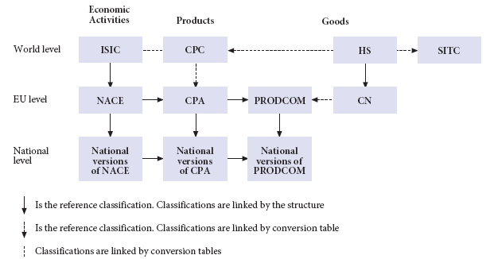
Major revisions of international and European classifications of economic activities and products (Operation 2007) took place between 2000 and 2007 leading to the ISIC rev 4. and the NACE Rev 2 at the European level. In order to ensure international comparability, the definitions and the guidelines established for use of NACE within the EU are consistent with those published in the introduction to ISIC.
NACE is a derived classification of ISIC: categories at all levels of NACE are defined either to be identical to, or to form subsets of, single ISIC categories. The first level and the second level of ISIC Rev. 4 (sections and divisions) are identical to sections and divisions of NACE Rev. 2. The third and fourth levels (groups and classes) of ISIC Rev. 4 are subdivided in NACE Rev. 2 according to European requirements. However, groups and classes of NACE Rev. 2 can always be aggregated into the groups and classes of ISIC Rev. 4 from which they were derived. The aim of the further breakdowns in NACE Rev. 2, as compared with ISIC Rev. 4, is to obtain a classification more suited to the structures of the European economies.
The classification of product by activity CPA is the European version of the CPC, and the purposes it serves are in line with those of the CPC. The EU adopted the criterion of economic origin for the development of the CPA, with NACE as the reference framework. Therefore, up to the fourth level (classes) the structure of CPA corresponds to NACE. In general, CPC subclasses are re-arranged according to their economic origin. The link between the CPA and NACE Rev. 2 is evident in the CPA code: at all levels of the CPA, the coding of the first four digits is identical with that used in NACE Rev. 2, with very few exceptions.
The NAICS is the North American Industry Classification System. NAICS was developed in the mid-1990s to provide common industry definitions for Canada, Mexico, and the United States, to facilitate economic analyses of the economies of the three North American countries. NAICS is developed on the basis of a production-oriented conceptual framework and classifies units, not activities. As a result, the structures of ISIC and NAICS are substantially different. However, statistical data collected according to NAICS can be aggregated into the two-digit divisions of ISIC Rev. 4/NACE Rev. 2, ensuring comparability of data. In many cases, more detailed links are possible. A detailed concordance between NAICS and ISIC is published on the NAICS website (USA: http://www.census.gov/eos/www/naics/concordances/concordances.html).

The US make table into European classification
The make table for the USA for the years 1997-2012 are available on the Bureau of Economic Analysis website and beginning with 2007, the benchmark input-output tables are fully integrated with the annual industry accounts. The make matrix has been compiled after redefinitions data from the Industry Input-Output (I-O) accounts as part of the comprehensive revision to the annual industry accounts (for years 1997-2012, released in January, 2014) as part of the annual revision to the industry accounts. Statistics for all years were prepared with methodologies that are unique to the I-O accounts and are for industries defined according to the 2007 North American Industry Classification System (NAICS).
The US make matrix presents a square table of industries and commodities, while in the European System of Accounts (ESA), the production matrix (transposed make matrix) the domestic output of industries is shown by products. The Annex 1 gives the bridge table between the NAICS codes used in the US table and the NACE Rev 2 and CPA 2008 codes used in the ESA.
Out of the 69 US industries categories, 27 have a one-to-one correspondence with the NACE Rev 2 and 30 have to be summed up for the NACE correspondence. These two groups are representing 72% of the total US supply in years 2008 -2011. The same applies to the commodities dimension, the 31 products.
The 12 n-to-m industries for which the correspondence between NAICS and NACE Rev 2 is not bijective have to be split between industries and commodities (see Table 1). There the 2007 benchmark make table available on the BEA website was used to split the n-to-m industries. This is under the assumption that the structure of the domestic output of those industries did not change over the years. Those industries and products (commodities) represent the left 28% of the total supply in years 2008 - 2011.
Table 1: relationship between NAICS industries and commodities with NACE CPA industries and products
 | Year 2009 |  | Year 2010 |  | Year 2011
Industries | In Mio US$ | In% | In Mio US$ | In % | In Mio US$ | In %
Total | 24 655 169 | 100,0% | 26 097 252 | 100,0% | 27 526 888 | 100,0%
GFE and GSLE industries | 743 673 | 3,0% | 761 174 | 2,9% | 784 771 | 2,9%
Industries one-to-one | 17 560 837 | 71,2% | 18 685 298 | 71,6% | 19 821 424 | 72,0%
Industries n-to-m | 7 094 329 | 28,8% | 7 411 956 | 28,4% | 7 705 460 | 28,0%
Commodities/products
Total | 24 655 169 | 100,0% | 26 097 252 | 100,0% | 27 526 888 | 100,0%
GFE and GSLE | 150 871 | 0,6% | 153 242 | 0,6% | 156 366 | 0,6%
Commodities one-to-one | 17 456 036 | 70,8% | 18 575 808 | 71,2% | 19 705 964 | 71,6%
Commodities n-to-m | 7 199 134 | 29,2% | 7 521 444 | 28,8% | 7 820 926 | 28,4%

The US make table includes some particular categories as Federal government enterprises, State and local government enterprises, Scrap, used and second hand goods and Non-comparable imports and rest-of-the-world adjustment. Treatment of those industries and commodities will be explained later on.

Benchmark data used for the correspondence of n-to-m industries
When looking at the bridge table in annex 1, some US industries have to be split or grouped into the industries activities of the NACE. To determine the correspondence, the benchmark of year 2007 was used for the structure to apply to years 2008 - 2011 data.
Here is an example of grouping, with the NAICS industries/commodities: 211, oil and gas extraction; 212 mining except oil and gas; 213 support activities for mining that correspond to industry/product B Mining in NACE/ CPA classification. Here we summed up the detail of the NAICS to get the NACE code:

Table 2: example of CPA B mining, year 2011
 |  | Industry code
NAICS  commodity  code | Label | 211 | 212 | 213 | Total
211 | Oil and gas extraction | 273 831 | 231 |  | 274 062
212 | Mining, except oil and gas |  | 105 507 | 205 | 105 712
213 | Support activities for mining |  | 24 | 121 185 | 121 209
Total |  | 273 831 | 105 762 | 121 390 | 500 983

It will correspond to the cell Mining (both for product and industry) with a supply of 500.983 Mio US$ of mining products by the mining industry.
The NAICS industries/commodities that needed to be distributed are listed in table 3.
Table 3: list of NAICS industries/commodities with n-to-m relationship with NACE
NAICS code | Label
113FF | Forestry, fishing, and related activities
22 | Utilities
3364OT | Other transportation equipment
325 | Chemical products
487OS | Other transportation and support activities
513 | Broadcasting and telecommunications
531 | Real estate
5412OP | Miscellaneous professional, scientific, and technical services
561 | Administrative and support services
81 | Other services, except government

Let’s take an example of splitting a NAICS code to different NACE codes with NAICS 561 Administrative and support services that will correspond to 3 NACE codes. The NAICS 561 is composed of 3 detailed codes that will correspond 1-to-1 to NACE codes:
Table 4: detailed NAICS codes for 561 Administrative and support services
NAICS 561 details | NACE code
5613 Employment services | N78 employment services
5615 Travel arrangement and reservation services | N79 Travel agency, tour operator reservation service and related activities
561A All other administrative and support services | N80-82 Security and investigation activities; services to buildings and landscape activities; office administrative, office support and other business support activities

The 2007 detailed make table gives the sub-table 5 for NAICS 561:

Table 5: structure of supply for NAICS 561
Industry/commodity | 5613 | 5615 | 561A | Total
5613 | 176 366 (30%) |  | 467 (0.1%)
5615 |  | 39 836 (6.8%)
561A |  |  | 365 085 (62.8%)
Total |  |  |  | 581 754 (100%)

This structure was then applied on the values of years 2008 - 2011.

The government and government enterprises
In the US make table appear four categories of industry/commodity:
GFG | Federal general government
GFE | Federal government enterprises
GSLG | State and local general government
GSLE | State and local government enterprises

The federal general government GFG and the state and local general government GSLG are included under the NACE codes O84 Public administration and defence; compulsory social security.
Compared to the first version published in 2013 the treatment of government enterprises has been simplified. In current estimates the federal government enterprises, both in industries and commodities are included under the NACE H53 Postal services.
The state and local government enterprises are allocated between three industries/commodities as follows: 30 % to CPA D35 electricity, gas steam and air-conditioning, 35 % to CPA E 36 Natural water; water treatment and supply services and 35% to E37-39 sewerage and waste. This allocation applies both to industries and to commodities.
The Non-comparable imports and rest-of-the-world adjustment of FGE has been treated as imports and is included under P33 Direct purchases abroad by residents.

The US use table into European classification
The US use table is available on BEA website. As for the make table, the use table is presented in producer’s prices, when the European consolidated tables are in basic prices. Eurostat will present the two concepts for each area: producer’s prices for the USA table and basic prices for the EU27 table.
The use table for USA shows the use of 71 goods and services by type of use, i.e. as intermediate use by industries and final use. The list of commodities includes some specific entries presented in table 6.

Table 6: Specific commodities entries in US use table
GFE | Federal government enterprises
GSLE | State and local government enterprises
Used | Scrap, used and second hand goods
Other | Non comparable imports and rest-of-the-world adjustment

The commodity Scrap, used and second hand goods from the US table has currently been associated to CPA E37-E39 Sewerage; waste collection; material recovery, but Eurostat is investigating the possibility to split the data into more detail
The commodity Other (non-comparable imports and rest-of-the world adjustment) has been treated as direct purchases abroad by residents (transaction coded P33 in the European table).
Out of the 67 commodities left, 57 would have a 1-to-1 or n-to-1 correspondence with NACE codes, representing around 73% of the total intermediate use. The remaining 10 n-to-m commodities, the same as in the make table, represent circa 17% of the total intermediate use and will have to be disaggregated into NACE codes, using the 2007 detailed benchmark use table. The nine commodities are the following:
Table 7: relationship between NAICS industries and commodities with NACE CPA industries and products in the US use table
 | Year 2009 |  | Year 2010 |  | Year 2011
Industries | Mio US $ | In % | Mio US $ | In % | Mio US $ | In %
Total | 10 237 228 | 100% | 11 138 990 | 100% | 11 993 050 | 100%
GFE and GSLE industries | 181 218 | 1.8% | 185 100 | 1.7% | 195 175 | 1.6%
Industries one-to-one | 7 663 987 | 74.9% | 8 392 297 | 75.3% | 9 114 972 | 76.0%
Industries n-to-m | 2 573 246 | 25.1% | 2 746 694 | 24.7% | 2 878 078 | 24.0%
Commodities/products
Total | 10 237 228 | 100% | 11 138 990 | 100% | 11 993 050 | 100%
GFE and GSLE | 85 744 | 0.8% | 86 617 | 0.8% | 88 024 | 0.7%
Commodities one-to-one | 6 682 800 | 65.3% | 7 346 613 | 66.0% | 8 017 676 | 66.9%
Commodities n-to-m | 3 554 429 | 34.7% | 3 792 378 | 34.0% | 3 975 380 | 33.1%

Benchmark to detailed 2007 table for n-to-m correspondence
One of the relationships between NAICS and NACE is n to 1. The NACE code results of the summation of NAICS codes. The table 8 gives the list of NAICS for which we have considered an one and only one NACE CPA code.
Table 8: relationship of n-to-1 between NAICS and NACE/CPA
NAICS | Label | CPA | Label
211 | Oil and gas extraction | B | Mining
212 | Mining, except oil and gas | B | Mining
213 | Support activities for mining | B | Mining
313TT | Textile mills and textile product mills | C13-C15 | Textiles, wearing apparel and leather products
315AL | Apparel and leather and allied products | C13-C15 | Textiles, wearing apparel and leather products
3361MV | Motor vehicles, bodies and trailers and parts | C29 | Motor vehicles, trailers and semi-trailers
337 | Furniture and related products | C31_C32 | Manufacture of furniture; other manufacturing
339 | Miscellaneous manufacturing | C31_C32 | Manufacture of furniture; other manufacturing
441 | Motor vehicle and parts dealers | G45 | Retail trade services, except of motor vehicles and motorcycles
445 | Food and beverage stores | G47 | Retail trade services, except of motor vehicles and motorcycles
452 | General merchandise stores | G47 | Retail trade services, except of motor vehicles and motorcycles
4A0 | Other retail | G47 | Retail trade services, except of motor vehicles and motorcycles
482 | Rail transportation | H49 | Land transport and transport via pipelines
484 | Truck transportation | H49 | Land transport and transport via pipelines
485 | Transit and ground passenger transportation | H49 | Land transport and transport via pipelines
486 | Pipeline transportation | H49 | Land transport and transport via pipelines
721 | Accommodation | I | Accommodation and food service activities
722 | Food services and drinking places | I | Accommodation and food service activities
514 | Information and data processing services | J62_J63 | Computer programming, consultancy and related activities; information service activities
5415 | Computer systems design and related services | J62_J63 | Computer programming, consultancy and related activities; information service activities
521CI | Federal Reserve banks, credit intermediation, and related activities | K64 | Financial service activities, except insurance and pension funding
525 | Funds, trusts, and other financial vehicles | K64 | Financial service activities, except insurance and pension funding
5411 | Legal services | M69_M70 | Legal and accounting activities; activities of head offices; management consultancy activities
55 | Management of companies and enterprises | M69_M70 | Legal and accounting activities; activities of head offices; management consultancy activities
621 | Ambulatory health care services | Q86 | Human health activities
622 | Hospitals | Q86 | Human health activities
623 | Nursing and residential care facilities | Q86 | Human health activities

Another relationship is, as for the supply table, to split the NAICS code into several NACE/CPA codes. Let’s take for example the NAICS code 5412OP ‘Miscellaneous professional, scientific, and technical services’. It is composed by 10 detailed products:
Table 9: Details of the commodity NAICS 5412OP ‘Miscellaneous professional, scientific, and technical services’
Commodities  included in  5412OP | Label
5412 | Accounting, tax preparation, bookkeeping, and payroll services
5413 | Architectural, engineering, and related services
5414 | Specialized design services
54161 | Management consulting services
5416A | Environmental and other technical consulting services
5417 | Scientific research and development services
5418 | Advertising and related services
5419A | Marketing research and all other miscellaneous professional, scientific and technical services
54192 | Photographic services
54194 | Veterinary services

The NACE/CPA codes corresponding are composed by:
Table 10: NACE/CPA products/industries corresponding to NAICS 5412OP
NACE/CPA
M69-70 Legal and accounting services; services of head offices; management consulting services
M71 Architectural and engineering services; technical testing and analysis services
M72 Scientific research and development services
M73 Advertising and market research services
M74_75 Other professional, scientific and technical services; veterinary services

The detailed 2007 benchmark table is used for the intersection of the NAICS 5412OP and the NACE/CPA listed in table 10. For the other industries using 5412OP, the amount is kept in the corresponding NACE/CPA codes. The part of the use table looks like the following for the year 2007:
NAICS | other industries… | M69-70 | M71 | M72 | M73 | M74-75 | Other industries…
5412 | 55% | 4% | 2% | 1% | 0% | 1% | 36% | 100%
5413 | 48% | 1% | 8% | 6% | 0% | 0% | 35% | 100%
5414 | 55% | 4% | 8% | 0% | 7% | 2% | 23% | 100%
54161 | 36% | 3% | 8% | 15% | 1% | 1% | 37% | 100%
5416A | 38% | 3% | 10% | 6% | 1% | 1% | 41% | 100%
5417 | 7% | 0% | 1% | 82% | 0% | 0% | 10% | 100%
5418 | 66% | 1% | 1% | 1% | 3% | 1% | 28% | 100%
5419A | 56% | 2% | 6% | 15% | 1% | 1% | 20% | 100%
54192 | 14% | 10% | 7% | 2% | 21% | 4% | 41% | 100%
54194 | 30% | 0% | 0% | 3% | 0% | 0% | 67% | 100%

Federal and state and local government enterprises
In the US use table, commodities include the federal and state and local government enterprises (GFE and GSLE). To match the European use table we had to reclassify this commodity to the relevant products. To do this a lot of information was searched for and the colleagues from the BEA were consulted in several occasions. In the first version of US supply and use tables in European classification the allocation of GFE and GSLE was rather detailed, but for the revised version it was decided to use the same assumptions as for the supply table, ie. all GFE is included under H53 Postal and courier activities and the GSLE is allocated 30 % to CPA D35 electricity, gas stem and air-conditioning, 35 % to CPA E 36 Natural water; water treatment and supply services and 35% to E37-39 sewerage and waste. This allocation applies both to industries and to commodities.
In terms of total output, the GFE and GSLE commodities represent about 0.6% of the total output both in years 2008 - 2011, but can make up a significant share in concerned products and industries. The table 11 shows the share of GFE and GSLE in respective industries.
Table 11: Share of GFE (Federal government enterprises) and GSLE in NACE industries in years 2008 – 2011
 | D35  (30% GSLE) | E 36  (35% GSLE) | E37-39  (35% GSLE) | H53  (GFE)
IC
2008 | 18% | 91% | 49% | 47%
2009 | 30% | 95% | 55% | 53%
2010 | 28% | 94% | 55% | 53%
2011 | 33% | 95% | 53% | 54%
VA
2008 | 7% | 83% | 53% | 59%
2009 | 7% | 82% | 52% | 59%
2010 | 8% | 81% | 49% | 56%
2011 | 8% | 81% | 51% | 53%
Total
2008 | 13% | 87% | 51% | 54%
2009 | 17% | 88% | 54% | 57%
2010 | 16% | 88% | 52% | 55%
2011 | 17% | 88% | 52% | 53%

Imports, exports
The use table of US provides vectors for imports and exports, where imports are entered with negative values. In the European tables, the imports are presented in the supply matrix. Therefore we transferred the imports (negatives entries) from the use table to the supply table after changing the sign.
In order to compare the European table with the US table, we have split the use table between the use table for domestic output and the use table for imports. The use table for imports is based on the import matrix available on BEA website. The use table for domestic production is calculated by difference.
To achieve the compilation of the use table for imports, the US import matrix was transformed to NACE/CPA classification: first commodities are recoded into CPA products; second the industries were distributed using the structure of the US use table (finalised in section 3.b); third the whole matrix was rescaled by product to match the imports by product from the supply table. The assumption of proportionality is the one used by the BEA. A comment attached to the import matrix data specifies that: “The imputed-import values are based on the assumption that each industry uses imports of a commodity in the same proportion as imports-to-domestic supply of the same commodity. (Domestic supply represents the total amount of a commodity available for consumption within the United States; it equals domestic output plus imports less exports.)”
A specificity of the US table is to have still negative imports in the use of imports table for three CPA products: G46 wholesale trade services, except of motor vehicles and motorcycles, H49 Land transport services and transport services via pipelines and H50 water transport services. We decided to distribute these negative amounts across all products proportional to the product imports in total imports. No allocation was done for services. By doing this we have introduced unbalancing between the products output in the use and in the supply, therefore we adjusted the exports of the product in the use table to balance the product output. And then we recalibrate the use table of imports on the new totals by product.

Input-output table
From the supply and use tables for the USA in the European classifications, the input-output tables for US will be compiled by the same way as Eurostat compiles European input-output tables. A transformation matrix is calculated according to market shares. This market share matrix shows the relative amount of product output by each industry. The transformation matrix is then multiplied with the use matrix to give the symmetric input-output table. This transformation is based on the industry technology assumption producing product-by-product tables (see Model B, Eurostat 2008 Manual of Supply, Use and Input-Output Tables, p.349).

US tables in others international databases and Eurostat’s compilation of US tables

The WIOD consortium (World Input-Output Database) has disseminated in November 2013 the latest version of the input-output tables. The database covers 27 EU countries and 13 other major countries in the world for the period from 1995 to 2009, including the USA.
The WIOD methodology was similar to the Eurostat’s methodology: the splitting of some products and industries to get appropriate WIOD products and industries was done the same way as for the Eurostat table, based on the benchmark table of 2002.
The user may find still differences between the two regarding the following points:
First, the classification of activities and products in the WIOD database is less detailed than the European ones used by Eurostat: the supply and use tables in WIOD cover 35 industries by 59 products, while Eurostat’s compilation covers 64 industries and 64 products;
Second in the WIOD US table the federal govenemenr enterprises and state and local general governement enterpirses are included in public administration.
Third the treatment of imports was different in WIOD and in Eurostat tables: as explained in the technical note on WIOD website because of the different valuation between supply, use and import tables, the imports were taken from the import tables and the difference between imports in the import table and in the supply table is then considered as CIF/FOB adjustment in the supply table.
US supply and use tables can be found also in the database of OECD (The Organisation for Economic Co-operation and Development). The current vintage of the SUIO database is based on 2005 IO tables and 2008 supply and use tables, in Nace rev 1.1. The vintage of data and different classification can make it complicated for users to compared and use data from different sources.

Comparison European Union, Germany and US tables
In the following part we compare the structure of the US supply and use tables with the tables for the European Union (EU) and for Germany. The figure 1 shows the development of Gross domestic product (GDP) of above listed economies over the last
Figure 1: Gross domestic product at market prices in Mio. € across some countries
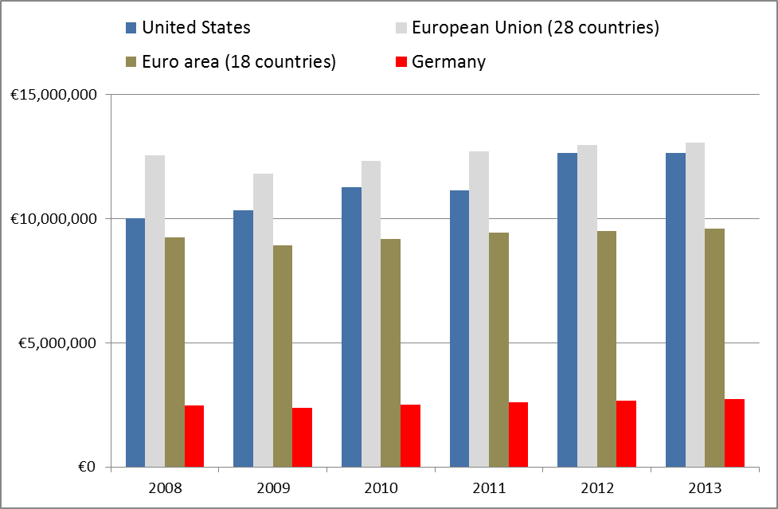

Supply side
On the supply side, the comparison for years 2008 – 2010 between the US, the EU and Germany shows that Germany is much more industrial country than the US and the EU.
Table 12: Share of NACE B - E Industry in the total output for the US, EU and Germany, 2008 – 2010
 | 2008 | 2009 | 2010
European Union | 34.7% | 31.4% | 32.7%
Germany | 45.5% | 41.2% | 43.7%
US | 29.7% | 25.8% | 27.7%

In the industrial sector, Germany is stronger as a producer of machinery and equipment and cars and electrical equipment: between 12 – 14% of the total supply compared to 4 - 5% for US.
On the services side, US does not have significantly higher share not only compared to Germany, but also in relation to the EU.
Table 13: Share of NACE F-U in the total output for the US, EU and Germany, 2008 – 2010
 | 2008 | 2009 | 2010
European Union | 63.5% | 66.9% | 65.6%
Germany | 53.2% | 57.6% | 55.1%
US | 68.9% | 72.8% | 70.9%

The most important differences in the structure are visible in NACE K Financial and insurance services, in NACE M-N Professional, scientific and technical services and in NACE O-Q Public administration and defence services; education services.

Table 14: Share of selected services in the total output for the US, EU and Germany, 2008 – 2010
 | 2008 | 2009 | 2010
NACE K
EU | 4.8% | 5.4% | 5.1%
DE | 4.2% | 4.7% | 4.6%
US | 6.9% | 7.2% | 6.9%
NACE M-N
EU | 9.4% | 9.7% | 9.6%
DE | 8.6% | 8.8% | 8.6%
US | 11.1% | 11.5% | 11.2%
NACE O-Q
EU | 11.3% | 12.7% | 12.3%
DE | 9.6% | 11.1% | 10.6%
US | 15.3% | 17.5% | 17.0%

In the services sector, the high share of public administration services in total supply could be partly explained also by the defence services, which are included under this activity: the United States of America have stronger military forces than Europe in general.

Use side
The use table permits to calculate input coefficient, showing how much of products or production factors are required to produce one unit of output for an industry. The Figure 2 indicates that for the total output of 2010 slightly more labour factor is needed in the USA (31%) compared to the European Union (26%) and Germany (25%). In 2010 the USA total output was using much less intermediate consumption (42%) than Germany (57%) and the European Union in total (53%).
Figure 2: Input coefficients for the year 2010 for total output across EU28 USA and Germany
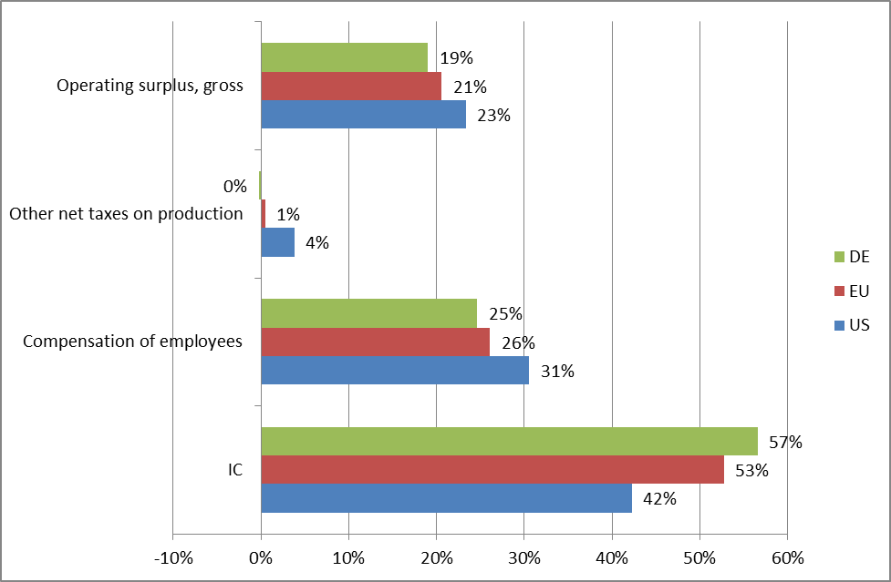
When looking the input coefficients for the EU, Germany and US at A*10 breakdown NACE (see Annex 2) some differences emerge between the three economies (see Figure 3).
Figure 3: Input coefficients by industries for the year 2010
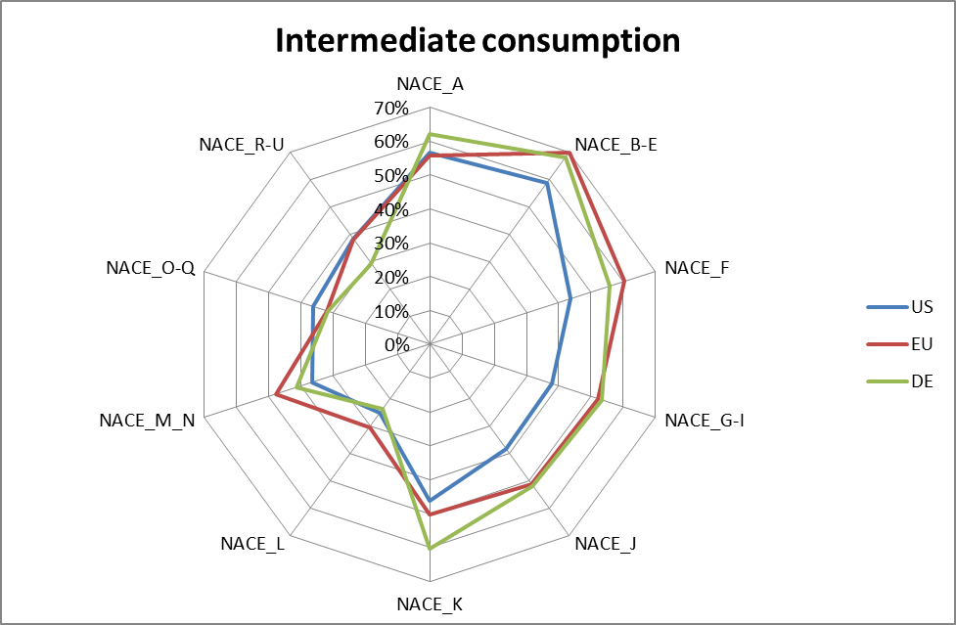
Looking at the coefficients for Intermediate consumption, most industries in Germany and the EU require more intermediate consumption than the industries in the US. Differencies are less significant in NACE O-Q Public administration, defence, education, human health and social work services and in NACE R-U Arts, entertainment and recreation; other services; services of household and extra-territorial organizations and bodies where the input requirements are rather similar.
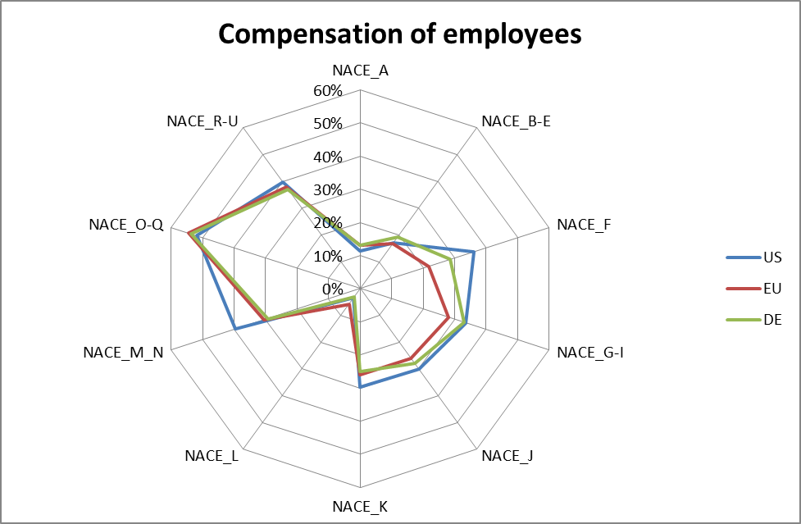
For the compensation of employees the US is showing the higher input need from the labour production factor. Though all three economies have similar pattern for labour needes, the US shows more important need for the labour input in NACE F Construction, in NACE K Financial and insurance services and in NACE M-N Professional, scientific and technical services; administrative and support services.
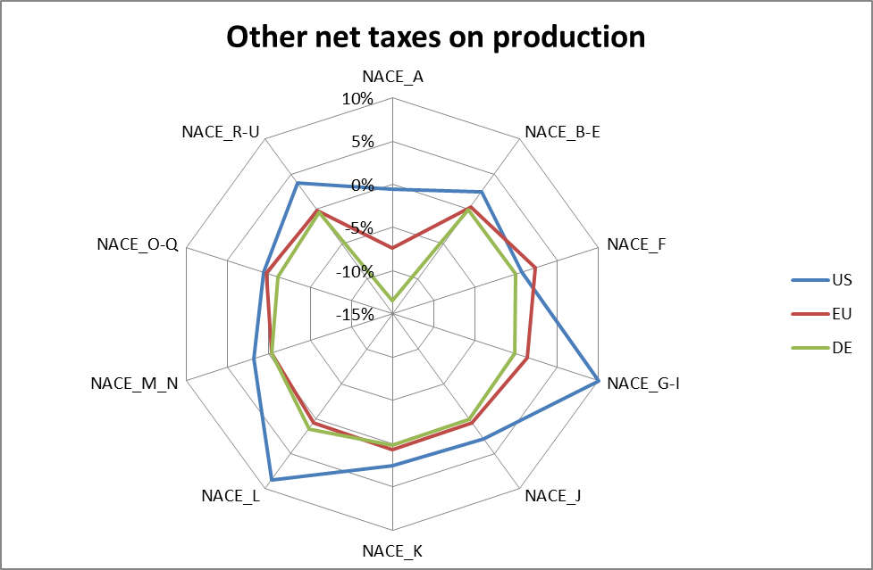
In case of Other net taxes on production the US is showing higher coefficients in all industries, except in NACE F Construction though Germany and the EU are having very similar input.
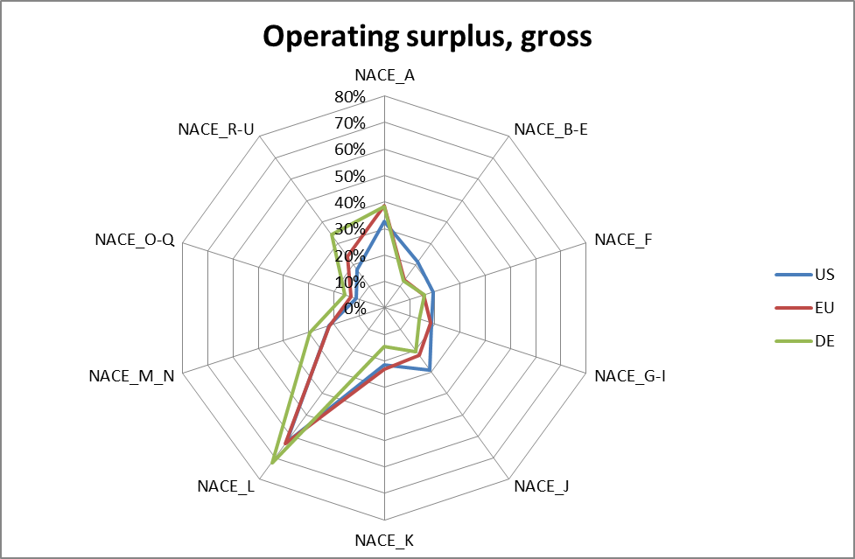
Input coefficients for Operating surplus remain quite similar for the EU, Germany and the US and have the highest values for the NACE L Real estate services. The US shows more important values for the NACE B-E Industrial products (except construction works) and for the NACE J Information and communication services. For the NACE R-U Arts, entertainment and recreation; other services; services of household and extra-territorial organizations and bodies the EU presents higher share compared to Germany and the US.
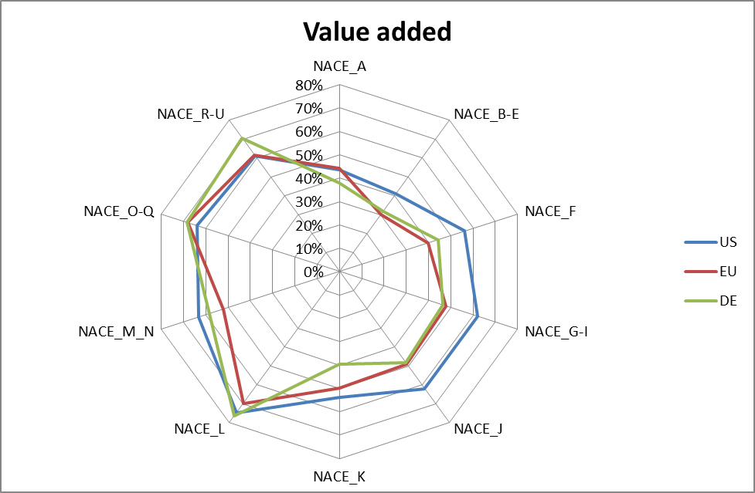
Looking at the Value Added in total, as the counterpart to intermediate consumption, the US has compared to the EU and Germany higher input requirements in majority of industries. Exceptions to that are NACE O-Q Public administration, defence, education, human health and social work services where the EU input is higher and in NACE R-U Arts, entertainment and recreation; other services; services of household and extra-territorial organizations and bodies where Germany has the biggest requirements. In current situation the comparison of final use structure in the US and in European economies would not give the correct picture due to conceptual differences. In frame of the Comprehensive revision of the Industry Economic Accounts for the years 1997 – 2012 the BEA has implemented also the System of National Accounts (SNA) 2008. European countries will have to implement the ESA 2010 (The European System of National and Regional Accounts). The structure and principles of the ESA 2010 are consistent with SNA 2008. The first data transmission under the ESA 2010 is foreseen for September 2010. The supply and use and input-output tables following the new concepts will be transmitted to Eurostat by end of 2014.
The biggest change compared to previous SNA and ESA95 is the capitalisation of R & D expenditures, which increase the Gross Fixed Capital (GFC) and decrease the IC. The same effect comes from capitalisation of investments in weapon systems, which previously were recorded under government expenditure.
It is difficult to estimate the magnitude of changes in the EU as the member states are only finalising their estimates, but the first rough analyses show the increase about 2%. Germany expects an increase around 3%, which is in line with results from BEA, who reported the impact of capitalisation to Gross Output around 1% and to VA around 3%.

Conclusion
The compilation of US tables into the European activities and products classification allows comparing the supply and use tables from the European Union and the United States of America. The work carried out since Autumn 2013 has resulted to supply and use and IO tables for the US in European classification and is available for years 2008 – 2011. Eurostat will continue to extend the time series back to 2005. This work is done together with the help and support from colleagues from the BEA whom we would like to thank for their feedback and cooperation.

.

Annex 1: Bridge table from NAICS to ESA NACE
Note that the CPA 2008 codes are identical to the NACE Rev 2 codes with a prefix “CPA_”
NAICS code | Label in USA table | NACE Rev 2 | label
111CA | Farms | A01 | Products of agriculture, hunting and related services
113FF | Forestry, fishing, and related activities | A02 | Products of forestry, logging and related services
211 | Oil and gas extraction | B | Mining and quarrying
212 | Mining, except oil and gas | B | Mining and quarrying
213 | Support activities for mining | B | Mining and quarrying
22 | Utilities | D35 | Electricity, gas, steam and air-conditioning
 |  | E36 | Natural water; water treatment and supply services
23 | Construction | F | Constructions and construction works
321 | Wood products | C16 | Wood and of products of wood and cork, except furniture; articles of straw and plaiting materials
327 | Non-metallic mineral products | C23 | Other non-metallic mineral products
331 | Primary metals | C24 | Basic metals
332 | Fabricated metal products | C25 | Fabricated metal products, except machinery and equipment
333 | Machinery | C28 | Machinery and equipment n.e.c.
334 | Computer and electronic products | C26 | Computer, electronic and optical products
335 | Electrical equipment, appliances, and components | C27 | Electrical equipment
3361MV | Motor vehicles, bodies and trailers, and parts | C29 | Motor vehicles, trailers and semi-trailers
3364OT | Other transportation equipment | C29 | Motor vehicles, trailers and semi-trailers
 |  | C30 | Other transport equipment
337 | Furniture and related products | C31_C32 | Furniture; other manufactured goods
339 | Miscellaneous manufacturing | C31_C32 | Furniture; other manufactured goods
311FT | Food and beverage and tobacco products | C10-C12 | Food products, beverages and tobacco products
313TT | Textile mills and textile product mills | C13-C15 | Textiles, wearing apparel and leather products
315AL | Apparel and leather and allied products | C13-C15 | Textiles, wearing apparel and leather products
322 | Paper products | C17 | Paper and paper products
323 | Printing and related support activities | C18 | Printing and recording services
324 | Petroleum and coal products | C19 | Coke and refined petroleum products
325 | Chemical products | C20 | Chemicals and chemical products
 |  | C21 | Basic pharmaceutical products and pharmaceutical preparations
326 | Plastics and rubber products | C22 | Rubber and plastics products
42 | Wholesale trade | G46 | Wholesale trade services, except of motor vehicles and motorcycles
441 | Motor vehicle and parts dealers | G45 | Wholesale and retail trade and repair services of motor vehicles and motorcycles
445 | Food and beverage stores | G47 | Retail trade services, except of motor vehicles and motorcycles
452 | General merchandise stores | G47 | Retail trade services, except of motor vehicles and motorcycles
4A0 | Other retail | G47 | Retail trade services, except of motor vehicles and motorcycles
481 | Air transportation | H51 | Air transport services
482 | Rail transportation | H49 | Land transport services and transport services via pipelines
483 | Water transportation | H50 | Water transport services
484 | Truck transportation | H49 | Land transport services and transport services via pipelines
485 | Transit and ground passenger transportation | H49 | Land transport services and transport services via pipelines
486 | Pipeline transportation | H49 | Land transport services and transport services via pipelines
487OS | Other transportation and support activities | H49 | Land transport services and transport services via pipelines
 |  | H53 | Other transportation and support activities
493 | Warehousing and storage | H52 | Warehousing and support services for transportation
511 | Publishing industries (includes software) | J58 | Publishing services
512 | Motion picture and sound recording industries | J59_J60 | Motion picture, video and television programme production services, sound recording and music publishing; programming and broadcasting services
513 | Broadcasting and telecommunications | J59_J60 | Motion picture, video and television programme production services, sound recording and music publishing; programming and broadcasting services
 |  | J61 | Telecommunications services
514 | Information and data processing services | J62_J63 | Computer programming, consultancy and related services; information services
521CI | Federal Reserve banks, credit intermediation, and related activities | K64 | Financial services, except insurance and pension funding
523 | Securities, commodity contracts, and investments | K66 | Services auxiliary to financial services and insurance services
524 | Insurance carriers and related activities | K65 | Insurance, reinsurance and pension funding services, except compulsory social security
525 | Funds, trusts, and other financial vehicles | K64 | Financial services, except insurance and pension funding
531 | Real estate | L68 | Real estate services
532RL | Rental and leasing services and lessors of intangible assets | N77 | Rental and leasing services
5411 | Legal services | M69_M70 | Legal and accounting services; services of head offices; management consulting services
5415 | Computer systems design and related services | J62_J63 | Computer programming, consultancy and related services; information services
5412OP | Miscellaneous professional, scientific, and technical services | M69_M70 | Legal and accounting services; services of head offices; management consulting services
 |  | M71 | Architectural and engineering services; technical testing and analysis services
 |  | M72 | Scientific research and development services
 |  | M73 | Advertising and market research services
 |  | M74_M75 | Other professional, scientific and technical services; veterinary services
55 | Management of companies and enterprises | M69_M70 | Legal and accounting services; services of head offices; management consulting services
561 | Administrative and support services | N78 | Employment services
 |  | N79 | Travel agency, tour operator and other reservation services and related services
 |  | N80-N82 | Security and investigation services; services to buildings and landscape; office administrative, office support and other business support services
562 | Waste management and remediation services | E37-E39 | Sewerage; waste collection, treatment and disposal activities; materials recovery; remediation activities and other waste management services
61 | Educational services | P85 | Education services
621 | Ambulatory health care services | Q86 | Human health services
622 | Hospitals | Q86 | Human health services
623 | Nursing and residential care facilities | Q86 | Human health services
624 | Social assistance | Q87_Q88 | Social work services
711AS | Performing arts, spectator sports, museums, and related activities | R90-R92 | Creative, arts and entertainment services; library, archive, museum and other cultural services; gambling and betting services
713 | Amusements, gambling, and recreation industries | R93 | Sporting services and amusement and recreation services
721 | Accommodation | I | Accommodation and food services
722 | Food services and drinking places | I | Accommodation and food services
81 | Other services, except government | C33 | Repair and installation services of machinery and equipment
 |  | G45 | Wholesale and retail trade and repair services of motor vehicles and motorcycles
 |  | G46 | Wholesale trade services, except of motor vehicles and motorcycles
 |  | S94 | Services furnished by membership organisations
 |  | S95 | Repair services of computers and personal and household goods
 |  | S96 | Other personal services
 |  | T | Services of households as employers; undifferentiated goods and services produced by households for own use
GFG | Federal general government
GFE | Federal government enterprises | H53 | Postal and courier services
GSLG | State and local general government
GSLE | State and local government enterprises | D35 | Electricity, gas, steam and air-conditioning
 |  | D36 | Natural water; water treatment and supply services
 |  | E37-E39 | Sewerage; waste collection, treatment and disposal activities; materials recovery; remediation activities and other waste management services
Used | Scrap, used and second-hand goods | E37-E39 | Sewerage; waste collection, treatment and disposal activities; materials recovery; remediation activities and other waste management services
Other | Non comparable imports and rest-of-the-world adjustment |  | Cif/ fob adjustments on imports; direct purchases abroad by residents

Annex 2: Nace Rev 2 A*10/11 breakdown
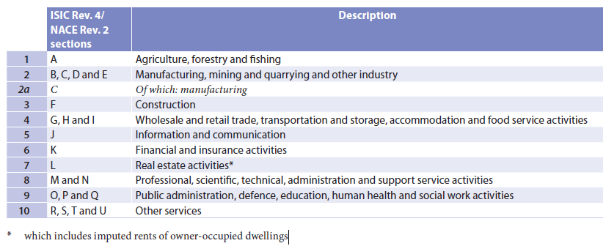

The legal act REGULATION (EC) No 1392/2007 OF THE EUROPEAN PARLIAMENT AND OF THE COUNCIL of 13 November 2007 amending Council Regulation (EC) No 2223/96 with respect to the transmission of national accounts data implemented the NACE Rev 2 and CPA 2008 in National Accounts.
The NACE Rev 2 basic document can be found on Eurostat website under the reference Product code: KS-RA-07-015 ; ISBN: 978-92-79-04741-1
HS is the Harmonised Commodity Description and Coding system managed by the World customs Organisations; Prodcom is the classification of goods used for statistics on industrial production in the EU; CN stands for the combined nomenclature, a European classification of goods used for foreign trade statistics.
http://www.bea.gov/industry/io_annual.htm
http://www.wiod.org/publications/source_docs/SUT_Input_Sources.pdf

