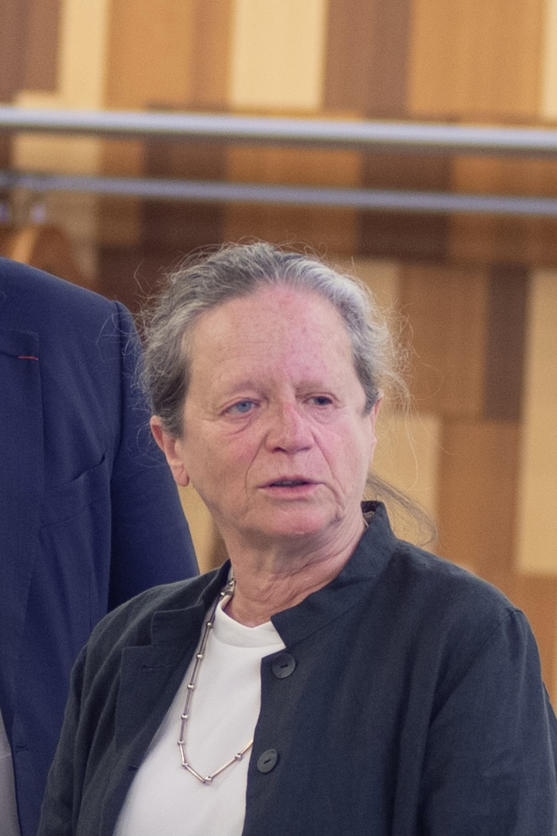Mrs Pervenche Berès is currently chair of the think tank Association Europe-Finances-Régulations (AEFR), a member of the ECB’s Audit Committee and of the Ethic Committee, and a member of the Climate and sustainable finance Committee of the Autorité des marchés financiers (AMF). She was a member of the European Parliament for 25 years (1994-2019), where she chaired the ECON and EMPL committees. She was rapporteur for the Special Committee on the financial, economic, and social crisis (CRIS).
Between 2001 and 2008 she was also member of Sèvres town council.
Graduated from the Institut d’Etudes Politiques in Paris, she worked from 1981 to 1994 as administrator in the French National Assembly and as advisor for international and European affairs to the President of the Assembly.
She is the author of several publications, mainly to economic governance.

