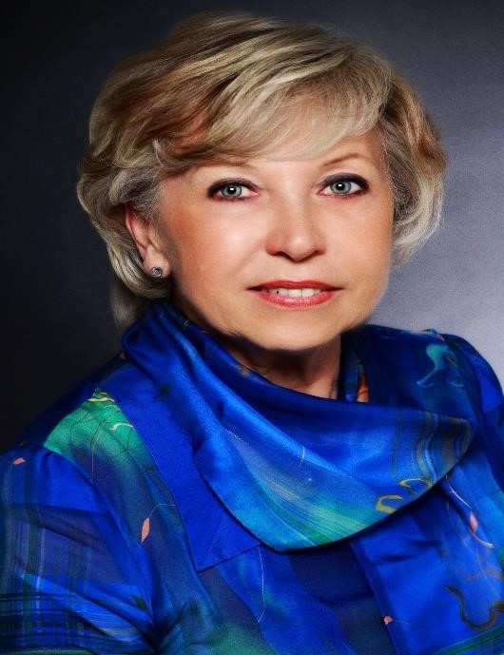
Marie Bohatá studied Econometrics at the University of Economics in Prague and got her degree in Systems Theory. She spent about 25 years in applied economic research. After the political changes in the Czech Republic in 1989, she was involved in many international projects and activities and served on boards of several professional associations, including those dealing with business and public service ethics.
In 1998, she entered the statistical community as President of the Czech Statistical Office, and later Deputy Director General of Eurostat (2004-14). After her retirement from Eurostat, she re-joined the Economics Institute of the Czech Academy of Sciences and has co-ordinated research projects focusing on public administration. Currently, she lectures at the University of Economics and Management in Prague. She is author of publications in economics, statistics and ethics.

