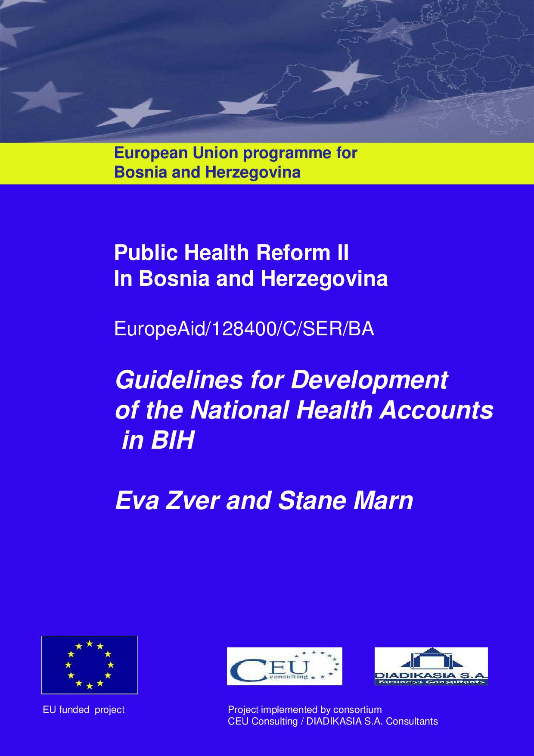
Project: Public Health Reform II

Contents

ABBREVIATIONS 3
1. Introduction 4
2. Development of the NHA in BiH 5
3. Basic information about the System of Health Accounts and the requirements of Joint Eurostat, WHO and OECD Questionnaire 6
3.1 Joint SHA Eurostat, WHO and OECD Questionnaire 8
1.2. Mini NHA Questionnaire of the World Health Organization 9
4. The process of NHA compilation 11
5. Term institutionalization of the NHA 13
6. Guidelines for development and institutionalization of the NHA in BiH 15
REFERENCES 30

ABBREVIATIONS
AFIP Agency for financial, information and agent services
APD Household Expenditure Survey
BD Brcko District
BHAS Agency for Statistics of BiH
BHAS EBD Agency for Statistics of Bosnia and Herzegovina – Branch Office Brčko District of BiH
BIH Bosnia and Herzegovina
COFOG Classification of the functions of the Government
COICOP Classification of Individual Consumption by Purpose
DOH Department of Health
ECHI European Community Health Indicators
ESA European System of Accounts
EUROSTAT Statistical Office of the European Communities
FBiH Federation of Bosnia and Herzegovina
FHIRF FBiH Health Insurance and Reinsurance Fund
FMOH FBiH Ministry of Health
HBS Household Budget Survey
HC Health Care Functions Classification
HF Health Funding Classification
HIF Health Insurance Fund
HP Health Providers Classification
ICHA International Classification for Health Accounts
MOCA Ministry of Civil Affairs
MOHSW Ministry of Health and Social Welfare (in the Republika Srpska)
OECD Organization of Economic Cooperation and Development
RS Republika Srpska
SHA The System of Health Accounts
SNA The System of National Accounts
WHO The World Health Organization

Introduction
Activities for the Development and Institutionalization of the National Health Accounts in BiH are part of the wider Public Health II project, financed by EU in the period 2012-2013.
Experts from the following institutions are involved in the project activities:

- Ministry of Civil Affairs of BiH,
- Agency for statistics of BiH,
- Directorate for economic planning of BiH,
- Ministry of finance and treasury of BiH,
- Ministry of health of the FBiH,
- Ministry of finance of the FBiH,
- Health insurance and re-insurance Fund of the FBiH,
- Institute for statistics of the FBiH,
- Public Health Institute of the FBiH,
- Institute for development programming of the FBiH,
- Ministry of health and social welfare of Republika Srpska,
- Ministry of Finance of Republika Srpska,
- Republic Institute of Statistics of Republika Srpska,
- Health Insurance Fund of Republika Srpska,
- Public Health Institute of Republika Srpska,
- Department for health and other services of the Government of Brčko District of BIH,
- Health Insurance Fund of Brčko District of BiH,
- Government of Brčko District of BiH – Directorate for finance,
- Agency for statistics of BIH – Branch office in Brčko District of BiH,
- Agency for drugs and medical aids BIH
The mandate of the NHA working group is the improvement of the national reporting system for NHA in BiH, which has become one of the key elements in the system of collecting statistical data in the area of health within international institutions (Eurostat, World Health Organization and the OECD). The NHA reporting in the EU member states is regulated by the special EC regulation in the area of public health statistics (EU Official Journal, 31.12.2008354/77) which provides the legal framework for the whole area of health statistics, and also refers to the NHA reporting. After auditing the methodology of the System of Health Accounts in 2011 (SHA 2011), a new special provision of the European Community is being prepared, which will in 2014 define NHA reporting as a regular statistical obligation of all European countries.
Within the Public Health Reform II project, NHA for the level of FBiH, Republika Srpska, Brčko District of BiH and Bosnia and Herzegovina was developed and established and included into the Mid-term program of statistical research for the period 2013-2017, which is a tool. The project also managed to get the Agency for Statistics of BiH, Republic Institute for statistics of RS and FBiH to take over the future development of the NHA at the level of the FBiH, Republika Srpska, Brčko District of BiH and Bosnia and Herzegovina. The Republic Institute for Statistics of RS has already in 2013 taken over the competencies for compilation and dissemination of the NHA for RS, and the Agency for statistics of BiH will take over the responsibility for BiH in 2014 and the FBiH Institute for statistics will do that no later than 2017, but that in the upcoming year it will closely cooperate with the Health Insurance and Re-insurance fund of the FBiH that is at the moment the leading institution for NHA development in Bosnia and Herzegovina.
According to the project Terms of Reference, one of the expected results is to provide the “Guidelines for collecting information and analysis of financial expenditure on public health for the purpose of a developed NHA”. Considering internationally agreed terminology used by the methodology of the System of Health Accounts 2011 and other related methodological papers, we named this document the “Guidelines for the Development of the NHA in BiH”.

Development of the NHA in BiH
The first pilot implementation of the National Health Accounts for BiH was conducted in the year 2007. As a result, the first NHA data and basic internationally comparable indicators on health expenditure for the period 2004-2006 were published in the First Report on the NHA for BiH (Zver, 2008). After these initial steps towards the NHA implementation, the Sector for Health of the MoCA took the responsibility of coordinating further development and compilation of the NHA for BiH. The working group for the NHA on the level of BIH was officially established in 2008, and since then, every year MoCA has collected the NHA data on public expenditure from FBiH and RS and Brcko District and prepared estimations on private health expenditure by using the data from the System of National Accounts for BiH (BHAS, 2008-2011). Thus, in the period 2008-2010, the MOCA compiled basic NHA results for BiH and reported them to WHO in the format of Mini NHA questionnaire of WHO.
In 2011, the MOCA for the first time reported NHA also to Eurostat by using the framework of Joint Eurostat/WHO/OECD Questionnaire. However, so far only two basic NHA tables (HFXHC and HFXHP) to the first digit level were reported and with still many departures from the SHA methodology. For that reason, the improvements in current data collection and further developments of the NHA for FBiH, RS, BD , and based on that to develop NHA for BiH, are very important in order to harmonise internal health statistics on expenditures for health, and also obligations on reporting health expenditure statistics to Eurostat and WHO in future.
An important task in BiH is also the development and institutionalization of the NHA on the level of FBiH and RS and Brcko District where NHA should be implemented following the bottom up approach and responsible institutions and regulations should be officially defined ("Bottom up" approach).

Basic information about the System of Health Accounts and the requirements of Joint Eurostat, WHO and OECD Questionnaire
The methodology of the System of Health Accounts provides a standard for classifying health expenditures according to the three axes of consumption, provision and financing. The intent is to describe a health system from an expenditure perspective. It also gives guidance and methodological support in compiling health accounts (OECD, Eurostat, WHO, 2011).
As more countries implement and institutionalize health accounts, there are increased expectations from analysts, policy makers and the general public alike for more sophisticated information that can be gained through the collection of health expenditure data. Thus, health accounts have two main roles – (i) for international purposes, where the emphasis is on a selection of internationally comparable expenditure data, and (ii) for national use with more detailed analyses of health care spending and a greater emphasis on comparisons over time (OECD, Eurostat, WHO, 2011).
More specifically, the main purposes of the System of Health Accounts 2011 are (OECD, Eurostat, WHO, 2011, p. 25):
- to provide a framework of the main aggregates relevant to international comparisons of health expenditures and health systems analysis;
- to provide a tool, expandable by individual countries, which can produce useful data in the monitoring and analysis of the health system;
- to define internationally harmonized boundaries of health care for tracking expenditure on consumption.

Since the year 2000 the compilers of the NHA followed the methodology described in the first version of the manual “The System of Health Accounts” (SHA 1.0) from the year 2000 (OECD, 2000) and the subsequent WHO/WB/USAID Guide for producing NHA with specific applications for low and middle income countries (WHO, WB, USAID, 2003). However, in the year 2011, a new revised version of the SHA manual (further on used SHA 2011) was published jointly by Eurostat, WHO and OECD (OECD, Eurostat, WHO, 2011). Therefore, the period 2013 to 2015 is supposed to be a transitional period when countries are requested to implement SHA 2011 and still report data also according to SHA 1.0. In the year 2016 reporting by revised methodology SHA 2011 will be requested as a regular statistics by Eurostat (European Commission, 2012).
In general, SHA methodology (old and revised version) made a clear separation between the financial, institutional and functional aspects of health care by proposing a tri-axial system of recording which answers three key questions:
- Where does the money come from? (from financing agent/schemes)
- Where does the money go? (to provider of health care services and goods)
- What kind of (functionally-defined) services are performed and what types of goods are purchased?
Nevertheless, the methodology of SHA 2011 introduces a number of changes and improvements compared with SHA 1.0. But first and foremost, it reinforces this tri-axial relationship at the root of the System of Health Accounts to describe health care and long term care expenditure; that is, what is consumed has been provided and financed. It means that this triangulation of consumption maintains the guiding principles of SHA 1.0 (2000). Most important, SHA 2011 offers more complete coverage within the functional classification in areas such as prevention and long-term care; a more concise picture of the universe of health care providers with closer links to standard industry classifications and the System of National Accounts; and a precise approach for tracking financing in the health care sector under the new classification of financing schemes. (SHA 2011, page 14).
Basic questions mentioned above are addressed respectively in the proposed International Classification for Health Accounts (ICHA) which breaks down into three basic classifications:
- Classification of health care functions (ICHA-HC)
- Classification of health care providers (ICHA-HP);
- Classification of financing schemes (ICHA-HF).

SHA 2011 defines additional dimensions compared to SHA 1.0 that allow the compilation of complementary indicators of the health system:

- Classification of types of revenues of health financing schemes (ICHA-FS); (the revenues in the health financing system are classified. It includes for example: transfers to institutes/funds of the health insurance done by the government on behalf of specific population groups, voluntary payments to private health insurance, direct foreign transfers to providers of health services, etc.);

- Classification of factors for health care provision (ICHA-FP); (the factors for health care provision that are included, for example: incomes for employed, incomes for self-employed, material costs, costs of medicines and other medical devices, non-health services and other goods);

- Classification of beneficiaries: age, gender, disease, socioeconomic characteristic or region; Classification as per certain characteristics of the health care beneficiary (age, gender, socioeconomic characteristics or geographic characteristics);

- Classification of human resources in health care (using ISCO 2008);
- Classification of health care goods and services.

The choice of these classification and categories of the ICHA was guided by their relevance for health policy and reform issues, in particular for monitoring structural changes, such as shifts from in-patient to out-patient care and the emergence and spread of multifunctional providers in national health care systems.

3.1 Joint SHA Eurostat, WHO and OECD Questionnaire

Dimensions of ICHA are cross-classified in three basic SHA tables requested by the Joint Questionnaire and two additional tables (2006):
The Dimensions of the International Classification for health accounts (ICHA) are cross classified in three basic SHA tables requested in the excel form by the Joint Eurostat/WHO/OECD SHA Questionnaire) (hereinafter: JQ) and two additional tables (2006):

1) Table HP x HF: Current expenditure on health by providers and by financing agents
2) Table HC x HF: Total expenditure on health by functions of care and by financing agents
3) Table HC x HP: Total expenditure on health by functions of care and by providers
Additional tables:

4) Table FS x HF: Total expenditure on health by financing sources and by financing agents
5) Table RC x HP: Resource costs (human resources) by providers of health care

Within the Joint Questionnaire for all completed tables the following methodological information is requested:
- Data sources specified for each ICHA code
- Correspondence tables between health expenditure categories used in national practice and the ICHA
- Current state of ICHA implementation:
  - Which deviations from ICHA are currently found in the country’s SHA compilation
  - Estimation procedures and adjustments

Revised version of Joint Questionnaire, based on SHA 2011, will come out in the beginning of year 2013.
The revised version of the Joint SHA questionnaire (JQ) based on SHA 2011 is now being tested and will be preliminary completed in 2013 for the first time (with the data for 2011). The basic tables are the same as in the previous version of the Joint Questionnaire, but have been adjusted to new, revised classifications ICHA: (1) HP X HF, (2) HC X HF and (3) HC X HP.
- Additionally the following tables of expended SHA 2011 methodology are requested: Table FS x HF: Total expenditure on health by financing sources and by financing agents;
- Table HP x FP: Current expenditure on health by service providers and factors of health care provision;
- Table HK x HP: Capital Investments by health care providers.

Joint SHA Questionnaire has to be delivered every year to Eurostat by the end of March for t-2.

Mini NHA Questionnaire of the World Health Organization

The World Health Organization collects and published the data and indicators on expenditures on health in the excel format from all countries in the world „Mini for Ministry of Health – National expenditure for Health (hereinafter Mini NHA Questionnaire of WHO). The World Health Organization uses as a tool the data from the Joint SHA Questionnaire sent to the Eurostat /exchange of data between the international organizations/ and the data from the National Accounts (SNA) available with the UN Economic Commission for Europe (UNECE) (all macroeconomic categories).

the Mini NHA Questionnaire of the WHO contains a multiyear series of:
- Key indicators on expenditures on health (in relation to GDP, in standards of purchasing power per citizen, structure of expenditures by financing agents, purposes and service providers)
- Absolute data on expenditures on health at the first level of classification HF, HC and part of HP.
- Main macroeconomic aggregates (GDP, government's expenditures, household’s' expenditures, GDP deflator, dollar exchange rate and standard purchasing power).

The World Health Organization requests every year by the end of January already from all WHO members (usually from the Ministry of health) to review and correct estimates for the main health expenditure indicators for t-2 (it is earlier than the data from the Joint SHA Questionnaire that are sent to the Eurostat by the end of March are available).
In Bosnia and Herzegovina the mini NHA Questionnaire has been checked and completed by the Ministry of civil affairs of BiH since 2007.
The Mini NHA Questionnaire of the WHO in a simple way enables international cross comparison of all key health expenditure indicators with all countries in the world. This being the main reason why the proposal of the project's working group for NHA is to have key indicators also for FBiH, Republika Srpska and Brčko District of BiH shown in BiH using the Mini NHA Questionnaire of the WHO as a sample.
The World Health Organization will in 2014 for the first time send beside the old one also the new Mini NHA Questionnaire of the WHO to all states, and it will be founded on SHA 2011. In the forthcoming period of several years the data and the indicators of expenditures for health will be completed and published in a parallel way in two questionnaires.

The process of NHA compilation

Key steps

The strategy how to implement the NHA and main approaches used in practice were first very clearly explained in SHA Guidelines (Office of National Statistics OK, 2004) and in Guide to producing national health accounts (WHO, WB, USAID, 2003). This two guides were updated in the context of SHA 2011 and are summarized in Chapter 14 of the SHA 2011 manual (OECD, Eurostat, WHO, 2011, pages: 319-338).
SHA 2011 proposes eight steps of implementation presented below:
Figure: The process of NHA compilation
(I) Understanding health care system under study
(II) Clarifying boundaries of NHA
(IV)Creating NHA database
(V) Background calculations and filling the tables
(IV)
Resolving issues (interative proces)
(VI) Preparing detailed documentaton of the work on NHA
(III) Investigating and evaluating data sources
(VII) Quality check of the results
(VIII) Presentation of the results

Source: SHA 2011 (OECD, Eurostat, WHO, 2011)

In terms of the timeline, step I (the conceptual investigation), step II (clarifying the differences between national health system boundaries and SHA boundaries), and step III (getting hold of key data sources) should be carried out first. Steps IV and V should follow as an iterative process: IV as an initial compilation of the database using identified data sources and (V) to identify gaps and problem areas in the database and resolved them by searching for new data sources, reconciling and making suitable estimations where necessary and then the database and tables update accordingly. This process should be repeated until a final version of the tables is achieved. All these steps should involve an elaborate and complex system of checks and balances, choices, trial and error to decide how to put all the data together. This system helps to determine which data to use and why. Judging the quality of data sources is a key part of the iterative process.
Step VI is important for regular production and institutionalization of the NHA - it is necessary to record the detailed data sources, calculation methods, adjustments and estimation procedures that are used in the compilation of NHA. Step VII is to check the quality of the results. These checks include the confrontation of data from different sources, the validation of the latest year’s data points with corresponding data points from the previous year and the investigation of any significant but unexplained changes. The final step VIII relates to the presentation of the results, giving key indicators and summary information about the data. The presentation may also include some particular analyses for a particular target audience.

Approaches
In general there are two main concepts of building the accounts: top-down and bottom-up approach (SHA 2011, page 324).

A top-down approach is used when most of the information for NHA is obtained taking figures directly from pre-existing aggregate health expenditure classifications and recording systems. This usually involves an extensive use of proxies, assumptions and other estimation techniques for breaking down pre-existing aggregates and also involves a limited amount of reconciliation. A typical example of this is when NHA developers attempt to migrate directly from National Accounts to National Health Accounts. More or less a top-down approach was used to develop the first version of the NHA in BiH in the year 2007 (Zver, 2008) and also in the following years 2008-2010.
A bottom-up approach is used when most of the information for NHA is obtained using detailed information, possibly presenting activity information at a detailed level. NHA databases are built by cross-classifying very detailed information on public financing (usually available at social health insurance funds and ministries of health). Here aggregate data is used less frequently and reconciliation is often carried out. Pre-existing information is still used but the NHA developer does not attempt to migrate directly from one system of recording to NHA data. Under the bottom-up approach, could be following the financing agents approach or providers approach, it depends what kind of data sources are primarily used. Usually source of funding approach is followed as primary approach and this means that the core data are financial data on expenditures by different financing agents. On the other hand provider approach means that the core data are: financial data on the receipts of the providers, data on the inputs used by providers (staff costs and intermediate consumption) and data on the output they produce (number of activities and their prices/ costs). This information is then integrated with data on sources of funding where possible. In practice, most of the countries use financing approach as primary approach, but in combination with data sources from provider’s side, especially for estimating private health expenditure.
SHA 2011 strongly recommends the NHA compilers to use a bottom-up approach since the full value of NHA is realized only in this way. However in the first development round(s), some components may typically be estimated using the so-called top-down approaches (that was the case also in BiH in the years 2004-2010, whereby existing health expenditure aggregates were broken down according to the availability of proxies and other estimation techniques). Over time, as NHA are redeveloped, compilers should aim to replace top-down by bottom-up methods. Therefore, one of the major activities of the Public Health II project in BiH is to build NHA databases for each entity, Brcko District and the level of BiH by following bottom up approach.

Term institutionalization of the NHA
NHA institutionalization is defined as a routine government-mandated compilation and utilization of a minimum set of globally agreed health expenditure data using the methodology of the System of Health Accounts as a standard health accounting framework. Countries are classified as having institutionalized NHA if they fulfil four criteria: (i) consistent government-mandated production of a minimum set of NHA data; (ii) consistent use of NHA data; (iii) adequate financial, human, and infrastructure capacity for production and utilization of NHA data; and (iv) use of the System of health accounts methodology in producing NHA data. (World Bank and HNPHDN, 2010). It means that to fulfil all criteria of institutionalization, above described process of compilation of the NHA has to be followed also by using NHA indicators for health policy purpose.
To help countries establish the NHA, special guide was developed by the WB to facilitate the process of assessment, improved NHA data collection, data management, improved quality and policy use of the NHA (2009 World Bank).
With an aim to prepare the Guidelines for the Development and Institutionalization of the NHA in Bosnia we found the WB guide very useful in order to report about the steps towards institutionalization of the NHA achieved during the project and also to propose activities which will have to be done in the near future to fully adopt international NHA methodology and to regularly report and analyse relevant indicators on health expenditure.
Following the WB guidelines the NHA activities towards institutionalization are divided into seven areas (draft NHA Generic Tool for Institutionalization Activities, 2009):
- Environment and governance structure: Favourable environment and governance structure is one of the major steps and prerequisite for NHA development and institutionalization.

- Human and financial resources: A second key aspect is availability of adequate financial, physical, and human resources for routine NHA activities.
- Data sources and collection: There needs to be an explicit process by which the underlying NHA data are collected and reported routinely.
- Data Management: In addition to having an explicit system for collection and reporting of data, institutionalization would also require an organized process for storing and managing of the data.
- Information Products: A critical challenge for NHA is turning raw data into useful information products which facilitate the use of NHA for policy decision. To be able to do this, a country must define some core indicators.
- Quality: NHA information should be timely; it should be consistent; proper validity checks should be in place; data coverage should be extensive; and, level of disaggregation should be consistent with policy needs.
- Dissemination and Use of NHA data: This is one of the most critical aspects of institutionalization of NHA. Even in some countries that routinely produce NHA there can be a lack of strategic thinking on dissemination and use of that information. For NHA to be institutionalized, it is important that users can easily access NHA data and that it is regularly used to inform policies and decision-making.
This framework for NHA institutionalization has been derived from the constraints that countries commonly face: these include the absence of a favourable environment for producing quality NHA data (including lack of mandates, poor understanding about use, and weak coordination mechanisms among stakeholders); general weak human capacity and absence of resources; weak data-generating systems; and difficulties in tracking private expenditure flows. Minimal use and sharing of NHA information for policy making and linking to general budgeting and planning processes have also hindered the institutionalization process in many countries. (GSAP)
Under each area of institutionalization listed above, the WB tool developed a list of key activities essential to achieving satisfactory results with respect to that area. To ensure that the NHA would become an effective health policy tool in BiH the most of the proposed activities were incorporated in the Public Health II: NHA Work Plan and are followed from the very beginning of the NHA consultancy in Bosnia. For the future it is expected that this Guidelines for NHA Development and Institutionalization in BiH will be used as a guide for local NHA experts and also for international organizations (WB, WHO, EC and other) in order to better understand NHA data and indicators of health expenditure for BiH and for FBiH and RS and Brcko District.

Guidelines for development and institutionalization of the NHA in BiH
NHA for BiH are important from internal and international perspective. They are used to analyse health care financing and health expenditure in BiH with internationally comparable indicators and they are requested by international organizations (Eurostat, WHO, WB).
However, beside the information of health care spending on the level of BIH, NHA are also important for FBiH and RS and BD, because health care policy, financing, organization and provision are in the responsibility of RS, FBiH and BD. It means that it is priority for RS, FBiH and BD to have its own health accounts, which could support health policy making on the entity level. Therefore, NHA tables in BiH are developed separately for RS, FBIH and BD and then, in general, they are aggregated on the level of BiH.
The “Guidelines on NHA Development in BiH” are also prepared for the Federation of Bosnia and Herzegovina, Republika Srpska, Brčko District of BiH and BiH as shown in a parallel way in Table 1, and the Annex present the schemes of data collection for the FBiH, Republika Srpska, Brčko District of BiH and BiH that are supplemented by the explanations in Table 1. The table 2 introduces all data sources, which were so far recognized as important.

In the years 2012-2013, NHA databases for BiH and for FBiH and RS and BD will be developed by following in parallel both methodologies - SHA 1.0 and revised SHA 2011. This is done so for the reason of continuity, because we are in the process of redeveloping all NHA databases which were used in BiH in the past and this are replaced by building the databases by bottom up methods. Beside, in the year 2013 it is still necessary to report to Eurostat and to WHO according to SHA 1.0. However, we expect that by the end of the year 2013 Bosnia will be able to switch on revised version of SHA 2011 and provide data for the period 2004-2011.

Within the Public Health Reform II project the NHA data bases for BiH, Federation of BiH, Republika Srpska and Brčko District will be developed based on two methodologies in a parallel way – SHA 1.0 and revised SHA 2011. It will be done for the sake of continuity, since we are in the process of re-developing all NHA data bases used in BiH in the past and which will be replaced by newly developed ones, using the „bottom-up“ approach. Also in 2013 and 2014 the reporting to Eurostat and the WHO is to be done according to SHA 1.0. We expect that BiH will be in position to report according to revised version of the SHA 2011 by the end of 2013 and that it will prepare the data for the period 2004-2011.
The NHA data bases for the FBiH, Republika Srpska, Brčko District and BiH will support reporting of the data for the basic thee tables required by the Joint SHA Questionnaire of the Eurostat, the World Health Organization and the OECD:
1) Table HP x HF: Current expenditure on health by providers and by financing agents
2) Table HC x HF: Total expenditure on health by functions of care and by financing agents
3) Table HC x HP: Total expenditure on health by functions of care and by providers

and additional table:

4) Table FS x HF: Total expenditure on health by financing sources and by financing agents

Further activities on development of these NHA basic tables are expected in the forthcoming years, as well as activities on development of additional classifications and SHA 2011 extended methodology tables (described in Chapter 3).

Table 1: Guidelines for NHA institutionalization in BIH (to be completed by the end of the project)

Dimension | Bosnia and Herzegovina | Federation of BIH | Republic of Srpska | Brčko District
Environment and governance structure  - Key institutions  - Other institutions involved  - Main tasks of key institutions  - Regulation/Legislation / protocols | Key institutions:  - Ministry of Civil Affairs (MoCA)  - Agency for statistics BIH (BHAS)  Other institutions involved:  - Ministry of Finance and Treasury BIH  - BIH Directorate for Economic Planning  - Agency for Drugs BIH  Indirect Taxation Authority of BiH Main tasks of key institutions:  2013:  - MoCA coordinates aggregation of NHA data for BiH , with support from the NHA project;  - MoCA reports to WHO: NHA tables (JQ) and additional WHO questionnaire with basic health expenditure indicators (by the end January for t-2)  - BHAS checks the quality and consistency of the NHA tables with National Accounts and reports NHA tables (JQ) to Eurostat (by end March for t-2)  2014 and on:  - BHAS will took the responsibility for compilation of the NHA tables (JQ) for BiH and will send fulfilled JQ to MoCA by the end of each year and to Eurostat by the end of March next year (for t-2);  - MoCA coordinates further development of NHA for BiH and supports use of NHA indicators  - MoCA will continue to report JQ to WHO and will provide analysis and annual report of key health expenditure indicators  Legislation/documents:  - Mid-term Statistical Programme 2013-2017 for BIH  - Annual Statistical Programme (participation on Public Health II project: Component NHA) | Key institutions:  - FBiH Ministry of Health (FMoH)  - FBiH Health Insurance and Reinsurance Fund (FHIRF)  - FBiH Statistical Office (FSO)  - FBiH Institute for Public Health  Other institutions involved:  - Cantonal health insurance funds  - Cantonal public health institutes  - Cantonal ministries of finance  - FBiH Ministry of Finance  - FBiH Institute for Development and Programming  Main tasks of key institutions:  - FHIRF coordinates data collection and compilation of the NHA tables (JQ) for Federation of BIH;  - FBiH Statistical Office cooperates with FHIRF to prepare estimation for private expenditure and capital investments and to check the consistency with National Accounts;  - FHIRF is responsible for reporting fulfilled NHA tables (JQ) to MoCA and BHAS and for reporting key health expenditure indicators to FMoH and to MoCA;  - FMoH coordinates and supports policy use of NHA indicators on the level of FBIH and supports further development of the NHA  - By the year 2017 FBiH Statistical Office will took the responsibility for statistical compilation of the NHA tables (JQ); however FHIRF will continue to analyse health expenditure in FBIH and report key health expenditure indicators for FBIH  Legislation/documents:  - Mid-term Statistical Programme 2013-2017 for FBIH  - Annual Statistical Programme for FBIH for 2013 (participation in Public Health II project: Component NHA)  - Health Resource Accounts Regulation (improved reporting forms OKZ 5 and OKZ6 to support NHA and amendments in legislation)  - Inter-institutional cooperation agreement between FHIRF and FSO (in preparation)  - Amendments to the proposal of new Health Insurance Act | Key institutions:  - Ministry of Health and Social Welfare (MoHSW)  - Institute for Statistics RS (ISRS)  - Health Insurance Fund of RS (HIF RS)  - Public Health Institute RS  Other institutions involved:  - Ministry of Finance RS  Main tasks of key institutions:  - Institute for Statistics RS is responsible for statistical compilation of NHA tables (JQ) and will report fulfilled NHA tables to MoHSW and to BHAS (from 2014 on);  - HIF RS will annually provide special data processing of HIF expenditure according to SHA and will report database to the Institute for Statistic RS  - MoHSW will annually provide budgetary expenditures classified according to SHA and will send them to Institute for Statistics  - MoHSW will help to collect additional data on public expenditures for the purpose of NHA (municipalities, cash-benefits for persons with ADL limitations, etc.) and will share the data with Institute for Statistics RS  - MoHSW will coordinate and support policy use of NHA indicators on the level of RS and will have the responsibility to analyse key health expenditure indicators for RS;  - MoHSW will report internationally requested indicators to MoCA (for the web portal and comparison analysis);  Legislation/documents:  - Mid-term Statistical Programme 2013-2017 for RS  - Annual Statistical Programme for RS for 2013 (participating in Public Health II project: NHA Component)  - Amendments to Health Insurance Act (in preparation)  - Protocol on exchange of the data between the Ministry of health and social welfare of RS, Institute for statistics of RS, Health Insurance Fund of RS and the Public Health Institute of RS | Key institutions:  - Department of Health and Other Services BD  - Bureau for Statistics BD (BHAS Office BD)  - Health Insurance Fund – branch in Brcko District (HIF BD)  Main tasks of key institutions:  - Department of Health BD is responsible for statistical compilation of NHA tables (JQ) and also for reporting health expenditure indicators to MoCA  - BHAS-BD will provide data for private expenditure and check consistency with National Accounts for BD  - Health Insurance Fund will annually provide requested data for NHA  Legislation/documents:  - Mid-term Statistical Programme 2013-2017 for BIH  - Official paper signed by mayor of BD to report data for the purpose of NHA (in preparation)  - Protocol on exchange of the data between the Department of health of Brčko District, Agency for Statistics of BIH – office in Brčko District, Health Insurance fund of BD and the Health Centre of BD
Human and financial resources  - NHA project group  - NHA coordinator  - NHA Technical Working group  - NHA Steering Committee | 2013: Public Health II project (EU funded) provides support and training for: two experts from MoCA, three experts from BHAS, one expert from Ministry of Finance, one expert from BIH Directorate for Economic Planning  NHA coordinator for BiH is nominated at MoCA and works regularly part time on the NHA.  One expert from BHAS will be nominated to work regularly part time on statistical compilation of the NHA for BiH.  NHA Technical Working Group on the level of BiH was established in 2008 by MoCA; new members from FBIH, RS and BD will be nominated in 2013.  Establishment of the Steering Committee of high-level representatives for BiH is in discussion | 2013: Public Health II project (EU funded) provides support and training for one expert from: FHIRF, FMoH, FBiH Statistical Office, FBiH Ministry of Finance and FBiH Institute for Economic Planning  NHA coordinator for FBIH is nominated from FHIRF and works regularly part time on the NHA.  NHA Technical Working Group in FBIH will be established and coordinated by FHIRF, with members from FMoH, FBiH Office for Statistics,  Five cantonal Health Insurance Fund (Mostar, Sarajevo, Bihać, Zenica, Tuzla), one cantonal Public Health Institute (Zenica), PHI of FBiH, Ministry of finance of FBiH, Federation Institute for development programming and Directorate for economic planning of BiH  Establishment of the Steering Committee of high-level representatives for FBIH i  Operational team for NHA in FBiH with high representatives for key institutions will be established by the Federation Ministry of health | 2013: Public Health II project (EU funded) provides support and training for: one expert from MoHSW, two experts from Institute for statistics RS, one expert from HIF RS; one expert from the Ministry of Finance  NHA coordinator for RS is nominated from MoHSW to regularly work part time on the NHA.  One expert from the Institute for statistics RS will be nominated to regularly work part time on the NHA  NHA Technical Working Group in RS will be established and coordinated by MoHSW RS, with members from the Institute for statistics RS, HIF RS, Ministry of Finance RS and Institute for Public Health RS  Steering Committee for NHA in RS with high-level representatives for key institutions will be established by MoHSW | 2013: Public Health II project (EU funded) provides support and training for: one expert from Department for Health BD, HIF BD, BHAS in BD and Government of BD – Directorate for Finance  NHA coordinator is nominated from DoH BD and regularly works part time on the NHA  NHA Technical Working Group in BD will be established and coordinated by DoH BD, with members from HIF BD, BHAS-BD  Steering Committee of high-level representatives for BD will be established by Department for Health BD
Data sources | Data Sources: see Table 2 | Data Sources: see Table 2 | Data Sources: see Table 2 | Data Sources: see Table 2
Data collection procedure | In 2013 the MoCA is coordinating consolidation of NHA tables (JQ) for the level of BiH with the support from the Public Health Reform II Project.  From 2014 and beyond:  The MoCA will collect additional data for NHA for the level of BiH, Federation of BiH, Republika Srpska and Brčko District from the BiH Agency for drugs (use of pharmaceuticals), Insurance Agency of BiH (expenditures of private health insurance companies), the Ministry of finance and treasury (foreign assistance in health) and NGOs, and will deliver the data to the FMoH, MoHSW RS, Department for Health of Brčko District and BiH Agency for statistics (BHAS) (annually by the end of June for t-1)  BHAS will collect complete NHA tables (JQ) from the FBiH, Republika Srpska and Brčko District (annually by the end of November for t-1)  BHAS will consolidate NHA tables for the BiH level and will check consistency with the BiH National Accounts and will deliver them to the MoCA (annually by the end of December for t-1) and to the Eurostat (annually by the end of March for t-2) | Health Insurance and Re-insurance Fund of the FBiH provides special data processing for the purpose of NHA by using the data collected with Account of funds in health FBIH (annually by the end of month June for t-1).  FBiH Ministry of Health will annually request from MoCA additional information needed for NHA FBiH (from BiH Agency for Drugs, BiH Insurance Agency, BiH Ministry of Finance and treasury and nongovernmental organizations in health) (annually by the end of June for t-1). FMoH will submit the data to the Health Insurance and Re-insurance Fund of FBiH (annually by the end of June for t-1).  FBiH Ministry of finance will collect annual budget reports of cantonal ministries of health and other Federation and cantonal ministries and submit the data to the FMoH (annually by the end of June for t-1). The FBiH Ministry of health will consolidate the data of cantonal budgets for the purpose of NHA and deliver them to the FBiH Insurance and Re-insurance Fund (annually by the end of September for t-1).  The FBiH Ministry of finance will deliver the data on expenditures in health by functional classification to the FMoH, including expenditures of municipalities (annually by the end of June for t-1). FMoH will forward the data to the Insurance and Re-insurance Fund (annually by the end of September for t-1).  The FBiH Institute for statistics will give an estimate of private expenditures for health and expenditures for gross investments in the health for the purpose of NHA and will forward the data to the FBiH Insurance and Re-insurance Fund (annually by the end of September for t-1).  FBiH Insurance and Re-insurance Fund will deliver complete NHA tables (JQ FBiH) to the FBiH Institute for statistics in order to check consistency of NHA data against National accounts (annually by the end of October for t-1)  The FBiH Institute for statistics will deliver checked NHA tables (JQ FBiH) to the Agency for statistics of BiH and FBiH Health Insurance and Re-insurance Fund (annually by the end of November for t-1)  Z FBiH Health Insurance and Re-insurance Fund will deliver NHA tables (JQ FBiH) and indicators in the form of the Mini NHA questionnaire of the WHO to the Ministry of Health of FBiH and to MoCA BiH (annually by the end of December for t-1). | Health Insurance Fund of RS provides special data processing for the purpose of NHA and delivers the data base to the Republic Institute for statistics of RS (annually by the end of June for t-1).  Ministry of health and social welfare of Republika Srpska makes annual budget report cross-classified with SHA codes and delivers the data to the Republic Institute for Statistics of RS (annually by the end of June for t-1).  Ministry of health and social welfare of Republika Srpska will annually request from the BiH Ministry of civil affairs additional data needed for the RS Health Account (from the BiH Agency for drugs, BiH Insurance Agency, BiH Ministry of finance and treasury and nongovernmental organizations in health) and will deliver the data to the Republic Institute for statistics of RS (annually by the end of June for t-1)  The Ministry of finance of Republika Srpska will provide detailed data in accordance with functional classification (COFOG) and will deliver the data to the Republic Institute for Statistics of RS (annually by the end of June for t-1)  Public Health Institute of RS will annually submit to the Republic Institute for Statistics RS information on turnover of pharmaceuticals in RS and detailed information from the RS budge of the PHI RS on incomes and expenditures for preventive health care and public health (annually by the end of June for t-1)  Republic Institute for Statistics RS will collect additional data necessary for estimating private expenditures in health (special surveys, from BiH Agency for drugs, etc.)  Republic Institute for Statistics RS will send complete NHA Tables (JQ RS) to the Ministry of health and social welfare of RS and BiH Agency for Statistics (annually by the end of November for t-1)  the Ministry of health and social welfare of RS will deliver to the MoCA BiH international indicators in the form of Mini NHA Questionnaire of the WHO (annually by the end of December for t-1) | Health Insurance Fund of BD provides special data processing for the purpose of NHA and delivers the data to the Department for health of BD (annually by the end of June for t-1).  the Department for health of BD will annually request from MoCA additional data needed for NHA BD (from BiH Agency for Drugs, BiH Insurance Agency, BiH Ministry of Finance and treasury and nongovernmental organizations in health) (annually by the end of June for t-1).  the Department for health of BD will request additional data from the Health Centre of Brčko needed to compile NHA.  The Department for health will deliver all collected data to the BHAS – Office in Brčko (annually by the end of June)  BHAS – Office Brčko will make an estimate of expenditures for health and gross investments in health for the purpose of NHA and will deliver the data to the Department for health of BD (annually by the end of September for a t-1).  Department for health of BD will deliver completed NHA tables (JQ BD) to the BHAS- Office Brčko in order to check consistency with the National accounts for BD (annually by the end of September for t-1) and BHAS – Office Brčko will return the NHA tables (JQ BD) to the Department for health of BD (annually by the end of October for t-1)  BHAS-Office BD will send completed NHA tables (JQ BD) to the BiH Agency for Statistics (annually by the end of November for t-1)  Department for health of BD will deliver to the MoCA BiH international indicators in the form of Mini NHA Questionnaire of the WHO (annually by the end of December for t-1)
Data Management  - NHA databases  - NHA tables (JQ) | Agency for Statistics and MoCA will provide support to organized storing of the NHA tables (JQ) for BiH | NHA database for FBIH is developed to support basic NHA tables (HFXHCXHP):  Internal Classification used for Health Resources Accounts of FBIH is improved and cross-classified by HC and HP codes.  - Budget reports of the HIF ( Bihać, Zenica, Tuzla) are cross-classified by HC and HP codes  In preparation:  - NHA database for table FSXHF  - The list of providers in health care by HP classification  FHIRF and FBiH statistical office will both manage NHA database and provide support to organized storing of the NHA tables (JQ) for FBIH | NHA database for RS is developed to support basic NHA tables (HFXHCXHP):  - Internally used classification of HIF RS is cross-classified by HC and HP codes.  - Budget reports of the MoHSW are cross-classified by HC and HP codes.  In preparation:  - NHA database for table FSXHF  - The list of providers in health care by HP classification  Institute for Statistics RS manage NHA database and provide support to organized storing of the NHA tables (JQ) for RS. | NHA database for BD is developed to support basic NHA tables (HFXHCXHP):  - HIF BD internally used classification is cross-classified by HC and HP codes  - Budget report of the Department for Health BD is cross-classified by HC and HP codes.  In preparation:  - NHA database for table FSXHF  - The list of providers in health care by HP classification  Department for Health BD and BHAS in BD will manage NHA data and provide support to organized storing of the NHA tables (JQ) for BD.
Information Products  - NHA tables (JQ)  - Key indicators (Mini NHA of WHO) (see annex 2)  Reports | Agency for Statistics BIH:  - Basic NHA excel tables from Joint Questionnaire (HCXHF, HPXHF, HCXHP, FSXHF) and methodological notes (reported to Eurostat and MoCA)  MoCA:  - Basic NHA excel tables from Joint Questionnaire (HCXHF, HPXHF, HCXHP, FSXHF) and methodological notes (reported to WHO, FMoH, MoHSW RS, DoH BD)  - Fulfilled WHO questionnaire with key indicators (reported to WHO)  - Annual report with key indicators for BIH (published by MoCA)  - Key health expenditure indicators for BIH, (MoCA ) | FBiH Health Insurance and Reinsurance Fund:  - Basic NHA excel tables from Joint Questionnaire (HCXHF, HPXHF, HCXHP, FSXHF) and methodological notes NHA tables (part of Health Resource Accounts; reported to BHAS and MoCA)  - The table with key indicators for expenditures on health in FBiH as Mini NHA questionnaire of the WHO (published by the Federation insurance and re-insurance fund and FMoH and delivered to the MoCA) (see Annex 2).  Federation Institute for statistics:  Basic NHA excel tables from the Joint questionnaire (JQ) (HCXHF, HPXHF, HCXHP, FSXHF) and methodological notes of NHA tables (delivered to BHAS and FBiH Insurance and re-insurance fund) | Institute for Statistics RS:  - Basic NHA excel tables from Joint Questionnaire (HCXHF, HPXHF, HCXHP, FSXHF) and methodological notes NHA tables (published on the web page; reported to BHAS and MoHSW)  MoHSW:  - The table with key indicators for expenditures on health in RS as Mini NHA questionnaire of the WHO (delivered to the MoCA) (see Annex 2).  - Annual report with key indicators for expenditures on health in RS. | Department for Health BD:  - Basic NHA excel tables from Joint Questionnaire (HCXHF, HPXHF, HCXHP, FSXHF) and methodological notes (reported to BHAS and MoCA)  - The table with key indicators for expenditures on health in BD as Mini NHA questionnaire of the WHO (delivered to the MoCA) (see Annex 2).  BHAS-Office BD:  - Basic NHA excel tables from the Joint questionnaire (JQ) (HCXHF, HPXHF, HCXHP, FSXHF) and methodological notes of NHA tables (delivered to BHAS).
Quality | Methodological notes and data gaps will be reported in SHA Joint Questionnaire (annex to the Guidelines).  Quality of NHA for BIH will be estimated by the end of the project by five SHA 2011 criteria: consistency, international comparability, timeliness, relevance for health policy | Methodological notes and data gaps will be reported in SHA Joint Questionnaire (annex to the Guidelines).  Quality of NHA for FBIH will be estimated by the end of the project by five SHA 2011 criteria: consistency, international comparability, timeliness, relevance for health policy | Methodological notes and data gaps will be reported in SHA Joint Questionnaire (annex to the Guidelines).  Quality of NHA for RS will be estimated by the end of the project by five SHA 2011 criteria: consistency, international comparability, timeliness, relevance for health policy | Methodological notes and data gaps will be reported in SHA Joint Questionnaire (annex to the Guidelines).  Quality of NHA for BD will be estimated by the end of the project by five SHA 2011 criteria: consistency, international comparability, timeliness, relevance for health policy
Dissemination and Policy Use of NHA data  - Publishing data  - Publishing list of indicators of FBIH, RS, BD and BIH (Mini NHA questionnaire of the WHO - see Annex 2) | Eurostat data base (expected)  WHO Health-for-all Database  BHAS Web page  MoCA web page (key indicators in the form of Mini NHA questionnaire of the WHO, reports, presentations)  Institutions with representatives in the technical working group for NHA can use the data and indicators for reporting and health policy.  Capacity building for future use of indicators on expenditures for health is included in the working plan of the Public Health Reform II Project (workshop held in April 2013; learning while working, e-exercises, writing reports).  (see Annex 1 – data and indicators dissemination scheme for BiH) | Public publishing of the data and indicators must be agreed and harmonized with the Federation Insurance and Re-insurance fund and the FBiH Institute for statistics  MoCA web page (key indicators in the form of Mini NHA questionnaire for FBiH)  Web page of the Federation Ministry of Health  Institutions with representatives in the technical working group for NHA can use the data and indicators for reporting and health policy.  Capacity building for future use of indicators on expenditures for health is included in the working plan of the Public Health Reform II Project (workshop held in April 2013; learning while working, e-exercises, writing reports). | Public publishing of the data and indicators must be agreed and harmonized with the Republic Institute for Statistics of Republika Srpska  Ministry of health and social welfare of Republika Srpska (publishing key indicators in the form of the Mini NHA of the WHO and report – to harmonize use of terminology with the Institute for statistics of Republika Srpska )  MoCA web page (key indicators in the form of Mini NHA questionnaire for RS –delivered to MoCA according to agreement on exchange of data between MoCA, and MOHSW RS and approved by the Institute for statistics of RS)  Institutions with representatives in the technical working group for NHA can use the data and indicators for reporting and health policy.  Capacity building for future use of indicators on expenditures for health is included in the working plan of the Public Health Reform II Project (workshop held in April 2013; learning while working, e-exercises, writing reports). | Public publishing of the data and indicators must be agreed and harmonized with the Department for health of BD an BHAS – Office BD  Department for health of Brčko District (publishing key indicators in the form of the Mini NHA questionnaire of the WHO)  MoCA web page (key indicators in the form of Mini NHA questionnaire for BD)  Institutions with representatives in the technical working group for NHA can use the data and indicators for reporting and health policy.  Capacity building for future use of indicators on expenditures for health is included in the working plan of the Public Health Reform II Project (workshop held in April 2013; learning while working, e-exercises, writing reports).

Table 2: Data sources for NHA in BIH by relevant financing agents* (to be completed by the end of the project)

SHA  2000 | SHA  2011 | Bosnia and Herzegovina | Federation of BIH | Republika Srpska | Brcko District
PUBLIC EXPENDITURE
(SHA 1.0: HF.1; SHA 2011: HF.1)
HF.1.1.1  Budget of the Council of Ministers | HF.1.1.1  Budget of the Council of Ministers | Ministry of Civil Affairs: Budget of the Department for Health | / | / | /
HF.1.1.2  Budget of entity/canton/district | HF.1.1.2  Budget of entity/canton/district | / | Detailed annual budget reports of:  - FBiH Ministry of Health and  - FBiH Ministry of Veterans and Disabled of the Liberation War  - 10 Cantonal Ministries of Health  (Note: Available by Economic Classification; Data from cantonal budgets are available only at Cantonal Ministries of Finance and not at FBiH Ministry of Finance)  Health Insurance and Reinsurance Fund FBIH:  - »Health Resource Accounts in FBIH« :  Cantonal Institutes of Public Health (10):  - Detailed data on expenditure for preventive care and public health  (Note: so far collected only for IPH Zenica)  Office for Statistics FBIH:  - Annual statistical survey on capital investments (for public health providers)  - National accounts: Capital formation in activity 85.1 Health | Detailed annual budget reports of the Ministry of Health and Social Welfare  (Notes: Detailed data are cross-classified by HC and HP)  Institute of Public Health RS:  - Detailed data on expenditure for preventive care and public health in RS  Institute for Statistics RS:  Annual statistical survey on capital investments (for public health providers) | Detailed annual budget reports of the Department for Health Brcko District  (Notes: Detailed data are cross-classified by HC and HP)  Institute of Public Health RS (Department for Health BD):  - Detailed data on expenditure for preventive care and public health in BD  BHAS-Branch office Brčko District:  Annual statistical survey on investments
HF.1.1.3  Local/  municipal government | HF.1.1.3  Local/  municipal government | / | FBiH Ministry of Finance:  Consolidated annual budget report – expenditure by functional classification for activity Health (O5) (available for Local government units and also for Total, Federation, Cantons, HIF).  Note: functional classification is not internationally comparable – not COFOG)  Health Insurance and Reinsurance Fund FBIH:  - Health Resource Accounts in FBIH (based on improved reporting forms  first data expected to be available in 2013) | Ministry of Finance RS: Local government expenditure are available by Classification of the Functions of the Government (COFOG),  Note: only aggregate figure (includes investments, social contributions to HIF for people without income, etc...)  MoHSW: data on cash-benefits for people with ADL limitations.  HIF RS: data of revenues from municipalities (for people with no income)
HF.1.2  Social security funds | HF.1.2.1  Social security funds | / | Health Insurance and Reinsurance Fund FBIH:  - »Health Resource Accounts in FBIH«  Cantonal Health Insurance Funds:  - Detailed Internal Databases of HIF Tuzla, Zenica, Bihać – databases are cross-classified by detailed HC and HP codes | Health Insurance Fund RS:  - Detailed Internal Database  (Note: special data processing for the purpose of NHA will be provided annually- based on cross-classification between internal classification and HC/HP codes) | Health Insurance Fund of BD: Detailed Internal Database – (note: available only expenditure by the first level of HC and HP codes)  Database of the General Hospital in Brčko (Structure of Hospital Expenditure by HC functions)  Database of the Health Centre in Brčko (Structure Health Centre expenditure by HC functions)
PRIVATE EXPENDITURE
(SHA 1.0: HF.2; SHA 2011: HF.2 + HF.3)
HF. 2.2  Private  Insurance enterprises | HF.2.1 Voluntary health insurance schemes | Agency for insurance of BiH:  - Premium for health insurance in BIH???  Damages for health insurance in BiH solved | Agency for insurance of BiH and Agency for insurance surveillance of the FBiH:  - Premium for health insurance in FBiH  Damages for health insurance in FBiH solved | Agency for insurance of BiH and Agency for insurance surveillance of Republika Srpska :  - Premium for health insurance in RS  Damages for health insurance in RS solved | Agency for insurance of BiH:  - Premium for health insurance in BD  Damages for health insurance in BD solved
HF.2.3  Private households out-of-pocket expenditure | HF.3  Private households out-of-pocket expenditure | Agency for Statistics BIH:  - Household Budget Survey 2004, 2007, 2011  - National Accounts: Gross Domestic Product by Expenditure Approach – experimental compilation – preliminary data (Household Final Consumption Expenditure by COICOP (05- Health) in Current Prices (data available for the period 2004-2010; only aggregate figure for BIH, not for FBIH, RS, BD)  Additional data sources for OOP expenditure on pharmaceuticals:  Agency for Drugs BIH:  - Data on total turnover of imported and self-produced pharmaceuticals in BIH for period 2009.-2011. and  disaggregation of turnover on FBIH, RS, BD for the year 2011  - The value of total import of non-registered pharmaceuticals in BIH  - The value of turnover of over-the-counter drugs in the year 2011; disaggregated by entities | Office for Statistics FBIH:  - Household Budget Survey 2004, 2007, 2011 (detailed data)  - Retail trade survey: data on turnover for pharmaceuticals and medical equipment in FBIH  - Annual financial statements of all public and private providers registered in 85.1 - Health care  - Annual statistical survey on capital investments of private enterprises registered in 85.1 Health care  - National Accounts: output for 85.1 – Health and detailed and for 52.3 - Retail sale of pharmaceutical, medical, cosmetic and other articles  Health Insurance and Reinsurance Fund FBIH: »Health Resource Accounts in FBIH«:  - Households cost-sharing (with HIF exp.) for certain health services and medicines provided by public providers  - Direct OOP payment to public health providers  - Expenditure for over-the counter drugs (reported also by private pharmacies, but still underestimated)  Additional data sources for OOP expenditure on pharmaceuticals:  FBiH Ministry of Health:  - The value of turnover of imported and self-produced pharmaceuticals in FBIH; disaggregated to hospital and outpatient;  - The value of total import of non- registered pharmaceuticals in FBIH | Institute for Statistics RS:  - Household Budget Survey 2004, 2007, 2011  - Special survey of households health expenditure of selected hospitals, clinics and primary level providers  - Retail trade survey: available data on turnover for pharmaceuticals and medical equipment in RS  - Annual financial statements of all public and private providers registered in 85.1 - Health care  - Annual statistical survey on capital investments of private enterprises registered in 85.1 Health care  - National Accounts: Gross Domestic Product by Expenditure Approach (available is Household Final Consumption Expenditure by COICOP (05- Health) in Current Prices, gross production and added value registered in 85.1 – Health Care and registered in 52.3 – Retail sale of medicines, medical, cosmetic and other products  - Statistics on import of pharmaceuticals and medical equipment  Institute for public health RS:  - Statistics on health facilities, medical staff and medical examination  - Statistics on manpower  Additional data sources for OOP expenditure on pharmaceuticals:  Institute of Public Health RS:  - The value of turnover of imported and self-produced drugs in RS; disaggregated to hospital and outpatient pharmaceuticals;  Agency for drugs BiH:  - Data on total turnover of imported pharmaceuticals and turnover of self-produced pharmaceuticals for period in RS  - The value of total import of non-registered pharmaceuticals in RS | Agency for Statistics – Department in Brcko District  - Household Budget Survey 2004, 2007, 2011  - Annual financial statements of all public and private providers in health care  - Survey on retail sale: available data on the total turnover for pharmaceuticals and other medical goods in BD  - Annual statistical survey on capital investments of public and private enterprises and institutions  - National Accounts: Gross Domestic Product of RS – Production Approach  Health Centre BD:  the value of cost-sharing paid by households  Additional data sources for OOP expenditure on pharmaceuticals:  Agency for drugs BiH:  Data on total turnover of imported pharmaceuticals and turnover of self-produced pharmaceuticals and division of turnover to FBiH, Republika Srpska and Brčko District of BiH
HF.2.4.  Non-profit institution | HF.2.2  Non-profit financing schemes | Ministry of Civil Affairs:  - Data collected with special questionnaire from main NGO active in health sector in BIH (not yet available) | Further investigation is needed | Further investigation is needed | Further investigation is needed
HF.2.5.  Corporations | HF.2.3  Enterprise financing schemes |  | Cantonal Institutes of Public Health (10):  Data on expenditure for »water and food safety control« on »other services« Further investigation is needed | Institute for public health RS:  Data on expenditure for »water and food safety control« on »other services« Further investigation is needed | Institute for public health BD  Data on expenditure for »water and food safety control« on »other services« Further investigation is needed
Additional data sources important for public and private expenditure (and for disaggregation by HC and HP)
 |  | Agency for Statistics BIH:  - National Accounts: Gross Domestic Product of BIH – Production Approach (data available for X- 2011; also for FBIH, RS, BD) | Office for Statistics FBIH:  - Annual financial statements of all public and private providers in health care  - National Accounts: Gross Domestic Product of FBIH – Production Approach (data available for X- 2011);  - Business register (administrative);each unit has ISIC code, personal code and tax code  - Price statistics  - Wages statistics | Institute for Statistics RS:  - Annual financial statements of all public and private providers in health care  - National Accounts: Gross Domestic Product of RS – Production Approach  - Business register (administrative);each unit has ISIC code, personal code and tax code  - Price statistics  - Wages statistics | Agency for statistics BIH:  - Annual financial statements of all public and private providers in health care  - National Accounts: Gross Domestic Product of RS – Production Approach  - Business register (administrative);each unit has ISIC code, personal code and tax code  - Price statistics  - Wages statistics
Data sources on foreign aid (important for table FSXHF – to be completed in the second stage of the project)
 |  | Ministry of Finance BIH: the list of projects in health sector financed by foreign aid or credit, with total expenditure spent in one year | FBiH Ministry of Health:  Additional detailed information on each foreign credit is available according to IP reporting form  Health Insurance and Reinsurance Fund FBIH: »Health Resource Accounts in FBIH«:  - Data on total revenues in public health institutions received by donors | Ministry of Health and Social Welfare  Additional detailed information on each foreign credit is available according to IP reporting form
*Only for financing agents that are relevant for BiH

REFERENCES
- Agency for Statistics BiH. (2008, 2009, 2010, 2011). Gross Domestic Product by Expenditure Approach. Experimental compilation – preliminary data.
- European Commission, International Monetary Fund, OECD, United Nations & World Bank. (2009). System of National Accounts 2008.
- European Commission, 2012. Draft Commission Regulation (EU) No. X for implementing Regulation (EC) No 1338/2008 of the European Parliament and of the Council on Community statistics on public health and health and safety at work, as regards statistics on health care expenditure and financing.
- OECD. (2000). A System of Health Accounts. Version 1. Paris.
- OECD, Eurostat & WHO. (2006). Joint OECD, Eurostat and WHO Health Accounts (SHA) Data Collection. Electronic Questionnaire. Explanatory notes, Methodological information. Paris: OECD
- OECD, Eurostat & WHO. (2011). A System of Health Accounts. Web page: http://dx.doi.org/10.1787/9789264116016-en
- The Office for National Statistics United Kingdom. (2004). SHA Guidelines. Practical guidance for implementing A System of Health Accounts in the EU. London: National Statistics.
- Rannan-Eliya, G., & Ravi, P. (2006). National Health Accounts Estimation Methods: Household Out-of-pocket Spending in Private Expenditure. Monograph prepared for WHO/NHA Unit, Geneva, Switzerland. Sri Lanka: Institute for Health Policy.
- World Bank & Health, Nutrition and Population Human Development Network. (2010). Promoting the Institutionalization of National Health Accounts: A Global Strategic Action Plan. Draft report July 2010. Washington: World Bank.
- WHO, World Bank & United States Agency for International Development. (2003). Guide to producing national health accounts with special applications for low-income and middle-income countries, Geneva: World Health Organization.
- Zver, E., (2008). Final report on National Health Accounts. Strengthening the BiH Health Care System for EU Integration. SOFRECO and Djikic Consulting. January 2008.

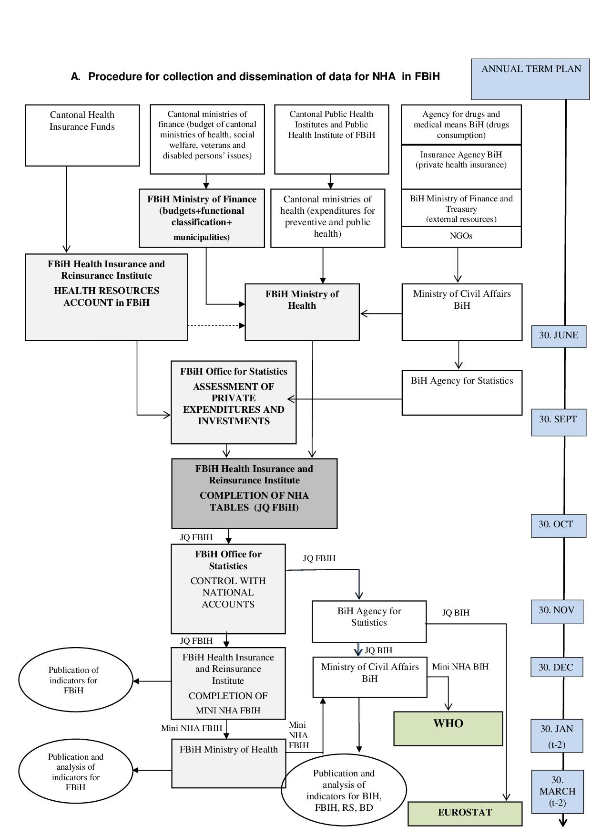

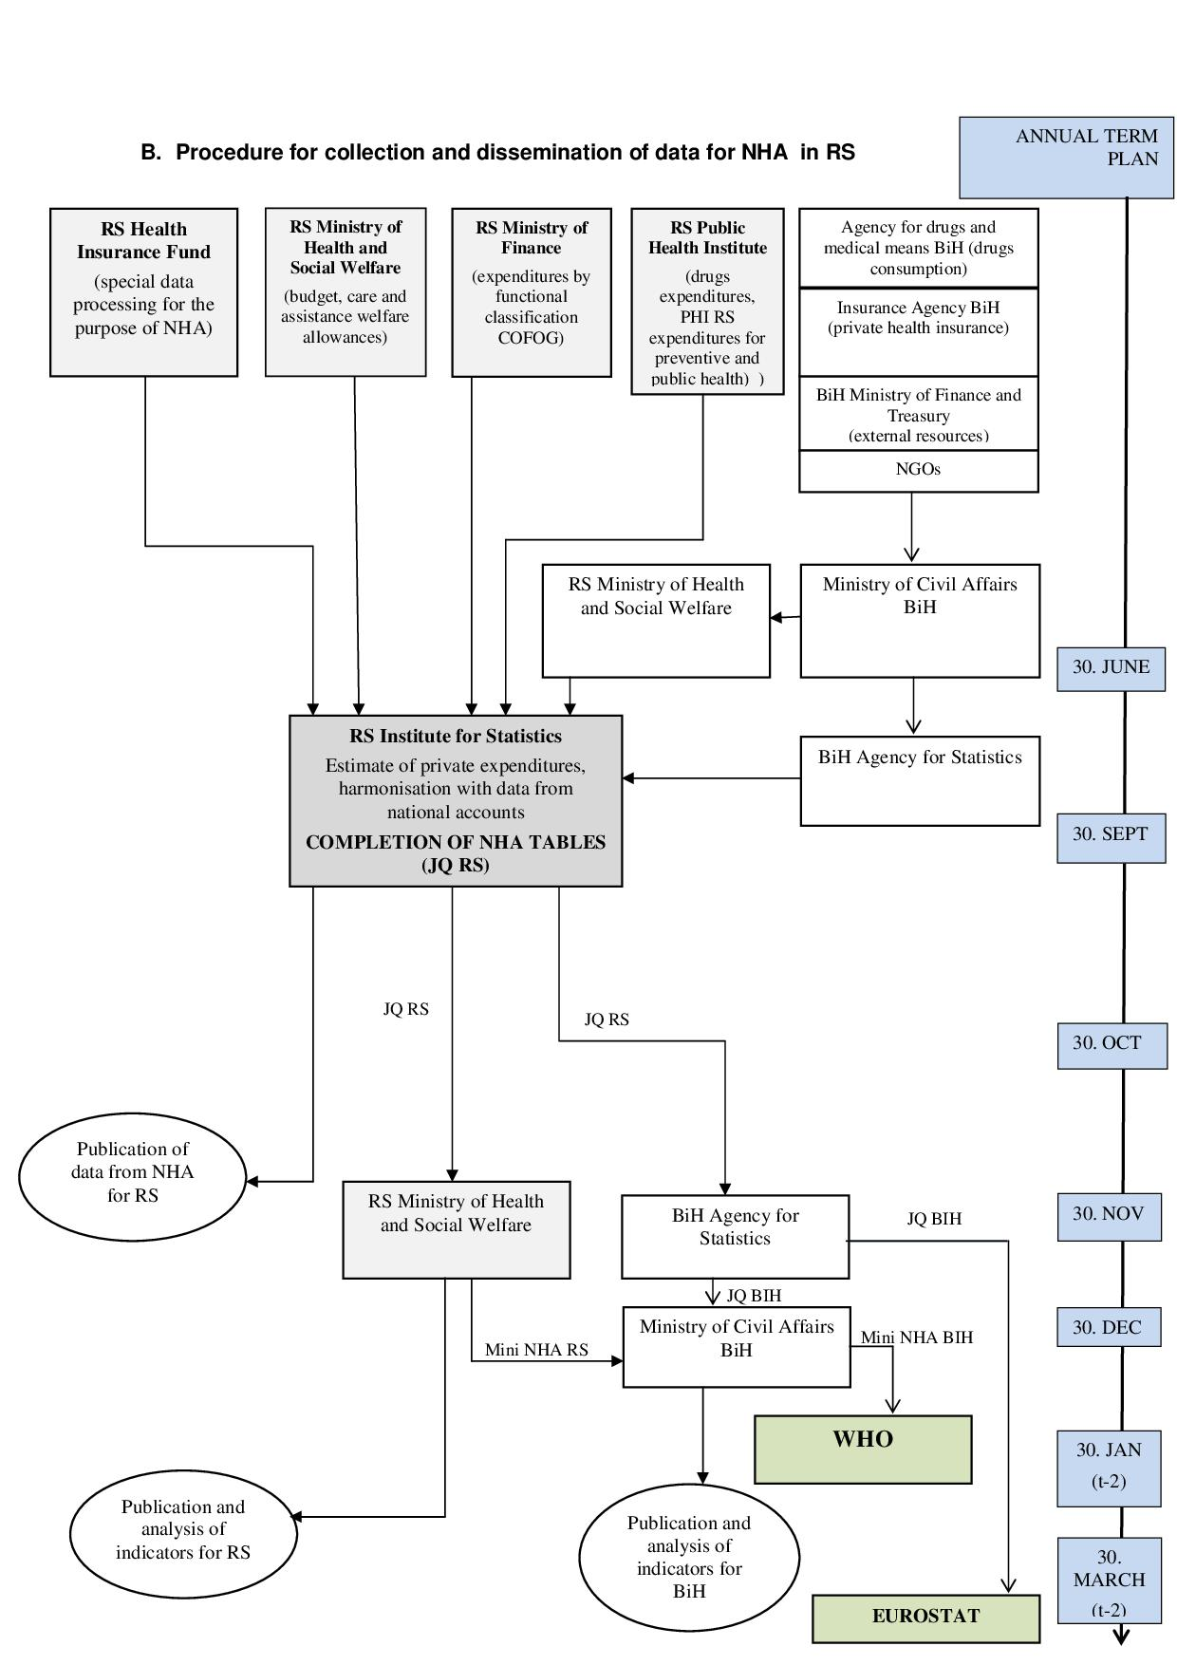
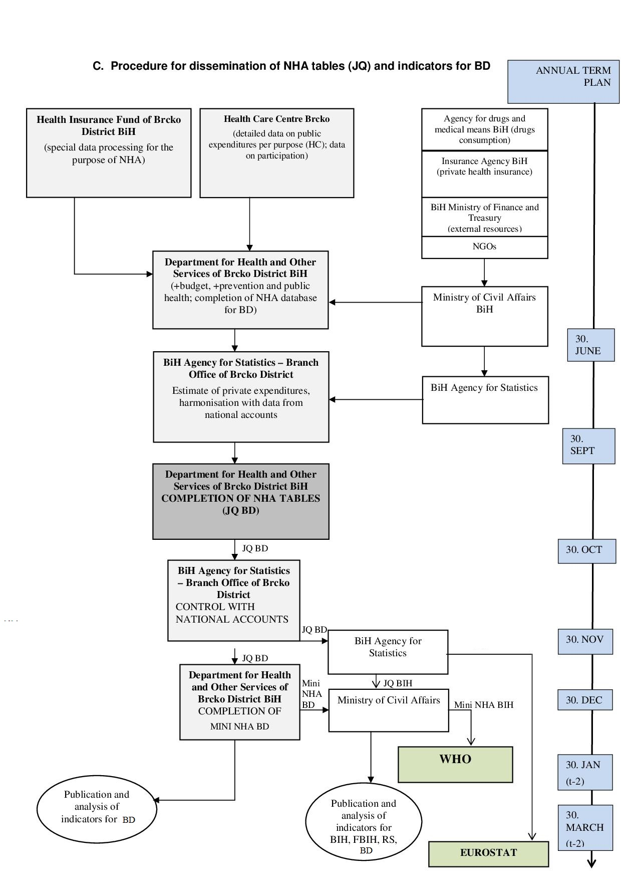
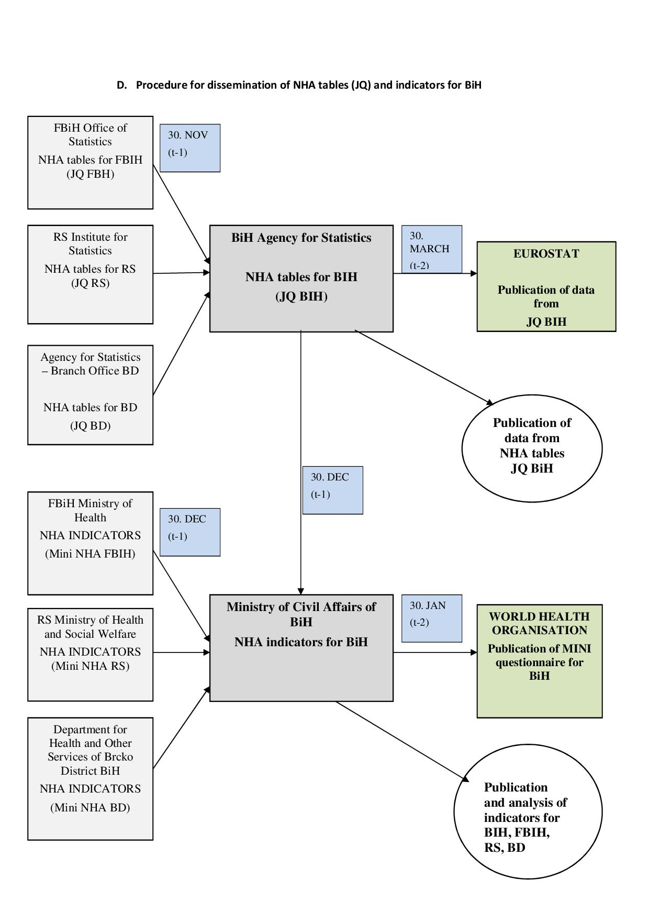

According to terminology of the Eurostat, OECD and the World Health Organization the term »System of health accounts« (international abbreviation SHA) refers to methodology, and the term national health accounts (abbreviation NHA) refers to health accounts of a country (for example NHA for Bosnia and Herzegovina). The term »national health accounts« when used for regions/entities (for example NHA of the FBiH, NHA of Republika Srpska, NHA of Brčko District of BiH) is used since the same methodology for preparation of health accounts at the region/entity level is used.
The data for BiH in the Mini NHA questionnaire of the World Health Organization are published at the web page of the World Health Organization: http://www.who.int/nha/country/en/
The SHA 2011 Methodology with classification of purposes/functions of health care (ICHA-HC) defines the limits of health care, which encompasses the following activities: health promotion and prevention; diagnosis, treatment and rehabilitation, care for chronic patients; care for person with disabilities; paliative care; provision of public health services and managing health system and health insurance. Related to these activities it is necessary to encompass all expenditure of the population having resident status in the national health accounts, and also expenditures from abroad (it means not to take into consideration of geaographic borders), but it does not includes expenditures made by a foreign citizen to the health care in another country (OECD, Eurstat, World Health organization, 2011, pages 52-56).
Also available in Serbian language.
All classifications are explained in detail in the manual a System of health accounts 2011 (OECD, Eurostat, World Health Organization, 2011), which is available at the web site: http://www.who.int/nha/sha_revision/en/
In this classification system, every part of expenditure is assigned to a specific function, provider and financing agents. The categories within each classification are broken down at different levels of detail, from the one-digit level to a maximum of a three-digit level.
This table indicates from where the money comes to the health care system, namely the sources of financing of the health care system (health insurance fund, government budget, private insurance companies).
Funds/Institutes of health insurance and government budgets usually do use their own internal classifications of goods and services used in the health care, which have to be cross-classified according to the codes of international classification for health accouns (ICHA)
It means in the current year for previous year.
Web page: http://www.who.int/nha/country/en/
More about each step is explained in SHA 2011 (pages 321-338).

