Press article long article

Crop diversification for carbon-rich grasslands

Mixed grasslands bring multiple benefits to Dutch dairy farm

Two years ago, Dutch dairy farmer Matté Eikelenboom started exploring crop diversification in his grazing land, to stimulate soil life and improve the health of his cows. His mixed pastures show promising results for the quality of his feed and the health of his animals. The variety of species also helps increase organic matter in the soil. Exchanging knowledge with other farmers has been valuable in getting the best results.

Matté has introduced a mix of herbs and clovers in two sections of his grassland, which originally solely consisted of ryegrass. He explains: “I had visited a fellow dairy farmer who grazed his cows on grassland with mixed herbs and grasses. He hadn’t used any antibiotics in over seven years. This encouraged me to test what the effect would be on the health of my own animals and the quality of my soils, which were very compacted at the time.”

The pastures now include red and white clover, plantain and chicory. “These herbs have deep roots that open up the soil and improve its structure. This helps retain water and prevents the soil from drying out. Clover also fixes nitrogen, allowing me to use less fertiliser.” Matté has added eggshells, sea salt and lava rock soil amendments to increase the amount of calcium and other minerals in the soil. He notices the positive effect on soil biodiversity: “The worms in the soil are the result of good pasture land, with a good structure and the right water levels, fertilised by solid manure mixed with straw. The mix of herbs and grasses also attracts bees, dragonflies and other insects. It just brings life to the land.”

The herb and grass mixture gives the dairy cows nutritious and protein-rich feed. Chicory and clover also have antiparasitic properties that benefit the health of the cows. Matté sees the benefits: “Not having to use antiparasitic medication helps us cut costs, and it improves the quality of the manure, which again benefits the soil.”

To stay up to date with new knowledge, Matté is now involved in the demonstration project ‘Carbon Cycle’, led by advisory service DLV Advies. This project brings together 15 conventional and organic farmers to explore ways to increase organic matter in the soil. This includes adding herb mixtures in grassland, using woodchips, on-farm composting and more. The farmers test different measures and share their experiences in the group, and with other farmers in the province of Utrecht. “We work with different soil types and have different ways of thinking. We are learning a lot from each other”, Matté says.

Matté is planning to gradually turn all of his pasture land into herbaceous grassland, and he is considering becoming an organic farmer. “We still need a few more years to get the best results, but what we see is promising. Having healthier cows means more yield. I see more biodiversity and lively soils, and I can cut costs. I think this is the future.”

Press article short article

Crop diversification for carbon-rich grasslands

Mixed grasslands bring multiple benefits to Dutch dairy farm

Two years ago, Dutch dairy farmer Matté Eikelenboom started exploring crop diversification in his grazing land, to stimulate soil life and improve the health of his cows. Exchanging knowledge with other farmers has been valuable in getting the best results.

Matté introduced a mix of herbs and clovers in his ryegrass pastures. He was inspired by a fellow dairy farmer who hadn’t used any antibiotics in over seven years. For Matté, the results are promising: “The herbs have deep roots that improve the soil’s structure. This helps retain water and prevents the soil from drying out. Clover fixes nitrogen, allowing me to use less fertiliser. The mix of herbs and grasses also attracts bees, dragonflies and other insects. It just brings life to the land.” The mixed pastures give the cows protein-rich feed, but Matté sees more benefits: “Chicory and clover have antiparasitic properties that allow us to cut down on medication. This saves us costs, and it improves the quality of the manure, which again benefits the soil.”

To keep up with new knowledge, Matté is involved in demonstration project ‘Carbon Cycle’, which brings together conventional and organic farmers to explore ways to increase soil organic matter. The farmers test different measures and share their experiences in the group and with other farmers. Matté is planning to turn all of his pastures into herbaceous grassland. “Having healthier cows means more yield. I see more biodiversity and lively soils, and I can cut costs. I think this is the future.”

Background information
Watch the press article’s movieclip

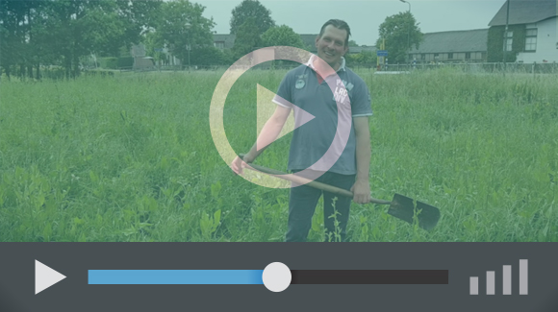

Project information
Matté en Sandra Eikelenboom
T: +31 6 5386 5647
sandra@lopikerkapel.com

The Demonstration project ‘Carbon Cycle’ project is funded by the Dutch Rural Development Programme. For more information you can contact advisory service DLV Advies that leads the project via info@dlvadvies.nl

EIP-AGRI Contact
Ina Van Hoye
Communication officer
EIP-AGRI Service Point
ina.vanhoye@eip-agri.eu
+32 486 90 77 43

Pictures
Click on the pictures to download the high resolution version. The pictures are free for use.

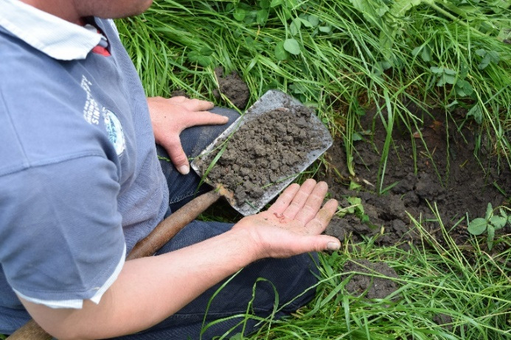 | 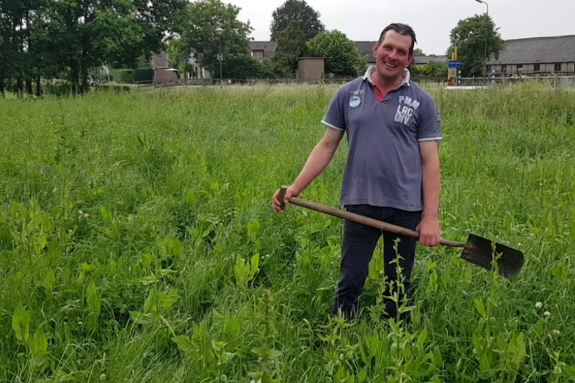
Dairy farmer Matté Eikelenboom testing the soils in his mixed grassland. – Copyright European Commission | Dairy farmer Matté Eikelenboom: “Having healthier cows means more yield. I see more biodiversity and lively soils, and I can cut costs. I think this is the future.” - Copyright European Commission

More information on crop diversification

Matté Eikelenboom’s farm was visited during the EIP-AGRI Workshop ‘Cropping for the future: Networking for crop rotation and crop diversification’ (Almere, the Netherlands – June 2019).

The Demonstration Project ‘Carbon Cycle’ where Matté is involved in was one of the 56 European innovative projects that have been presented at the workshop. Information on all the projects is available in the workshop’s projects booklet, including projects from following countries:

- Austria: 2 Operational Groups
- Estonia: Cluster project
- France – Belgium: 1 project
- Germany: 3 Operational Groups
- Italy: 5 Operational Groups
- Mediterranean region: 1 project
- Netherlands: 8 Operational Groups – 2 innovative projects
- Nort-West Europe: 1 interreg project
- Poland: 1 innovative project
- Portugal: 6 Operational Groups
- Slovenia: 1 Operational Group
- Spain: 4 Operational Groups
- Sweden: 2 innovative projects
- EU: 3 thematic networks – 8 multi-actor projects – 2 Life projects – 4 ERA-NETs

Multi-actor projects are projects in which end users and multipliers of research results such as farmers and farmers’ groups, advisers, enterprises and others, are closely cooperating throughout the whole research project period.

Thematic networks are multi-actor projects which collect existing knowledge and best practices on a given theme to make it available in easily understandable formats for end-users such as farmers, foresters, advisers etc.

Other Operational Groups working on crop diversification

25 Operational Groups working on crop diversification are available in the EIP-AGRI Operational Groups database (5 September 2019)
- France: 5
- Germany: 2
- Ireland: 1
- Italy: 6
- Netherlands: 2
- Portugal: 3
- Spain: 4
- UK: 2

EIP-AGRI
The European Innovation Partnership 'Agricultural Productivity and Sustainability' (EIP-AGRI) is one of five EIPs which have been launched by the European Commission in a bid to promote rapid modernisation of the sectors concerned, by stepping up innovation efforts. The EIP-AGRI aims to foster innovation in the agricultural and forestry sectors by bringing research and practice closer together – in research and innovation projects as well as via the EIP-AGRI network.
EIPs aim to streamline, simplify and better coordinate existing instruments and initiatives, and complement them with actions where necessary. Two specific funding sources are particularly important for the EIP-AGRI: the EU Research and Innovation framework, Horizon 2020, as well as the EU Rural Development Policy.

- EIP-AGRI Brochure on the EIP-AGRI Network (2015) (EN – BG – DE – ES – FR – GR – HU – IT – PT – RO)
- EIP-AGRI Brochure on Funding opportunities under Horizon 2020 – Calls 2020 Calls (EN)
- EIP-AGRI Brochure on Horizon 2020 Multi-actor projects (EN – BG – DE – FR – SI)
- EIP-AGRI Brochure on Thematic Networks under Horizon 2020 (EN – BG – DE – ES – FR – HU)

EIP-AGRI Operational Groups
- 98 rural development programmes (27 member states) provide support to EIP Operational Groups
- Over 3200 Operational Groups are expected to be established under the approved RDPs (2014 – 2020)
- 934 Operational Groups projects have been selected for funding and are currently ongoing (or already finished)*

* Information officially submitted to the European Commission by RDP managing authorities on 27 March 2019

EIP-AGRI Operational Groups are groups of people who work together in an innovation project funded by Rural Development Programmes (RDPs). They bring together partners with complementary knowledge. The composition of the group can vary according to the theme and specific objectives of each project. Farmers, advisers, scientists, businesses or other relevant partners work together to find practical solutions for specific problems facing people in the European farming and forestry sectors. Farmers and foresters need to be closely involved throughout the project to ensure that the innovative solutions are relevant and likely to be quickly applied in the field.
Find out more in the EIP-AGRI brochure on Operational Groups. The brochure on Operational Groups is available in English, Bulgarian, Czech, French, German, Greek, Hungarian, Portuguese, Romanian, Slovak, Slovenian and Spanish
Operational Groups can benefit from networking and collaborating with organisations from outside their partnership and from other regions and countries, such as other Operational Groups, research projects, farmers’ organisations or local authorities and European knowledge networks. Read the EIP-AGRI Brochure ‘Operational Groups – Collaborate to innovate’. It shows some examples of successful collaborations. It provides Operational Groups with inspiration and tools for further knowledge exchange within the EIP-AGRI network. This brochure is available in English, Latvian, Romanian and Slovenian.
Check out the 'Operational Groups' dedicated section on the EIP-AGRI website, including:
- More than 800 Operational Groups are available in the database
- detailed information on how to set up Operational Groups, on supporting networks and relevant EIP-AGRI seminars and workshops
- links to results and contact details of ongoing Operational Groups in the EIP-AGRI database
- a list of all RDP Managing Authorities

Contact information
Ina Van Hoye
Communication officer
EIP-AGRI Service Point
ina.vanhoye@eip-agri.eu
+32 486 90 77 43

