Press article long article

Portuguese farmer experiments with cover crops to suppress nutsedge

Operational Group combats weeds with non-chemical alternatives

Agriculture in the EU and worldwide has become increasingly dependent on the use of pesticides. Change is needed because the use of these chemicals can impact the environment and the health of animals and humans. Inspired by results in other member states, the Portuguese Operational Group HortInf is trying to find non-chemical alternatives to conventional weed management that could be used by Portuguese farmers.

One of the farmers involved in this project is Francisca Chaves Ramos. For 10 years she has been primarily cultivating potatoes, corn and barley in Golega, in the centre of Portugal. “I had already been struggling for a while with the chemical weed management on my farm. When my children started asking why I was using harmful chemicals on the farm, I answered that there aren’t any suitable alternatives for farming on large areas. When farmers` organisation AgroMais Plus approached me to join this project, I immediately said yes.”

Perennial weeds like nutsedge (Cyperus rotundus and Cyperus esculentus) multiply through bulbs, rhizomes (rootstalks) and root sections. Traditional mechanical weeding methods actually help to create more rhizomes which propagates these weeds instead of eliminating them. Francisca: “At my farm approximately 90% of the weed control is done by chemicals. Right now, in the context of our Operational Group project, we are looking for ways to use cover crops to suppress the nutsedge. This is interesting, because I didn’t know this was possible before, and it may help us to reduce our chemical weed management. By the end of this project, I hope that the weed will be a little more under control, but it may take a long time to eliminate it completely. Every stage probably needs a different approach, so we have to be patient and keep believing in the solutions.”

Francisca is very positive about the cooperation with the researchers. “It is great that we as farmers can help the researchers to test ideas in the field. This is always more useful than when you can only test it in the lab. Therefore, I think that every farmer should be willing to participate in a cooperation like this.”

Isabel Calha is one of the researchers involved in the project. “Working with farmers allows us to discuss the limitations and constraints that we face while testing new crops or the introduction of new tillage equipment. It is important that we listen to their opinion to understand their expectations for this project. So for every new technology that we would like to test, compromise, commitment and confidence are necessary. This may take some time, but we eventually achieve better results.”

“We also learned to take more issues into account like access to equipment, costs and farmers’ perception about advantages and disadvantages of each practice in the short and in the long term. Trials in the fields of the farmers are a good way to achieve these goals”, concludes Isabel.

Press article short article

Portuguese farmer experiments with cover crops to suppress nutsedge

Operational Group combats weeds with non-chemical alternatives

Agriculture in the EU and worldwide has become increasingly dependent on pesticides. Inspired by results in other member states, the Portuguese Operational Group HortInf is trying to find non-chemical alternatives to conventional weed management that are suitable for Portuguese farmers.

One of the farmers involved in this project is Francisca Chaves Ramos. For 10 years she has primarily cultivated potatoes, corn and barley. “I had been struggling with the chemical weed management on my farm. When farmers` organisation AgroMais Plus approached me to join their project, I immediately said yes.”

Perennial weeds like nutsedge (Cyperus rotundus and Cyperus esculentus) multiply through bulbs, rhizomes (rootstalks) and root sections. Traditional mechanical weeding methods lead to more rhizome sections which propagates these weeds instead of eliminating them. Francisca: “At my farm we use chemicals for approximately 90% of the weed control. We are now looking for ways to use cover crops to suppress the nutsedge.”

Francisca is positive about cooperating with the researchers. “It is great that we farmers can help researchers to test ideas in the field. I think every farmer should be willing to participate in a cooperation like this.”

Isabel Calha, one of the researchers involved in the project, also appreciates the cooperation. “Working with farmers allows us to discuss the limitations and constraints that we face while testing new crops or equipment. We also learnt to take issues into account like access to equipment, costs and farmers` perceptions about advantages and disadvantages of each practice in the short and in the long term”, concludes Isabel.

Background information
Watch the press article’s movieclip

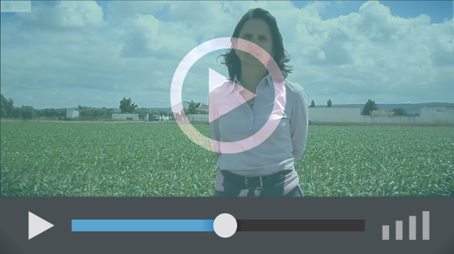

Project information
Ms. Francisca Chaves Ramos (Sociedade Agrícola de S. João de Brito, S.A)
francisca.vscr@gmail.com

Ms. Isabel Calha (Instituto Nacional de Investigacão Agrária e Veterinária – INIAV)
isabel.calha@iniav.pt

Operational Group project sheet at the EIP-AGRI website
Operational Group website: https://hortinf.webnode.pt/

EIP-AGRI Contact
Ina Van Hoye
Communication officer
EIP-AGRI Service Point
ina.vanhoye@eip-agri.eu
+32 486 90 77 43

Pictures
Click on the pictures to download the high resolution version. The pictures are free for use. Please mention the copyright: © European Commission

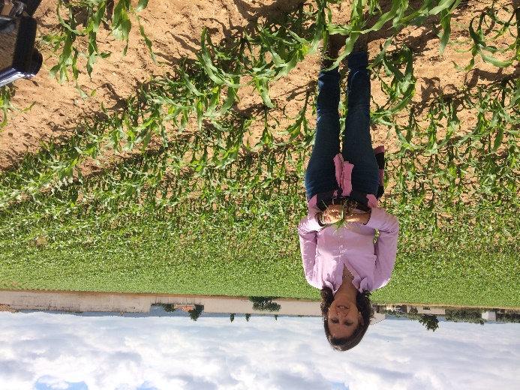 | 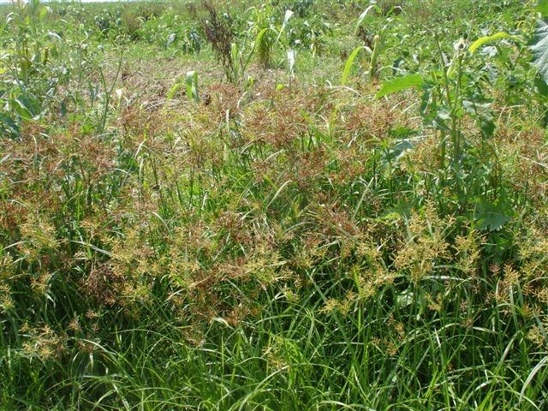
Farmer Francisca standing in her field that is used for trials to find non-chemical alternatives to conventional weed management. | Traditional mechanical weeding methods used to combat nutsedge increases these weeds instead of eliminating them.

More information on weed management
The EIP-AGRI Focus Group ‘Non-chemical weed management in arable cropping systems’ visited Francisca’s farm during their second meeting in May 2019. The Focus Group report is scheduled to be published in end 2019.

Horizon 2020 multi-actor projects working on weed management
- Thematic network INNOSETA - Accelerating Innovative practices for Spraying Equipment, Training and Advising in European agriculture through the mobilization of Agricultural Knowledge and Innovation Systems: website - CORDIS (05/2018-04/2021)
- Multi-actor project IWMPRAISE - Integrated Weed Management: PRActical Implementation and Solutions for Europe: website - CORDIS(06/2017-05/2022)
- Multi-actor project EMPHASIS - Effective Management of Pests and Harmful Alien Species - Integrated Solutions: website - CORDIS(03/2015-02/2019)
Multi-actor projects are projects in which end users and multipliers of research results such as farmers and farmers’ groups, advisers, enterprises and others, are closely cooperating throughout the whole research project period.

Thematic networks are multi-actor projects which collect existing knowledge and best practices on a given theme to make it available in easily understandable formats for end-users such as farmers, foresters, advisers etc.

Other Operational Groups working on weed management
- 23 Operational Groups working on weed management available in the EIP-AGRI Operational Groups database (23 August 2019):

- Belgium: 1  - Finland: 1  - France: 5  - Germany: 3  - Ireland: 2 | - Netherlands: 3  - Poland: 1  - Slovenia: 1  - Spain: 3  - UK: 3
- Operational Group BIOBO (Austria) working on soil fertility through carbon storage also offered a solution to suppress annual weeds. Watch the EIP-AGRI video or read the press article.

EIP-AGRI
The European Innovation Partnership 'Agricultural Productivity and Sustainability' (EIP-AGRI) is one of five EIPs which have been launched by the European Commission in a bid to promote rapid modernisation of the sectors concerned, by stepping up innovation efforts. The EIP-AGRI aims to foster innovation in the agricultural and forestry sectors by bringing research and practice closer together – in research and innovation projects as well as via the EIP-AGRI network.
EIPs aim to streamline, simplify and better coordinate existing instruments and initiatives, and complement them with actions where necessary. Two specific funding sources are particularly important for the EIP-AGRI: the EU Research and Innovation framework, Horizon 2020, as well as the EU Rural Development Policy.

- EIP-AGRI Brochure on the EIP-AGRI Network (2015) (EN – BG – DE – ES – FR – GR – HU – IT – PT – RO)
- EIP-AGRI Brochure on Funding opportunities under Horizon 2020 – Calls 2020 Calls (EN)
- EIP-AGRI Brochure on Horizon 2020 Multi-actor projects (EN – BG – DE – FR – SI)
- EIP-AGRI Brochure on Thematic Networks under Horizon 2020 (EN – BG – DE – ES – FR – HU)

EIP-AGRI Operational Groups
- 98 rural development programmes (27 member states) provide support to EIP Operational Groups
- Over 3200 Operational Groups are expected to be established under the approved RDPs (2014 – 2020)
- 934 Operational Groups projects have been selected for funding and are currently ongoing (or already finished)*

* Information officially submitted to the European Commission by RDP managing authorities on 27 March 2019

EIP-AGRI Operational Groups are groups of people who work together in an innovation project funded by Rural Development Programmes (RDPs). They bring together partners with complementary knowledge. The composition of the group can vary according to the theme and specific objectives of each project. Farmers, advisers, scientists, businesses or other relevant partners work together to find practical solutions for specific problems facing people in the European farming and forestry sectors. Farmers and foresters need to be closely involved throughout the project to ensure that the innovative solutions are relevant and likely to be quickly applied in the field.
Find out more in the EIP-AGRI brochure on Operational Groups. The brochure on Operational Groups is available in English, Bulgarian, Czech, French, German, Greek, Hungarian, Portuguese, Romanian, Slovak, Slovenian and Spanish
Operational Groups can benefit from networking and collaborating with organisations from outside their partnership and from other regions and countries, such as other Operational Groups, research projects, farmers’ organisations or local authorities and European knowledge networks. Read the EIP-AGRI Brochure ‘Operational Groups – Collaborate to innovate’. It shows some examples of successful collaborations. It provides Operational Groups with inspiration and tools for further knowledge exchange within the EIP-AGRI network. This brochure is available in English, Latvian, Romanian and Slovenian.
Check out the 'Operational Groups' dedicated section on the EIP-AGRI website, including:
- More than 800 Operational Groups are available in the database
- detailed information on how to set up Operational Groups, on supporting networks and relevant EIP-AGRI seminars and workshops
- links to results and contact details of ongoing Operational Groups in the EIP-AGRI database
- a list of all RDP Managing Authorities

Contact information
Ina Van Hoye
Communication officer
EIP-AGRI Service Point
ina.vanhoye@eip-agri.eu
+32 486 90 77 43

