Press article long

German Operational Group investigates effective application of Mycorrhiza in the field

Mycorrhiza fungi as green alternative for mineral fertilisers

Mycorrhiza fungi can be a useful bio stimulant for agriculture. It can contribute to better crop quality and a higher yield with less fertiliser, as the fungi can help plant roots to take up nutrients such as nitrogen, potassium and phosphate from a much larger volume of soil. This can also help prevent nutrients leaching into the groundwater. In Northern Germany, the Operational Group AMF AGRI investigated how Mycorrhiza can be applied in the field effectively and easily. The project found some answers leading to more interesting research questions.

The Institute for Plantculture (Institut für Pflanzenkultur) led the project. This institute works with farmers on knowledge development and exchange, while also managing its own farm. Dr. Carolin Schneider, who coordinated the project, says: “Our Operational Group aimed to support efficient and resource-saving nutrient management. We tested automated and targeted application of Mycorrhiza in the field to help crops to take up nutrients and grow. We also found that micro-spreaders are helpful in applying the Mycorrhiza, because they can spread the Mycorrhiza inoculum directly into the seed row. This inoculum is a very fine powder, which should be combined with carrier material for application in the field.”

“We wanted to test the use of the Mycorrhiza in a conventional and organic system, during 2 growing seasons. Two farmers cooperated with us to test the use of Mycorrhiza in their crops. Michael Cordts cultivates soya and corn on 155 ha of land on his organic farm. Bernd Trumann cultivates potatoes on his 350 ha in the conventional way. The Mycorrhiza was inoculated in granulate, suitable for micro-spreaders. The farmers did field preparation, seeding, maintenance and harvest. Their experience and knowledge on micro-spreaders proved very valuable in developing an effective application method for the Mycorrhiza.”

The project yielded some interesting insights. Schneider: The main result of this Operational Group was that the Mycorrhiza had positive effects on the yield and biomass of soybean and corn for organic farming. Unfortunately, it turned out that the potato farmer Trumann didn’t get great results with the Mycorrhiza. We don’t know exactly why, because without a detailed investigation, there can be many different reasons. At the end of the project, we concluded that we needed to do more tests to explore the reasons for the different results of Mycorrhiza treatments.”

“We also had some unanswered questions regarding the precise application of the Mycorrhiza with the micro-spreader. Therefore, we set up the Precision-AMF Operational Group project in February 2019 that will investigate the area-specific application of Mycorrhiza by a micro-spreader by using precision technology. In 2020 the institute also started the follow-up Operational Group project Bioseed. It investigates the effectiveness of coating seeds with Mycorrhiza. This could save farmers time, as it would mean that they would not need to spread the Mycorrhiza separately. Applying Mycorrhiza to crops may be a promising way for arable farmers to produce more with less, but there are still many practical questions to be answered”, concludes Dr.Schneider.

Press article short

German Operational Group investigates effective application of Mycorrhiza in the field

Mycorrhiza fungi as green alternative for mineral fertilisers

Mycorrhiza fungi can be a useful bio stimulant for agriculture. It can contribute to better crop quality and a higher yield with less fertiliser, as the fungi can help plant roots to take up nutrients such as nitrogen, potassium and phosphate from a much larger volume of soil. In Northern Germany, the Operational Group AMF AGRI investigated how Mycorrhiza can be applied in the field effectively and easily. The project found some answers leading to more questions.

The Institute for Plantculture (Institut für Pflanzenkultur) led the project. Dr. Carolin Schneider, the project coordinator, says: “Our Operational Group aimed to support efficient and resource-saving nutrient management. We tested automated and targeted application of Mycorrhiza in the field to help crops to take up nutrients. We also found that micro-spreaders can improve Mycorrhiza application, by spreading the Mycorrhiza inoculum directly into the seed row.”

“We wanted to test the use of the Mycorrhiza in a conventional and organic system, during 2 growing seasons. Two farmers cooperated with us to test the use of Mycorrhiza in their crops. Michael Cordts cultivates soya and corn on 155 ha of land on his organic farm. Bernd Trumann cultivates potatoes on his 350 ha in the conventional way.”

The project yielded interesting insights. Schneider: ”The main result of this Operational Group was that the Mycorrhiza positively affected the yield and biomass of soybean and corn for organic farming. We also concluded that we needed to do more tests to investigate the reasons for the different results of Mycorrhiza treatments. We started the project Bioseed and Precision-AMF to do so.”

Background information
AMF Agri was one of the project presented during the EIP-AGRI workshop ‘Organic is Operational’ – 14-15 June 2017 in Hamburg, Germany.

Project information

Dr. Carolin Schneider
schneider@pflanzenkultur.de
Phone: +49 5842 472

- Project factsheet in the EIP-AGRI booklet from the workshop ‘Organic is Operational’
- Operational group project webpage in the EIP-AGRI database

EIP-AGRI contact
Ina Van Hoye
Communication officer
EIP-AGRI Service Point
ina.vanhoye@eip-agri.eu
+32 486 90 77 43

Pictures
Click on the pictures to download the high resolution version. The pictures are free for use. Please mention the copyright: Operational Group AMF AGRI

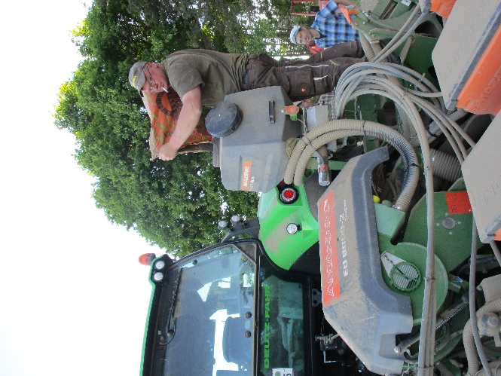 | 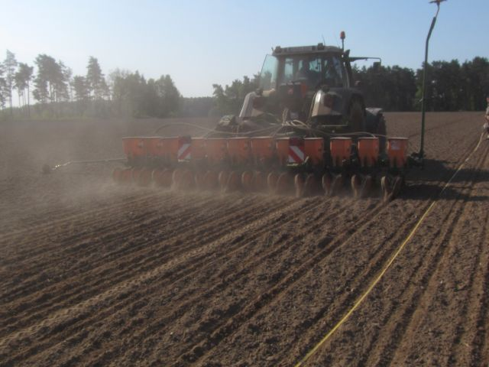
Filling mycorrhiza inoculum in the microspreader | Soybean trial sowing

More EIP-AGRI information on organic farming
The EIP-AGRI has carried out different activities relevant to organic farming, including:

- EIP-AGRI Focus Group on Organic Optimising arable yields: Focus Group report - factsheet
- EIP-AGRI Focus Group on carbon storage in arable farming: Focus Group report - factsheet
- EIP-AGRI Focus Group Non-chemical weed management in arable cropping systems: Focus Group report
- EIP-AGRI workshop ‘Organic is Operational: Workshop report

EIP-AGRI publications

- EIP-AGRI Brochure on Innovative solutions for organic farmers in the EU - Optimising arable yields
- EIP-AGRI brochure: Organic is Operational
- In 2020 the EIP-AGRI Service Point dedicates the June newsletter to organic farming

Green Deal: Farm to Fork Strategy
The European Commission launched 20 May 2020 the Farm to Fork Strategy. It is at the heart of the European Green Deal aiming to make food systems fair, healthy and environmentally-friendly.

The strategy focuses on:
- Making sure Europeans get healthy, affordable and sustainable food
- Tackling climate change
- Protecting the environment and preserve biodiversity
- Fair economic return in the food chain
- Increasing organic farming

Organic farming is an environmentally-friendly practice that needs to be further developed. The Commission proposes to boost the development of EU organic farming area with the aim to achieve 25 % of total farmland under organic farming by 2030.

Horizon 2020 projects working on organic farming

- More than 20 Horizon 2020 projects are available at the multi-actor projects webpage and the thematic networks webpage at the EIP-AGRI website > ecological approaches

Multi-actor projects are projects in which end users and multipliers of research results such as farmers and farmers’ groups, advisers, enterprises and others, are closely cooperating throughout the whole research project period.
Thematic networks are multi-actor projects which collect existing knowledge and best practices on a given theme to make it available in easily understandable formats for end-users such as farmers, foresters, advisers etc.

Operational Groups working on organic farming
The EIP-AGRI Innovative projects catalogue (128MB) includes 39 projects, including Operational Groups, working on organic farming.

63 Operational Groups working on organic farming are available in the EIP-AGRI Operational Groups database (update 3 June 2020)
- Austria: 4
- Belgium: 1
- France: 4
- Germany: 22
- Ireland: 2
- Italy: 10
- Netherlands: 4
- Portugal: 2
- Spain: 10
- UK: 4

EIP-AGRI inspirational ideas on organic farming
Austria | Looking after the soil to bring life and carbon back  Inspirational idea – EIP-AGRI video
Croatia | Protecting plants against insects, naturally!
Denmark, Sweden, Latvia, UK, Norway | Perfumes for pests
France | Cutting atmospheric carbon: a central role for soils
Germany, Italy, Sweden | Climate-friendly practices
Germany | Alternatives for expensive protein feed for laying hens
Germany | Organic and “conventional” farmers joining forces for innovation
Italy | Goats in good company
Italy | Agro-industrial waste put to good use as biofertiliser
Poland | Protecting soil organic carbon in Poland
Portugal | A passion for permanent pasture
Portugal | Portuguese farmer experiments with cover crops to suppress nutsedge  Inspirational idea – EIP-AGRI video
Spain | Finding new in the old, reviving former links between forest and agricultural land
Spain | Local food networks inspiring people to take up organic farming
Sweden | Swedish organic farm leads the way in fighting climate change
UK | Increasing farm profitability while cutting carbon emissions, a toolkit developed by farmers for farmers
EU | Cloud technology to safeguard integrity of the organic sector

EIP-AGRI
The European Innovation Partnership 'Agricultural Productivity and Sustainability' (EIP-AGRI) is one of five EIPs which have been launched by the European Commission in a bid to promote rapid modernisation of the sectors concerned, by stepping up innovation efforts. The EIP-AGRI aims to foster innovation in the agricultural and forestry sectors by bringing research and practice closer together – in research and innovation projects as well as via the EIP-AGRI network.
EIPs aim to streamline, simplify and better coordinate existing instruments and initiatives, and complement them with actions where necessary. Two specific funding sources are particularly important for the EIP-AGRI: the EU Research and Innovation framework, Horizon 2020, as well as the EU Rural Development Policy.

- EIP-AGRI Brochure on the EIP-AGRI Network (2015) (EN – BG – DE – ES – FR – GR – HU – IT – PT – RO)
- EIP-AGRI Brochure on Funding opportunities under Horizon 2020 – Calls 2020 Calls (EN)
- EIP-AGRI Brochure on Horizon 2020 Multi-actor projects (EN – BG – DE – FR – SI)
- EIP-AGRI Brochure on Thematic Networks under Horizon 2020 (EN – BG – DE – ES – FR – HU)

EIP-AGRI Operational Groups

- 98 rural development programmes provide support to EIP Operational Groups *
- Over 3200 Operational Groups are expected to be established under the approved RDPs (2014 – 2020)
- Over 1500 Operational Groups projects have been selected for funding and are currently ongoing (or already finished)*

* Information officially submitted to the European Commission by RDP managing authorities (September 2019)

EIP-AGRI Operational Groups are groups of people who work together in an innovation project funded by Rural Development Programmes (RDPs). They bring together partners with complementary knowledge. The composition of the group can vary according to the theme and specific objectives of each project. Farmers, advisers, scientists, businesses or other relevant partners work together to find practical solutions for specific problems facing people in the European farming and forestry sectors. Farmers and foresters need to be closely involved throughout the project to ensure that the innovative solutions are relevant and likely to be quickly applied in the field.
Find out more in the EIP-AGRI brochure on Operational Groups. The brochure on Operational Groups is available in English, Bulgarian, Czech, French, German, Greek, Hungarian, Portuguese, Romanian, Slovak, Slovenian and Spanish
Operational Groups can benefit from networking and collaborating with organisations from outside their partnership and from other regions and countries, such as other Operational Groups, research projects, farmers’ organisations or local authorities and European knowledge networks. Read the EIP-AGRI Brochure ‘Operational Groups – Collaborate to innovate’. It shows some examples of successful collaboration. It provides Operational Groups with inspiration and tools for further knowledge exchange within the EIP-AGRI network. This brochure is available in English, Latvian, Romanian and Slovenian.
Check out the 'Operational Groups' dedicated section on the EIP-AGRI website, including:
- More than 1300 Operational Groups are available in the database
- detailed information on how to set up Operational Groups, on supporting networks and relevant EIP-AGRI seminars and workshops
- links to results and contact details of ongoing Operational Groups in the EIP-AGRI database
- a list of all RDP Managing Authorities

Contact information
Ina Van Hoye
Communication officer
EIP-AGRI Service Point
ina.vanhoye@eip-agri.eu
+32 486 90 77 43

