Press article long

On-farm hatching improves welfare and health of broiler chicks

Broiler chicks hatching in natural and stress-free conditions with direct access to feed and water. This is the main idea of on-farm hatching. Three hatcheries located in Belgium and the Netherlands started a project on this idea to improve welfare and health of broilers. One of the poultry farmers involved in the project is Gerard Witlox. He owns two broiler farms in the south-east of the Netherlands.
“Several years ago our broilers were suffering from Enterococcosis, which slowed their growth and meant we had to use a lot of antibiotics. I had heard about on-farm-hatching and I was wondering if this could work on my farm. By chance, one of the hatcheries that I was working with was developing new on-farm hatching techniques, one called NestBorn and the other One2Born. When they were ready to test, I told them that I would be very happy to pilot these methods on my farm. We started with on-farm-hatching in two broiler houses. In the other two, we worked with the previous method, where we received hatched chicks from the hatchery. During this process the hatchery assisted me in exchanging knowledge and specific data on the technique”, says Gerard.
On-farm hatching improves the health, development and welfare of the chicks since the stressful post-hatching period and processing in the hatchery is cut out of the production process. The pre-hatched eggs are gently placed in a natural litter bed. A real-time monitoring platform of the egg shell temperature in the broiler house allows the farmer and hatchery to team up in order to create optimal temperature and humidity conditions for the hatching chicks.
Gerard: “The first thing that we noticed in the broiler houses, was that the chicks were very calm. In addition, in the first 14 days their weight was 15 gram heavier than normal. The broilers also needed less antibiotics, they had fewer leg problems and their immunological and gut development improved. This resulted in stronger and more robust broilers.”
Gerard would recommend the on-farm hatching method. “It doesn´t cost more than the usual procedure. The only thing you have to pay attention to is planning. The broiler houses should be equipped with food and water and heated 3 days earlier than with the conventional method where you receive the hatched chicks. You also need to spend extra time during the hatching, to monitor the process and intervene if needed. Data from the poultry veterinarian who is assisting in this project showed reductions in the use of antibiotics of 50% to 62%. I have now been using on-farm hatching since 2 years and I consider it the most significant innovation in broiler production during the past 30 years. In my case, it resulted in more work joy and satisfaction, because of the easier production cycles with healthier and more lively chicks.”

Press article short

On-farm hatching improves welfare and health of broiler chicks

Broiler chicks hatching in natural and stress-free conditions with direct access to feed and water. This is the main idea of on-farm hatching. Three hatcheries located in Belgium and the Netherlands started a project on this idea. One of the Dutch poultry farmers involved in the project is Gerard Witlox.
“Several years ago our broilers were suffering from Enterococcosis, which slowed their growth and meant we had to use a lot of antibiotics. I had heard about on-farm-hatching and I was wondering if this could work in my farm. By chance, one of the hatcheries that I was working with was developing new on-farm hatching techniques. When they were ready to test, I told them that I would be very happy to pilot them on my farm.
On-farm hatching improves chick health, development and welfare since the stressful post-hatching period and processing in the hatchery is cut out of the production process. The pre-hatched eggs are gently placed in a natural litter bed. A real-time monitoring platform of the egg shell temperature allows the farmer and hatchery to team up in order to create optimal conditions for the hatching chicks.
Gerard: “The first thing that we noticed was that the chicks were very calm. They needed less antibiotics, had fewer leg problems and their immunological and gut development improved. I would recommend this method. For me it resulted in more work joy and satisfaction, because of the easier production cycles with healthier and livelier chicks. I consider it the most significant innovation in broiler production for the past 30 years.”

Background information

Watch the press article’s movieclip

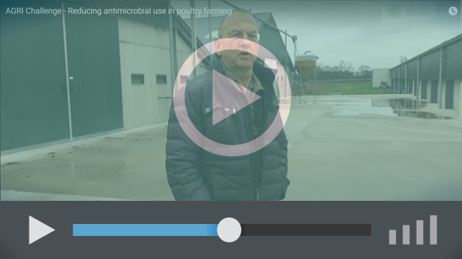

Project information
Erik Hoeven (Hatchery Vervaeke-Belavi)
Mailaddress: e.hoeven@vervaekebelavi.be
Phone number: +32 496 56 35 27

EIP-AGRI contact
Ina Van Hoye
Communication officer
EIP-AGRI Service Point
ina.vanhoye@eip-agri.eu
+32 486 90 77 43

Pictures
Click on the pictures to download the high resolution version. The pictures are free for use in the context of on-farm hatching of Nestborn.

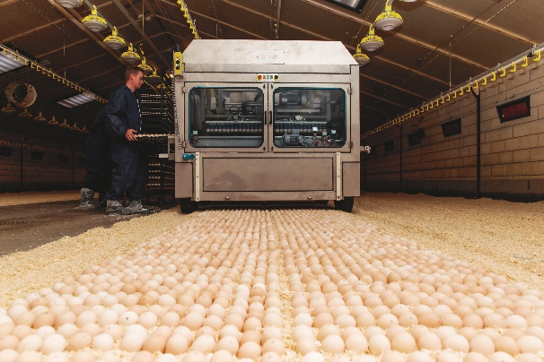 | 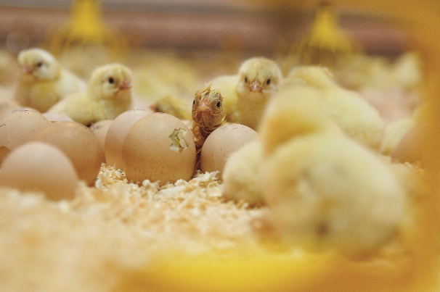
On-farm hatching improves the health, development and welfare of the chicks since the stressful post-hatching period and processing in the hatchery is cut out of the production process. | Gerard Witlox: “The first thing that we noticed in the broiler houses, was that the chicks were very calm. The broilers also needed less antibiotics.

More information on reducing antimicrobial use in poultry
The experts from the EIP-AGRI Focus Group ‘Reducing antibiotics in poultry’ visited Gerard Witlox' farm during the Focus Group meeting. The Focus Group members now continue to work on the Focus Group report and the minipapers, scheduled to be published in 2020.

Horizon 2020 multi-actor projects working on antimicrobial use in poultry
- DISARM: Disseminating Innovative Solutions for Antibiotic Resistance Management:
CORDIS (01/2019-12/2021)
- ROADMAP: Rethinking Of Antimicrobial Decision-systems in the Management of Animal Production: CORDIS (06/2019-05/2023)
Multi-actor projects are projects in which end users and multipliers of research results such as farmers and farmers’ groups, advisers, enterprises and others, are closely cooperating throughout the whole research project period.

Thematic networks are multi-actor projects which collect existing knowledge and best practices on a given theme to make it available in easily understandable formats for end-users such as farmers, foresters, advisers etc.

Operational Groups working on reducing antimicrobial use in poultry

10 Operational Groups working on reducing antimicrobial use in poultry are available in the EIP-AGRI Operational Groups database (3 February 2020).

Fattening of eco-hybrid roosters with farm-own feed | Germany
Senior laying hens: optimization of animal welfare and significant extension of the residence period for vital senior laying hens in organic farming | Germany
Admixture of certified biochar in compound feed of turkeys and broilers considering animal welfare. | Germany
Automated behavioural enrichment for poultry - development of an innovative system to improve animal welfare | Germany
Organic egg | Germany
Marketing of laying hens at the end of the laying period and males in innovative product lines | Germany
Basis Business Models for a sustainable and innovative agricultural poultry meat production | Italy
Product, process, technological and marketing innovation related to the hatching of "Niemodliński chicks" in the Magnuszowice hatchery | Poland
Campyfree: Control strategies of Campylobacter in poultry meat and meat products derived | Portugal
Dustbath in rearing cages - a challenge for the Swedish egg industry | Sweden

EIP-AGRI
The European Innovation Partnership 'Agricultural Productivity and Sustainability' (EIP-AGRI) is one of five EIPs which have been launched by the European Commission in a bid to promote rapid modernisation of the sectors concerned, by stepping up innovation efforts. The EIP-AGRI aims to foster innovation in the agricultural and forestry sectors by bringing research and practice closer together – in research and innovation projects as well as via the EIP-AGRI network.
EIPs aim to streamline, simplify and better coordinate existing instruments and initiatives, and complement them with actions where necessary. Two specific funding sources are particularly important for the EIP-AGRI: the EU Research and Innovation framework, Horizon 2020, as well as the EU Rural Development Policy.

- EIP-AGRI Brochure on the EIP-AGRI Network (2015) (EN – BG – DE – ES – FR – GR – HU – IT – PT – RO)
- EIP-AGRI Brochure on Funding opportunities under Horizon 2020 – Calls 2020 Calls (EN)
- EIP-AGRI Brochure on Horizon 2020 Multi-actor projects (EN – BG – DE – FR – SI)
- EIP-AGRI Brochure on Thematic Networks under Horizon 2020 (EN – BG – DE – ES – FR – HU)

EIP-AGRI Operational Groups

- 98 rural development programmes provide support to EIP Operational Groups *
- Over 3200 Operational Groups are expected to be established under the approved RDPs (2014 – 2020)
- Over 1000 Operational Groups projects have been selected for funding and are currently ongoing (or already finished)*

* Information officially submitted to the European Commission by RDP managing authorities (September 2019)

EIP-AGRI Operational Groups are groups of people who work together in an innovation project funded by Rural Development Programmes (RDPs). They bring together partners with complementary knowledge. The composition of the group can vary according to the theme and specific objectives of each project. Farmers, advisers, scientists, businesses or other relevant partners work together to find practical solutions for specific problems facing people in the European farming and forestry sectors. Farmers and foresters need to be closely involved throughout the project to ensure that the innovative solutions are relevant and likely to be quickly applied in the field.
Find out more in the EIP-AGRI brochure on Operational Groups. The brochure on Operational Groups is available in English, Bulgarian, Czech, French, German, Greek, Hungarian, Portuguese, Romanian, Slovak, Slovenian and Spanish
Operational Groups can benefit from networking and collaborating with organisations from outside their partnership and from other regions and countries, such as other Operational Groups, research projects, farmers’ organisations or local authorities and European knowledge networks. Read the EIP-AGRI Brochure ‘Operational Groups – Collaborate to innovate’. It shows some examples of successful collaboration. It provides Operational Groups with inspiration and tools for further knowledge exchange within the EIP-AGRI network. This brochure is available in English, Latvian, Romanian and Slovenian.
Check out the 'Operational Groups' dedicated section on the EIP-AGRI website, including:
- More than 900 Operational Groups are available in the database
- detailed information on how to set up Operational Groups, on supporting networks and relevant EIP-AGRI seminars and workshops
- links to results and contact details of ongoing Operational Groups in the EIP-AGRI database
- a list of all RDP Managing Authorities

Contact information
Ina Van Hoye
Communication officer
EIP-AGRI Service Point
ina.vanhoye@eip-agri.eu
+32 486 90 77 43

