Press article long article

Working together to find promising fruit varieties

It takes many years to develop new varieties of apples and pears and even longer before the newly planted trees start producing marketable volumes of fruit. For this reason, fruit growers are very interested in assessing whether there are new varieties which could help them respond to market demands. The Belgian research centre Proefcentrum Fruitteelt (pcfruit), has set up the Operational Group `Plant for a Customer’ to increase the success ratio of new varieties and reduce the risk for growers of planting an unsuccessful variety.

“It is a substantial financial loss for fruit growers when they find out after 7 or 8 years that their apples or pears aren’t commercially attractive for the market or do not technically match the current standards. In this Operational Group we develop a process that will help fruit growers to evaluate which varieties to plant, according to customer preference. Promising ones are evaluated faster, hence can be planted earlier and are better supported. The process will help them to strengthen their competitiveness and reduce the risk of failure”, says Dany Bylemans, CEO of pcfruit.

The idea for this project came about in 2014 when the fruit sector was in crisis. A broad consortium was set up to address the fruit growers’ needs. It includes 20 fruit growers, and also different research centres, auction houses, tree nurseries, breeders and the Flemish government. Together they are designing a decision support tool to help decide whether or not to continue with a fruit variety. It considers commercial aspects, for example popular taste among customers and technical aspects such as the sensitivity to diseases. This comes along with questions related to fruit sensitivity to frost or bacteria.

Pcfruit is also involved in the European thematic network EUFRUIT (funded through Horizon 2020), which originated from European Fruit Research Institutes and EUFRIN. Dany: “In the working groups of these networks we can review the results that we have achieved with our Operational Group. We discuss for instance the assessment of the plant varieties in various European conditions. Researchers from all over Europe are involved in these networks and therefore you can find out how a specific variety of apple or pears grows in other countries, climates and soils. This is very valuable and really helps the research to progress faster. So conclusions in the Operational Group are not just taking into account the local results, but the results of all EUFRUIT and EUFRIN partners.”

For the use of the research results it is essential that researchers are aware of the aspects that are important for fruit growers. Dany: “Sometimes not only the technical properties play a big role, but also picking efficiency, labour intensity and labour costs that are linked to an apple or pear variety. Therefore, it’s important that farmers and researchers are already in contact at the beginning of the project, so that all the relevant aspects can be integrated in the research. Eventually this leads to an innovation that is better thought through and supported”.

Press article short article

Working together to find promising fruit varieties

It takes many years to develop new varieties of apples and pears and even longer before the newly planted trees start producing marketable volumes of fruit. For this reason, fruit growers are very interested in assessing whether a new variety will match market demands The Belgian research centre Proefcentrum Fruitteelt (pcfruit) has set up the Operational Group `Plant for a Customer’ to increase the success ratio of new varieties and reduce the risk for growers of planting an unsuccessful variety.

“We have set up this Operational Group to develop a process that will help fruit growers to evaluate which varieties to plant according to customer preference. Promising ones are evaluated faster, hence can be planted earlier and are better supported”, says Dany Bylemans, CEO of pcfruit.

A broad consortium was set up to address the fruit growers’ needs. Together they are designing a decision support tool to help decide whether or not to continue with a fruit variety.

Pcfruit is also involved in the European thematic network EUFRUIT (Horizon 2020), which originated from European Fruit Research Institutes and EUFRIN. Dany: “In the working groups of these networks we can review the results that we have achieved with our Operational Group. Researchers from all over Europe are involved in these networks and therefore you can find out how a specific variety of apple or pears grows in other countries, climates and soils. It really helps the research to progress faster. So conclusions in the Operational Group are not just taking into account the local results, but the results of all EUFRUIT and EUFRIN partners.”

Background information
Dany Bylemans was interviewed at NetworX – Inspiring rural Europe 11-12 April 2019, in Brussels, Belgium by EIP-AGRI Service Point's Willemine Brinkman to explain how the EIP-AGRI network supported him in his work.

Download the event poster and the background presentation

This Operational Group is one of many that has found added value in the collaboration with other Operational Groups, multi-actor projects and/or thematic networks. The official Horizon 2020 Work Programme for 2020 with new calls for multi-actor projects will be released on Monday 24 June 2019. On Thursday 4 July 2019, the European Commission organises an Horizon 2020 Info Day on Societal Challenge 2 to give more insight into the Societal Challenge 2 calls for proposals of Horizon 2020, for the Work Programme of 2020, covering food security, sustainable agriculture and forestry, marine and maritime and inland water research and the bioeconomy.

Through the Societal Challenge 2, Horizon 2020 aims to create solutions for problems which farmers and foresters currently face. It funds projects in which researchers and stakeholders build solutions together, sharing knowledge and producing results that are ready to be put into practice.

The new EIP-AGRI brochure on Horizon 2020 will help you find your way through the different calls for 2020. EIP-AGRI Brochure on Funding opportunities under Horizon 2020 - Calls 2020 (available from end June 2019 onwards)

More project information

More information in the EIP-AGRI Operational Groups database: https://ec.europa.eu/eip/agriculture/en/find-connect/projects/plant-voor-een-klant
More information: https://www.pcfruit.be/en/rethink-process-variety-screening-plant-customer
More information in Dutch (with infographic); https://www.pcfruit.be/nl/plant-voor-een-klant

Pictures
Click on the pictures to download the high resolution version. The pictures are free for use. Please mention the copyright: © pcfruit

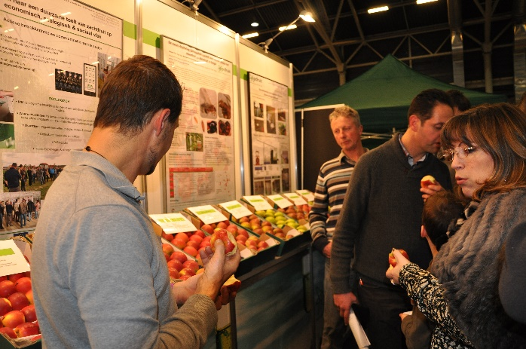 | 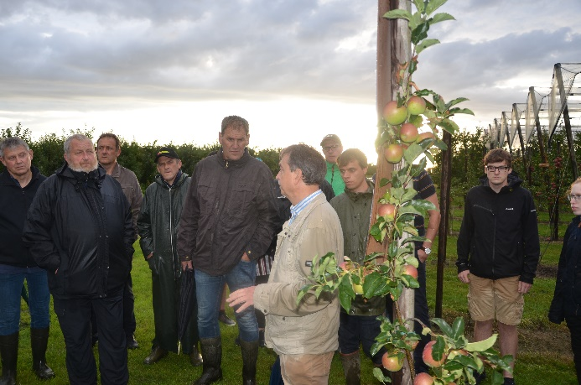
Dany Bylemans: “We have set up this Operational Group to develop a process that will help fruit growers to evaluate which varieties to plant according to customer preference.”

Operational Groups
- 98 rural development programmes (27 member states) provide support to EIP Operational Groups
- Over 3200 Operational Groups are expected to be established under the approved RDPs (2014 – 2020)
- 934 Operational Groups projects have been selected for funding and are currently ongoing (or already finished)*

* Information officially submitted to the European Commission by RDP managing authorities on 27 March 2019

EIP-AGRI Operational Groups are groups of people who work together in an innovation project funded by Rural Development Programmes (RDPs). They bring together partners with complementary knowledge. The composition of the group can vary according to the theme and specific objectives of each project. Farmers, advisers, scientists, businesses or other relevant partners work together to find practical solutions for specific problems facing people in the European farming and forestry sectors. Farmers and foresters need to be closely involved throughout the project to ensure that the innovative solutions are relevant and likely to be quickly applied in the field.
Find out more in the EIP-AGRI brochure on Operational Groups. The brochure on Operational Groups is available in English, Bulgarian, Czech, French, German, Greek, Hungarian, Portuguese, Romanian, Slovak, Slovenian and Spanish
Operational Groups can benefit from networking and collaborating with organisations from outside their partnership and from other regions and countries, such as other Operational Groups, research projects, farmers’ organisations or local authorities and European knowledge networks. Read the EIP-AGRI Brochure ‘Operational Groups – Collaborate to innovate’. It shows some examples of successful collaborations. It provides Operational Groups with inspiration and tools for further knowledge exchange within the EIP-AGRI network. This brochure is available in English, Latvian, Romanian and Slovenian.
Check out the 'Operational Groups' dedicated section on the EIP-AGRI website, including:
- detailed information on how to set up Operational Groups, on supporting networks and relevant EIP-AGRI seminars and workshops
- links to results and contact details of ongoing Operational Groups in the EIP-AGRI database
- a list of all RDP Managing Authorities

More information on Thematic Networks and Multi-actor projects
Thematic networks are multi-actor projects which collect existing knowledge and best practices on a given theme to make it available in easily understandable formats for end users such as farmers, foresters, advisers and others. 29 thematic networks are already ongoing.

Thematic Networks overview at EIP-AGRI website

Multi-actor projects are projects in which end users and multipliers of research results such as farmers and farmers’ groups, advisers, enterprises and others, are closely cooperating throughout the whole research project period.
The EU has allocated around one billion euros to fund around 180 multi-actor projects of interest to agriculture, forestry and rural development in the seven years of Horizon 2020 (2014-2020). Over 100 of these projects have already started.

Multi-actor projects overview at EIP-AGRI website

- EIP-AGRI Brochure on Funding opportunities under Horizon 2020 – Calls 2020 Calls (EN)
- EIP-AGRI Brochure on Horizon 2020 Multi-actor projects (EN – BG – DE – FR – SI)
- EIP-AGRI Brochure on Thematic Networks under Horizon 2020 (EN – BG – DE – ES – FR – HU)

EIP-AGRI
The European Innovation Partnership 'Agricultural Productivity and Sustainability' (EIP-AGRI) is one of five EIPs which have been launched by the European Commission in a bid to promote rapid modernisation of the sectors concerned, by stepping up innovation efforts. The EIP-AGRI aims to foster innovation in the agricultural and forestry sectors by bringing research and practice closer together – in research and innovation projects as well as via the EIP-AGRI network.
EIPs aim to streamline, simplify and better coordinate existing instruments and initiatives, and complement them with actions where necessary. Two specific funding sources are particularly important for the EIP-AGRI: the EU Research and Innovation framework, Horizon 2020, as well as the EU Rural Development Policy.

- EIP-AGRI Brochure on the EIP-AGRI Network (2015) (EN – BG – DE – ES – FR – GR – HU – IT – PT – RO)

Contact information
Ina Van Hoye
Communication officer
EIP-AGRI Service Point
ina.vanhoye@eip-agri.eu
+32 486 90 77 43

