Press article long article

Alternatives for expensive protein feed for laying hens

German farmer searches sustainable alternatives for imported protein feed

Sourcing the protein components of animal feed is expensive and farmers often have to rely on imported oilcakes and soya. A number of European farmers are now searching for viable alternatives. German farmer Peter Probst, who runs an enterprise of organic eggs, and Prof. Knut Schmidtke, chairman of Organic Farming at the Dresden University of Applied Sciences (HTW Dresden), have started an Operational Group project to test and evaluate the impact of using clover in animal feed.

Peter Probst's farm has been organic since 2011. He owns over 100 ha of farmland in the German state of Saxony. As well as sheep, cows and horses, he has 1600 laying hens. Peter currently feeds his hens with pellets containing sesame seed meal for protein. He recently teamed up with the applied research and technology institute ZAFT at Dresden University. Knut Schmidtke suggested Peter to test red and white clover as a suitable replacement. He explains: “In previous experiments clover had shown to be a suitable nitrogen source in fertilising gardening plots, so we had the idea to also use it as a protein compound in the feed of non-ruminants such as laying hens.” Peter adds: “We needed to add clover into our crop rotation for non-ruminants because this is good farm practice in ecological farming. We chose to set up an Operational Group to cultivate the white and red clover and test it to increase the proportion of protein components in the feed produced in Germany and even on-farm.”

Peter continues: “We wanted to evaluate whether red and white clover pellets are easily digestible for the laying hens, and analyse the nutritional values. In doing so, we worked with a poultry expert and tried different mixes of feed with differently aged hens. Each time, we evaluated the feedstuffs regarding laying hen performance and egg quality, compared to the regular feed. This happened every 8 weeks in a group of 100 hens.”

The project has been running for over a year now and results have already proven useful for Peter. “We found out that white clover is indeed well-suited as a feed component. On the other hand, when 15% of red clover pellets are used in the feed this had a negative influence on egg production and egg quality. It may be that smaller proportions could work better. When it comes to the costs, there is not much difference compared to our normal protein components. Depending on the nutritional value and protein content, some mixtures we tested were slightly cheaper, others a bit more expensive.”

Peter will use the results in his daily work: “We have decided to start with using a proportion of 5% white clover pellets in the diet of the laying hens and we will gradually raise the percentage. For the older hens this means the feedstuff will be 0.01€ cheaper per kg. For the younger hens this actually makes the feedstuff 0.02€ more expensive per kg, because they contain a necessary additional 4% potato protein. However, a significant improvement in production rate was noticed and the feedstuff give the yolk a very attractive and even colour.”

Press article short article

Alternatives for expensive protein feed for laying hens

German farmer searches sustainable alternatives for imported protein feed

Sourcing the protein components of animal feed is expensive and farmers often have to rely on imported oilcakes and soya. German farmer Peter Probst has started an Operational Group project to test and evaluate the impact of using clover in animal feed as an alternative for imported soya.

Peter Probst's farm has been organic since 2011. He owns over 100 ha of farmland in the German state of Saxony and has 1600 laying hens. He recently teamed up with the applied research and technology institute ZAFT at the Dresden University of Applied Sciences (HTW Dresden). Peter: “We chose to set up an Operational Group to cultivate the white and red clover and test it in the animal feed to increase the proportion of protein components produced in Germany and even on-farm.”

The project has been running for over a year now and results have already proven useful for Peter. “We found out that white clover is indeed well-suited as a feed component. On the other hand, when 15% of red clover pellets are used in the feed this had a negative influence on egg production and egg quality. When it comes to the costs, there is not much difference. Depending on the nutritional value and protein content, some mixtures we tested were slightly cheaper, others a bit more expensive.”

For the younger hens this actually makes the feedstuff €0.02 more expensive per kg, because of a necessary additional 4% potato protein. However, a significant improvement in production rate was noticed and the feedstuff gives the yolk a very attractive and even colour”.

Background information

Project information
Company/ project: LandGut Naundorf GmbH
Website: https://www.landgutnaundorf.de/
Contact persons:
- Peter Probst - Landgut-naundorf@gmx.de and
- Prof. Knut Schmidtke knut.schmidtke@htw-dresden.de, https://www.htw-dresden.de/luc/forschung/forschungsgruppe-oekologischer-landbau.html
Factsheet Operational Group: database Freistaat Sachsen – EIP-AGRI website

Pictures
Pictures below are free for use.
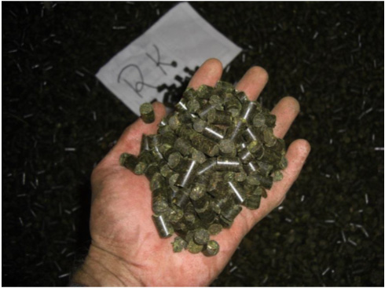 | 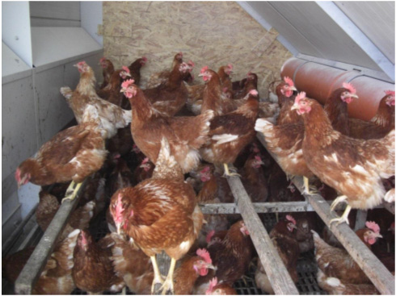
Pelleted red clover produced  Copyright: Simon Scheffler | Feeding of the hens with white clover

European Commission’s report on development of plant proteins in Europe
The European Commission is exploring how to harness the potential of EU protein plant production, responding to the needs of farmers, producers and consumers. By the end of 2018, the Commission intends to publish a report on the development of plant proteins in the European Union, which will examine the current supply and demand of plant proteins in the EU. The report will also map current initiatives, which support plant protein production at EU, national or regional level. Furthermore, it will identify market potential for plant protein produced in the EU, and assess factors that will help unlock this potential.

On 22 and 23 November 2018, the report is presented and discussed at a high-level conference organised in Vienna, Austria.

More information on Development of Plant Proteins in the European Union

More EIP-AGRI information on protein crops

- EIP-AGRI Factsheet on protein crops
- EIP-AGRI Brochure on competitive protein crops (available in EN – PT - EE)
- EIP-AGRI Focus Group on Protein crops
- EIP-AGRI workshop on Protein Crops

- 2016, International Year of Pulses, nutritious seeds for a sustainable future
- Interview with FAO’s Eleonara Dupouy on the International Year of Pulses

Horizon 2020 Thematic Networks on protein crops
- OK-Net Ecofeed (MAA) - Organic Knowledge Network on Monogastric Animal Feed: website - CORDIS (2017)
Thematic networks are multi-actor projects which collect existing knowledge and best practices on a given theme to make it available in easily understandable formats for end-users such as farmers, foresters, advisers etc. More information on www.eip-agri.eu

EIP-AGRI Inspiration from your country on protein crops
Here below you find a list of topics that have been covered in one of the EIP-AGRI events and / or EIP-AGRI publications.

Inspirational idea | Innovative technology for animal feed rich in protein | Bulgaria
Inspirational idea | Feeding pigs and poultry: tips for a 100% organic diet | Denmark, Netherlands, UK, Sweden, Austria, Germany, Finland, Switzerland, France and Lithuania
Inspirational idea | Producing protein feed and fuel from biomass (Agrinnovation 2016 - p.10) | Denmark
Press article | Growing protein crops to optimise livestock farms’ profits | France
Article, Agrinnovation magazine n°5 – p20 | Protein autonomy on the farm: exploring protein crop production for quality feed | France
Presentations at the EIP-AGRI workshop ‘'How to make protein crops profitable in the EU?' – November 2014 | LEGATO: LEGumes for the Agriculture of Tomorrow | EU
 | Pôle Agronomique Ouest | France
 | The yield gap to overcome: the French case | France
 | Building a market: from farm to end-users Food Opportunities | France/ EU
 | How to make protein crops profitable in the EU? The EU Feed Industry perspective | Hungary/ EU
 | Protein in Ireland | Ireland
 | Soy in the Netherlands | Netherlands
 | How to make protein crops profitable in the EU  EUROLEGUME Project contribution | Portugal/ EU
 | Breeding priorities | Spain
 | A view of the food sector | Spain
Presentation | Fava beans – UK farmers perspective | UK

Operational Groups on protein crops in your country?
At the end of October 2018, the EIP-AGRI Operational Groups database on the EIP-AGRI website included 38 Operational Groups in the EU working on protein crops:
- Belgium: 1
- Finland: 1
- France: 6
- Germany: 15
- Italy: 5
- Netherlands: 4
- Spain: 6

EIP-AGRI
The European Innovation Partnership 'Agricultural Productivity and Sustainability' (EIP-AGRI) is one of five EIPs which have been launched by the European Commission in a bid to promote rapid modernisation of the sectors concerned, by stepping up innovation efforts.
The EIP-AGRI aims to foster innovation in the agricultural and forestry sectors by bringing research and practice closer together – in research and innovation projects as well as via the EIP-AGRI network.
EIPs aim to streamline, simplify and better coordinate existing instruments and initiatives, and complement them with actions where necessary. Two specific funding sources are particularly important for the EIP-AGRI: the EU Research and Innovation framework, Horizon 2020, as well as the EU Rural Development Policy.
- EIP-AGRI Brochure on the EIP-AGRI Network (2015)
(EN – BG – FR – GR – HU – IT – PT – RO - SP)
- EIP-AGRI Brochure on Thematic Networks under Horizon 2020 (EN – BG – FR – HU – SP)
- EIP-AGRI Brochure Horizon 2020 multi-actor projects (EN – BG)
- EIP-AGRI Brochure on Funding opportunities under Horizon 2020 - 2018 Calls (EN)

EIP-AGRI Operational Groups
EIP-AGRI Operational Groups are groups of people who work together in an innovation project funded by Rural Development Programmes (RDPs). Operational Groups are the EIP-AGRI’s main tool for turning innovative ideas into real solutions for the field.
An Operational Group consists of several partners with a common interest in a specific, practical innovation project. The people involved in the Operational Group should bring in different types of practical and, where necessary, scientific expertise. They may include farmers, scientists, agri-business representatives and many others. Every country or region has the possibility to define specific national demands or restrictions on how to put together an Operational Group.
- Visit the Operational Groups page on the EIP-AGRI website
- EIP-AGRI Brochure on Operational Groups: Turning your idea into innovation (update 2016)
(EN – BG – CZ – FR - HU – PT – RO – SK – SP)

Contact information
Ina Van Hoye
Communication officer
EIP-AGRI Service Point
ina.vanhoye@eip-agri.eu
+32 486 90 77 43

