Press article long article

Preventing food loss on the farm

Irish potato company solving food waste challenges

Agriculture is at the centre of challenges associated with population growth, food security, climate change and resource scarcity. Inefficiencies in the agri-food chain can lead to reduced productivity and wasted energy, so the natural resources that are invested can become waste. Therefore, measures to prevent this food loss are important. The Irish Meade Potato Company is one of the companies that has come up with some interesting ideas to do so.

“From a business point of view, it makes sense to use every resource we have at our disposal. Growing and selling potatoes and vegetables, we are in a high volume, low margin business. This means that investment in more efficient production methods and recovery of by-products is crucial and that we have to take decisions from a sustainable point of view”, says Eleanor Meade. She is Business manager at the potato company. Since 1982 this family company has been running different product lines in potatoes, fruit, vegetables and salads. The company nowadays has a 1500 m2 packing facility and 5000 m2 of storage.

“The first steps to limit food waste are made as soon as the trucks come in, by doing a quality check. The boxes of fruit and vegetables are rarely rejected; instead they are sorted out” says Eleanor: “When the delivery boxes enter the facility floor, they aren’t left between the fridge and packing machine, but put into the right fridge. There are five specific fridges with different temperatures to match the needs of the different vegetables. The size of the packaging for the supermarkets changes during the season, to adapt to the crop and to consumer demand. We always say: if you know what the consumer wants, you can reduce your waste. Additionally, we negotiate with supermarkets to see whether they can adapt their standards to the reality of the vegetables received. Not only for potatoes, but for all the food that we deliver to them. This isn’t always easy, but an honest discussion is always better than trying to get around their requirements”.

“When it comes to potatoes, Meade is largely consumer-driven”, says field manager Connor O’Malley. “Our quality check results in 3 types of rejected potatoes. There are potatoes that are out of spec, too large or too small. However, we can still sell the small ones as baby potatoes, for which there is a huge demand. The potatoes that are too scathed are peeled and cooked and can afterwards be sold as prepared potatoes. Those peeled potatoes can be sold to the entire sales market, but also to catering companies. The leftovers go to feed for cattle. By sorting potatoes into these groups and finding the right market for them, we can really limit food loss”.

Some of the perfectly edible potatoes that are surplus or out of spec, are donated to charity. NGO Green accompanies them to enable this. “It also brings some challenges, because you need staff to organise it. But if you set yourself a commitment to zero-waste you must do it”, concludes Eleanor.

Press article short article

Preventing food loss on the farm

Irish potato company solving food waste challenges

Agriculture is at the centre of challenges associated with population growth, food security, climate change and resource scarcity. Inefficiencies in the agri-food chain can lead to reduced productivity and food loss. Therefore, measures to prevent food loss are important. The Irish Meade Potato Company is one of the companies that has come up with some interesting ideas to do so.

”From a business point of view, it makes sense to use every resource we have at our disposal. Growing and selling potatoes and vegetables, we are in a high volume, low margin business. This means that investment in more efficient production methods and by-products recovery is crucial and that we have to take decisions from a sustainable point of view”, says Eleanor Meade, Business manager at the potato company.

The first steps to limit food waste are made as soon as the trucks come in, by doing a quality check. “The boxes of fruit and vegetables are rarely rejected: instead they are sorted out”, says Eleanor. There are for example 3 types of rejected potatoes, those that are out of spec, too large or too small. By sorting them and finding the right market, we can really limit food loss.”

Some of the perfectly edible potatoes that are surplus or out of spec, are donated to charity. NGO Green accompanies them to enable this. “It also brings some challenges, because you need staff to organise it. But if you set yourself a commitment to zero-waste you must do it”, concludes Eleanor.

Background information

More information
Contact person: Jeni Meade: jenimeade@meadepotato.com

Pictures
Pictures below are free for use. Click on the picture to download the high resolution version

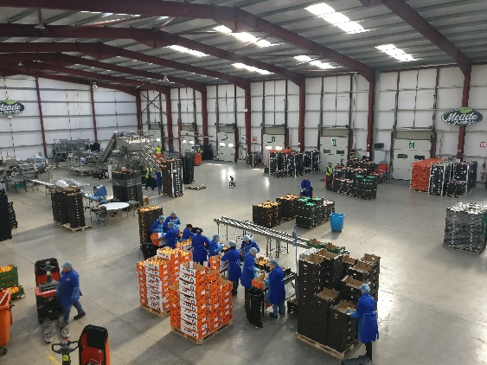 | 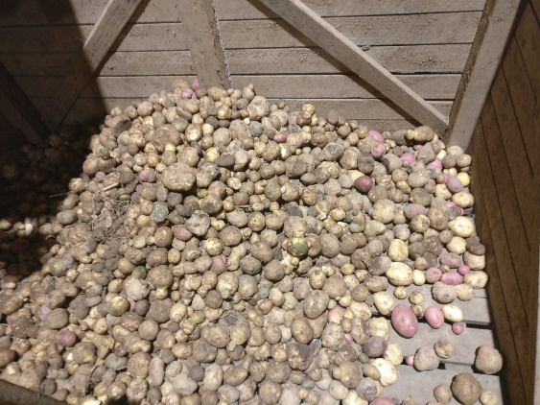
When the delivery boxes enter the facility floor, they aren’t left between the fridge and packing machine, but put into the right fridge with temperatures that match the needs of the vegetables. | Rejected potatoes from the conveyor belt are redirected for other use.

More information on reducing food loss on the farm

The EIP-AGRI Focus Group ‘Reducing food loss on the farm’ visited the Meade Potato Company during their first meeting in June 2018. The 20 experts will meet for a second time in January 2019 and continue to work on the minipapers and prepare to publish the Focus Group report later that year.

More EIP-AGRI topics related to reducing food loss

- EIP-AGRI factsheet circular economy (EN – FR – PT)
- EIP-AGRI Factsheet on Cities and Food (EN – FR)
- EIP-AGRI Factsheet Innovative Short Food Supply Chain Management (EN – FR)
- EIP-AGRI Workshop: Innovation in the supply chain: creating value together

Horizon 2020 Thematic Networks on reducing food loss on the farm
- EU FRUIT ^{(MAA)} - Fruit – cultivar development,minimising residues, storage and fruit quality, sustainability of production systems: website - CORDIS (2015)
- SKIN ^{(MAA)} Short supply chain Knowledge and Innovation Network: website - CORDIS (2016)
Thematic networks are multi-actor projects which collect existing knowledge and best practices on a given theme to make it available in easily understandable formats for end-users such as farmers, foresters, advisers etc. More information on www.eip-agri.eu

EIP-AGRI Inspiration from your country on reducing food loss on the farm and circular economy
Here below you find a list of topics that have been covered in one of the EIP-AGRI events and / or EIP-AGRI publications.

Belgium | Smart logistics to connect producers and consumers | Inspirational idea
Finland | Ordering local food through social networks | Inspirational idea
France | Turning waste into a resource | Inspirational idea
France | Mixed farming in the Aveyron river basin | Inspirational idea
Italy | Plant-based bioproducts to boost regional development | Agrinnovation magazine – n°2 – page 7
Netherlands | Concrete solutions for sustainability and animal welfare | Inspirational idea

EIP-AGRI
The European Innovation Partnership 'Agricultural Productivity and Sustainability' (EIP-AGRI) is one of five EIPs which have been launched by the European Commission in a bid to promote rapid modernisation of the sectors concerned, by stepping up innovation efforts.
The EIP-AGRI aims to foster innovation in the agricultural and forestry sectors by bringing research and practice closer together – in research and innovation projects as well as via the EIP-AGRI network.
EIPs aim to streamline, simplify and better coordinate existing instruments and initiatives, and complement them with actions where necessary. Two specific funding sources are particularly important for the EIP-AGRI: the EU Research and Innovation framework, Horizon 2020, as well as the EU Rural Development Policy.
- EIP-AGRI Brochure on the EIP-AGRI Network (2015)
(EN – BG – FR – GR – HU – IT – PT – RO - SP)
- EIP-AGRI Brochure on Thematic Networks under Horizon 2020 (EN – BG – FR – HU – SP)
- EIP-AGRI Brochure Horizon 2020 multi-actor projects (EN – BG)
- EIP-AGRI Brochure on Funding opportunities under Horizon 2020 - 2019 Calls (EN)

EIP-AGRI Operational Groups
EIP-AGRI Operational Groups are groups of people who work together in an innovation project funded by Rural Development Programmes (RDPs). Operational Groups are the EIP-AGRI’s main tool for turning innovative ideas into real solutions for the field.
An Operational Group consists of several partners with a common interest in a specific, practical innovation project. The people involved in the Operational Group should bring in different types of practical and, where necessary, scientific expertise. They may include farmers, scientists, agri-business representatives and many others. Every country or region has the possibility to define specific national demands or restrictions on how to put together an Operational Group.
- Visit the Operational Groups page on the EIP-AGRI website
- EIP-AGRI Brochure on Operational Groups: Turning your idea into innovation (update 2016)
(EN – BG – CZ – FR - HU – PT – RO – SK – SP)

Contact information
Ina Van Hoye
Communication officer
EIP-AGRI Service Point
ina.vanhoye@eip-agri.eu
+32 486 90 77 43

