Press article

Slovenia integrates advisors in its national Agricultural Knowledge and Innovation System

New CAP ensures stronger AKIS connections for more competent advisors
Advisors play a key role in well-functioning Agricultural Knowledge and Innovation Systems (AKIS), in which innovative solutions are co-created, widely shared and used by farmers, foresters, rural communities, researchers and other actors in the innovation ecosystem. In the Slovenian advisory service, trusted farm advisors successfully work with specialist advisors to maximise knowledge exchange and offer a broad and even more competent spectrum of advisory support.
In Slovenia, the agricultural advisory service is a public body under the Chamber of Agriculture and Forestry. With 315 advisors, it supports all types of farmers across the country with a broad range of advice. Slovenian advisory support is divided into three levels: trusted field advisors, specialist advisors, and coordinating advisors. By working together, they make the most of the knowledge that is available and help build more efficient knowledge and innovation flows.
Anton Jagodic, advisor at the Chamber of Agriculture and Forestry, explains: “Our field advisors have already built up a good relationship with the farmers. Trust is an excellent basis for knowledge exchange. The advisors give their clients tailored advice to support them in their daily on-farm tasks and farm development, including information on soil improvement, organic farming, pest management or agri-environmental measures.”
When the field advisors need more in-depth knowledge, they can call on specialist advisors who are well-connected to researchers, national CAP networks, experts from public services, and other advisors. These specialist advisors manage expert groups where researchers, relevant experts and other advisors meet. They also organise training for the field advisors and prepare educational materials for producers. Coordinating advisors bring together specialist advisors around a specific theme, such as vineyards, hops, organic farming, or Rural Development Programmes, to coordinate the advice on that theme.
The cooperation between advisors helps them cover a broad spectrum of knowledge, and strengthens their connections with farmers, rural communities and innovative projects. All Slovenian EIP-AGRI Operational Group projects must include an advisor, to bring partners together, help prepare and implement the project, promote project results and organise networking events with other Operational Groups to exchange knowledge.
The collaboration with specialist advisors does not exist in many countries yet, but it can be a great help to farmers in their decision making. “Our approach has proven its value”, Anton says. “To further improve our AKIS system, we are now working to strengthen and improve the ties with researchers and education programmes, and organise more and broader training and on-farm demonstration activities.
In the new Common Agricultural Policy (2023-2027), the role of advisors will receive more attention and become much broader. Advisors will need to offer tailored advice on economic, environmental and social dimensions, and stay updated on technological and scientific information to help foster innovation. EU Member States will actively need to support the competences of advisors and their connections with others in national Agricultural Knowledge and Innovation Systems. Member States can improve the opportunities for advisors to network, share knowledge, receive training, and work in synergy with farmers, researchers, CAP networks and other advisors, to upscale their competences, strengthen knowledge and innovation flows, and help make agriculture, forestry and rural areas smarter, more sustainable and more competitive.

Background information
Anton Jagodic presented the Slovenian advisory structure at the EIP-AGRI Seminar ‘CAP Strategic Plans: the key role of AKIS in Member States’.
Download the presentation or watch the presentation video

Contact information
- More information on the website of the Chamber of Agriculture and Forestry of Slovenia
- Contact: Anton Jagodic – anton.jagodic@kgzs.si

EIP-AGRI contact
Ina Van Hoye
Communication manager Support Facility ‘Innovation & Knowledge exchange | EIP-AGRI’
ina.vanhoye@eip-agri.eu
+32 486 90 77 43

Project photos
Click on the pictures to download the high resolution versions. The pictures are free for use, please mention the copyright.

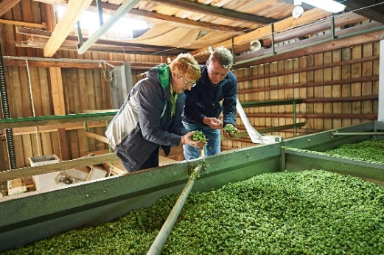 | 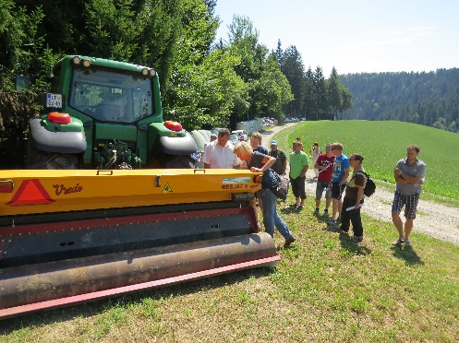
When field advisors need more in-depth knowledge, they can call on specialist advisors. Agricultural specialist advisor for hops, Irena Friskovec, advises a hops farmer, discussing the conditions for achieving the best quality when drying hops. © Chamber of Agriculture and Forestry of Slovenia | Slovenian advisors and farmers meet on Slovenian Technology Days. Anton Jagodic: “To further improve our AKIS system, we are now working to strengthen and improve the ties with researchers and education programmes, and organise more and broader training and on-farm demonstration activities.” © Chamber of Agriculture and Forestry of Slovenia
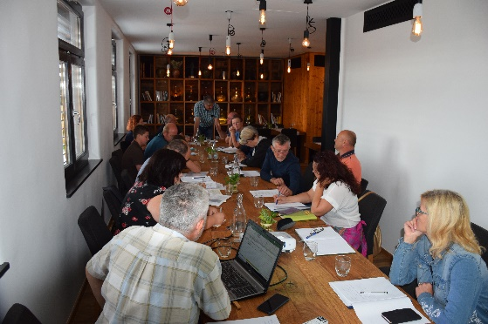
The cooperation between Slovenian advisors helps them cover a broad spectrum of knowledge, and strengthens their connections with farmers, rural communities and innovative projects. Here: Farmers and other partners in an EIP-AGRI Operational Group project meet. © Chamber of Agriculture and Forestry of Slovenia

More information on AKIS

The freshly published EIP-AGRI brochure ‘AKIS: Strengthening knowledge flows across Europe’ highlights key features and inspiring examples to help build a stronger AKIS.

Watch the EIP-AGRI animated video to see what AKIS stands for, and how it can help to tackle current and future challenges for farmers, foresters, rural communities and many others.


AKIS: building effective knowledge flows across Europe

EIP-AGRI activities

Previous EIP-AGRI networking activities on AKIS
- On 16-18 September 2020, the European Commission, Directorate-General for Agriculture and Rural Development, and the EIP-AGRI Service Point organised the online seminar 'CAP Strategic Plans: the key role of AKIS in Member States'. Find all presentations, videorecordings of the presentations and background information at the event webpage. The seminar included many examples of member states.
- EIP-AGRI Workshop “Enabling farmers for the digital age: the role of AKIS” – 26-27 April 2018
- EIP-AGRI Seminar “Promoting creativity and learning through agricultural knowledge systems and interactive innovation”- 3-4 December 2015

EIP-AGRI publications
- EIP-AGRI brochure on AKIS (2018).
- Final report of EIP-AGRI Seminar ‘Promoting creativity and learning through agricultural knowledge systems and interactive innovation’
- Final report of EIP-AGRI workshop “Enabling farmers for the digital age: the role of AKIS”

AKIS in the EIP-AGRI spotlight

- The AKIS webpage gives you access to important information, results from EIP-AGRI activities, publications, valuable resources and more.
- An EIP-AGRI Youtube channel playlist collects presentations from the EIP-AGRI seminar on CAP Strategic Plans
- The new EIP-AGRI brochure ‘AKIS: Strengthening knowledge flows across Europe’ highlights key features and inspiring examples to help build a stronger AKIS.

EIP-AGRI projects on AKIS
Operational Groups
- OG ECOPIONET (ES) fosters the implementation of organic farming through knowledge transfer, training, dedicated guidelines and more.
- OG ‘Gate of Innovations’ (LT) wants to stimulate the creation, implementation and dissemination of agricultural innovations on the chain “farms – advisory – research”
- AKIS & advisory support: OG RARES (FR) – Bringing together the different advisors for accompanying atypical rural and agricultural entrepreneurs in Burgundy, France
- OG ECOPRADERAS (ES): Knowledge transfer for improved management and sustainable productivity in irrigated meadows and other Extremadura pastures
- OG ‘Knowledge transfer and implementation of agroforestry systems in Austria’ (AT)
- OG ‘Mobile professor’ (BG) – Supporting knowledge transfer and innovation
- OG “All for the sheep” – web-based platform (BG)
- OG ‘Independent application of good agricultural practice on the farm – a virtual assistant to farmers’ (LT)
Horizon 2020 multi-actor projects
- EUREKA – European Knowledge repository for best agricultural practices: website – CORDIS (01/2020 – 12/2021)
- FAIRshare – Farm Advisory digital Innovation tools Realised and Shared: website – CORDIS (11/2018 – 10/2023)
- I2connect – Connecting advisors to boost interactive innovation in agriculture and forestry: website – CORDIS (11/2019 – 10/2024)
- AgriDemo-F2F - Building an interactive AgriDemo-Hub community: enhancing farmer to farmer learning: website – CORDIS

Horizon 2020 Thematic Networks
- 4D4F - Data Driven Dairy Decisions 4 Farmers: website - CORDIS (03/2016-02/2019)
- EURAKNOS – Connecting Thematic Networks as Knowledge Reservoirs: towards a European Agricultural Knowledge Innovation Open Source System: website – CORDIS (01/2019 – 12/2020)

The CAP of the Future
The reform of the Common Agricultural Policy (for 2023-2027) has been formally approved end November 2021. Find all information on the new CAP on the European Commission website.

Innovation & knowledge exchange | EIP-AGRI
The European Innovation Partnership 'Agricultural Productivity and Sustainability' (EIP-AGRI) has been launched in 2013 by the European Commission in a bid to promote rapid modernisation of the sectors concerned, by stepping up innovation efforts. The EIP-AGRI aims to foster innovation in the agricultural and forestry sectors and in rural areas by bringing research and practice closer together – in research and innovation projects as well as via the EIP-AGRI network. Also grassroots ideas from farmers get developed into innovations through the so-called Operational Group innovation projects. The EIP-AGRI aims to streamline, simplify and better coordinate existing instruments and initiatives, and complement them with actions where necessary. More information at the ‘About section’ of the EIP-AGRI website.

EIP-AGRI Operational Groups
- 98 Rural Development Programmes provide support to innovative EIP Operational Group projects *
- Over 3200 Operational Groups are planned to be established under the approved RDPs (2014 – 2020)
- More than 2200 Operational Groups projects have been selected for funding and are currently ongoing (or already finished)*. Member States will still start more Operational Group projects which may run until 2025 (under current transitional rules for EU rural development programmes). Find information on all of them in the EIP-AGRI database.

* Information officially submitted to the European Commission by RDP Managing Authorities (November 2020)

EIP-AGRI Operational Groups are groups of people who work together in an innovation project funded by Rural Development Programmes (RDPs). They bring together partners with complementary knowledge. The composition of the group will vary according to the theme and specific objectives of each project. Farmers, advisors, scientists, businesses or other relevant partners work together to find practical solutions for specific problems or opportunities for European farmers and foresters. Farmers and foresters need to cooperate throughout the project to ensure that the innovative solutions are practical and likely to be quickly applied in the field. Read the basic principles. Innovation support services (including advisors with a focus on innovation), and in particular innovation brokering, can therefore play a crucial role in getting worthwhile projects off the ground by facilitating contacts.

Check out the section on the EIP-AGRI website dedicated to 'Operational Groups', including:
- more than 2200 Operational Groups available in the database
- detailed information on how to set up Operational Groups, on supporting networks and relevant EIP-AGRI seminars and workshops
- links to results and contact details of ongoing Operational Groups in the EIP-AGRI database
- a list of all RDP Managing Authorities

EIP-AGRI videos
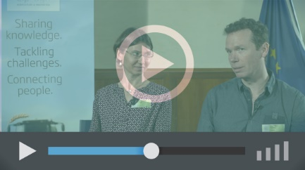 | 
Operational Groups – first experiences | Operational Groups – collaborate to innovate

 | 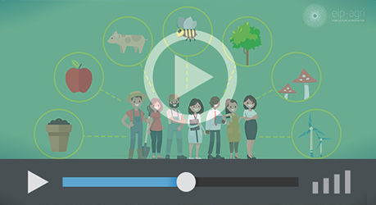
Innovation Support Services, supporting innovation in EU farming and forestry | EIP-AGRI Focus Groups, sharing knowledge to inspire innovation
EIP-AGRI, 7 years of innovation

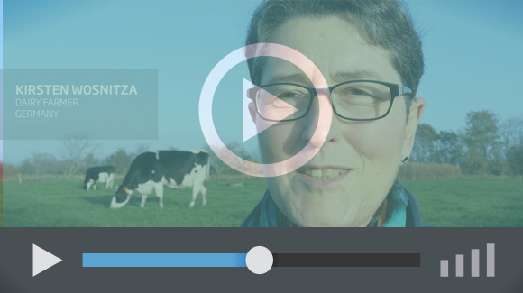 |  | The enthusiasm of the EIP-AGRI network members is essential to the success of the EIP-AGRI, and in ensuring that everyone can benefit. Watch this EIP-AGRI video to hear researchers, farmers, advisors, Managing Authorities and National Rural Networks explain how the EIP-AGRI has helped them over the past 7 years.
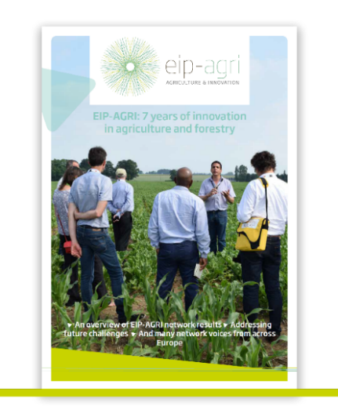 | Since 2013, the EIP-AGRI has been promoting interactive innovation to make EU agriculture and forestry more sustainable, productive, and fit for the future. This report shows how the EIP-AGRI network has grown into a thriving network. Read the report

