Press article

Farmers can tackle more challenges through EU-funded innovative projects

German Operational Group develops job opportunities for people with disabilities

In the past seven years, EIP-AGRI Operational Group projects have become a successful tool for turning innovative ideas into real solutions for European farmers and foresters. Based on the provisional agreement for the new Common Agricultural Policy (2023-2027), Operational Groups and other EU-funded innovative projects will be able to tackle an even broader range of challenges in agriculture, forestry and rural areas, including social innovation.
In the more than 2000 Operational Group projects that have started since 2014, farmers, foresters, researchers, businesses and other partners have worked together to unlock solutions to specific problems facing European agriculture and forestry. By sharing their results widely across Europe, Operational Group projects have helped to strengthen innovation and knowledge exchange under the Common Agricultural Policy (CAP), making the sector more sustainable and competitive.
The reformed CAP, which has provisionally been agreed on, is now set to bring fresh opportunities for EIP-AGRI Operational Groups and other innovative projects. Based on the current proposal, this new CAP (2023-2027) will have a wider scope, and will focus on supporting environmental, economic and social sustainability in agriculture, forestry and rural areas. It will also foster modernisation, digitalisation, knowledge sharing and innovation. A CAP that covers more topics will allow Operational Groups to tackle a wider range of challenges, covering all types of rural innovation. This includes themes such as protecting food and health quality, increasing farm competitiveness, preserving landscapes and biodiversity, rural areas, climate change, social innovation and more.
In the region of Saxony, Germany, Operational Group project ‘InnoLAWI’ has already explored rural challenges and social innovation. During its three years, the project has been developing job opportunities for people with disabilities in the agricultural sector. This means that inclusive employment is offered on seven pilot farms, to combine the best of both worlds – agriculture and social work.
“Agriculture offers a diverse field of activities, and is therefore very suitable for creating work opportunities on the farm”, says project coordinator Stephan Beetz. “For the farms that participated in the project, employing people with disabilities has helped them activate different fields of work, establish a social branch of the business, or explore options for farm succession. People with disabilities have welcomed farming jobs as an alternative to existing sheltered workshops. Working in a team has allowed them to develop new social skills in an atmosphere close to the primary labour market.”
The model farms received intensive support from Mittweida University of Applied Sciences and other partners, to help them create good job offers. Most of the work was integrated into the existing daily operations. Some farms made changes to their overall organisation. Stephan explains: “When necessary, the work places were adapted to the specific needs of people with disabilities. Some farms hired specialist staff, and three project managers passed an exam to become certified specialists in employment and professional development. The project gave rise to new cooperations between farms and social institutions.”
The Operational Group project has now ended, but Stephan sees new opportunities in the future: “We are still in close contact with the farmers and other partners in the Operational Group. At the moment we are looking for follow-up financing, to be able to solidify the project results and establish new and necessary advisory structures.”

Project information
- Project coordinator: Prof. Dr. phil. Stephan Beetz – beetz@hs-mittweida.de
- More information on InnoLAWI in the EIP-AGRI database, in the database of the German Rural Network, or on the InnoLAWI project website
- Watch the project video

EIP-AGRI contact
Ina Van Hoye
Communication manager Support Facility ‘Innovation & Knowledge exchange | EIP-AGRI’
ina.vanhoye@eip-agri.eu
+32 486 90 77 43

Project photos
Click on the pictures to download the high resolution versions. The pictures are free for use, please mention the copyright.

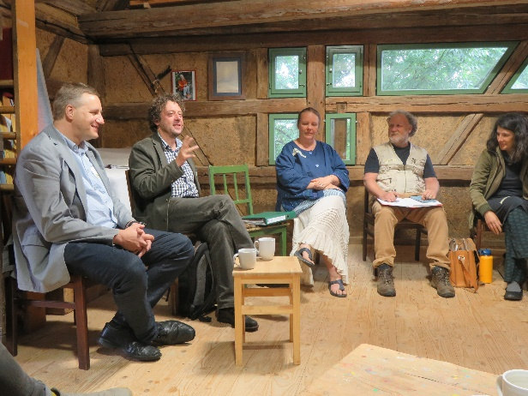 | 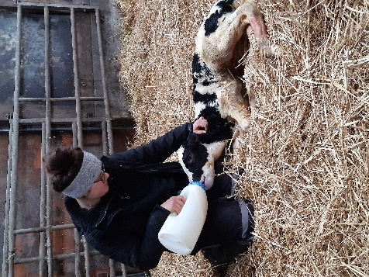
Operational Group project ‘InnoLAWI’ has developed on-farm job opportunities for people with disabilities. Coordinator Stephan Beetz: “The project gave rise to new cooperations between farms and social institutions.” © Melina Camilo | For the farms that participated in the project, employing people with disabilities has helped them activate different fields of work. © Annika Kokott
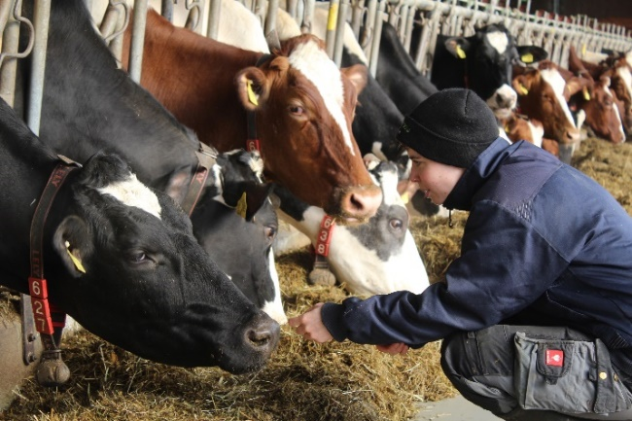 | 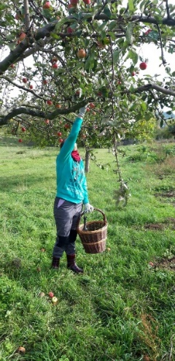
Coordinator Stephan Beetz: “Agriculture offers a diverse field of activities, and is therefore very suitable for creating work opportunities on the farm.” © Annika Kokott | Working in a team has allowed people with disabilities to develop new social skills in an atmosphere close to the primary labour market. © Uta Franke

EIP-AGRI projects on social innovation
Operational Groups

3 other Operational Groups working on social innovation are available in the EIP-AGRI Operational Groups database (update 25 October 2021)

- Added value of social farming for agricultural production - Germany
- Organic vegetables: Enabling regional cultivation, creating jobs for people with disabilities, shaping processing, developing sales - Germany
- GORTA; Innovation Operative Group for the recovery of Abandoned Lands – Spain

Other projects (available in the EIP-AGRI project database – update 25 October 2021)
- Desira: Digitisation: Economic and Social Impacts in Rural Areas – Horizon 2020 project
- SIMRA: social innovation in marginalized lands – Horizon 2020 project
- Urban agriculture for changing cities: governance models for better institutional capacities and social inclusion – EU Framework programmes

Inspirational ideas on social innovation
- Growing organic vegetables and jobs! – Germany

The CAP of the Future
The reform of the Common Agricultural Policy (for 2023-2027) has provisionally been agreed on. A formal approval is expected in autumn 2021. Find all information on the new CAP on the European Commission website.

Innovation & knowledge exchange | EIP-AGRI
The European Innovation Partnership 'Agricultural Productivity and Sustainability' (EIP-AGRI) has been launched in 2013 by the European Commission in a bid to promote rapid modernisation of the sectors concerned, by stepping up innovation efforts. The EIP-AGRI aims to foster innovation in the agricultural and forestry sectors and in rural areas by bringing research and practice closer together – in research and innovation projects as well as via the EIP-AGRI network. Also grassroots ideas from farmers get developed into innovations through the so-called Operational Group innovation projects. The EIP-AGRI aims to streamline, simplify and better coordinate existing instruments and initiatives, and complement them with actions where necessary.

EIP-AGRI Operational Groups
- 98 Rural Development Programmes provide support to innovative EIP Operational Group projects *
- Over 3200 Operational Groups are planned to be established under the approved RDPs (2014 – 2020)
- More than 2000 Operational Groups projects have been selected for funding and are currently ongoing (or already finished)*. Member States will still start more Operational Group projects which may run until 2025 (under current transitional rules for EU rural development programmes). Find information on all of them in the EIP-AGRI database.

* Information officially submitted to the European Commission by RDP Managing Authorities (November 2020) EIP-AGRI Operational Groups are groups of people who work together in an innovation project funded by Rural Development Programmes (RDPs). They bring together partners with complementary knowledge. The composition of the group will vary according to the theme and specific objectives of each project. Farmers, advisers, scientists, businesses or other relevant partners work together to find practical solutions for specific problems or opportunities for European farmers and foresters. Farmers and foresters need to be cooperating throughout the project to ensure that the innovative solutions are practical and likely to be quickly applied in the field. Read the basic principles. Innovation support services (including advisers with a focus on innovation), and in particular innovation brokering, can therefore play a crucial role in getting worthwhile projects off the ground by facilitating contacts.

Check out the section on the EIP-AGRI website dedicated to 'Operational Groups', including:
- more than 2000 Operational Groups available in the database
- detailed information on how to set up Operational Groups, on supporting networks and relevant EIP-AGRI seminars and workshops
- links to results and contact details of ongoing Operational Groups in the EIP-AGRI database
- a list of all RDP Managing Authorities

EIP-AGRI videos
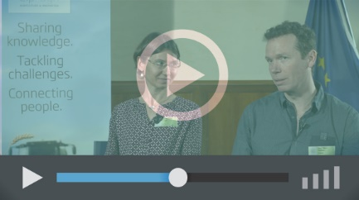 | 
Operational Groups – first experiences | Operational Groups – collaborate to innovate
 | 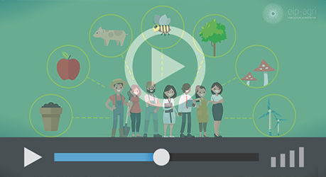
Innovation Support Services, supporting innovation in EU farming and forestry | EIP-AGRI Focus Groups, sharing knowledge to inspire innovation

AKIS: building effective knowledge flows across Europe
EIP-AGRI, 7 years of innovation

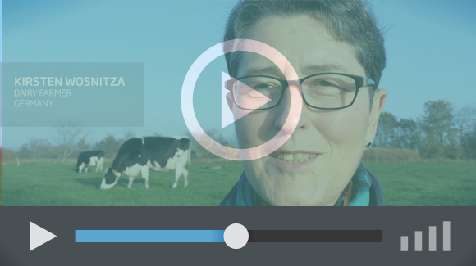 |  | The enthusiasm of the EIP-AGRI network members is essential to the success of the EIP-AGRI, and in ensuring that everyone can benefit. Watch this EIP-AGRI video to hear researchers, farmers, advisers, Managing Authorities and National Rural Networks explain how the EIP-AGRI has helped them over the past 7 years.
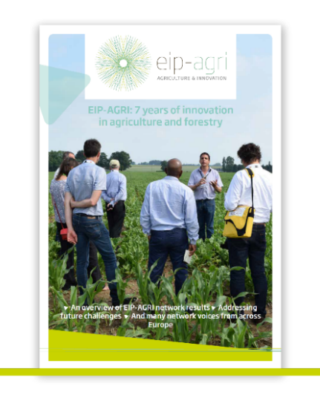 | Since 2013, the EIP-AGRI has been promoting interactive innovation to make EU agriculture and forestry more sustainable, productive, and fit for the future. This report shows how the EIP-AGRI network has grown into a thriving network. Read the report

