Press article 500words

Climate-friendly farms
A pioneering Swedish organic farm leads the way in fighting climate change

At Körslätts farm, an organic chicken farm located in Skåne, Sweden, farmer Magnus Bengtsson is committed to fighting climate change. “Managing weeds and pests with more climate-friendly methods is a challenge, but a rewarding one,” says Bengtsson. “All farming affects nature, so I think I should work with it, rather than against. By working with nature, I help to reduce greenhouse gas emissions, while bringing down economic costs at the same time.”

Bengtsson has been running Körslätts farm since 1998. This chicken farm has 90 hectares of forest and 130 hectares of fields, where Bengtsson grows crops mainly to feed to the chickens. The Körslätts farm is one of twelve organic farms involved in the European project SOLMACC. Co-funded by the EU LIFE programme, this project aims to show which farm practices can help fight climate change, while keeping farm operations economically viable. Participating farmers are applying a range of practices, such as optimised tillage and crop rotation, on-farm nutrient recycling and agroforestry.

Bengtsson is trying to find alternative, more climate-friendly solutions to challenges such as weed management. In the SOLMACC project, he has been reducing tillage, and growing cover crops. “As an organic farmer, I do not have chemical pesticides in my toolbox. This made it harder to decide not to plough, as ploughing helps with weed control,” says Bengtsson. He continues to explain: “Growing a good crop is the best form of weed control as the crop can shade out the weeds. Also, the less we move the soil, the less we activate the soil’s seed bank.” For the medium heavy clay soil, Bengtsson stopped ploughing in the autumn, favouring soil cultivation combined with a root cutting tool. He sows radishes to cover the field during the winter, catch nitrogen and let the roots prepare the soil for next spring. In the spring he uses the cultivator a second time, and then sows directly in the soil. “So far I seem to get about the same yields as when I was ploughing”, says Bengtsson. “I think that I save around 100€ [of fuel] per hectare not having to plough.”

Another method Bengtsson has used in the project is mixing trees and shrubs with arable crops and grazing animals in the same cultivation system. Agroforestry systems have great potential to sequester carbon and can also protect the soil from erosion and increase biodiversity. Bengtsson: “We planted hedgerows and tree strips to help capture carbon. I also use part of the woody biomass for heating, thereby replacing fossil fuel.”

The SOLMACC project will finish in late 2018. Predictions for the demonstrated practices in the SOLMACC project, like on Körslätts farm, are optimistic: they will positively impact the fighting of climate change, while being economically viable at the same time. Although Bengtsson cannot yet forecast the results, already now, he finds that there are more useful insects that buzz around the farm. Bengtsson: “Leading to more pollination, this simply feels good.”

Press article 250words

Climate-friendly farms
A pioneering Swedish organic farm leads the way in fighting climate change

At Körslätts farm, an organic chicken farm located in Skåne, Sweden, farmer Magnus Bengtsson is committed to fighting climate change. “Managing weeds and pests with more climate-friendly methods is a challenge, but a rewarding one,” says Bengtsson.

Bengtsson has been running Körslätts farm since 1998. This chicken farm has 90 hectares of forest and 130 hectares of fields, where Bengtsson grows crops mainly to feed to the chickens. The Körslätts farm is one of twelve organic farms involved in the European project SOLMACC. Co-funded by the EU LIFE programme, this project aims to show which farm practices can help fight climate change, while keeping farm operations economically viable.

In the SOLMACC project, Bengtsson has been reducing tillage, and growing cover crops. “Growing a good crop is the best form of weed control as the crop can shade out the weeds,” explains Bengtsson. “Also, the less we move the soil, the less we activate the soil’s seed bank.” For the medium heavy clay soil, Bengtsson stopped ploughing in the autumn, favouring soil cultivation combined with a root cutting tool. He sows radishes to cover the field during the winter, catch nitrogen and let the roots prepare the soil for next spring. In the spring he uses the cultivator a second time, and then sows directly in the soil. “So far I seem to get about the same yields as when I was ploughing”, says Bengtsson. “I think that I save around 100€ [of fuel] per hectare not having to plough.”

Background information

Pictures
Pictures below are free for use

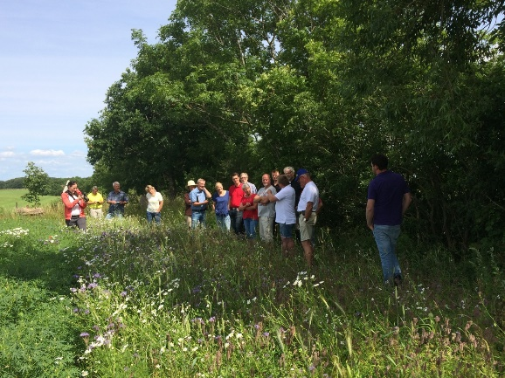 | 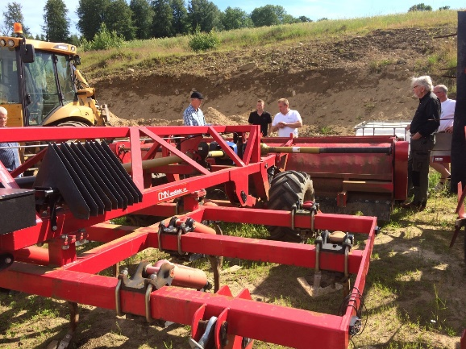
Biodiversity stripes at Körslätt stimulating pollination and avoiding leaching into the creek that runs along the SOLMACC field, where spring wheat is growing this year.  Copyright: Niels Andresen | Discussions about the role of machinery, when reducing tillage.  Copyright: Niels Andresen

Project information
SOLMACC, a LIFE-co-funded project: http://solmacc.eu/
Körslätts farm: http://www.korslatt.se/ (Swedish)

More information on organic farming & climate change
- EIP-AGRI Focus Group Organic farming - Optimising arable yields
- EIP-AGRI factsheet Organic Farming (EN – FR – PT)
- EIP-AGRI brochure Innovative solutions for organic farmers in the EU - Optimising arable yields (EN – PO – PT)

- EIP-AGRI workshop ‘Organic is Operational’
- Operational Groups represented at the EIP-AGRI workshop ‘Organic is Operational’
- EIP-AGRI brochure ‘Organic is Operational’

- EIP-AGRI Focus Group Agroforestry, introducing woody vegetation
- EIP-AGRI Factsheet Agroforestry

- EIP-AGRI Focus Group: carbon storage in arable farming

EIP-AGRI Inspiration from your country on organic farming & climate change
Here below you find a list of topics that have been covered in one of the EIP-AGRI events and / or EIP-AGRI publications.

Austria | Improving soil quality for a better yield | Brochure organic is operational -p4
EU | Agforward, Agroforestry for Europe | Video channel
EU, Germany | Complying with environmental regulations when spraying crops | Inspirational idea
EU, Denmark, Latvia, Sweden, UK | Perfumes for pests | Inspirational idea
EU, France | Dealing with pests from the air | Inspirational idea
EU | Cloud technology to safeguard integrity of the organic sector | Inspirational idea
EU, Austria | Winter harvest- supporting the development of organic winter growing | Inspirational idea
Croatia | Protecting plants against insects, naturally! | Inspirational idea
Finland | Waste not, want not (EN – PO – PT) | Brochure organic farming – p8
Finland | Improving forestry value chains in Finland | Inspirational idea
France | From great soil comes great food – a farmers’ story | Inspirational idea
France | Evolving with the grain (EN – PO – PT) | Brochure organic farming – p9
France | Decision support to manage fungal diseases of shallots | Brochure organic is operational -p6
France | Solutions for protein self-sufficiency | Brochure organic is operational -p5
Germany | A problem shared is a problem… solved (EN – PO – PT) | Brochure organic farming – p11
Germany | Catch cropping for improved soil fertility | Brochure organic is operational -p4
Italy | Producing organic spirulina using converted wastewater | Brochure organic is operational -p6
Netherlands | The right combination (EN – PO – PT) | Brochure organic farming – p10
Slovenia | An app to find out where our food comes from (EN – BU -CZ) | Inspirational idea
Spain | Local food networks inspiring people to take up organic farming | Inspirational idea
Spain | Finding new in the old, reviving former links between forest and agricultural land | Inspirational idea
Spain | Local food networks inspiring people to take up organic farming | Inspirational idea
Spain | Strength in numbers (EN – PO – PT) | Brochure organic farming – p10

EIP-AGRI
The European Innovation Partnership 'Agricultural Productivity and Sustainability' (EIP-AGRI) is one of five EIPs which have been launched by the European Commission in a bid to promote rapid modernisation of the sectors concerned, by stepping up innovation efforts.
The EIP-AGRI aims to foster innovation in the agricultural and forestry sectors by bringing research and practice closer together – in research and innovation projects as well as via the EIP-AGRI network.
EIPs aim to streamline, simplify and better coordinate existing instruments and initiatives, and complement them with actions where necessary. Two specific funding sources are particularly important for the EIP-AGRI: the EU Research and Innovation framework, Horizon 2020, as well as the EU Rural Development Policy.
- EIP-AGRI Brochure on the EIP-AGRI Network (2015) (EN – FR – GR – HU – IT – PT – RO - SP)
- EIP-AGRI Brochure on Funding opportunities under Horizon 2020 - 2018 Calls (EN)

EIP-AGRI Operational Groups
EIP-AGRI Operational Groups are groups of people who work together in an innovation project funded by Rural Development Programmes (RDPs). Operational Groups are the EIP-AGRI’s main tool for turning innovative ideas into real solutions for the field.
An Operational Group consists of several partners with a common interest in a specific, practical innovation project. The people involved in the Operational Group should bring in different types of practical and, where necessary, scientific expertise. They may include farmers, scientists, agri-business representatives and many others. Every country or region has the possibility to define specific national demands or restrictions on how to put together an Operational Group.
- Visit the Operational Groups page on the EIP-AGRI website
- EIP-AGRI Brochure on Operational Groups: Turning your idea into innovation (update 2016) (EN – CZ – FR - HU – PT – RO – SK – SP)

Contact information
Ina Van Hoye
Communication officer
EIP-AGRI Service Point
ina.vanhoye@eip-agri.eu
+32 486 90 77 43

