Press article 500words

UK farmers stepping in for climate change

Farmer Adam Twine developed a tool to increase farm profits while cutting carbon emissions

Adam Twine is a farmer in the UK who is concerned about climate change: “I discussed this issue with several other farmers, who were also convinced that we, as farmers, have a role to play in tackling climate change. We found that there was no farmer-led organisation to provide practical support for reducing farm greenhouse gas emissions. Nor a clear farmer-informed platform on the importance and urgency of tackling climate change.”

Exchanging and developing knowledge on climate change

So in 2009, Adam and several other farmers set up the Farm Carbon Cutting Toolkit (FCCT) to allow farmers to exchange and develop knowledge and to encourage the awareness of climate change within the UK’s farming community. “We looked for information that could help us adapt or change the way we farm to reduce greenhouse gas emissions while maintaining, or even improving farm profitability” explained Adam. This non-profit organisation is run by farmers and it depends on a lot of voluntary support.

On-farm meetings to involve researchers

The Farm Carbon Cutting Toolkit website provides a wealth of free information and practical tools. In addition, they organise on-farm meetings, where they invite researchers to help answer specific questions, such as why the results of the analyses of soil carbon content could vary so much, and how to obtain reliable results. “Getting researchers to meet with farmers, on a farm, has led to many valuable new insights, both for the farmers and for the researchers.”, Adam stated.

Steps for action: Measure & actions, improving existing systems and making changes

The toolkit provides clear steps to help farmers decide which actions to take. The user-friendly Farm Carbon Calculator can help farmers to pinpoint where their farms are producing emissions, and where they are contributing to carbon storage. And so the calculator helps to reduce the amount of the greenhouse gas carbon dioxide present in the air.
The toolkit states: “Improving the efficiency of what you're already doing will be the most straightforward action. It will also deliver immediate financial benefits to your business and a reduction in GHG emissions.” Finally, it provides a relevant and relatively straightforward list of priority actions such as soil management.

Stephen Goodwin – farmer engaged with FCCT, Northants, involved in the initiative said: "It’s been a great opportunity to take a step back from the business and look at it through fresh eyes, to look at where we could tweak management to get better efficiencies, improve our environmental credentials and save money."

Press article 250words

UK farmers stepping in for climate change

Farmer Adam Twine developed a tool to increase farm profits while cutting carbon emissions

Adam Twine is a farmer in the UK who is concerned about climate change: “I discussed this issue with several other farmers, who were also convinced that we, as farmers, have a role to play in tackling climate change. We found that there was no farmer-led organisation to provide practical support for reducing farm greenhouse gas emissions. Nor a clear farmer-informed platform on the importance and urgency of tackling climate change.”

So in 2009, Adam and several other farmers set up the Farm Carbon Cutting Toolkit (FCCT) to allow farmers to exchange and develop knowledge and to encourage the awareness of climate change within the UK’s farming community. www.farmcarbontoolkit.org.uk provides a wealth of free information and practical tools. In addition, they organise on-farm meetings, where they invite researchers to help answer specific questions, such as how to obtain reliable results. “This has led to many valuable new insights, both for the farmers and for the researchers.”, Adam stated.

The toolkit provides clear steps to help farmers decide which actions to take, such as the user-friendly Farm Carbon Calculator.

Stephen Goodwin, one of the farmers engaged with FCCT, said "It’s been a great opportunity to take a step back from the business and look at it through fresh eyes, to look at where we could tweak management to get better efficiencies, improve our environmental credentials and save money."

More information
Adam Twine was one of the 16 farmers who highlighted success stories to demonstrate the changes that take place in approaches to knowledge transfer, learning and innovation in the agricultural, forestry and rural development sectors. These stories were presented at the EIP-AGRI Seminar: ‘Promoting creativity and learning through agricultural knowledge systems and interactive innovation’.

More success stories on knowledge exchange were discussed on:
- Farmer-to-farmer knowledge exchange
  - Innov’Action (France)
  - Farmer Story (France)
- Social media for farmers
  - #AgriChatUK (United Kingdom)
  - Agraari / Kaytannon Maamies (Finland)
- Farmer-led interactive innovation and learning
  - Field Laboratories (United Kingdom)
  - Stable Schools (Germany)
- Innovative agricultural media
  - VILT (Belgium)
  - Farmer Story (Germany)
- Better farm performance through bench-marking
  - Benchmarking in Farmer Discussion Groups (Finland)
  - Farmer Story (Ireland)
- Knowledge networking
  - WINETWORK (EU-wide)
  - Farm Carbon Cutting Toolkit (United Kingdom)
- Thinking out of the box
  - Farmer Story (Belgium)
  - Farmer Story (Austria)
- Pooling resources and knowledge for future farming
  - Farmer story (Germany)
  - Farmer story (The Netherlands)

Download the success stories pdf (including links to the powerpoints, speakers,…)

Images
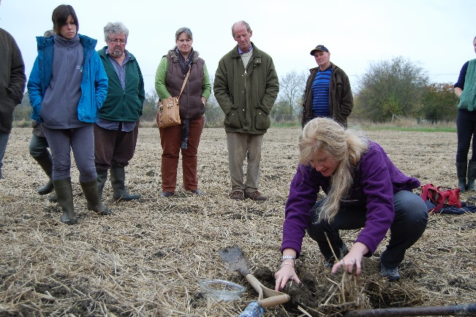

Download the high resolution image
Credits: www.farmcarbontoolkit.org.uk

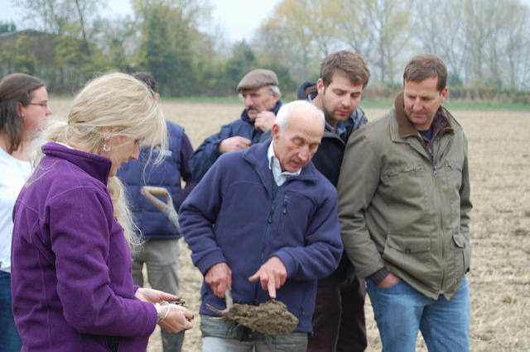

Download the high resolution image
Credits: www.farmcarbontoolkit.org.uk

Background information

EIP-AGRI
The European Innovation Partnership 'Agricultural Productivity and Sustainability' (EIP-AGRI) is one of five EIPs which have been launched by the European Commission in a bid to promote rapid modernisation of the sectors concerned, by stepping up innovation efforts. The EIP-AGRI aims to foster innovation in the agricultural and forestry sectors by bringing research and practice closer together – in research and innovation projects as well as via the EIP-AGRI network.
EIPs aim to streamline, simplify and better coordinate existing instruments and initiatives and complement them with actions where necessary. Two specific funding sources are particularly important for the EIP-AGRI: the EU Research and Innovation framework, Horizon 2020, as well as the EU Rural Development Policy.

Contact information

Ina Van Hoye
Communication officer
EIP-AGRI Service Point
ina.vanhoye@eip-agri.eu
+32 486 90 77 43

