Procurement Monitoring Report
In view of the Member States' reporting process
under the Directives 2014/23/EU, 2014/24/EU and 2014/25/EU

General information

Scope of reporting
The purpose of this report is to send a set of information about public procurement conducted in Romania between 1st of January 2017 and 31th of December 2017.

General information
The number of public procurement procedures initiated by publication of an contract notice (AP)/ call for offers (IP)/invitation to simplified procedure (APS), number of contracts awarded.

In 2017, the contracting authorities / entities initiated through the AP / APS – IP within the Electronic Public Procurement System (SEAP), a number of 28,165 public procurement procedures.
A number of 61,294 contracts were awarded from the total public procurement procedures initiated in 2017.

The number mentioned above is based on the information available and published by the contracting authorities/entities in SEAP in 2017, until 28th of February 2018.

NOTE:
The number of contracts awarded in 2017 is based only on the public procurement procedures initiated by an AP / APS-IP published in 2017.
The situation regarding the number of contracts awarded in 2017 was made available to our institution by the SEAP operator, based on the award notices published in the system until February 28th, 2018.
The information is based on the data available in SEAP, as were published by the contracting authorities / entities; the information has been made available to our institution by the Agency for the Digital Agenda of Romania – the operator of SEAP.
The accuracy of the data may be affected by the material errors araised at filling in / publishing of contract award notices by contracting authorities/entities in SEAP.

Information on monitoring and reporting bodies
We are analysing and elaborating the list of entities in charge of the report. We will forward the information in the next report.

Estimation of the aggregated total value of procurement which would have been covered by the directives if its value had exceeded the relevant thresholds

Estimation of the aggregated total value of procurement which would have been covered by the directives if its value had exceeded the relevant thresholds | In the national legislation, the public procurement procedures whose estimated value is lower than the thresholds for publication in OJEU are the ”Simplified Procedure” and the ”Call for offers” (provided by GEO no. 114/2011 on defence and security procurement).  The total estimated value of the national procedures – Simplified procedures and Calls for Tenders (below the threshold for publication in OJEU) in 2017 was € 3,230,452,129.13 (estimated value of the simplified procedures initiated in 2017 - € 3,205,423,919.84, the estimated value for calls for tenders initiated in 2017 - € 25,028,209.29).  NOTE:  The data were taken from the Electronic Public Procurement System (SEAP), as there were published by the contracting authorities / entities;  The information has been made available to our institution by the Agency for the Digital Agenda of Romania – the operator of SEAP.  The accuracy of the data may be affected by the material errors raised at filling in / publishing of information by contracting authorities/entities in SEAP.

Most frequent sources of wrong application or of legal uncertainty, including possible structural or recurring problems in the application of the rules

II.1. Qualitative reporting on application of public procurement rules
Main sources of wrong application or of legal uncertainty | In order to avoid duplication of information, we would like to inform you that relevant data for this section are transmitted by the responsible institutions to various European Commission (EC) departments through the following channels:  following channels:  According to the provisions of Regulation (EU, Euratom) No. 2012/966 of the European Parliament and of the Council of 25 October 2012 on financial rules applicable to the general budget of the European Union and repealing Regulation (EC, Euratom) 2002/1605 of the Council, The Audit Authority send to the European Commission, until 15th February of the next financial year, an annual summary of the final audit reports and of the controls carried out, including an analysis of the nature and occurrence of errors and system failures identified at the level of the management and control system set up for the management of European non-reimbursable funds, taken or planned.  The Anti-Fraud Department (DLAF) developed in cooperation with the national institutions involved and submitted Romania's contribution to the PIF Report for 2017 in COCOLAF, which contains the legislative, administrative, organizational and optional measures adopted at national level in the year reference for the protection of the financial interests of the European Union and the progress report on the recommendations made by the European Commission in the previous year.
Specific legal provisions (from EU or national law) which appear to raise significant problems of application | Taking in consideration the relatively reduced period for the application of the new legislative framework, we are in the process of identification of significant problems caused by specific legal provisions. In the next report, we will present the first categories of identified problems.
An assessment on whether a wrong application of rules might exist, by observing patterns of application of the rules which do not by themselves constitute cases of wrong application of the rules, but nonetheless point at structural or recurring problems yielding a sub-optimal outcome. | After finalizing the identification of the categories of significant problems, we will proceed to their evaluation and we will analyse the causes that led in certain situations to achieve results below those considered optimal. In the next report we will present the stage and possible results obtained in this respect.
II.2 Supporting documents
Please provide any available evidence of the issues identified under section II.1. | The concrete evidence for the problems which will be identified there will be transmitted simultaneously with those provided in Section II.1.
II.3. Quantitative indicators | This section contains quantitative indicators related to section II.1. Other indicators can also be included in the report.
Indicators about the national review system | Information and indicators on the national remedies system can be found at the following addresses:  http://www.cnsc.ro/wp-content/uploads/2018/raport/Raport.2017.RO.pdf
Histogram of values of procedures, covering also procedures below the thresholds | Histograms of estimated values of public procurement procedures initiated by contracting authorities / entities by publication of APS / IP ("national" procedures with values below the OJEU threshold) within SEAP, depending on the type of contract:  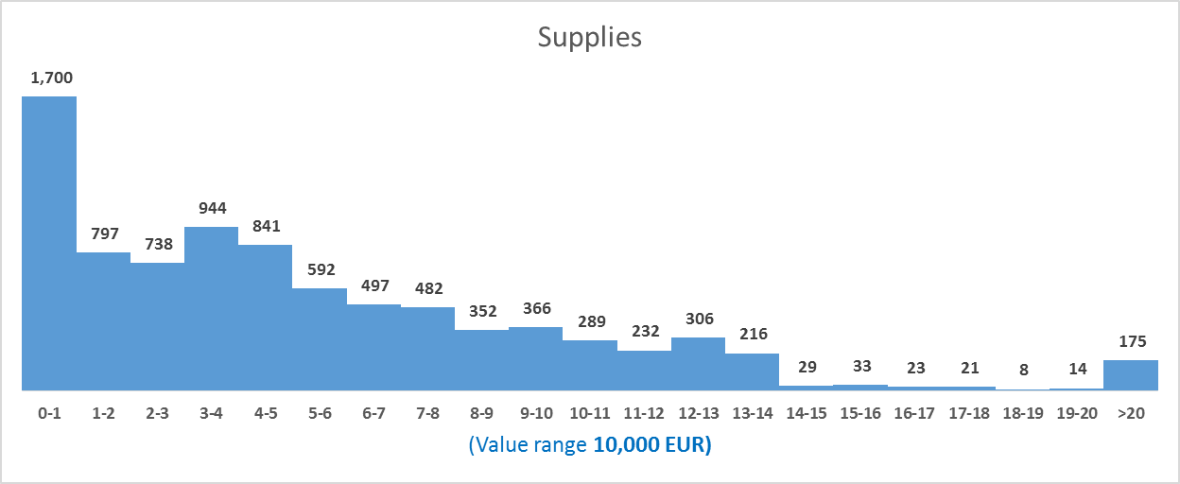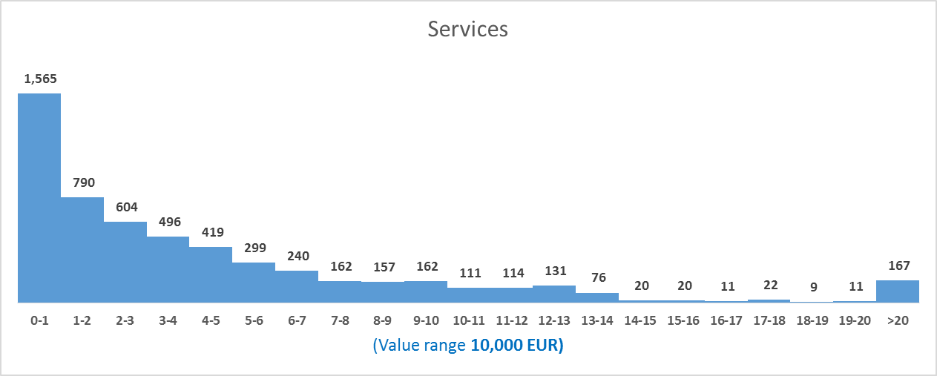  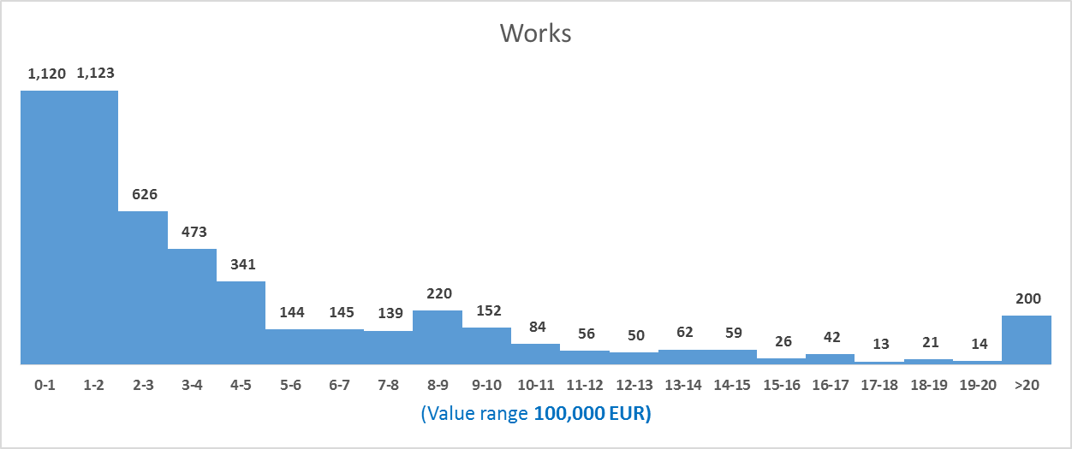  NOTE:  The histograms are based on the estimated value of the procedure available within the invitation to Simplified procedure / Invitations to tender published by the contracting authorities / entities in SEAP, between 01st of January and 31th of December 2017.  The value ranges for the reporting were EUR 10,000 for supplies / services contracts and EUR 100,000 for works contracts (it was chosen to change the interval for works contracts for an optimal distribution of the "national" public procurement procedures - whose estimated value is below the thresholds for publication of contract notices in the Official Journal of the European Union -OJEU).  Histograms of estimated values of public procurement procedures initiated by contracting authorities / entities by publication by AP (procedures with values above the OJEU threshold) within SEAP, depending on the type of contract:  The scale used for delimiting the value ranges is € 100,000 on each type of contract.  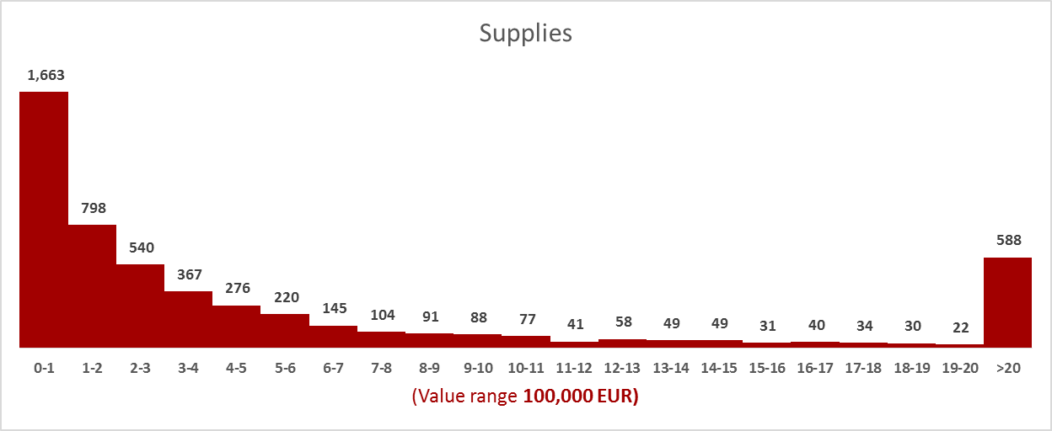  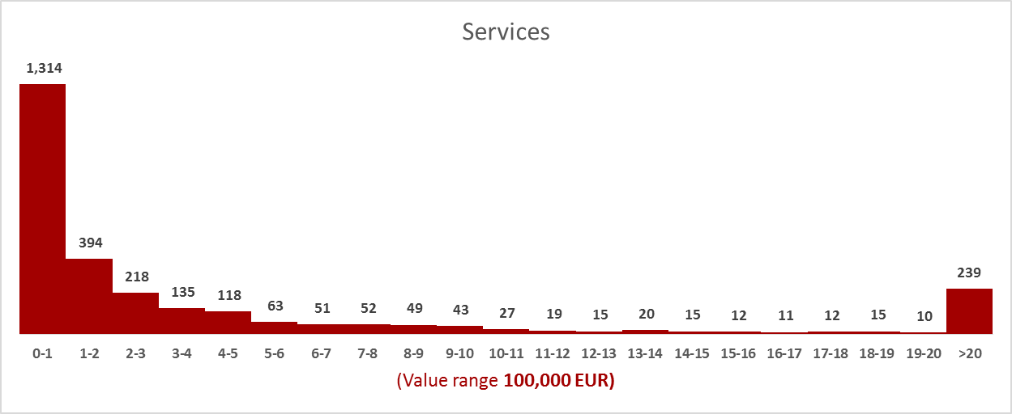  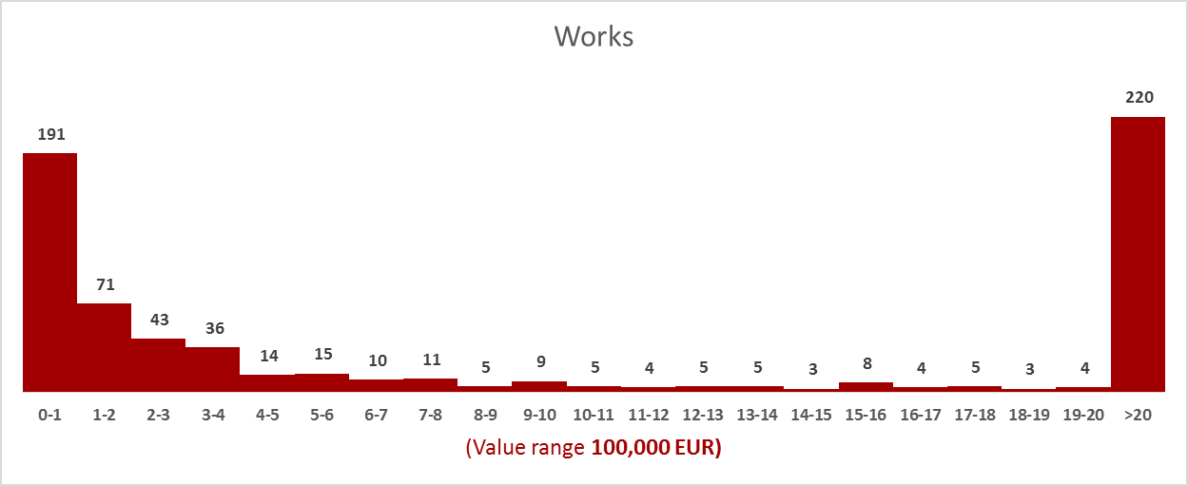

Prevention, detection and adequate reporting of cases of procurement fraud, corruption, conflict of interests and other serious irregularities

III.1. Qualitative reporting on fraud, corruption, conflict of interests etc.
Describe the actions undertaken and/or mechanisms put in place to ensure compliance with the new provisions on the prevention, detection and adequate reporting of public procurement irregularities including fraud and corruption | The information requested in this section is available through the following communication channels:  - http://www.consiliulconcurentei.ro/uploads/docs/items/bucketI1/id11013/ghid_practici_anticoncurențiale_licitații.pdf;  - http://www.consiliulconcurenței.ro/uploads/docs/items/bucket12/id12037/ghid_consortii_final.pdf  - http://www.antifrauda.gov.ro/ro/despre noi/rapoarte/  - www.curtea deconturi.ro/AutoritateAudit.aspx
Describe the actions undertaken and/or mechanisms put in place to ensure compliance with the new provisions on the prevention, detection and adequate reporting of conflicts of interests | The information requested in this section is available through the following communication channels:  https://www.integritate.eu/prevent.aspx

III.2. Supporting documents
Please provide any available evidence on the actions/mechanisms and measures described under section III.1. above demonstrating compliance with the new provisions on the prevention, detection and adequate reporting of public procurement irregularities and conflicts of interests | The information required in this section is available at the communication channels specified in section III.1

III.3. Quantitative indicators
Statistical distribution of buyers by frequency of actual competition | In 2017 a number of 2,685 contracting authorities / entities had initiated and awarded 20,291 procedures, based on which 61,284 public procurement contracts were awarded.  In 2017, an average of 6 tenders were received for public procurement procedures completed by awarding a contract / framework agreement.  We mention that from the calculation of this indicator there have been eliminated the public procurement procedures initiated by the publication of the Simplified Participation notices/ call for offers because for these kind of procedures we have no data regarding the number of submitted offers.  For 10,271 contracts awarded in 2017 the contracting authorities / entities received only one tender.  NOTE:  The total number of contracts awarded in 2017 is related to public procurement procedures by initiated by contracting authorities / entities by publication of AP / APS-IP in SEAP in 2017;  The situation regarding the number of contracts awarded in 2017 has been made available to our institution by the SEAP operator, based on the award contract notices published in the system until 28th of February 2018.  We mention that for calculating the number of the awarded contracts for which it was received a single bid, there have been eliminated the simplified procedures initiated by publication of an invitation, because for this kind of procedure we have no data regarding the number of submitted offers.  The data were taken from the Electronic Public Procurement System (SEAP), as there were published by the contracting authorities / entities;  The information has been made available to our institution by the Agency for the Digital Agenda of Romania – the operator of SEAP.  The accuracy of the data may be affected by the material errors araised at filling in / publishing of information by contracting authorities/entities in SEAP.  The indicator was NOT calculated for each contracting authority.
Statistical distribution of buyers by frequency of using a negotiated procedure without the prior publication of a call of competition | A number of 28,165 procurement procedures had been initiated by the contracting authorities/entities in 2017, by publication of the AP / APS-IP in SEAP and a number of 3,335 awarding contract notices have been published for Negotiations without prior publication.  From the total number of 28,165 procedures initiated in 2017, a number of 16,956 procedures have been finalized by awarding contracts in the same year.  From the total number of procedures awarded in 2017 (16,956 + 3335), NFPP represents 16.44%.  NOTE:  The situation regarding the number of contracts awarded in 2017 has been made available to our institution by the SEAP operator, based on the award contract notices published in the system until 28th of February 2018.  The data were taken from the Electronic Public Procurement System (SEAP), as there were published by the contracting authorities / entities;  The information has been made available to our institution by the Agency for the Digital Agenda of Romania – the operator of SEAP.  The accuracy of the data may be affected by the material errors araised at filling in / publishing of information by contracting authorities/entities in SEA  The indicator was calculated at the level of the national public procurement system.
Quantitative assessment of collusion risks | Information on this section is available at: http://www.consiliulconcurentei.ro/ro/publicatii/rapoarte-anuale.html
Risk of undiscovered conflict of interest | Information on this section is available at: https://www.integritate.eu/prevent.aspx

Level of SMEs' participation in public procurement

SMEs are defined in the Commission Recommendation (2003/361/EC) as having less than 250 persons employed and an annual turnover of up to EUR 50 million or a balance sheet total of no more than EUR 43 million. Further information is available at
http://ec.europa.eu/growth/smes/business-friendly-environment/sme-definition_en.

IV.1. Qualitative reporting on SME participation
Key challenges encountered | In order to provide the requested information, we are preparing the infrastructure necessary for collecting and processing data for filling the report.

IV.2. Supporting documents

Please report any available evidence or supporting document for point IV.1, illustrating the measures, achievements or challenges faced, relating to the facilitation of the participation of SMEs in public procurement

IV.3. Quantitative indicators

Please provide, when available, any quantitative data (statistics, etc.) illustrating the achievements and challenges identified under section IV.1. above

Information on the practical implementation of national strategic procurement

V.1 Green procurement ('GPP') | In order to provide the requested information, we are preparing the infrastructure necessary for collecting and processing data for filling the report.

V.1.1 Qualitative reporting
Key challenges encountered

V.1.2. Supporting documents

Please report any available evidence or supporting document for point V.1, illustrating the measures, achievements or challenges faced, relating to the promotion of green public procurement.

V.1.3. Quantitative indicators
Please provide, when available, any quantitative data (statistics, etc.) illustrating the achievements and challenges identified under section V.1.1 above. To the extent possible, these indicators should be further grouped by type of legal problem.
V.2 Socially responsible public procurement ('SRPP') | In order to provide the requested information, we are preparing the infrastructure necessary for collecting and processing data for filling the report.

V.2.1 Qualitative reporting

Key challenges encountered
V.2.2. Supporting documents
Please report any available evidence or supporting document for point V.2.1 illustrating the measures, achievements or challenges faced, relating to the promotion of SRPP.
V.2.3. Quantitative indicators
Please provide, when available, any quantitative data (statistics, etc.) illustrating the achievements and challenges identified under section V.2.1 above.
V.3 Public procurement of innovation | In order to provide the requested information, we are preparing the infrastructure necessary for collecting and processing data for filling the report.

V.3.1 Qualitative reporting
Key challenges encountered

V.3.2. Supporting documents

Please report any available evidence or supporting document illustrating the measures, achievements or challenges faced, relating to the promotion and implementation of innovation procurement.

Replicability

This section should provide information allowing anyone to fully replicate the quantitative results presented in the report.

Links to datasets used to prepare the report | www.e-licitatie.ro  When interested individuals or legal persons wants to copy the quantitative results presented in the report and they invoke other sources of information than those mentioned above (e.g.: www.data.gov.ro), they must ensure themselves that these do not contain material errors that can significantly change the results.
Files used to obtain the results from the datasets | Reports received by the National Procurement Agency (ANAP) from the Electronic Procurement System Operator (SEAP).

Annex I:
Methodology for estimating the value of procurement which would have been covered by the directives if its value had exceeded the relevant thresholds

The statistical information transmitted in this report was based on the data provided by the SEAP operator, such as it was submitted for publication by the contracting authorities / entities.

1. Classification and methodology

Indicate the basic characteristics of the methodology used by selecting from the options below. Description of the methodology is to be given in the subsequent section.

1.1. General approach:
[data available under national publication requirements]
- [sample-based estimates]
- [combined]
Please note that in our opinion using existing administrative data is preferable, as it implies both lower administrative burden (no additional data collection is necessary) and higher data quality.

If a sampling approach is taken, both the source of the sample and the sampling methodology, provided in the following subsection, must be able to withstand careful scrutiny. This ensures that the estimate is representative of the whole Member State.

1.2. Source of data:
Scope:  Source of data: | above national publication thresholds [] | below national publication thresholds []
[e-notification platforms]
[e-submission platforms]
[invoices]
[budgets]
[other]

2. Methodology description
Indicate, amongst others, information on the sources of data, approaches taken to deal with possible missing data and erroneous data, and representativeness of the sample used (if a sample-based approach was taken). If methodology is different depending on the thresholds or source of data, please clearly indicate this, including the relevant thresholds.

