Generic Metadata Model - OOTS
The generic metadata model provides the opportunity to exchange evidences in a light-weight manner. It has been designed specifically to facilitate the automated exchange of unstructured evidences or evidences exchanged on the basis of a national data model which is not aligned with one of the common data models for a specific evidence type. To steer the data exchange the Evidence Broker and the Data Service Directory are needed. Below first a graphical overview of the information that is stored in the Evidence Broker is shown and further explained in detail in the corresponding tab. The next overview picture shows how information that is stored in the Data Service Directory is connected with the evidences that are provided by the the Evidence Provider data services. Message specific information are included in the details of the tab, but not in the overview figure.
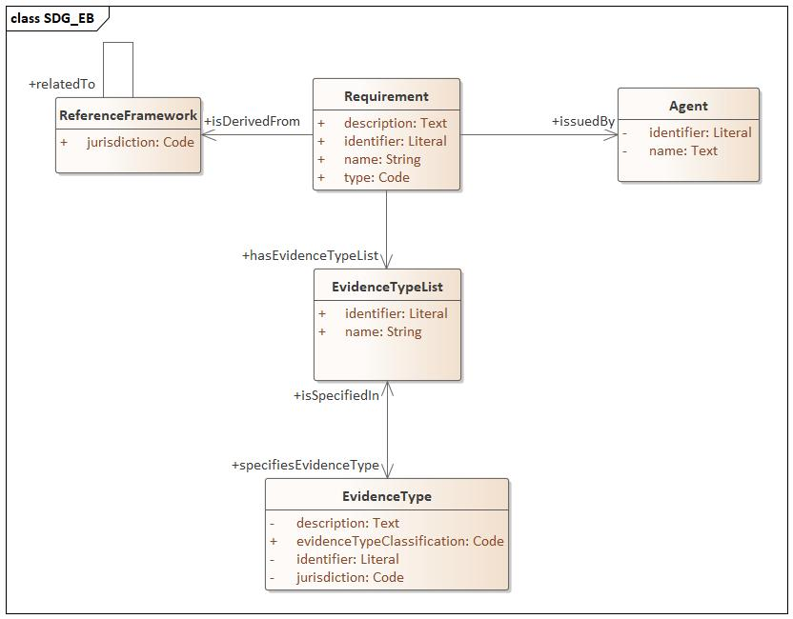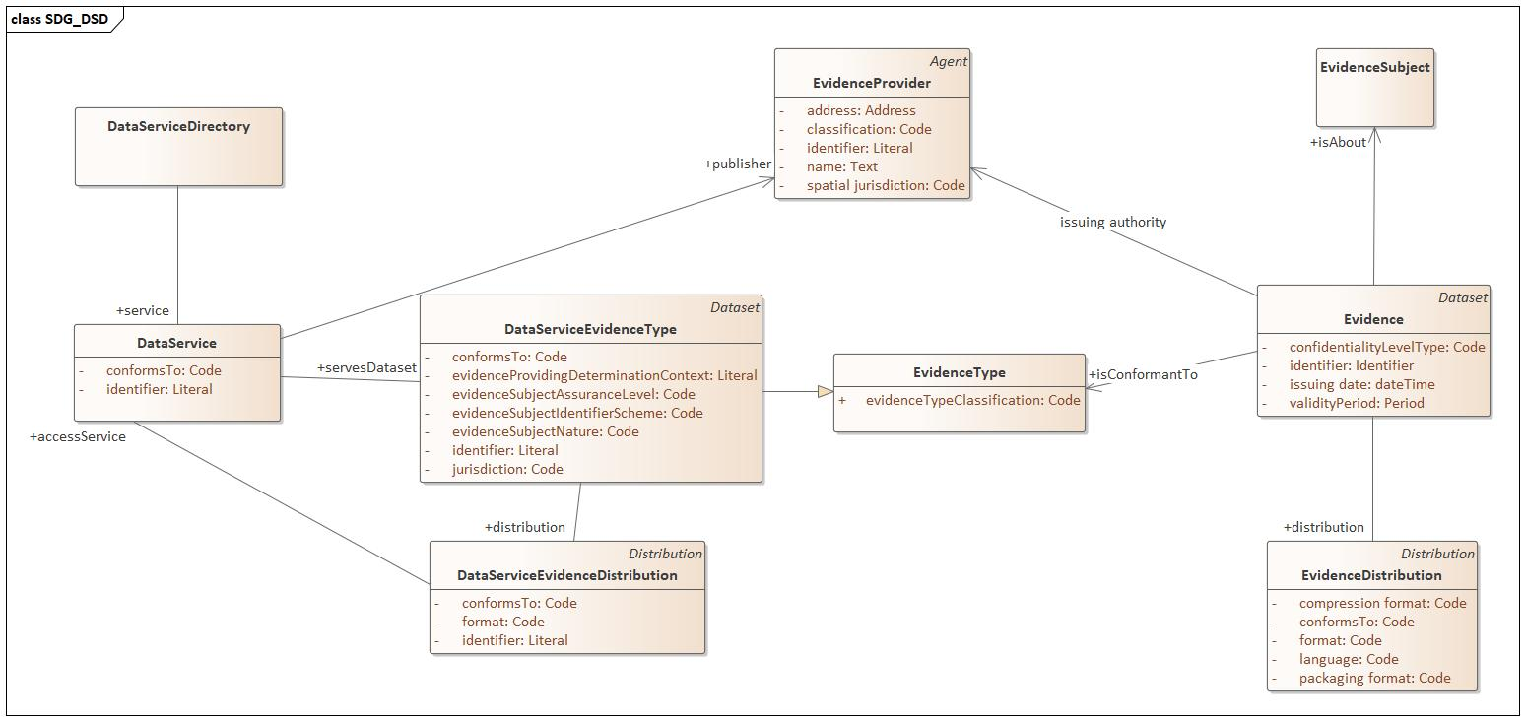

- Evidence Broker
The Evidence Broker (EB) is a service that publishes which types of evidence Member States can provide to prove a particular requirement of a procedure. The EB is an application profile of CCCEV, more specifically an application profile of the request (requirement) side of CCCEV.
The EB application profile is distinct from, yet connected with the application profile for the evidence request. Through the EB the evidence types that are needed for fulfilling a procedure can be found. Using these evidence types the Data Service Directory (DSD) can be queried to retrieve the data services where the evidences can be requested for the evidence subject.
Disclaimer
The Properties and Entities that are included in this application profile are sufficient to address the following base functionalities:
- to find the evidence types that are supplied and accepted by MSs, and
- to find a procedure and the evidence types they require.
Information that is required to create an operational register with coherent and qualitative data is not included, expect for the identifiers.
Ranges identified as a code reflect the following situation:
- the allowed values are subject to a controlled vocabulary
- the value representation is yet to be decided
- master data management for the controlled vocabulary has to be decided

Reference Framework
Correspondence: cv:ReferenceFramework
Definition: A source from where Requirements are identified and derived. In the EB restricted to the procedures and their instan at MS
Property | XML tag | URI | Range | Cardinality | Definition | Usage notes
identifier | Identifier | dct:identifier | Literal | 1..1 | An identifier | N/A
jurisdiction | Jurisdiction | sdg:jurisdiction | Code | 1..1 | the administrative level in which this reference framework applies
relatedTo | RelatedTo | dct:relation | Code | 0..1 | A relationship to a codelist denoting all procedures in the SDGR Annex II
title | Title | dct:title | Text | 0..1 | A name to identify in common language the reference framework
description | Description | dct:description | Text | 0..1 | A short explanation about the nature, attributes, uses or any other additional information that helps clarify the understanding of the Requirement being instantiated.

Requirement
Correspondence: cv:Requirement
Definition: A condition or prerequisite that someone requests and someone else has to meet.
In the context of the EB the intend is that requirements are SDG common requirements. MS express the EB registered procedures solely in terms of the SDG common requirements. The definition of these SDG common requirements are done in cocreation with all MSs.
The associated Evidence Type lists express the combinations of evidence types a MS can provide to fulfill the requirement. It is assumed that any associated evidence type lists provided by MS A can be accepted by all other MSs B. Any reason which would block the acceptance of an evidence type list by another MS must be addressed in coordination with the MSs.
Info
The core vocabulary CCCEV foresees more attributes and relationships for cv:Requirement. Those that are needed for the core functionality of the EB are included in this table.
Property | XML tag | URI | Range | Cardinality | Definition | Usage notes
identifier | Identifier | dct:identifier | Literal | 1..1 | An identifier
name | Name | skos:prefLabel | String | 0..1 | A name to identify in common language the Requirement.
description | Description | dct:description | Text | 0..1 | A short explanation about the nature, attributes, uses or any other additional information that helps clarify the understanding of the Requirement being instantiated.
issued by | IssuedBy | cv:issuedBy | Agent | 0..1 | The Agent that has issued the Requirement. | As the Requirements are commonly maintained, this will be the EU
has evidence type list | EvidenceTypeList | cv:hasEvidenceTypeList | Evidence Type List | 0..n | The single or various combinations of Evidence Types for supporting a Requirement. Out of the different Lists, one of them must be satisfied by the response to the Requirement. | The associated evidence type lists are MS specific.
is derived from | ReferenceFramework | cv:isDerivedFrom | ReferenceFramework | 0..n | The Reference Framework that is responsible for the creation/initiation of the Requirement.

Evidence Type
Correspondence: cv:EvidenceType
Definition: . Information about the characteristics of an expected Evidence
The Evidence Type is a kind of evidence that can be provided in a jurisdiction. It is expected that any evidence type present in the EB is further detailed in the DSD to enable automatic retrieval through the OOTS of the evidence.
Property | XML tag | URI | Range | Cardinality | Definition | Usage notes
identifier | Identifier | dct:identifier | Literal | 0..1 | An identifier
evidence type classification | EvidenceTypeClassification | cv:evidenceTypeClassification | Code | 1..1 | A classification code to specify the layout and content expected for an Evidence.
jurisdiction | Jurisdiction | cv:evidenceTypeJurisdiction | Code | 0..1 | The jurisdiction to which this evidence type applies

Evidence Type List
Correspondence: cv:EvidenceTypeList
Definition: A combination of Evidence Types for each of which a conforming Evidence must be provided.
Property | XML tag | URI | Range | Cardinality | Definition | Usage notes
identifier | Identifier | dct:identifier | Literal | 1..1 | An identifier
name | Name | skos:prefLabel | String | 0..1 | A name to identify in common language ement.
description | Description | dct:description | Text | 0..1 | A short explanation about the nature, attributes, uses or any other additional information that helps clarify the understanding of the Requirement being instantiated.
specifies Evidence Type | Evidence Type | cv:evidenceTypeList | Evidence Type | 1..n | Indicates one Type of Evidence included in a List of Evidence Types.

- Data Service Directory
The Data Service Directory (DSD) is a catalogue of evidence providing data services. The DSD has knowledge about the type of evidences the data service provides and its responsible organisation. The DSD is used in the Evidence Exchange process by the Evidence Requesters to discover the evidence providing data services that can provide the evidences they need. The DSD is a designed as an application profile of DCAT.
Disclaimer
The Properties and Entities that are included in this application profile are sufficient to address the following base functionalities:
- to find the evidence providing data services based on the kind of evidence they provide, as on the location of the evidence provider, and
- to configure a Document based query request in order to initiate the retrieval of evidences as documents, being structured or unstructured.
Information that is required to create an operational register with coherent and qualitative data is not included, expect for the identifiers.
Ranges identified as a code reflect the following situation:
- the allowed values are subject to a controlled vocabulary
- the value representation is yet to be decided
- master data management for the controlled vocabulary has to be decided

Data Service Directory
Correspondence: dcat:Catalog
Definition: A collection of evidences providing data services.
Property | URI | Range | Cardinality | Definition | Usage notes
service | dcat:service | DataService | 0..n | The evidence providing data services. | N/A

Data Service
Correspondence: dcat:DataService
Definition: An evidence providing data service.
Info
No connection or configuration information is required. The SDG OOP will use data service identifier to look up the connection details. When registering a data service into the SDG OOP network, the registered configuration is connected with the identifier of the data service description in the Data Service Directory.
Property | XML tag | URI | Range | Cardinality | Definition | Usage notes
identifier | Identifier | dct:identifier | Literal | 1..1 | An identifier | N/A
conforms to | ConformsTo | dct:conformsTo | Code | 0..1 | The exchange message specification which this service implements. (e.g. a codified value stating that it supports the SDG Regrep v4 profile). | N/A
serves evidence type | ServesEvidenceType | dcat:servesDataset | Dataset | 1..n | the evidence types that the data service is providing information about. | N/A
publisher | Publisher | dct:publisher | Evidence Provider | 1..1 | The responsible organisation for issuing evidences via this data service.

Data Service Evidence Type
Correspondence: dcat:Dataset
Definition: A dataset of an Evidence Type provided by an Evidence Provider.
Info
This dataset does not necessarily exist as a physical manifestation. It is a subclass of cccev:EvidenceType.
The responsible organisation, i.e. the Evidence provider, for a data service Evidence type is the publisher of the associated data services.
Any data Service Evidence Type is a further detailing of the corresponding Evidence Type in the EB.
Property | XML tag | URI | Range | Cardinality | Definition | Usage notes
identifier | Identifier | dct:identifier | Literal | 0..1 | An identifier
conforms to | ConformsTo | dct:conformsTo | Code | 1..1 | A registered schema or application profile in the semantic repository describing the content of the evidence provided.
evidence subject assurance level | EvidenceSubjectAssuranceLevel | sdg:evidenceSubjectAssuranceLevel | Code | 0..1 | The minimal level of assurance level properties must have in order to be taken into account for the subject record matching by this dataset. Corresponds to the eIDAS abilities.
evidence subject identifier scheme | EvidenceSubjectIdentifierScheme | sdg:evidenceSubjectIdentifierScheme | Code | 0..n | The indication of the identifier schemes are supported by the subject record matching.
evidence subject nature | EvidenceSubjectNature | sdg:evidenceSubjectNature | Code | 0..1 | The nature of the evidence subject that is taken into account. Corresponds to the eIDAS abilities.
distributed as | DistributedAs | dcat:distribution | Evidence Type Distribution | 1..n | The representations that are supported by the Evidence Type Dataset.
evidence provider determination context | EvidenceProviderDeterminationContext | sdg:evidenceProviderDeterminationContext | Literal | 0..1 | The information that is required to select the to be used Evidence Provider for this associated Evidence type | Example: "the place of birth" is expressing that the information that a SDG OOP user should use to determine the to-be used Evidence Provider is the evidence subject's place of birth.
evidence type classification | EvidenceTypeClassification | cv:evidenceTypeClassification | Code | 0..1 | The evidence type that this dataset is supporting.
jurisdiction | Jurisdiction | cv:evidenceTypeJurisdiction | Code | 0..1 | The jurisdiction to which this data service evidence type applies

Evidence Type Distribution
Correspondence: dcat:Distribution
Definition: A technical format according to which a evidence is being distributed.
Property | XML tag | URI | Range | Cardinality | Definition | Usage note
conforms to | ConformsTo | dct:conformsTo | URI | 0..1 | A registered schema or application profile in the semantic repository describing the content of the evidence provided in this representation. | This URI must come from the semantic repository.
format | Format | dct:format | Code | 1..1 | The technical representation of the evidence.
dataservice | Dataservice | dcat:accessService | DataService | 0..n | A detailing of the relationship serves evidence type (dcat:servesDataset). | It enables to express that for one Data Service Evidence Type, the data service A is providing the distribution XML and data service B is providing the distribution JSON.
transformation | Transformation | sdg:transformation | URI | 0..n | A transformation that can be applied to this distribution expressed in the form an executable language suited for the format of this distribution. | E.g. If the distribution format is XML, then XSLT is a suited language to express the transformation into.  This URI must come from the semantic repository.

Evidence Provider
Correspondence: foaf:Agent
Definition: A trusted provider of evidences. An Evidence provider is an organisation which either publishes an evidence providing data service or it is the issuing authority for the evidences that are retrievable via an evidence providing service.

Info
In the Data Service Directory only the Evidence Providers has have as role publisher of a data service are registered.
property | XML tag | uri | range | cardinality | definition | usage note
identifier | Identifier | dct:identifier | Literal | 0..1 | a unique identification for the agent
name | Name | foaf:name | Text | 0..1 | a short label for the agent
address | Address | locn:address | Address | 0..1 | An location of the Evidence Provider in the form of an address. | If the spatial jurisdiction cannot be supplied, the address can be supplied to facilitate the functional requirement for determining the Evidence Provider based in location information.
classification | Classification | org:classification | Code | 0..n | A classification of the Evidence Provider.
jurisdiction | Jurisdiction | cv:spatialJurisdiction | Code | 1..1 | The spatial juridisdiction of the Evidence Provider w.r.t. the evidence type it is supplying. | The code should reflect the most precise spatial description for the applicable jurisdiction in the used code list. E.g. if the jurisdiction is the city of Vienna, then the code for Vienna should be used and not the code for the country Austria.  It is assumed that the used codes are organised in a code list that can support the navigation and search functionalities required by the UI to determine the to-be used Evidence Provider quickly.

- Document Request Query
The application profile for the Evidence Request defines the semantic perspective for the Evidence Request Message (Evidence Request Syntax Mapping - SDG Once-Only Collaborative Space - CEF Digital (europa.eu)) . The Evidence Request is the message created by the Evidence Requester (ER), containing all the necessary information requirements for requesting evidences. The Evidence Request is based on the retrieved information from the Data Service Directory and contextual information.

Evidence Request
Correspondence: sdg:EvidenceRequest
Definition: A request for an evidence to the data service of an evidence provider.
request specific: included here to provide a complete semantical description of the information in the Evidence Request message.
Property | URI | Range | Cardinality | Definition | Usage notes
specification | sdg:specification | Code | 1..1 | The specification version according to which this request message is constructed. | For now, the value "oots-edm:v2.1" must be used.
issue date | dct:issued | Literal | 1..1 | The time of the request. | The value must be according to xsd:dateTime.

Evidence Requester
Correspondence: foaf:Agent
Definition: The agent that is requesting the evidence.
request specific: included here to provide a complete semantical description of the information in the Evidence Request message.

property | XML tag | uri | range | cardinality | definition | usage note
identifier | Identifier | dct:identifier | Literal | 0..1 | a unique identification for the agent
name | Name | foaf:name | Text | 0..1 | a short label for the agent
address | Address | locn:address | Address | 0..1 | An location of the Evidence Requester in the form of an address.
location | Location | locn:location | Location | 0..1 | The location of the Evidence Requester from where the Evidence Requester is operating.

Requirement
Correspondence: cv:Requirement
Definition: A requirement is a named set of requests for information that may be made for making a judgment or decision, see draft implementing act.
Info
The requirement in the Evidence Request is contextual information that can be used to perform legal logging. It is not (yet) expected to be required to determine the evidence for the evidence subject.
The value is obtained by the Evidence Requester from the Evidence Broker while executing a SDG service.
Property | XML tag | URI | Range | Cardinality | Definition | Usage notes
identifier | Identifier | dct:identifier | Literal | 1..1 | The identifier for the requirement.
name | Name | skos:prefLabel | Text | 0..1 | A name to identify in common language the Requirement.
description | Description | dct:description | Text | 0..1 | A short explanation about the nature, attributes, uses or any other additional information that helps clarify the understanding of the Requirement being instantiated.

Evidence Type
Correspondence: sdg:DataServiceEvidenceType
Definition: The characteristics about the expected Evidence. Only the registered evidence types in the Data Service Directory are considered.
Property | XML tag | URI | Range | Cardinality | Definition | Usage notes
identifier | Identifier | dct:identifier | Literal | 1..1 | The identifier of the Data Service Evidence Type | It is assumed that every data service implementation is aware of the identifiers that were used to describe the data service in the Data Service Directory.
distribution | Distribution | dcat:distribution | Distribution | 1..n | The kind of distributions that are expected as response to this request. | Each distribution describes a format and scheme in which the evidence about the data subject should be provided. The allowed combinations are one of the combinations expressed in the Data Service Directory. So only distributions can be requested that the data service is able to provide.

Evidence Subject
Correspondence: foaf:Agent
Definition: The subject from whom the evidence is requested to the Data Service.
Info
For more details about the structure on the Evidence Subjects we refer to the Agents section. The Evidence Subject has a complexity dependent on the nature of the subject and the agreements made in the context of identity record matching.

Evidence Subject Representative
Correspondence: foaf:Agent
Definition: The representative for the Evidence Subject on whose behalf the Evidence Request is made.
Info
For more details about the structure on the Evidence Subject Representatives we refer to the Agents section. The Evidence Subject is subject to the same conditions as the Evidence Subject and has thus a complexity dependent on the nature of the subject and the agreements made in the context of identity record matching.

Requested Evidence Distribution
Correspondence: dcat:Distribution
Definition: The distribution of the evidence that is requested.
Info
The values correspond to the information available in the Data Service Directory.
Property | XML tag | URI | Range | Cardinality | Definition | Usage notes
conforms to | ConformsTo | dct:conformsTo | URI | 0..1 | A registered schema or application profile in the semantic repository describing the content of the evidence provided in this representation.
format | Format | dct:format | Code | 1..1 | The technical representation of the evidence.
- Document Request Response
The Evidence Response is the response to an Evidence Request from the Evidence Provider (EP) to the Evidence Requester (ER), containing the necessary information for the correlation of the Evidence Response with the respective Evidence Request, the actual data provided and the metadata of the Evidence Provider who is the responder.

Evidence Response
Correspondence: sdg:EvidenceResponse
Definition: A request for an evidence to the Data Service of an Evidence Provider (EP).
request specific: included here to provide a complete semantical description of the information in the Evidence Response message.
Property | URI | Range | Cardinality | Definition | Usage notes
specification | sdg:specification | Code | 1..1 | The specification version according to which this request message is constructed. | For now, the value "oots-edm:v2.1" must be used.
issue date | dct:issued | Literal | 1..1 | The time when the response is submitted. | The value must be according to xsd:dateTime

Evidence Provider
Correspondence: foaf:Agent
Definition: The agent that is issuing the evidence.
Info
This organisation can be the one that is publishing the data service endpoint from which this response comes, but this is not mandatory. In some cases the data services is operated and maintained by one organisation, while another organisation is responsible for the content, i.e. the evidence. In the Evidence Response this agent only occurs only in the role of a the issuing authority of the evidence.
property | XML tag | uri | range | cardinality | definition | usage note
identifier | Identifier | dct:identifier | Literal | 0..1 | a unique identification for the agent
name | Name | foaf:name | Text | 0..1 | a short label for the agent
address | Address | locn:address | Address | 0..1 | An location of the Evidence Provider in the form of an address. | If the spatial jurisdiction cannot be supplied, the address can be supplied to facilitate the functional requirement for determining the Evidence Provider based in location information.
classification | Classification | org:classification | Code | 0..n | A classification of the Evidence Provider.
jurisdiction | Jurisdiction | cv:spatialJurisdiction | Code | 1..1 | The spatial juridisdiction of the Evidence Provider w.r.t. the evidence type it is supplying. | The code should reflect the most precise spatial description for the applicable jurisdiction in the used code list. E.g. if the jurisdiction is the city of Vienna, then the code for Vienna should be used and not the code for the country Austria.  It is assumed that the used codes are organised in a code list that can support the navigation and search functionalities required by the UI to determine the to-be used Evidence Provider quickly.

Evidence
Correspondence: cv:Evidence
Definition: Any document or data, including text or sound, visual or audiovisual recording, irrespective of the medium used, required by a competent authority to prove facts or compliance with procedural requirements.
Info
In the context of the Evidence Response it is the envelope wrapped by the Evidence Provider around the actual evidence data.
An evidence can be provided in different formats. These are called distributions. Common information across all distributions are associated with the Evidence class, while format specific information is associated with the Distribution class.
Property | XML tag | URI | Range | Cardinality | Definition | Usage notes
is about | IsAbout | cv:isAbout | Evidence Subject | 1..1 | The evidence subject, namely the agent which the evidence is about. | This can be a person or organisation.
issuing authority | IssuingAuthority | cv:issuingAuthority | Evidence Provider | 1..1 | The evidence provider, namely the agent that is issuing the evidence. | This is an organisation.
is conformant to | IsConformantTo | dct:isConformantTo | Evidence Type | 1..1 | The kind of evidence. | The evidence types considered are those that has been registered in the Data Service Directory.
identifier | Identifier | dct:identifier | Literal | 1..1 | The identifier of an evidence.
issuing date | IssuingDate | dct:issued | Literal | 1..1 | The moment the evidence has been issued by the Evidence Provider. | The value must be unambiguous for interpretation. It either includes the time zone or it is defined as UTC. The value must be according to xsd:dateTime
distribution | Distribution | dcat:distribution | Distribution | 1..n | The distributions that are provided by the Evidence Provider of this evidence. | The returned amount of distributions should correspond to the requested amount in the Evidence Request (Reword XXX)
validity period | ValidityPeriod | cv:validityPeriod | Period | 0..1 | The validity period of the evidence ensured by the Evidence Provider. | As long the end date has not surpassed the consumer (Data Requester (DR), Data Evaluator (DE)) can make decisions on this document. When the end date has surpassed the consumer (DR, DE) are expected to discard this evidence and request a new one. Any use beyond the end date is at the risk of the (DR, DE).

Distribution
Correspondence: dcat:Distribution
Definition: A concrete representation of the Evidence that is transported through the OOP as part of the response to the request.
Info
In the Evidence Response the data is being transferred along with the below defined descriptive information. Evidence Providers (EP) should follow the guidelines on how include the evidence data and how to relate the below descriptions about the included data with the included data.
Property | XML tag | URI | Range | Cardinality | Description | Usage notes | Codelist
format | Format | dct:MediaTypeOrExtent | Code | 0..1 | The format of the evidence. | Restrict the usage to a controlled vocabulary that is under EU control | NAL file-type
packaging format | PackagingFormat | dct:MediaType | Code | 0..1 | The format that is used to group the content of the evidence together. | restrict the usage to a controlled vocabulary that is under EU control | NAL file-type
compression format | CompressionFormat | dct:MediaType | Code | 0..1 | The format that is used to compress the content of the evidence. | Restrict the usage to a controlled vocabulary that is under EU control | NAL file-type
language | Language | dct:LinguisticSystem | Code | 1..n | The language in which the evidence is provided. |  | NAL language
conforms to | ConformsTo | dct:Standard | Code | 0..1 | The specification/schema according to which the distribution is provided. | Restrict to the registered specifications and schemas in the semantic repository.

Evidence Subject
Correspondence: foaf:Agent
Definition: The subject from whom the evidence is requested to the Data Service.
Property | URI | Range | Cardinality | Definition | Usage notes
identifier | dct:identifier | Literal | 1..1 | The identifier about the Evidence Subject.
- Agent
This section offers a generic perspective on agents in the SDG OOTS. The usage context of the information is not taken into account in this section. The objective of this section is
- to provide an insight in the information that is/might be required to operate the SDG OOTS in the vast majority of cases, and
- to provide insight in the typical SDG OOTS agent roles.

Overview
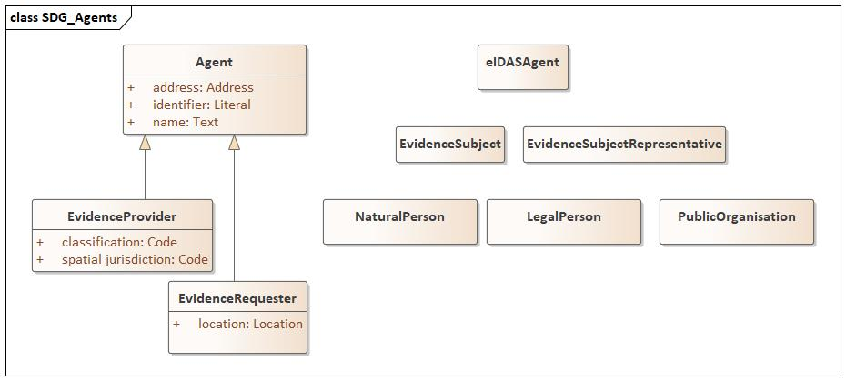

SDG OOTS agent roles
The following roles are involved in the Evidence exchange of the SDG OOTS.
role | definition | usage note
evidence provider | the agent that is responsible for providing, supplying evidences | This is a organisation. Mostly it is a public organisation, however in some MS for some evidence types businesses have been accredited to supply them.  An evidence provider must be registered in the Data Service Directory in order to be activated in the SDG OOTS.
evidence subject | the agent about whom the evidence is provided/requested | The agent nature can a natural person or an organisation.  The profile is dependent on the SDG OOTS record matching agreements. The provided values are primely bound to the eIDAS agreements.
evidence subject representative | the agent that is acting on behalf of the evidence subject to request the evidence | The agent nature can a natural person or an organisation.  The profile is dependent on the SDG OOTS record matching agreements. The provided values are primely bound to the eIDAS agreements.
evidence requester | the agent that is requesting the evidence on behalf of the evidence subject | This is the portal/organisation that initiates the SDG OOP requests.  No central registry of evidence requesters is required. The details provided as minimal to enable legal logging or facilitate the processing of the evidence request.

The detailed profiles of these SDG OOTS agent roles is found at the bottom of this document.

Generic Agent profiles
The Core Vocabularies define data models for the 3 natures of agents: natural persons (Core Person), businesses (Core Business) and public organisations (Core Public Organisation). For each agent nature a set of properties in accordance with the respectively Core Vocabulary is listed. The tables below do not express the need to provide or use these properties; compared to the core vocabulary the tables add cardinality constraints.

In some cases the detailed nature of the agent is irrelevant, for instance for the evidence requester. In that case a more abstract profile is applied.

Agent (foaf:Agent)
property | XML tag | uri | range | cardinality | definition | usage note
identifier | Identifier | dct:identifier | Literal | 0..1 | a unique identification for the agent
name | Name | foaf:name | Text | 0..n | a short label for the agent | to be used if-and-only-if no more precise Agent profile is being used.

Natural Person (person:Person)
From Core Person (https://semiceu.github.io/Core-Person-Vocabulary/releases/2.00/#Person)
An individual person who may be dead or alive, but not imaginary.
Full name of the Person given upon their birth.​
property | XML tag | uri | range | cardinality | definition | usage note
identifier | Identifier | dct:identifier | Literal | 0..1 | a unique identification for the agent
alternative name | AlternativeName | dct:alternative | Text | 0..n | Any name by which an individual is known other than their full name
birth name | BirthName | person:BirthName | Text |  | Full name of the Person given upon their birth.
citizenship | Citizenship | dct:citizenship | Juridiction | 0..n | The citizenship relationship links a Person to a Jurisdiction that has conferred citizenship rights on the individual such as the right to vote, to receive certain protection from the community or the issuance of a passport.
country of birth | CountryOfBirth | person:countryOfBirth | Location | 0..1 | The country in which a Person was born.
country of death | CountryOfDeath | person:countryOfDeath | Location | 0..1 | The country in which a Person died.
date of birth | DateOfBirth | schema:birthDate | Literal with type xsd:dateTime | 0..1 | The day on which the Person was born.
date of death | DateOfDeath | schema:deathDate | Literal with type xsd:dateTime | 0..1 | The day on which the Person died.
family name | FamilyName | foaf:familyName | Text | 0..1 | A family name is usually shared by members of a family.
full name | FullName | foaf:name | Text | 0..1 | The full name contains the complete name of a person as one string.
gender | Gender | schema:gender | Code | 0..1 | Gender of the Person.
given name | GivenName | foaf:givenName | Text | 0..1 | A given name, or multiple given names, are the denominator(s) that identify an individual within a family.
patronymic name | PatronymicName | person:patronymicName | Text | 0..1 | Name based on the given name of the Person's father.
place of birth | PlaceOfBirth | person:placeOfBirh | Location | 0..1 | The Location where the Person was born.
place of death | PlaceOfDeath | person:placeOfDeath | Location | 0..1 | The Location where the Person died.
residency | Residency | person: | Jurisdiction | 0..n | Residency typically provides an individual with a subset of the rights of a citizen.

Legal Person (legal:LegalEntity)
From Core Business (https://semiceu.github.io/Core-Business-Vocabulary/releases/2.00/#Legal%20Entity)
property | XML tag | uri | range | cardinality | definition | usage note
identifier | Identifier | dct:identifier | Literal | 0..1 | a unique identification for the agent
legal identifier | LegalIdentifier | legal:legalIdentifier | Identifier | 0..1 | The legal status of a business is conferred on it by an authority within a given jurisdiction. The legal identifier is therefore a fundamental relationship between a Legal Entity and the authority with which it is registered
legal name | LegalName | http://www.w3.org/ns/legal#legalName | Text | 0..1 | The legal name of the business.
registered address | RegisteredAddress | http://www.w3.org/ns/legal#registeredAddress | Address | 0..1 | In almost all jurisdictions, Legal Entities must register a public address. This may or may not be the actual address at which the Legal Entity does its business, it is commonly the address of their lawyer or accountant, but it is the address to which formal communications can be sent.
alternative name | AlternativeName | dct:alternative | Text | 0..n | Some jurisdictions recognise concepts such as a trading name or alternative forms of a legal entity's name. The alternative name property can be used to record such names but should not be used to record translations of the primary legal name.

Public Organisation (cv:PublicOrganisation)
Any organisation that is defined as being part of the public sector by a legal framework at any level.

property | XML tag | uri | range | cardinality | definition | usage note
identifier | Identifier | dct:identifier | Literal | 0..1 | a unique identification for the agent
address | Address | locn:address | Address | 0..1 | A property to link a public organisation to its address.
alternative label | AlternativeLabel | skos:altLabel | Text | 0..n | An alternative or informal name, irrespective of language.
preferred label | PreferredLabel | skos:prefLabel | Text | 0..1 | An preferred label is used to provide the primary, legally recognised name of the organisation
resulted from | ResultedFrom | org:resultedFrom | FoundationEvent | 0..1 | Public Organizations are formed and changed in response to events. This may be the result of new legislation, new policies, taking on new obligations etc. The Foundation Event describes the event that initiated the public organisation in the context of a formal framework.

Address (locn:Address)
Defined in Core Location, an Address is a spatial object that in a human-readable way identifies a fixed location of a property.
It is included in this section as its use in the context of the SDG OOTS Evidence exchange limited to a usage in the context of agents.
property | XML tag | uri | range | cardinality | definition | usage note
identifier | Identifier | dct:identifier | Literal | 0..1 | a unique identification for the address
adminstrative unit level 1 | AdminstrativeUnitLevel1 | locn:adminUnitL1 | Code | 0..1 | The name or names of a unit of administration related to the exercise of jurisdictional rights, for local, regional and national governance. Level 1 refers to the uppermost administrative unit for the address, almost always a country.
administrative unit level 2 | AdministrativeUnitLevel2 | locn:adminUnitL2 | Code | 0..1 | The name or names of a unit of administration related to the exercise of jurisdictional rights, for local, regional and national governance. Level 2 referst to the region of the address, usually a county, state or other such area that typically encompasses several localities.
full address | FullAddress | locn:fullAddress | Text | 0..1 | The complete address written as a formatted string.
locator designator | LocatorDesignator | locn:locatorDesignator | String | 0..1 | A number or a sequence of characters which allows a user or an application to interpret, parse and format the locator within the relevant scope. A locator may include more locator designators.
locator name | LocatorName | locn:locatorName | Text | 0..1 | Proper noun(s) applied to the real world entity identified by the locator.
post code | PostCode | locn:postCode | String | 0..1 | The post/zip code of an address. (INSPIRE's definition is "A code created and maintained for postal purposes to identify a subdivision of addresses and postal delivery points.")
post city name | PostCityName | locn:postName | Text | 0..1 | The key postal division of the address, usually the city. (INSPIRE's definition is "One or more names created and maintained for postal purposes to identify a subdivision of addresses and postal delivery points.) For example, "Paris".
post office box | PostOfficeBox | locn:poBox | String | 0..1 | The Post Office Box number.
thoroughfare | Thoroughfare | locn:thorughfare | Text | 0..1 | An address component that represents the name or names of a passage or way through from one location to another. A thoroughfare is not necessarily a road, it might be a waterway or some other feature.
address area | AddressArea | locn:addressArea | Text | 0..1 | The name or names of a geographic area or locality that groups a number of addressable objects for addressing purposes, without being an administrative unit.

Location (dct:Location)
Defined in Core Location, a Location is an identifiable geographic place or named place.
It is included in this section as its use in the context of the SDG OOTS Evidence exchange limited to a usage in the context of agents.
property | XML tag | uri | range | cardinality | definition | usage note
geographic identifier | GeographicIdentifier | rdfs:seeAlso | Code | 0..1 | A code (URI) that identifies the Location. | Not any URI will be allowed, since the usage objective is to be able to organise and aid a user to find the connected entities via the location. For a good UI experience a code list is required.
geographic name | GeographicName | locn:geographicName | Text | 0..1 | A geographic name is a proper noun applied to a spatial object

Jurisdiction
Several entities include the Jurisdiction to which the entity applies. Ideally there is a code list that is organized and managed by all MSs expressing the administrative organisation of each MS to the level that for that MS is required in the context of the SDG OOTS. Some MSs suffice with one level, while others have a much more elaborated structure. To a large extend this is covered by combining existing codelists such as NUTS and LAU into a coherent structure. If the integrated codelist cannot be realized the jurisdiction can be expressed by using a structure consisting of distinct properties administrative unit level for each necessary level having an appropriate codelist.

eIDAS agent profiles
Since eIDAS is the identity provision service in the SDG OOP, these profiles have an important impact on the information that is available. In particular the roles evidence subject and the evidence subject representative are impacted by the avaiable information through eIDAS.
The current eIDAS agent profiles are defined in eIDAS eID Profile. More information on the SDG OOTS guidelines w.r.t. evidence subject identification and record matching are documented User Identification, Authentication and Record Matching - OOTS - SDG Once-Only Collaborative Space - CEF Digital (europa.eu)

SDG OOTS agent profile details

Evidence provider (foaf:Agent)

property | XML tag | uri | range | cardinality | definition | usage note
identifier | Identifier | dct:identifier | Literal | 0..1 | a unique identification for the agent
name | Name | foaf:name | Text | 0..1 | a short label for the agent
address | Address | locn:address | Address | 0..1 | An location of the Evidence Provider in the form of an address. | If the spatial jurisdiction cannot be supplied, the address can be supplied to facilitate the functional requirement for determining the Evidence Provider based in location information.
classification | Classification | org:classification | Code | 0..n | A classification of the Evidence Provider.
jurisdiction | Jurisdiction | cv:spatialJurisdiction | Code | 1..1 | The spatial juridisdiction of the Evidence Provider w.r.t. the evidence type it is supplying. | The code should reflect the most precise spatial description for the applicable jurisdiction in the used code list. E.g. if the jurisdiction is the city of Vienna, then the code for Vienna should be used and not the code for the country Austria.  It is assumed that the used codes are organised in a code list that can support the navigation and search functionalities required by the UI to determine the to-be used Evidence Provider quickly.

Evidence Requester (foaf:Agent)
property | XML tag | uri | range | cardinality | definition | usage note
identifier | Identifier | dct:identifier | Literal | 0..1 | a unique identification for the agent
name | Name | foaf:name | Text | 0..1 | a short label for the agent
address | Address | locn:address | Address | 0..1 | An location of the Evidence Requester in the form of an address.
location | Location | locn:location | Location | 0..1 | The location of the Evidence Requester from where the Evidence Requester is operating.

Evidence Subject & Evidence Subject Representative
Use the generic agent profile according to the nature of the agent: so a NaturalPerson, LegalPerson or PublicOrganisation.
- Supportive concepts
The generic metadata model is built on top of generic supportive agreements.

Primitive Types

dateTime
Whenever time information is required, there is need to refer to the time unambiguously. This can be done by including the time zone information or recording the information as UTC time.

Language aware Text and String
Whenever a string value is language aware the primitive type Text is used. When the primitive type String is used, then the value is normally language agnostic. It means that the value is just a sequence of characters e.g. an identifier or a code.

Identifiers
A semantical model connects information through identifiers into a knowledge graph. In some use cases, meta information about the identifier, such as the registry that maintains the identifier or the encoding schema are required. When these identifiers are dereferenceable inside the ecosystem, meaning there is a dereferencing service available that would return key information about a given identifier, then the data shared can be based on those identifiers.
These expectations are expressed by mapping one of the following semantical patterns:
- mapping on dct:identifier
The identifier is a value without any meta data requirement:
Property-URI | Range | Notes
dct:identifier | rdfs:Literal
The identifier is a value according to a known encoding schema:
Property-URI | Range | Notes
dct:identifier | rdfs:Literal | With type http://www.w3.org/2001/XMLSchema#anyURI. This constraint imposes that the identifier value must be a URI.
- mapping on adms:identifier
The identifier is a value with metadata requirement:
Property-URI | Range | Notes
adms:identifier | adms:Identifier
adms:Identifier (Asset Description Metadata Schema (ADMS) (w3.org)
Property | Property-URI | Range | Description | Notes
notation | skos:notation | rdfs:Literal with type S | the value of the identifier encoded according to the schema S. If no schema is assumed or mentioned the type is per default string. | (part of adms)
assigned by | dct:creator | rdfs:Resource | the agent that has assigned the identifier | (part of adms)
assigned by | adms:schemaAgency | rdfs:Literal | the name of the agent that has assigned the identifier | (part of adms)
issuing date | dct:issued | xsd:dateTime or xsd:date | the moment that the identifier has been assigned | (part of adms)

Codes and Codelists
A controlled vocabulary, or commonly referred to as codelist, is an authoritative list of terms to be used in indexing. Controlled vocabularies do not necessarily have any structure or relationship between terms within the list. By default, code lists should follow the SKOS principles, be published with persistent identifiers and management by an an authoritative organisation, ideally the Publications Office.

Assurance Level
In the SDG OOTS there is need to express the level of assurance a data provider gives to a value. For instance, if the first name of a person is retrieved from an official citizen register, the trust is high, but if it has been the result of entering the name in a UI then this information has a lower trust.
In particular to do subject record matching, i.e. determining the identity of a subject by an evidence provider this difference in assurance may play a role. In eIDAS this annotation has been introduced, and this is here made into a more generic approach for the whole SDG OOTS data models.
Instead of incorporating this as a part of the semantical data models and so changing the structures, an annotation approach is proposed.

property | uri | range | definition | usage note
assurance level | sdg:assurranceLevel | Code | the level of assurance a data provider assigned to the value | nal_assurancelevel:high

XML Design
Mapping the semantical application profile on an XML structure is a design activity. Both have their own style guides; sometimes they are coïnciding, but sometimes there is no one-to-one mapping possible.
The XML structures that are derived from the application profile follow the next basic design rules:
- tag names are uppercamelcase strings based on the entity (class/property) names
- application profile classes are defined as complex types in which entities are sequences of properties
- tag names are defined in a sdg namespace which will be mapped to the appropriate application profile entity

