 | EUROPEAN COMMISSION  DIGIT  Connecting Europe Facility

Quick Start Guide
for the
Business Document Metadata Service Location (BDMSL)

Version [2.1]
Status [Final]
Document Approver(s):
Approver Name | Role
Joao RODRIGUES | CEF eDelivery

Document Reviewers:
Reviewer Name | Role
Adrien FERIAL | Product Owner

Summary of Changes:
Version | Date | Created by | Short Description of Changes
1.5 | 26/08/2016 | Adrien FERIAL | Version
1.6 | 30/09/2016 | Yves ADAM | Align to new template
1.7 | 19/07/2017 | Flavio SANTOS | Add configuration parameters
1.8 | 16/01/2018 | Flavio SANTOS | Add encryption configuration parameters
1.9 | 27/03/2018 | CEF Support | Reuse policy notice added, e-SENS profile replaced by eDelivery profile
1.10 | 24/04/2018 | Flavio SANTOS | Configuration files in detail
2.0 | 08/05/2019 | Joze Rihtarsic | Update for SML 4.0
2.1 | 04/06/2019 | Joze Rihtarsic | configuration for weblogic/oracle and add chapter for BIND DNS configuration added

Table of Contents

1. Introduction 5
1.1. Purpose of the Quick Start Guide 5
1.2. Pre-requisites 5
1.3. Binaries repository 5
1.4. Source Code Repository 6
1.5. Database Scripts 6
2. Database Creation 7
2.1. MySQL database 7
2.2. Oracle database 7
3. Tomcat Configuration 9
3.1. Configuring the Extra CLASSPATH for Tomcat 9
3.2. Configuring the Datasource for Tomcat 10
3.3. JDBC Driver 10
3.4. Deployment 10
3.5. Verification of the Installation 10
4. Weblogic configuration 11
4.1. Configuring the Extra CLASSPATH for WebLogic 11
4.2. Configuring datasource for WebLogic 13
4.3. Deployment 15
4.4. Verification of the Installation 15
5. Configuration 16
5.1. Environment parameters 16
5.2. BDMSL parameters 17
5.3. How to generate a private key file 19
5.4. How to encrypt a password 19
5.5. Certificate to sign responses 21
5.6. Files to be copied under application server 22
5.7. DNS integration 22
5.7.1. Securing DNS integration with SIG(0) 23
5.7.2. Enabling SIG(0) in BDMSL 25
6. Contact information 26

Introduction
BDMSL stands for Business Document Metadata Service Location. BDMSL is the sample implementation of the SML maintained by DG DIGIT. The version of the BDMSL refered in this document is 4.x versions. This version implements the eDelivery BDXL profile (see https://ec.europa.eu/cefdigital/wiki/display/CEFDIGITAL/eDelivery+BDXL )

Purpose of the Quick Start Guide
This document provides a brief description of the installation of the BDMSL component. Opposite to previous version, this version of the application does not use Liquibase as a database management tool. Before the installation, a database must be created using SQL scripts bundled in the sml-4.x-setup.zip file. The application bussines properties are stored in the database table BDMSL_CONFIGURATION. Application properties such as datasource JNDI, log folder, etc., are located in the smp.config.properties which must be located in the classpath of the server.
This guide illustrates the different steps to install the BDMSL application on a Tomcat server with a MySQL database and Weblogic 12.2.1.3 with an oracle database.

Pre-requisites
Please install the following software on the target system. For further information and installation details, please refer to the software owner's documentation.
- Java runtime environment (JRE) 8 only:
http://www.oracle.com/technetwork/java/javase/downloads/index.html
- One of the supported Database Management Systems :
  - MySQL 5,7 or above
  - Oracle 10g+
- One of the supported Application Servers:
  - Tomcat 8
  - WebLogic 12.2

Binaries repository
The CEF BDMSL artefacts can be downloaded from the CEF Digital site.

Source Code Repository
The source code of CEF BDMSL is available in the GIT repository at the following location:
https://ec.europa.eu/cefdigital/code/projects/EDELIVERY/repos/bdmsl/browse
As mentioned in the prerequisites, the deployment of the CEF BDMSL was only tested on Tomcat 8.5 and WebLogic 12.2.1.3 application server.
The deployment of the CEF BDMSL is made of the following mandatory steps:
- Database configuration
- Application Server preparation
- BDMSL Initial configuration
- BDMSL file deployment
Remark:
The environment variable, cef_edelivery_path, refers to the name of the folder where the BDMSL package is installed (CATALINA_HOME for Tomcat and DOMAIN_HOME for Oracle Weblogic).

Database Scripts
The scripts to create (or migrate) the Oracle or MySQL databases are included in the following downloadable zip file from the CEF Digital site (section §1.3): sml-4.x-setup.zip.
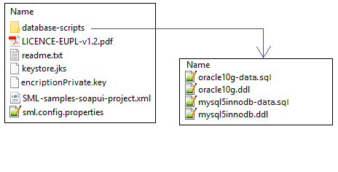

Database Creation
This section describes the steps necessary to create the database, the tables and the BDMSL database user (dbuser used for database connection purpose).
For this step you need to use the script included in the zip file downloaded in section §1.5.

MySQL database
  - Download and copy the mysql5innoDb.ddl script to cef_edelivery_path/database-scripts
  - Open a command prompt and navigate to the cef_edelivery_path/database-scripts folder
  - Execute the following MySQL commands (WARNING: this step will delete the user schema if it already exists in the database):
mysql -h localhost -u root_user –-password=root_password -e "drop schema if exists bdmsl_schema;create schema bdmsl_schema;alter database bdmsl_schema charset=utf8; create user sml_dbuser@localhost identified by 'sml_password';grant all on bdmsl_schema.* to sml_dbuser@localhost;"
This creates the bdmsl_schema and a bdmsl database_dbuser with (all) privileges for the bdmsl_schema.
Execute the following command to create the required objects (tables, etc.) in the database:

mysql -h localhost -u root_user -proot_password bdmsl_schema < mysql5innoDb.ddl

Execute the following command to set up the initial data:

mysql -h localhost -u root_user -proot_password bdmsl_schema < mysql5innoDb-data.sql

Oracle database
1. Download and copy the oracle10g.ddl script to cef_edelivery_path/sql-scripts
2. Navigate to cef_edelivery_path/sql-scripts directory
3. Execute the following commands:

sqlplus sys as sysdba (password should be the one assigned during the Oracle installation )
=================================================================== Once logged in Oracle: create user sml_dbuser identified by sml_dbpassword;
grant all privileges to sml_dbuser;
connect sml_dbuser
show user
(BDMLS environment property file) in the folder classes. (should return : sml_dbuser)
(run the scripts with the @ sign from the location of the scripts)
@oracle10g.ddl (the Oracle database creation)
@oracle10g-data.sql (the Oracle init data)

exit

Tomcat Configuration
In order to deploy the BDMSL on Tomcat, the steps below need to be completed.

Configuring the Extra CLASSPATH for Tomcat
In this Tomcat example, a directory called cef_edelivery_path will be created in the root path of the Tomcat installation (CATALINA_HOME) and the CLASSPATH modified to include this new directory using an existing Tomcat batch file (CATALINA_HOME/bin/setenv.[sh|bat]).
- classes
- keystores
For Linux:
Edit the CATALINA_HOME/bin/setenv.sh file
#!/bin/sh
# Set CLASSPATH to include sml environment property file:
# sml.config.properties
export CLASSPATH=$CATALINA_HOME/classes
For Windows:
Edit the %CATALINA_HOME%/bin/setenv.bat file
REM Set CLASSPATH to include sml environment property file:
REM sml.config.properties

set classpath=%classpath%;%catalina_home%\classes

Place the sml.config.properties (BDMLS environment property file) in the folder classes.
Example can be downloaded from the CEF Digital site (section §1.3): sml-4.x-setup.zip. Detailed description of environment properties is in section §5.1.
For tomcat/mysql configuration the file must have following properties and values:

sml.hibernate.dialect=org.hibernate.dialect.MySQLDialect
sml.datasource.jndi=java:comp/env/jdbc/edelivery
sml.jsp.servlet.class=org.apache.jasper.servlet.JspServletsml.log.folder=./logs/

Configuring the Datasource for Tomcat
Create a new data source in Tomcat named java:comp/env/jdbc/edelivery.
For that go to TOMCAT_HOME/conf/context.xml and add the block:
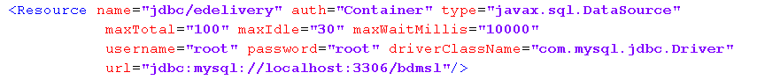

JDBC Driver
The JDBC driver needs to be downloaded from the manufacturer website:
- For Mysql: https://www.mysql.com/products/connector/
The JDBC driver (.jar file) must be copied to the following directory: cef_edelivery_path/lib.

Deployment
Copy the cef_bdmsl-webapp-4.X.war file to the Tomcat webapps directory (cef_edelivery/webapps).

Verification of the Installation
Use your browser to go to the following address: http://[hostname]:[port]/bdmsl-webapp-4.0.0/

If the deployment is successful, the following page is displayed:
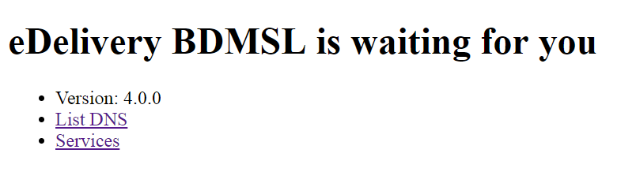
Important: Context path (example above: /bdmsl-webapp-4.0.0) should be the same as is deployment WAR file. If the war file is called sml.war then the URL will be http://[hostname]:[port]/sml.

Weblogic configuration
This section does not include the installation of a WebLogic 12.2.x application server. It is assumed that the WebLogic Server is installed and a WebLogic domain is created with an administration server and a managed server on which the BDMSL will be deployed.
Hereafter the domain location will be referred as DOMAIN_HOME (user-defined name).
In the examples below, we will use the following Domain and Server names:

- Domain Name : SMLDOMAIN
- Administration Server : AdminServer
- SMP Managed Server : SML_ManagedServer

As shown below:
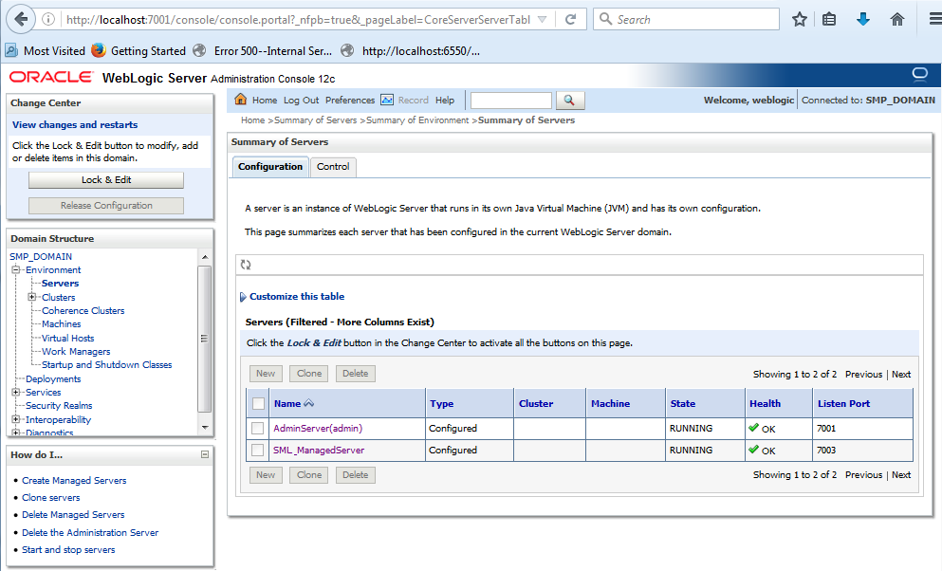
In order to deploy the SMP on the WebLogic Application Server platform, two preliminary steps need to be completed:
- Configuring the Extra CLASSPATH for WebLogic
- Configure datasource

This is described in the following two sections.

Configuring the Extra CLASSPATH for WebLogic
Under the DOMAIN_HOME directory, create the following sub-directories:
- classes
- logs

Edit the WebLogic DOMAIN_HOME/bin/setDomainEnv.sh.
For Linux:
Add the EXPORT CLASSPATH=${CLASSPATH}:${DOMAIN_HOME}/classes/ statement at the end of the CLASSPATH definition as shown below:
../
if [ "${PRE_CLASSPATH}" != "" ] ; then
CLASSPATH="${PRE_CLASSPATH}${CLASSPATHSEP}${CLASSPATH}"
export CLASSPATH
fi
CLASSPATH=${CLASSPATH}:${DOMAIN_HOME}/classes
export CLASSPATH
/..

For Windows:
../
If NOT "%PRE_CLASSPATH%"=="" (
set CLASSPATH=%PRE_CLASSPATH%;%CLASSPATH%
)
set CLASSPATH=%CLASSPATH%;%DOMAIN_HOME%\classes
/..

Place the sml.config.properties (BDMLS environment property file) in the folder classes.
An example can be downloaded from the CEF Digital site (section §1.3): sml-4.x-setup.zip. Detailed description of environment properties is in section §5.1.

For weblogic/oracle configuration, the file must have following properties and values:

sml.hibernate.dialect=org.hibernate.dialect.Oracle10gDialect
sml.datasource.jndi=jdbc/cipaeDeliveryDs
sml.jsp.servlet.class=weblogic.servlet.JSPServlet
sml.log.folder=./logs/

Configuring datasource for WebLogic
Clik on Services/Data sources on left Domain structure panel. Then on configuration tab click on button 'New' and select 'Generic data source'.
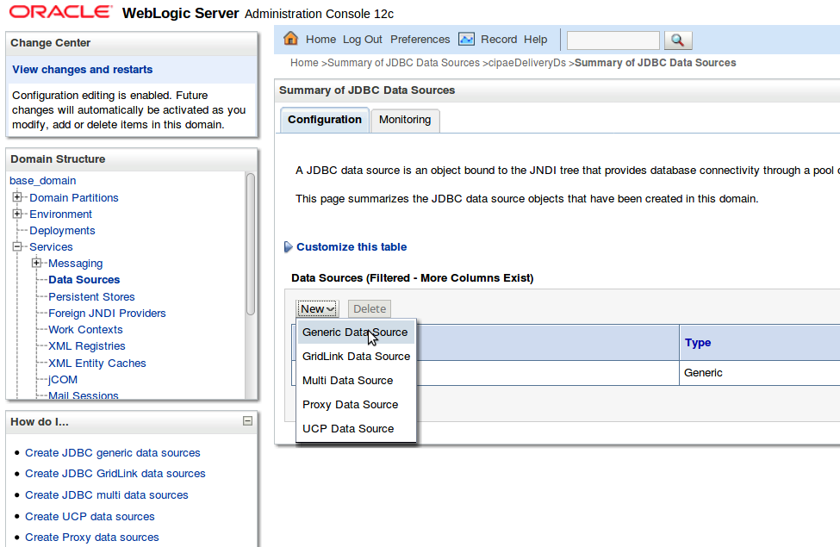
New datasource wizard ' Create a New Data Source ' is triggered which will guide you thought Datasource creation. In the first wizard page enter values:
Set Name value: cipaeDeliveryDS
JNDI name: jdbc/cipaeDeliveryDS
Database Type: oracle
and click next.
In next wizard page select Database driver: Oracle's Driver (Thin) and click next twice.
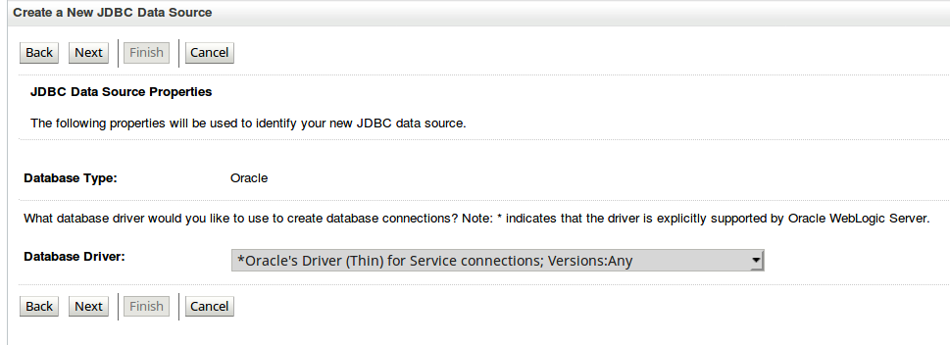
In the following wizard page enter datasource values. (Values below are just an example. Use values from your oracle configuration!).
Database Name: xe
Port: 1521
Database user sml_dbUser
Pasword: sml_dbPassword
Confirm password: sml_dbPassword
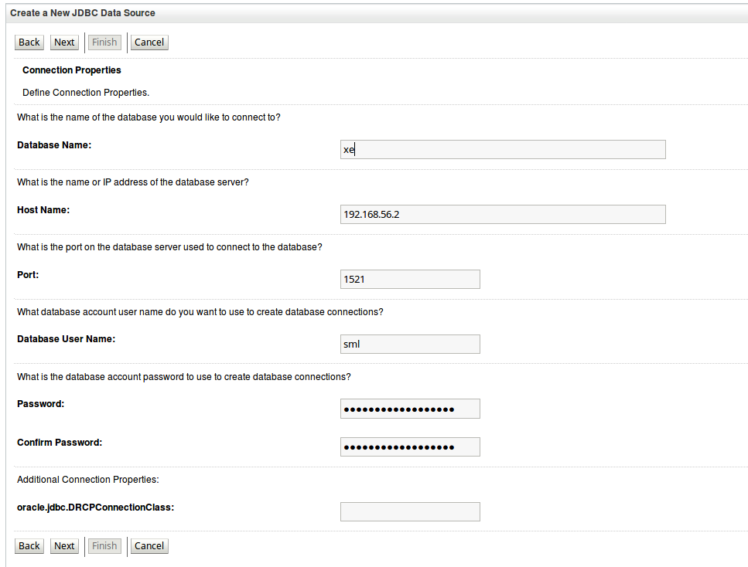
Then click 'Next' followed by click on 'Finish' button. Then a new Datasource configuration appears in the datasource table:
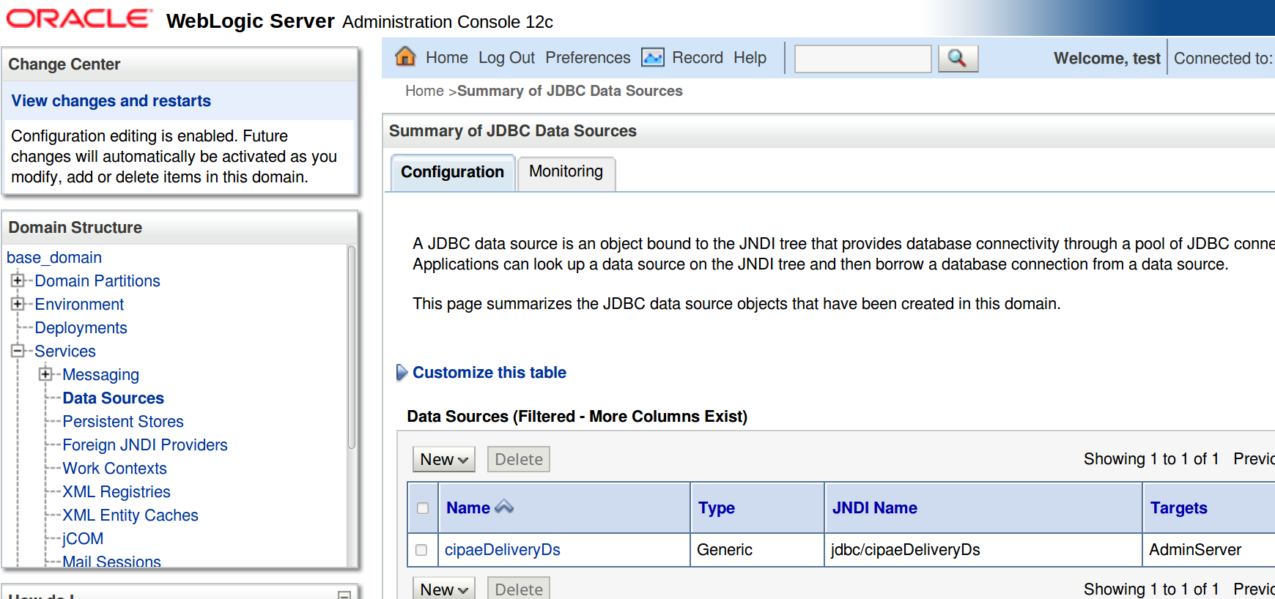

Deployment
Deploy the .war file within WebLogic using the Oracle Weblogic deployer feature or using the Weblogic Administration Console.

An example of using the Oracle the weblogic.deployer is shown below:

java weblogic.Deployer -adminurl t3://${WebLogicAdminServerListenAddress}:${WebLogicAdminServerPort} \
-username ${WebLogicAdminUserName} \
-password ${WebLogicAdminUserPassword} \
-deploy -name bdmsl-webapp-4.X.war \
-targets ${SMP_ManagedServer} \
-source $TEMP_DIR/bdmsl-webapp-4.X.war

Verification of the Installation
Use your browser to navigate to the following address: http://[hostname]:[port]/edelivery-sml/

If the deployment is successful, the following page is displayed:

Configuration

Environment parameters
BDMSL application has environment parameters stored in property file sml.config.properties. Configuration is in property file because they are required before database connection. In the setup bundle sml-4.x-setup.zip (section §1.5), there is example of configuration preset for Tomcat/MySql installation:
# *********************************
# Hibernate dialect configuration
# *********************************
# Oracle hibernate example
#sml.hibernate.dialect=org.hibernate.dialect.Oracle10gDialect
# Mysql dialect
sml.hibernate.dialect=org.hibernate.dialect.MySQLDialect

# *********************************
# Datasource JNDI configuration
# *********************************
# weblogic datasource JNDI example
#sml.datasource.jndi=jdbc/cipaeDeliveryDs
# tomcat datasource JNDI example
sml.datasource.jndi=java:comp/env/jdbc/edelivery

# *********************************
# JSP implementation configuration
# *********************************
# Weblogic
#sml.jsp.servlet.class=weblogic.servlet.JSPServlet
# tomcat, jboss
sml.jsp.servlet.class=org.apache.jasper.servlet.JspServlet

# *********************************
# Logging implementation
# *********************************
sml.log.folder=./logs/
The configuration file has the following parameters:
- sml.hibernate.dialect: hibernate dialect for accessing the database
- sml.datasource.jndi: datasource JNDI name configured in section §1.5
- sml.jsp.servlet.class: application server implementation of JSP framework
- sml.log.folder: logging folder.

BDMSL parameters
BDMSL application contains its parameters in database table BDMSL_CONFIGURATION. Parameters can be updated:
- via the sql script as showed below:
mysql -h localhost -u root_user -proot_password bdmsl_schema -e "update bdmsl_configuration set value='true', last_updated_on=NOW() where property='unsecureLoginAllowed'";
- or by calling the webservice operation: BDMSLAdminServices/SetProperty(). For more details, check the ICD document.
All properties are refreshed without server restart, except CRON schedule definitions: sml.property.refresh.cronJobExpression, certificateChangeCronExpression and dataInconsistencyAnalyzer.cronJobExpression.
Properties are refreshed as defined by the cron property: sml.property.refresh.cronJobExpression. By default, properties are refreshed (if changed) every hour. If a property is changed by the sql script, make sure that the value last_updated is also changed, otherwise the properties will not be updated.
Property | Example | Mandatory | Description | Enc.
adminPassword | $2a$10$...Bi | FALSE | BCrypt Hashed password to access admin services | FALSE
authentication.bluecoat.enabled | FALSE | TRUE | Is blue coat enabled.  Possible values: true/false. | FALSE
authorization.smp.certSubjectRegex | ^.*(CN=SMP_|OU=PEPPOL TEST SMP).*$ | TRUE | User with ROOT-CA is granted SMP_ROLE only if its certificates Subject matches configured regexp | FALSE
unsecureLoginAllowed | FALSE | TRUE | true if the use of HTTPS is not required. If the VALUES is set to true, then the user unsecure-http-client is automatically created.  Possible VALUES: true/false | FALSE
configurationDir | ./ | TRUE | The path to the folder containing all the configuration files (keystore and sig0 key) | FALSE
sml.property.refresh.cronJobExpression | 0 53 */1 * * * | TRUE | Property refresh cron expression (def 7 minutes to each hour)! | FALSE
certificateChangeCronExpression | 0 0 2 ? * * | TRUE | Cron expression for the changeCertificate job. Example: 0 0 2 ? * * (everyday at 2:00 am) | FALSE
dataInconsistencyAnalyzer.cronJobExpression | 0 0 3 ? * * | TRUE | Cron expression for dataInconsistencyChecker job. Example: 0 0 3 ? * * (everyday at 3:00 am) | FALSE
dataInconsistencyAnalyzer.recipientEmail | email@domain.com | TRUE | Email address to receive Data Inconsistency Checker results | FALSE
dataInconsistencyAnalyzer.senderEmail | automated-notifications@nsome-mail.eu | TRUE | Sender email address for reporting Data Inconsistency Analyzer. | FALSE
dataInconsistencyAnalyzer.serverInstance | localhost | TRUE | Server instance (hostname) to generate report. | FALSE
mail.smtp.host | mail.server.com | TRUE | Email server - configuration for submitting the emails. | FALSE
mail.smtp.port | 25 | TRUE | Smtp mail port - configu1ration for submitting the emails. | FALSE
mail.smtp.protocol | smtp | TRUE | smtp mail protocol- configuration for submitting the emails. | FALSE
mail.smtp.username |  | FALSE | smtp mail protocol- username for submitting the emails. | FALSE
mail.smtp.password |  | FALSE | smtp mail protocol - encrypted password for submitting the emails. | TRUE
mail.smtp.properties |  | FALSE | smtp mail ;-separated properties: ex: mail.smtp.auth:true;mail.smtp.starttls.enable:true;mail.smtp.quitwait:false. | FALSE
dnsClient.SIG0Enabled | FALSE | TRUE | true if the SIG0 signing is enabled. Required fr DNSSEC. Possible VALUES: true/false | FALSE
dnsClient.SIG0KeyFileName | SIG0.private | TRUE | The actual SIG0 key file. Should be just the filename if the file is in the classpath or in the configurationDir | FALSE
dnsClient.SIG0PublicKeyName | sig0.acc...ec.test.eu. | TRUE | The public key name of the SIG0 key | FALSE
dnsClient.enabled | FALSE | TRUE | true if registration of DNS records is required. Must be true in production. Possible VALUES: true/false | FALSE
dnsClient.publisherPrefix | publisher | TRUE | This is the prefix for the publishers (SMP). This is to be concatenated with the associated DNS domain in the table bdmsl_certificate_domain | FALSE
dnsClient.server | ddnsext.tech.ec.europa.eu | TRUE | The DNS server | FALSE
encriptionPrivateKey | encriptionPrivateKey.private | TRUE | Name of the 256 bit AES secret key to encrypt or decrypt passwords. | FALSE
useProxy | FALSE | TRUE | true if a proxy is required to connect to the internet. Possible VALUES: true/false | FALSE
httpProxyHost | localhost | TRUE | The http proxy host | FALSE
httpProxyPassword | vXA7JjCyEN1Qwg== | TRUE | Base64 encrypted password for Proxy. | TRUE
httpProxyPort | 8012 | TRUE | The http proxy port | FALSE
httpProxyUser | user | TRUE | The proxy user | FALSE
signResponse | FALSE | TRUE | true if the responses must be signed. Possible values: true/false | FALSE
keystoreAlias | senderalias | TRUE | The alias in the keystore for signing reponses. | FALSE
keystoreFileName | keystore.jks | TRUE | The JKS keystore file. Should be just the filename if the file is in the classpath or in the configurationDir | FALSE
keystorePassword | vXA7JjCy0EN1Qwg== | TRUE | Base64 encrypted password for Keystore. | TRUE

How to generate a private key file
SML provides a tool to create a private key to encrypt proxy and signing keystore passwords. In order to create a private key, please follow the steps below:
- Download one of the latest BDMSL war files (eg: bdmsl-webapp-4.0.x.war ) from the repository https://ec.europa.eu/cefdigital/wiki/display/CEFDIGITAL/SML
- Extract the war file using any extracting tool
- Run the following commands to create a private key:
- cd bdmsl-webapp-4.0.x
- java -cp "WEB-INF/lib/*" eu.europa.ec.bdmsl.common.util.PrivateKeyGenerator c:\temp\encriptionPrivateKey.private
Required parameter = Full directory path where the private key will be created
Example:
Printed result:
Private key created at c:\temp\encriptionPrivateKey.private
Once the private key is generated, please copy the private key file name to the value of the property encriptionPrivateKey in the table BDMSL_Configuration, and copy the private file to the path configured in the property configurationDir.

How to encrypt a password
If using webservices for setting passwords, the passwords are encrypted automatically. Below you will find the procedure for manual password encryption.
After generating a private key at item “§4.3- How to generate a private key file”, please configure the proxy or keystore (used to sign response) password if needed as follows:
- Inside the folder already extracted from BDMSL .war file, please run the command below:
java -cp "WEB-INF/lib/*" eu.europa.ec.bdmsl.common.util.EncryptPassword c:\temp\privateKey.private Password123
1st parameter = private key location
2nd parameter = plain text password
- To configure the proxy password, please copy the printed encrypted and base64 encoded password to the value of the httpProxyPassword property in the table BDMSL_CONFIGURATION.
Example:
httpProxyPassword = vXA7JjCy0iDQmX1UEN1Qwg==
- To configure the keystore password, please copy the printed encrypted and base64 encoded password to the value of the keystorePassword property in the table BDMSL_CONFIGURATION.
Example:
keystorePassword = vXA7JjCy0iDQmX1UEN1Qwg==

Certificate to sign responses
If the flag signResponse=true in the table BDMSL_CONFIGURATION, a keystore file name, its alias and password must be provided in the same table.
For testing purposes only, it is possible to create a self-signed keystore as follows:
- Open the command console on whatever operating system you are using and navigate to the directory where keytool.exe is located (usually where the JRE is located, e.g. c:\Program Files\Java\jre8\bin on Windows machines).
- Run the following command (where validity is the number of days before the certificate will expire):
keytool -genkey -keyalg RSA -alias selfsigned -keystore keystore.jks -storepass password -validity 360 -keysize 2048

- Fill in the prompts for your organization information as below:

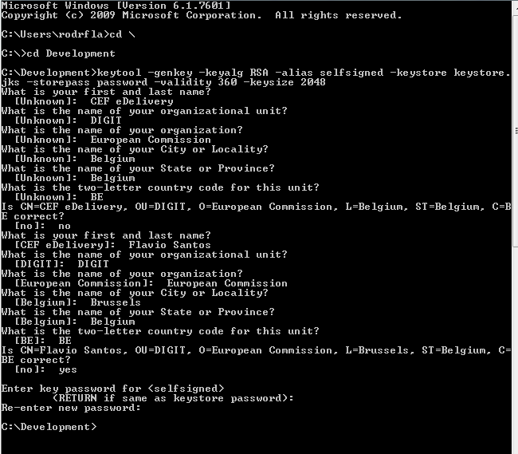

- This will create a keystore.jks file containing a private key and your sparklingly fresh self-signed certificate. Now you just need to configure your Java application to use the .jks file.
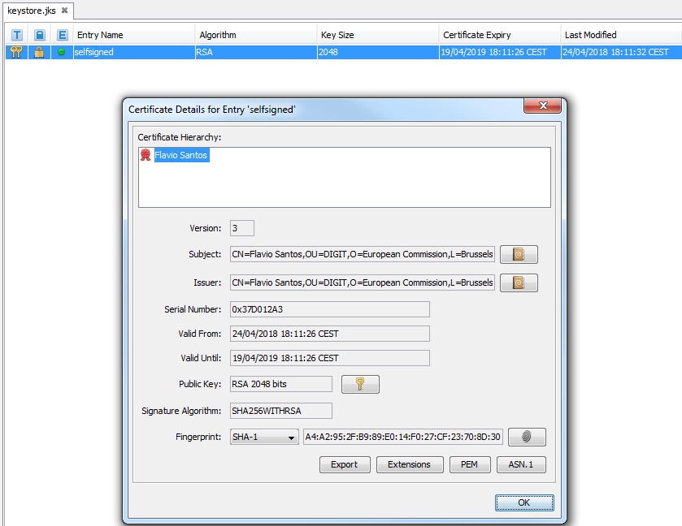

Files to be copied under application server
In the configuration directory that you specified in the configurationDir property, you need to put the following files:
- keystore.jks (the name can be changed in the property keystoreFileName): this keystore must contain your private key with the alias and password defined in the keystoreAlias and keystorePassword properties.
- sig0.private (the name can be changed in the property dnsClient.SIG0KeyFileName): this file is only required if you use DNSSEC (i.e. property dnsClient.SIG0Enabled set to true).
- encriptionPrivateKey.private (the name can be changed in the property encriptionPrivateKey): this private key file is only required if you use Proxy or Sign Response.
Once the needed files have been copied, restart the server(s).

DNS integration
BDMSL was developed and tested with using a BIND9 DNS server. The DNS integration can be switched on/off by setting attribute dnsClient.enabled to true/false. If the property is set to true then parameter dnsClient.server must contain hostname/ip address of the DNS server.

To secure DNS integration BDMSL has implemented SIG(0). This option can be enabled/disabled by parameter: dnsClient.SIG0Enabled with values: true/false.
If option is set to false DNS should allow updates to any (not advised in production environment) or for example narrow down update permission to requester ip address.
Below is example of configuration for BIND9 zone example.edelivery.eu.local without use of SIG(0) (in this case the BDMSL should have dnsClient.SIG0Enabled=false).

zone "example.edelivery.eu.local" {
type master;
file "/var/lib/bind/db.example.edelivery.eu.local ";
allow-update { 10.22.1.3;}
allow-transfer { 10.22.0.0/16; };
};

Securing DNS integration with SIG(0)
SIG0 are asymmetric key-pairs, usually with filename with endings .key for a public key and filename with endings .private which is private key.
In general: keys can be any of the asymmetric key algorithms: DSA, RSAMD5, RSASHA1. But BDMSL supports only DSA.
SIG(0) key pair can be created with dnssec-keygen utility (which is supplied as part of a BIND9 DNS server)
Example:
dnssec-keygen -a DSA -b 1024 -n HOST -T KEY sig0.example.edelivery.eu. local

The command produces following files:
Ksig0.example.edelivery.eu.local.+003+03054.key
Ksig0.example.edelivery.eu.local.+003+03054.private

The content of the file:
Ksig0.example.edelivery.eu.+003+03054.key
Is DNS Key entry which should be put to DNS zone
Example:
sig0.example.edelivery.eu.local. 604800 IN KEY 512 3 3 CLC4l6DtbztWAIJIMkYrv4MClWvj2BUclxqCd86vzX/f0ka+oS73dFCp tb9Yv9oYjGmG1JLNv4EKuPiGPa8O/CQWrbJ5I7Yts3GDMgZNRswxMije H6OoYkZ6ywRpjv8nommw6JMzDaDhcU5/tLQXhvz3U/c7W5QepAXfHb6Z gGwL4TkqR/RGp5xcxayID4b/+DJvqi04BjNO9WR3XGRHWZ5aO0pRcRjx imDtlnIjpsykE59o03UyQ+YT1CYNPjNlmOoT1JVgBEFGgouAm7yEZq3A HWsqZEHCeucvQKBADmIk5rHwfZJwv7dzXrZR2U5AqE/AxqhrWyTpItRg oGEkc+piGciuPRtwRZPkD6+GcFn/2knJ3YuRBOiog0+5mtbqaIPOew+B +BtQk6X5E5tNnEuQJeRjjxznGYdzN7hTDFPvtwGEQvDUoU4SP/6YHoAd AaH5Vs+YTRHjdISvnJIV6VRxIbQFJWaf3Z+UT4ns0+4pIGXm7C0ADA2a 1wGpj4QF8A37VAofcFWlUErtNv9YmVHQcA2l

When public key correctly registered to dns server it can be tested with dig util as example below:
$dig sig0.example.edelivery.eu.local @localhost KEY

ANSWER
; <<>> DiG 9.10.3-P4-Ubuntu <<>> sig0.example.edelivery.eu.local @localhost KEY
;; global options: +cmd
;; Got answer:
;; ->>HEADER<<- opcode: QUERY, status: NOERROR, id: 36443
;; flags: qr aa rd ra; QUERY: 1, ANSWER: 1, AUTHORITY: 1, ADDITIONAL: 2
;; OPT PSEUDOSECTION:
; EDNS: version: 0, flags:; udp: 4096
;; QUESTION SECTION:
; sig0.example.edelivery.eu.local. IN KEY
;; ANSWER SECTION:
sig0.example.edelivery.eu.local. 604800 IN KEY 512 3 3 CLC4l6DtbztWAIJIMkYrv4MClWvj2BUclxqCd86vzX/f0ka+oS73dFCp tb9Yv9oYjGmG1JLNv4EKuPiGPa8O/CQWrbJ5I7Yts3GDMgZNRswxMije H6OoYkZ6ywRpjv8nommw6JMzDaDhcU5/tLQXhvz3U/c7W5QepAXfHb6Z gGwL4TkqR/RGp5xcxayID4b/+DJvqi04BjNO9WR3XGRHWZ5aO0pRcRjx imDtlnIjpsykE59o03UyQ+YT1CYNPjNlmOoT1JVgBEFGgouAm7yEZq3A HWsqZEHCeucvQKBADmIk5rHwfZJwv7dzXrZR2U5AqE/AxqhrWyTpItRg oGEkc+piGciuPRtwRZPkD6+GcFn/2knJ3YuRBOiog0+5mtbqaIPOew+B +BtQk6X5E5tNnEuQJeRjjxznGYdzN7hTDFPvtwGEQvDUoU4SP/6YHoAd AaH5Vs+YTRHjdISvnJIV6VRxIbQFJWaf3Z+UT4ns0+4pIGXm7C0ADA2a 1wGpj4QF8A37VAofcFWlUErtNv9YmVHQcA2l
;; AUTHORITY SECTION:
example.edelivery.eu.local. 604800 IN NS ns. example.edelivery.eu.local.
;; ADDITIONAL SECTION:
ns.example.com.local. 604800 IN A 192.168.56.3

To allow DNS updates for the zone " example.edelivery.eu.local " only by requests signed by private key of the sig0.example.edelivery.eu.local we have to update the DNS zone configuration as example:

zone "example.edelivery.eu.local" {
type master;
file "/var/lib/bind/db.example.edelivery.eu.local ";
allow-update { key " sig0.example.edelivery.eu.local.";}
allow-transfer { 10.22.0.0/16; };
};

Enabling SIG(0) in BDMSL
To enable BDMSL to use SIG(0) following parameters must be set:
Value of the parameter dnsClient.SIG0PublicKeyName must be DNS name of the DNS KEY entry, For the example above this value is:
dnsClient.SIG0PublicKeyName= sig0.example.edelivery.eu.local
Next the private key must be put into to the BDMS configuration folder and Value of the parameter dnsClient.SIG0KeyFileName must be the name of the private key filename.
As example:
dnsClient.SIG0KeyFileName= Ksig0.example.edelivery.eu.local.+003+03054.private

Finaly we have to enable SIG(0) with parameter:
dnsClient.SIG0Enabled=true

Note that BDMLS for transfer is not using. BDMSL use transfer DNS records for generating inconsistency report and for when calling http get resource /listDNS
Therefore allow-transfer in DNS configuration must be set any or secured by IP.

zone "example.edelivery.eu.local" {
type master;
file "/var/lib/bind/db.example.edelivery.eu.local ";
allow-update { key " sig0.example.edelivery.eu.local.";}
allow-transfer { 10.22.0.0/16; };
};

Contact information
CEF Support Team
By email: CEF-EDELIVERY-SUPPORT@ec.europa.eu
Support Service: 8am to 6pm (Normal EC working Days)

https://ec.europa.eu/cefdigital/wiki/display/CEFDIGITAL/SML

