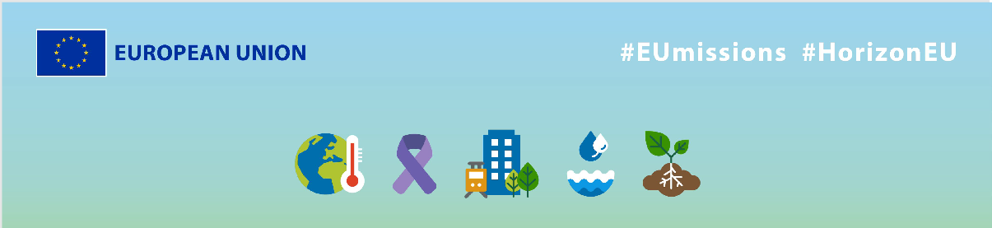
EU Missions - SOLUS
Social media Package
KEY INFO:
EU platform:
ENG: https://ec.europa.eu/research-and-innovation/en/horizon-magazine/mission-beat-cancer
Italian: https://ec.europa.eu/research-and-innovation/en/horizon-magazine/missione-sconfiggere-il-cancro
Related Instagram account: @eu_science | Main hashtag: #ResearchImpactEU
Related Facebook account: https://www.facebook.com/EUScienceInnov
Secondary hashtags: #EUGreenDeal
Creative assets: Static images, motion videos (EN, Italian)

- Suggested messages for promoting the EU Missions.
Platform | Copy
Twitter | What if we could revolutionise breast #cancer diagnosis? 🎗️  That’s what Dr Paola Taroni & her team are trying to achieve with the 🇪🇺 by developing a more accurate screening experience, that can save patients from unnecessary procedures. 👇  #ResearchImpactEU
What if we could improve the lives of millions of women in the 🇪🇺?

A group of Italian researchers is developing new screening methods to reduce unnecessary, painful breast cancer biopsies.

Find out more about their innovative research👇

#ResearchImpactEU

Platform | Copy
Facebook | New knowledge and breakthrough innovation helps us to improve the lives of millions of women. 💙  False positive results during #breastcancer screening can be scary and stressful for patients, but thanks to Dr Paola Taroni and her team at the San Raffaele Hospital in Milan, this may soon be a thing of the past.  These researchers have developed a new medical imaging tool that can determine whether irregularities detected by breast cancer screening programmes are benign or malignant.  Read more about the results here 👇  #ResearchImpactEU
What if we could improve cancer diagnosis for millions of women?
That’s the mission of a team of researchers with help from the EU, by developing new screening methods & avoiding needless, painful #breastcancer biopsies.

Find their story here 👇
https://ec.europa.eu/research-and-innovation/en/horizon-magazine/mission-beat-cancer

#ResearchImpactEU

Platform | Copy
LinkedIn | Women face a 50% chance of getting a false positive from a mammography throughout their life.  A team of Italian researchers is conducting a groundbreaking research to develop new screening methods, to accurately determine whether irregularities detected by breast cancer screening programs are benign or malignant. And as a result, to avoid painful biopsies for millions of women!  Read on to discover more about their mission. 👇  https://ec.europa.eu/research-and-innovation/en/horizon-magazine/mission-beat-cancer  #ResearchImpactEU #BreastCancer

Platform | Copy
Instagram | Beating breast cancer together🎗  Women face a 50% chance of getting a false positive from a mammography throughout their life and this can be stressful. A team of Italian researchers are on a mission with the 🇪🇺 to spare women from these needless biopsies.  Ready to revolutionise breast cancer diagnosis? Read more via the link in bio.  #ResearchImpactEU #EUGreenDeal #research #innovation #breastcancerawareness #cancer #breastcancerawarenessmonth #BreastCancer #cancerfighter #breastcancersurvivor #cancersurvivor #healthyliving #cancerawareness #survivor #health #pinkribbon #cancercare
Italian professor of physics Dr Paola Taroni and her team are on a mission with the 🇪🇺 to revolutionise breast cancer screening. 💝

They have developed a new medical imaging tool that can determine whether irregularities detected by breast cancer screening programmes are benign or malignant.

Read more via the link in bio to learn how their research improves people’s lives.
#ResearchImpactEU #EUGreenDeal #research #innovation #breastcancerawareness #cancer #breastcancerawarenessmonth #BreastCancer #cancerfighter #breastcancersurvivor #cancersurvivor #healthyliving #cancerawareness #survivor #health #pinkribbon #cancercare

