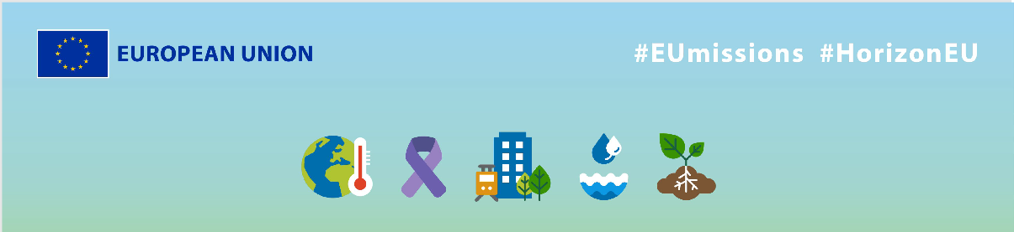
EU Missions - SOCLIMPACT
Social media Package
KEY INFO:
EU platform:
ENG: https://ec.europa.eu/research-and-innovation/en/horizon-magazine/mission-save-our-islands
Spanish: https://ec.europa.eu/research-and-innovation/en/horizon-magazine/una-mision-salvar-nuestras-islas
Related Instagram account: @eu_science | Main hashtag: #ResearchImpactEU
Related Facebook account: https://www.facebook.com/EUScienceInnov
Secondary hashtags: #EUGreenDeal
Creative assets: Static images, motion videos (EN, Spanish)

- Suggested messages for promoting the EU Missions.
Platform | Copy
Twitter | People living on islands are particularly vulnerable to #climatechange.  Oceanographer Dr Gabriel Jordà and his team are on a mission with the 🇪🇺 to protect the island’s unique ecosystems.  Learn how their research helps protect our #oceans. 👇  #ResearchImpactEU
The impact of climate change is becoming more visible every year.
Thanks to projects like SOCLIMPACT, we can learn to adapt. Researchers measure the expected impact of climate change to protect the island’s unique ecosystems.

Read more👇
#ResearchImpactEU

Platform | Copy
Facebook | Islands are particularly vulnerable to climate change.  Oceanographer Dr Gabriel Jordà and his team are on a mission with the 🇪🇺 to protect the island’s unique ecosystems.  Learn how their research helps protect our #oceans. 👇  #ResearchImpactEU
Researchers on a mission to save the islands in Europe and beyond 🌍

Spanish researchers and 24 partners from across Europe are stepping up to develop sustainable solutions to protect our islands from the effects of extreme weather and rising sea levels. 💚

Find out more about their work 👇

#ResearchImpactEU

Platform | Copy
LinkedIn | Europe’s islands are on the front line of climate change, but research & innovation is helping us to adapt.  Spanish researchers from the SOCLIMPACT project have designed a way to measure the expected impact of climate change on different EU islands to help them better prepare for its effects.  Discover their results now 👉 https://ec.europa.eu/research-and-innovation/en/horizon-magazine/mission-save-our-islands  #ResearchImpactEU #EUGreenDeal

Platform | Copy
Instagram | 🌊 Meet Spanish oceanographer Dr Gabriel Jordà and his team, who are on a mission to save islands from the impacts of climate change.  These researchers have designed a way to measure the expected impact of #climatechange on different EU islands to help them better prepare for its effects.  Together, EU countries can work more effectively, by pooling funding and expertise from around the world, coordinating international efforts, and benefitting from local knowhow.  Check the link in bio to learn how their research helps protect our #oceans.  #ResearchImpactEU #EUGreenDeal #island #EU #risingsea #weather  #climate #environment #globalwarming #nature #climatecrisis #sustainable #sustainability #ocean #zerowaste #oceanlife #sealife #savetheocean #nomoreplastic #saveourbeach #underwater #sea #marinebiology
🌊 Islands are vulnerable to #climatechange, so researcher Dr Gabriel Jordà and his team are working together with the 🇪🇺 to protect Europe's island communities. By measuring the impact and developing tailored solutions, they empower locals and protect the blue economy.

Follow their mission 👉 Check link in bio

#ResearchImpactEU #EUGreenDeal #island #EU #risingsea #weather
#climate #environment #globalwarming #nature #climatecrisis #sustainable #sustainability #ocean #zerowaste #oceanlife #sealife #savetheocean #nomoreplastic #saveourbeach #underwater #sea #marinebiology

