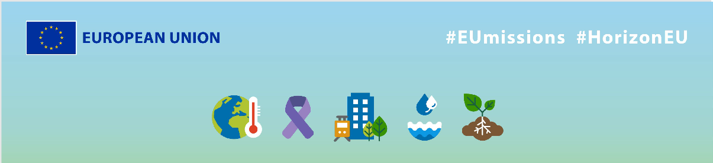
EU Missions – SMARTER
Social media Package
KEY INFO:
EU platform:
ENG: https://ec.europa.eu/research-and-innovation/en/horizon-magazine/mission-build-energy-efficient-homes
Romanian: https://ec.europa.eu/research-and-innovation/en/horizon-magazine/misiunea-construirea-de-locuinte-eficiente-din-punct-de-vedere-energetic
Related Instagram account: @eu_science | Main hashtag: #ResearchImpactEU
Related Facebook account: https://www.facebook.com/EUScienceInnov
Secondary hashtags: #EUGreenDeal
Creative assets: Static images, motion videos (EN, Romanian)

- Suggested messages for promoting the EU Missions.
Platform | Copy
Twitter | 🌳🏡 Did you know that 40% to 50% of CO2 emissions in #Europe come from the buildings we live in?  Romanian researchers are on a mission to tackle this problem and build more energy-efficient homes.  Find out here how👇  #ResearchImpactEU
🏡 Are we ready to revolutionise the housing market?

That’s the mission of Romanian researchers and the 🇪🇺, who are working hard to make the world's #housing and living solutions greener.

Discover their work 👇

#ResearchImpactEU

Platform | Copy
Facebook | Together for a greener future 🌳  Romanian economist Dr Monica Ardeleanu and a team of partners from 17 🇪🇺 countries are working together to make our homes more energy-efficient and affordable.  Join them on their mission towards a greener #future.  Read more: https://ec.europa.eu/research-and-innovation/en/horizon-magazine/mission-build-energy-efficient-homes  #ResearchImpactEU
Romanian environmental economist, Dr Monica Ardeleanu, and her team are on a mission with the 🇪🇺 to build energy-efficient homes 🏡

With EU funding & 17 partner organisations, Dr Ardeleanu is designing #sustainable homes that are cheaper to run, energy-efficient and have a higher resale value.

Read more to learn how these researchers are improving people’s lives. 👇

#ResearchImpactEU

Platform | Copy
LinkedIn | 🏡 Are energy-efficient homes the solution to a cleaner planet?  EU funding has allowed Dr Monica Ardeleanu and a team of partners from 17 🇪🇺 countries to work together to make our homes more energy-efficient and affordable.  Join them on their mission towards a greener future.  Read more: https://ec.europa.eu/research-and-innovation/en/horizon-magazine/mission-build-energy-efficient-homes  #ResearchImpactEU #housing #sustainable #green

Platform | Copy
Instagram | Is your house too hot in summer and too cold in winter?  The solution are energy-efficient houses. 🏡 A team of researchers is on a mission with the EU to make homes more sustainable & affordable.  Read more to learn how via the link in bio.  #ResearchImpactEU #EUGreenDeal #research #innovation #energyefficient #design #energy #housing #architecture #home #greenbuilding #sustainable #energyefficienthouse #greenplanet #climate #climatechange #environment #globalwarming #climateaction
Why are energy-efficient homes important? 🏡

Cities produce more than 70% of global CO2 emissions, so energy-efficient housing is a step towards a greener 🌍.

Romanian environmental economist, Dr Monica Ardeleanu, and her team are on a mission with the 🇪🇺 to build energy-efficient homes. They have partnered up with financial institutions with the aim to design homes meeting high environmental standards, and prepare cities for the effects of climate change. 🌍

🌱Click on the link in bio to learn how these researchers are improving people’s lives.

#ResearchImpact #EUGreenDeal #research #innovation #energyefficient #design #energy #housing #architecture #home #greenbuilding #sustainable #energyefficienthouse #greenplanet #climate #climatechange #environment #globalwarming #climateaction

