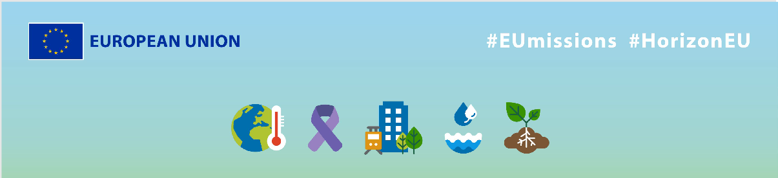
EU Missions – Plastic Pirates
Social media Package
KEY INFO:
EU platform:
ENG: https://ec.europa.eu/research-and-innovation/en/horizon-magazine/mission-beat-plastic-pollution
German: https://ec.europa.eu/research-and-innovation/en/horizon-magazine/auf-mission-im-kampf-gegen-plastikverschmutzung
Related Instagram account: @eu_science | Main hashtag: #ResearchImpactEU
Related Facebook account: https://www.facebook.com/EUScienceInnov
Secondary hashtags: #EUGreenDeal
Creative assets: Static images, motion videos (EN, German)

- Suggested messages for promoting the EU Missions.
Platform | Copy
Twitter | 🌊 Plastic pollution in oceans & rivers has increased 10x since 1980.  We need to join forces to make our waters healthy again. Learn more about how a German researcher is fighting #plastic pollution with the help of school students & the 🇪🇺. 👇  #ResearchImpactEU
Plastic pollution in 🇪🇺 rivers is a real problem.
But research & EU-funding can help tackle this challenge.
Discover the work of a German researcher who works with children to map the #plasticpollution. 👇
#ResearchImpactEU

Platform | Copy
Facebook | The impact of plastic pollution on our 🌍 is undeniable.  Let's take action & join Dr Tim Kiessling and his team in their mission to beat plastic pollution in European rivers.  Discover more about their research here 👉 https://ec.europa.eu/research-and-innovation/en/horizon-magazine/mission-beat-plastic-pollution  Together, we can create a healthier and more sustainable future!  #ResearchImpactEU
The health of our oceans, rivers, and wildlife is threatened by plastic pollution, so it’s time to take action!

A German researcher & his team are working on mapping plastic pollution in Europe’s rivers, with the help of school children & EU funding.

Learn how they’re making a difference!

#ResearchImpactEU

Platform | Copy
LinkedIn | 🌊 Plastic pollution in oceans and rivers has increased tenfold since 1980.  EU-funded projects like ‘Plastic Pirates Go Europe’ help tackle this challenge. Researchers work with school children to collect data and map the plastic pollution in European rivers.  Read about the results here 👇  https://ec.europa.eu/research-and-innovation/en/horizon-magazine/mission-beat-plastic-pollution  #ResearchImpactEU

Platform | Copy
Instagram | How to do research to help our planet and have fun while doing it?  👉 Plastic Pirates EU  This EU-funded project creates an overview of plastic pollution in Europeans rivers, thanks to a collaboration between researchers and school kids.  Learn more about the project ➡️ link in bio.  #ResearchImpactEU #EUGreenDeal #PlasticPollution #Innovation #Climate #plasticpollution #waters #rivers #innovation #climate
A safer future of our rivers 🌊

A German marine biologist is on a mission to discover the true scale of plastic pollution in rivers across Europe, with the help school children. They work together to create a safer future for our waters.

Discover more about their work ➡️ check the link in bio.

#ResearchImpactEU #EUGreenDeal #PlasticPollution #Innovation #Climate #plasticpollution #waters #rivers #innovation #climate

