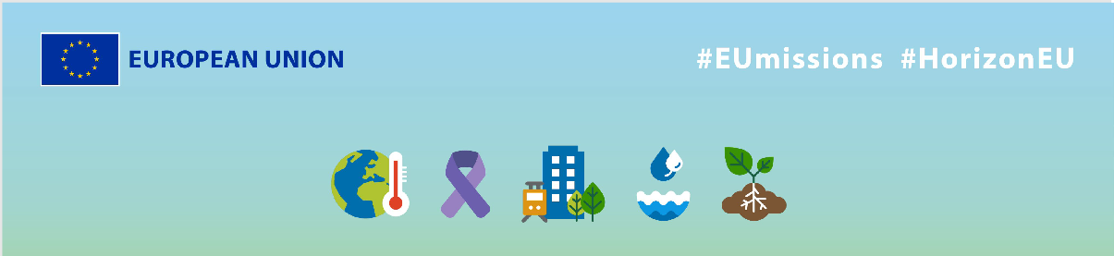
EU Missions – MyPal
Social media Package
KEY INFO:
EU platform:
ENG: https://ec.europa.eu/research-and-innovation/en/horizon-magazine/mission-transform-palliative-healthcare
Greek: https://ec.europa.eu/research-and-innovation/en/horizon-magazine/apostoli-gia-ton-metashimatismo-tis-parigoritikis-frontidas
Related Instagram account: @eu_science | Main hashtag: #ResearchImpactEU
Related Facebook account: https://www.facebook.com/EUScienceInnov
Secondary hashtags: #EUGreenDeal
Creative assets: Static images, motion videos (EN, Greek)

- Suggested messages for promoting the EU Missions.
Platform | Copy
Twitter | How can #technology redefine palliative care for cancer patients? 🎗️  Discover how a Greek researcher and his team are transforming the doctor-patient relationship with the MyPal Project. ⬇️  #ResearchImpactEU
The EU is on a mission to improve people’s lives 💝

Thanks to EU-funding & collaboration with 16 healthcare partners from across Europe, researchers
developed a new approach to patient #care with the MyPal project.🎗

#ResearchImpactEU

Platform | Copy
Facebook | The EU and researchers in Greece are on a mission to redefine palliative care for cancer patients.  The result? Better personalised care and improved communication between doctors and patients. 💪  Discover their research here ➡️ https://ec.europa.eu/research-and-innovation/en/horizon-magazine/mission-transform-palliative-healthcare  #ResearchImpactEU
Greek researcher, Dr Pantelis Natsiavas, is revolutionising palliative healthcare for cancer patients with the help of the EU. Over 2 years, 200 patients across 5 🇪🇺 countries took part in a trial and saw their doctor–patient relationship change. 💪

Read more 👉 https://ec.europa.eu/research-and-innovation/en/horizon-magazine/mission-transform-palliative-healthcare

#ResearchImpactEU

Platform | Copy
LinkedIn | Cancer affects everyone regardless of age, gender or social status and represents a tremendous burden for patients and families.  Technology can help to take some of the burden away, as Greek researcher Dr Natsiavas shows. He worked on the EU-funded MyPal project to bridge the gap between patients and doctors and improve the quality of care, and therefore the quality of life, of those affected by cancer.  Read more 👉 https://ec.europa.eu/research-and-innovation/en/horizon-magazine/mission-transform-palliative-healthcare

Platform | Copy
Instagram | Cancer patients often face many challenges, including a lack of access to quality care.  Greek researcher Dr Pantelis Natsiavas and his team are aiming to address this, with the help of technology and EU funding. 🇪🇺  Discover more via the link in bio.  #ResearchImpactEU #EUGreenDeal #HealthTech #CancerCare #EUResearch #Innovation #PalliativeCare #MedicalResearch #PatientCare #DigitalHealth #HealthcareTech
A mission to transform healthcare 🌟

Greek researcher, Dr Pantelis Natsiavas, is working together with the EU and partners across the 🇪🇺 to use technology to support cancer patients in receiving better palliative care.

Discover how research is improving our lives: check the link in bio.

#ResearchImpactEU #EUGreenDeal #HealthTech #CancerCare #EUResearch #Innovation #PalliativeCare #MedicalResearch #PatientCare #DigitalHealth #HealthcareTech

