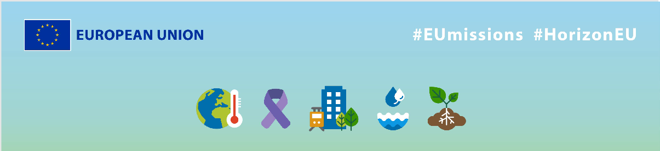
EU Missions - LANDSUPPORT
Social media messages
KEY INFO:
EU platform:
ENG: https://ec.europa.eu/research-and-innovation/en/horizon-magazine/mission-save-our-soils
IT: https://ec.europa.eu/research-and-innovation/en/horizon-magazine/missione-salvare-i-nostri-terreni
Related Instagram account: @eu_science | Main hashtag: #ResearchImpactEU
Related Facebook account: https://www.facebook.com/EUScienceInnov
Secondary hashtags: #EUGreenDeal
Creative assets: Static images, motion videos (EN, Italian)

- Suggested messages for promoting the EU Missions
Platform | Copy
Twitter | Did you know that healthy soil is essential for 95% of our food supply? We better take care of it. 💚  Through EU collaboration, scientists are working hand in hand to protect and conserve our soils for the #future. 🌱  Discover their research 👇  #ResearchImpactEU
We need to work together to tackle complex environmental problems 🤝💚
That's why an Italian researcher teamed up with people from across the 🇪🇺 to make better decisions to improve #soil quality & boost local economies at the same time.

Learn more 👇

#ResearchImpactEU

Platform | Copy
Facebook | How to preserve our soil? 🌱  Did you know that healthy soils play a vital role in producing 95% of our food and mitigating climate change? Researchers from various European countries are coming together to safeguard our soils for the next generations.  Discover how they are contributing to this cause.👇  https://ec.europa.eu/research-and-innovation/en/horizon-magazine/mission-save-our-soils  #ResearchImpactEU
Discover the story of oenologist Marco Giulioli, who is using a new digital tool to make better decisions for his soil and vines. EU funding allowed farmers, policymakers and urban planners to work together to come up with this digital solution to better manage soil.

Find out why this is important ➡️ https://ec.europa.eu/research-and-innovation/en/horizon-magazine/mission-save-our-soils

#ResearchImpactEU

Platform | Copy
LinkedIn | On a mission to save our soil 🌱  Italian soil scientist Prof Fabio Terribile is on a mission to improve soil quality, with the help of EU funding and 19 partners across Europe – ‘everyone working individually in their corner doesn’t allow us to tackle the complex problem of environmental degradation and climate change’, is his philosophy.  Discover the impact of their research here ➡️ https://ec.europa.eu/research-and-innovation/en/horizon-magazine/mission-save-our-soils  #ResearchImpactEU #SaveOurSoils #EUresearch #SoilHealth #Sustainability

Platform | Copy
Instagram | On a mission to save our soils 🌱  Discover the work of Italian scientist Prof Fabio Terribile and his team, who have created an all-in-one tool to improve soil quality and boost local economies. Thanks to EU funding & 19 partners across Europe, they're helping to save our soil for future generations. 🌍  Find out how their research is improving our lives ➡️ link in bio!  #ResearchImpactEU #SaveOurSoils #EUGreenDeal #EUresearch #SoilHealth #Sustainability  #research #innovation #soil #healthysoil #Environement #organic #agriculture #nature #growyourown #farm #cultivate #farms #soilhealth #regenerativeagriculture #soilgrown #organicagriculture #organicfarming #ecosystem #healthyplanet #climatechange #sustainability #biodiversity
The fight against climate change is one we face together 💪

Research & innovation and collaboration across Europe are vital to find solutions to global challenges, like the work of these researchers, to improve the quality and use of soil.

Learn more about the impact of their work ➡️ see link in bio.

#ResearchImpactEU #SaveOurSoils #EUGreenDeal #EUresearch #SoilHealth #Sustainability
#research #innovation #soil #healthysoil #Environement #organic #agriculture #nature #growyourown #farm #cultivate #farms #soilhealth #regenerativeagriculture #soilgrown #organicagriculture #organicfarming #ecosystem #healthyplanet #climatechange #sustainability #biodiversity

