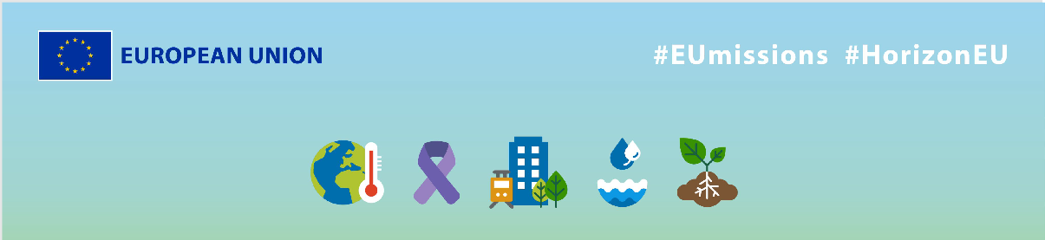
EU Missions – DUET
Social media Package
KEY INFO:
EU platform:
ENG: https://ec.europa.eu/research-and-innovation/en/horizon-magazine/mission-transform-our-cities
NL: https://ec.europa.eu/research-and-innovation/en/horizon-magazine/op-een-missie-om-onze-steden-te-transformeren
Related Instagram account: @eu_science | Main hashtag: #ResearchImpactEU
Related Facebook account: https://www.facebook.com/EUScienceInnov
Secondary hashtags: #EUGreenDeal
Creative assets: Static images, motion videos (EN, NL)

- Suggested messages for promoting the EU Missions.
Platform | Copy
Twitter | Meet researcher Gert Vervaet, who is on a mission to improve urban living. 🌇  He developed a tool allowing #urban planners to test out different scenarios to make decisions about traffic & pollution.  Discover how it's improving our lives.⬇️  #ResearchImpactEU
Thanks to EU investments, Belgian researcher Gert Vervaet and his team are on a mission to improve the quality of life by transforming urban planning.
Find out more about this cutting-edge #technology and how it is changing in urban planning 👇
#ResearchImpactEU

Platform | Copy
Facebook | 🏙️ Have you ever wondered how urban planners make decisions about traffic & pollution in our cities?  Meet Gert Vervaet and his team, who have developed a tool that allows them to test different scenarios.  Read more to learn how these researchers are improving people’s lives. ⬇️  #ResearchImpactEU
How could we improve the quality of life in our cities? 🏙️

Researchers from the DUET project worked with the 🇪🇺 to develop a tool for people to understand how urban changes have an impact on their environment, specifically on air and noise pollution.

Join the EU's #ResearchImpactEU efforts to tackle global challenges. 🌍

Read more 👇

#ResearchImpactEU

Platform | Copy
LinkedIn | Transforming urban planning one city at a time! 🏙  Belgian smart city researcher Gert Vervaet is on a mission to improve the quality of life in cities. He has developed a digital twin of Ghent, allowing urban planners to test different scenarios and make decisions about traffic and pollution. This research is part of the EU's efforts to address global challenges. 🙌  Read about the project’s results here: https://ec.europa.eu/research-and-innovation/en/horizon-magazine/mission-transform-our-cities  #ResearchImpactEU #cities #traffic #pollution #DigitalTwin #UrbanPlanners

Platform | Copy
Instagram | What if we could improve the quality of life in our cities ? 🌆  A researcher from Belgium worked together with the EU and partners around the 🌍 to develop an an innovative tool allowing to test different scenarios for urban planning.  Read more about how their research is improving residents’ lives.  LINK in bio.  #ResearchImpactEU #EUGreenDeal #cities #traffic #pollution #DigitalTwin #UrbanPlanners  #research #innovation #city #airpollution #airpollutioncontrol #airquality #stopairpollution #globalwarming #freshair #climatecrisis #cleanair
75% of EU citizens live in urban areas, and thanks to a team of Belgian researchers their lives can be improved. 💙

Their new approach to urban planning is transforming the way we design, manage, and optimise our urban spaces.

Learn more about their story via the link in bio!

#ResearchImpactEU #EUGreenDeal #cities #traffic #pollution #DigitalTwin #UrbanPlanners
#research #innovation #city #airpollution #airpollutioncontrol #airquality #stopairpollution #globalwarming #freshair #climatecrisis #cleanair

