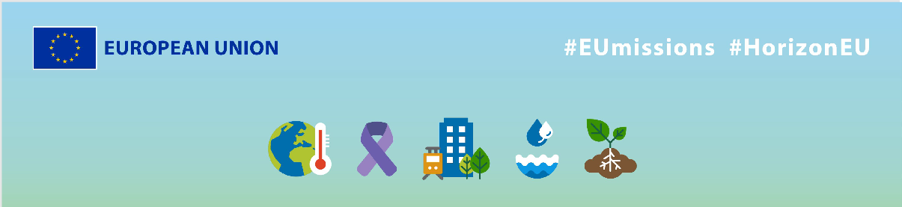
EU Missions - CIRCASA
Social media Package
KEY INFO:
EU platform:
ENG: https://ec.europa.eu/research-and-innovation/en/horizon-magazine/mission-put-carbon-back-soil
FR: https://ec.europa.eu/research-and-innovation/en/horizon-magazine/en-mission-pour-stocker-du-carbone-dans-les-sols
Related Instagram account: @eu_science | Main hashtag: #ResearchImpactEU
Related Facebook account: https://www.facebook.com/EUScienceInnov
Secondary hashtags: #EUGreenDeal
Creative assets: Static images, motion videos (EN, French)

- Suggested messages for promoting the EU Missions.
Platform | Copy
Twitter | Soil health for a better world 🌍💚  With EU funding, researcher Dr Jean-Francois Soussana is measuring organic carbon in #soil, helping farmers improve soil health & increasing agricultural productivity.  Discover his work 👇  #ResearchImpactEU
Did you know that soil stores carbon? 🌱

This is vital for our food production & fight against #climatechange. A new methodology has been developed for measuring organic carbon in soil, to help farmers adopt to improving soil health. 🌍

Read it here 👇

#ResearchImpactEU

Platform | Copy
Facebook | On a mission for healthy soil 🌍💚  Soil scientist Dr Jean-Francois Soussana is on a mission to increase carbon storage in agricultural soil. With EU funding and partners from 17 countries, his work helps to improve soil health for better agricultural productivity and a healthier diet.  Join us in supporting #ResearchImpactEU 🌱 ➡️ https://ec.europa.eu/research-and-innovation/en/horizon-magazine/mission-put-carbon-back-soil  #ResearchImpactEU #SoilHealth
Meet French soil scientist Dr Jean-Francois Soussana, who’s on a mission to improve soil health & increase carbon storage in agriculture. With EU funding and his innovative approach, farmers can increase their productivity and we can enjoy a healthier diet. 💚

Find out more about his work: https://ec.europa.eu/research-and-innovation/en/horizon-magazine/mission-put-carbon-back-soil

#ResearchImpactEU #SoilHealth

Platform | Copy
LinkedIn | Between 60 and 70% of EU soils are unhealthy. 🌱 Soil is a fragile resource that needs to be carefully managed and protected for future generations.  That’s why French soil scientist Dr Jean-Francois Soussana is on a mission to increase carbon storage in soil and promote better soil health.  Join us in supporting #ResearchImpactEU and the inspiring work of researchers like Antonio in creating a more sustainable future for all. 🌍  https://ec.europa.eu/research-and-innovation/en/horizon-magazine/mission-put-carbon-back-soil  #ResearchImpactEU #EUGreenDeal

Platform | Copy
Instagram | Did you know that soil stores carbon and that it plays a critical role in the fight against climate change? 🌍  Thanks to EU funding for research and innovation across the 🇪🇺, researchers like Dr Jean-Francois Soussana can develop innovative solutions to protect our planet’s future.  Read more about the results on the website!  ➡️ Link in bio.  #ResearchImpactEU #EUGreenDeal #EUResearch #research #innovation #soil #healthysoils #organic #agriculture #nature #farm #cultivate #farms #soilgrown #healthyfood #organicfarming #farming #ecosystem #healthyplanet #climatechange #environment #livingsoil #sustainability #biodiversity #SoilHealth #HealthySoil
Is "carbon farming" the future of agriculture? 🌱

French soil scientist Dr Jean-Francois Soussana is on a mission to store more carbon in soil & improve soil health. With funding from the 🇪🇺 and 22 partners from around the world, this project aims to make every farmer a "carbon farmer".

Learn more! Link in bio.

#ResearchImpactEU #EUGreenDeal #EUResearch #research #innovation #soil #healthysoils #organic #agriculture #nature #farm #cultivate #farms #soilgrown #healthyfood #organicfarming #farming #ecosystem #healthyplanet #climatechange #environment #livingsoil #sustainability #biodiversity #SoilHealth #HealthySoil

