EUROPEAN COMMISSION
Directorate-General for Research & Innovation

H2020 Programme

Guidance
PCP procurement documents

Version 2.1
07 January 2020

Disclaimer
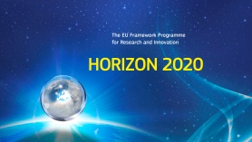
This document is aimed at assisting H2020 beneficiaries that implement PCP grants or normal H2020 grants with PCP. It is provided for information purposes only and is not intended to replace professional legal advice. Neither the Commission nor its executive agencies and funding bodies (or any person acting on their behalf) can be held responsible for the use made of this guidance document.
IMPORTANT NOTICE
This document is designed to help Horizon 2020 beneficiaries that implement PCP grants (or beneficiaries of normal H2020 grants with PCP) with their procurement documents (i.e. the request for tenders (RFT) and the notices for OJ publication on the TED — tenders electronic daily website).
The documents are presented in the order they should be prepared. (The RFT is shown before the contract notice because you should start preparing it well in advance.)
The notices are to be filled out online. The blue instructions in this document will help you.
The RFT can be downloaded and used as a template.
For more detailed information on PCP grants, see the H2020 AGA — Annotated Grant Agreement.

HISTORY OF CHANGES
Version | Publication date | Changes
1.0 | 08.03.2016 | - Initial version
2.0 | 3.10.2017 | - Merging of all PCP guidance documents in one.  Small presentational changes in the RFT.  Update to reflect the new online forms for the 2014 EU public procurement directives.
2.1 | 07.01.2020 | - Updated to VM 4.0 / PP > FTP / Updated gofund links

TABLE OF CONTENTS

1. Prior information notice (PIN) 4
2. Request for tenders (RFT) 15
3. Contract notice 56
4. Contract award notice 67

1. Prior information notice (PIN)

PCP PRIOR INFORMATION NOTICE (PIN) FOR THE OPEN MARKET CONSULTATION
How does this document work?
- Instructions are in blue.
- Recommended text is in black.
- Options are in blue [in square brackets].
- Data to be added is shown in [grey in square brackets].

The PIN has to be filled out online on the TED — tenders electronic daily website.
Use the English version of the simap standard form that is most appropriate for your type of organisation:
- for lead procurers in the public sector: ‘Prior information notice’
- for lead procurers in the utilities sector: ‘Periodic indicative notice — utilities’.
- for lead procurers in the defence and security sector: ‘Prior information notice for contracts in the field of defence and security’
In addition to English, you may publish the PIN (or a summary) in any other language(s).
Do not forget that a copy of the PIN must be submitted as a deliverable to the EU at the latest 5 days before publication (i.e. 5 days before the date of dispatch of the PIN notice — see Article 19 H2020 PCP-PPI MGA).

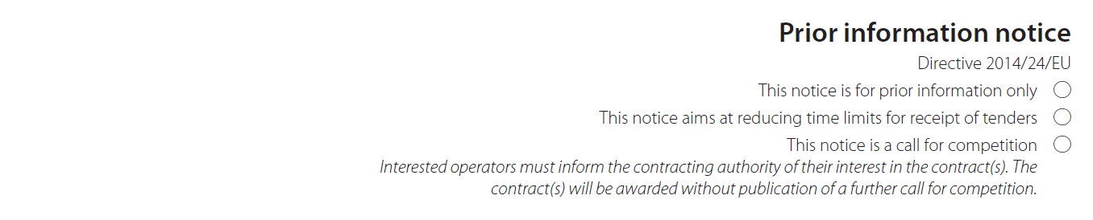
Select the first bullet, i.e. this notice is for prior information only.

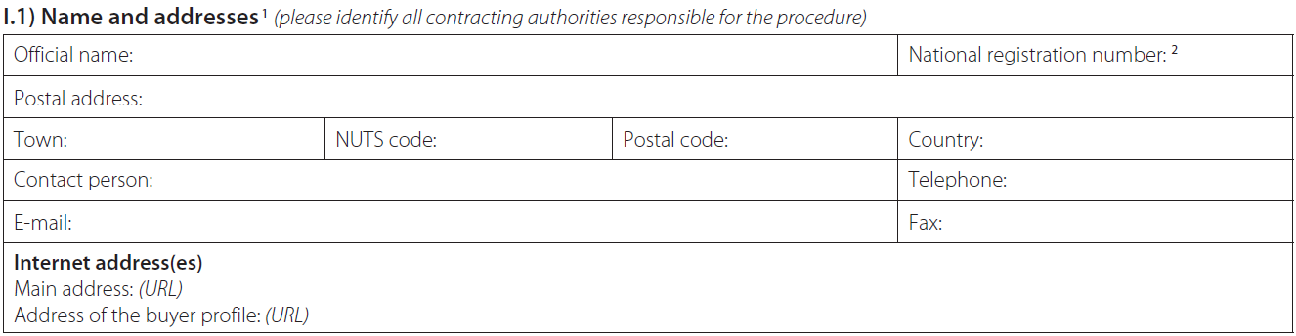
Give the contact details of the lead procurer and all the procurers in the buyers group.
In the internet addresses section, give the project website if you do not want to use the general website of the lead procurer and procurers in the buyers group. Use the address of the buyer profile of the lead procurer and procurers in the buyers group respectively.

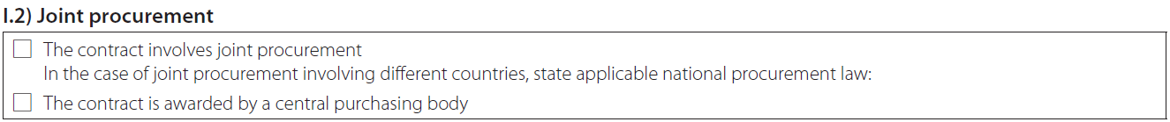
Select ‘yes’ for the first question, i.e. this contract involves joint procurement.
Insert the following text in the free text field for 'in the case of joint procurement involving different countries, state applicable national procurement law': ‘This pre-commercial procurement (PCP) is carried out by [insert name of the lead procurer] who was appointed as lead procurer to coordinate and lead the joint procurement in the name and on behalf of the buyers group listed in I.1. The applicable national procurement law is [insert the applicable national procurement law of the lead procurer]’.
Only select ‘yes’ for the second question, i.e. the contract is awarded by a central purchasing body, if this is the case for your PCP.

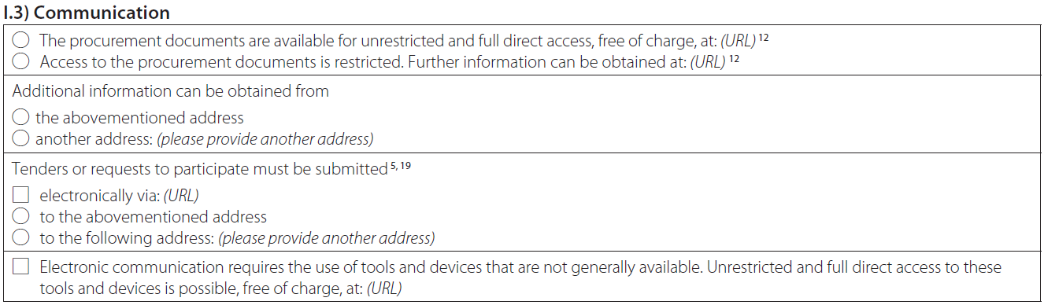
Select the applicable options to clarify how interested tenderers can obtain the procurement documents and additional information and how they must submit their tenders.

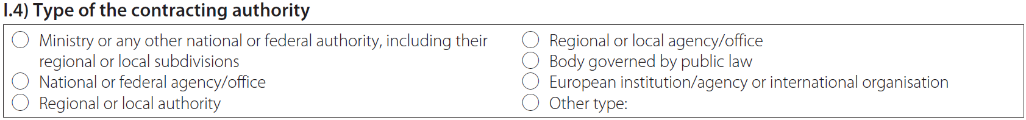
This section is to be filled in ONLY if the lead procurer is a contracting authority (i.e. NOT a contracting entity).

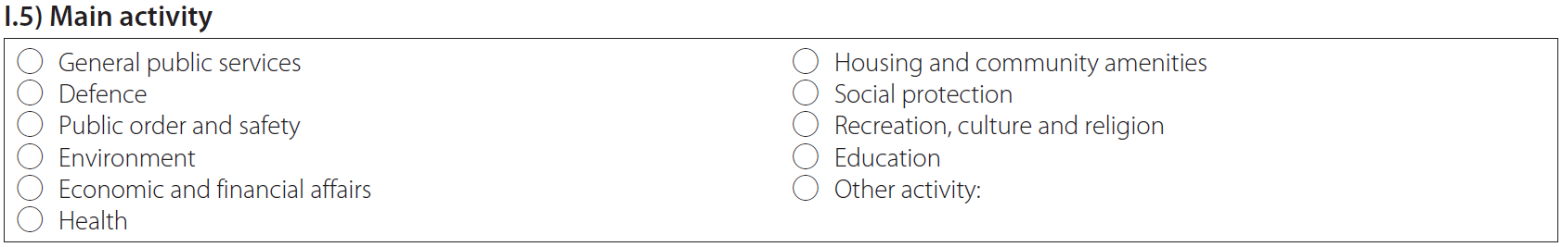
Select the lead procurer's main activities.

Use this title: ‘Pre–commercial procurement (PCP) to buy R&D (research and development) services to [specify in a few words the subject and scope of this PCP e.g. improving the energy efficiency of buildings]’.

Use CPV 73100000 for R&D services and additional other CPVs, if relevant to the object of the contract (e.g. CPV for medical equipment if the PCP is for medical equipment-related R&D, CPV for software development services if software-related R&D is needed).

Select ‘Services’ (not ‘Supplies’ or ‘Works’; PCP is an R&D services contract).

Use this text:
This PIN provides early information about the expected starting date and purchase volume for a pre-commercial procurement (PCP) and about the open market consultation that is organised in preparation of this procurement. More information about the open market consultation is provided in section II.2.14.
The procurement aims to trigger new solutions to be developed and tested to address the following challenge: [specify briefly the subject and scope of this PCP e.g. improving the energy efficiency of buildings].
[OPTION for PCPs with lots: As the common challenge exists of a number of sub-challenges, the procurement will be divided into the following lots, each corresponding to one sub-challenge:
- lot 1: [insert name of the sub-challenge to which the lot corresponds]
- lot 2:
- …]
The main technical challenges to be addressed [per lot] are: [indicate the main target quality/efficiency and/or functionality/performance improvements compared to the current state-of-the art technology – per lot, if applicable - e.g. 30 % energy efficiency improvement, 20% cost reduction, etc].
This PCP procurement is a joint procurement by different procurers across Europe that are all facing the same common challenge and are thus looking for similar solutions (so-called ‘buyers group’).
Provide any other relevant information. If needed to cope with the character-limit in the forms, distribute text also over ‘II.2.4) Description of the procurement’ and ‘II.2.14) Additional information’.

Give the total estimated value of the PCP framework agreement in euros/other currency (excluding VAT).

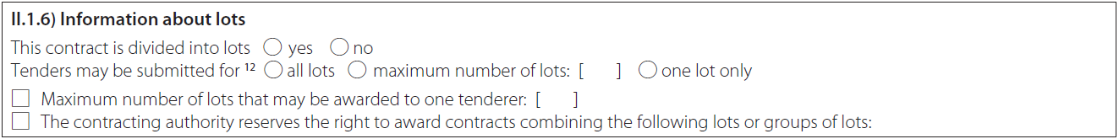
For PCPs with lots select ‘yes’. Consider carefully the consequences of restricting the number of lots that tenders may be submitted for, if applicable.

Only fill in if lots are used. Fill in the title and number of each lot.

Only fill in if lots are used. Use the CPV codes for each lot.

Do NOT fill out the fields ‘NUTS code’ and ‘main site or place of performance’. (The place of performance meant here is a specific place; it has nothing to do with the place of performance requirement under the H2020 grant agreement (i.e. to do at least 50% of the contracted R&D services in EU Member States or Horizon 2020 associated countries).

Provide any further relevant information on differences in scope per lot.
Use this text to describe the procurement:
The procurement will take the form of a pre-commercial procurement (PCP) under which R&D service contracts will be awarded to a number of R&D providers in parallel in a phased approach. This will make it possible to compare competing alternative solutions.
Each selected operator will be awarded a framework agreement that covers 3 R&D phases.
The 3 phases are:
- solution design
- prototyping
- original development and validation and testing of a limited set of first products or services.
After each phase, intermediate evaluations will be carried out to progressively select the best of the competing solutions. The contractors with the best-value-for-money solutions will be offered a specific contract for the next phase. [OPTION for PCPs with lots: The phased approach with parallel contracts and intermediate evaluations will be followed within each lot.]
Testing is expected to take place in [add the locations where testing is expected to take place, in particular test locations of the procurers and other additional test locations]. This testing may also serve as a first customer test reference for the contractors. The procurement is expected to start in [add expected starting date of the PCP] and end in [add expected completion date of the PCP].
The selected operators will retain ownership of the intellectual property rights (IPRs) that they generate during the PCP and will be able to use them to exploit the full market potential of the developed solutions i.e. beyond the procurement. [The market potential is estimated at [insert available figures about the potential total market size, i.e. beyond the procurers].]

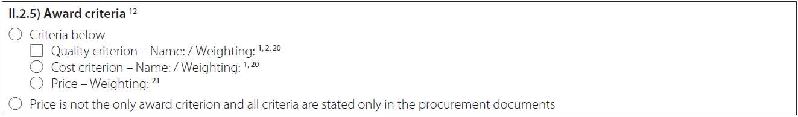
Select one of the 2 options (‘the criteria below’ OR ‘price is not the only award criterion and all criteria are stated only in the procurement documents’).
If you select the first option (‘the criteria below’), you must indicate all the criteria and their weighting.

Only fill in if lots are used.

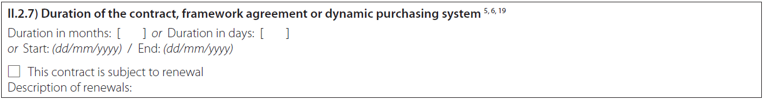
Enter the duration.

Select ‘No’. In PCP, the use of variants is not necessary, since the PCP approach inherently supports the development of several alternative solutions in parallel.

Complete if applicable.

Select ‘yes’.
Use this text:
This procurement receives funding from the European Union’s Horizon 2020 Research and Innovation Programme, under grant agreement No [insert number] — [insert project acronym] (see [insert project website]).
[OPTION if the procurement also receives funding from other EU programmes (i.e. if there are procurers in the buyers group whose financial contribution to the PCP budget is funded by other EU programmes, for example the European Structural and Investment Funds (ESIF)): The procurement receives funding from the [OPTION for EU programmes: European Union’s [insert name of EU programme]][OPTION for national programmes co-funded by the EU (e.g. by Regional Funds, Agricultural Funds): [insert name of national programme] co-financed by the European Union]:
- [insert beneficiary name and grant agreement number and acronym].]
The EU has given a grant for this procurement, but is not participating as a contracting authority in the procurement.
Note that it is not allowed for one and the same procurer to receive funding for his part of the PCP budget from different EU programmes (e.g. H2020 and ESIF). But it is possible for different procurers in the buyers group to receive funding from different EU sources.

All interested operators are invited to take part in an open market consultation (regardless of their geographic location, the size or governance structure of their organisation).
The open market consultation will provide you with an overview on the procurement objectives, the PCP process and the main clauses of the contract. You will also have the opportunity to ask questions. It will be held in English [and [add additional language(s), if any]].
The open market consultation will be organised in the form of a [insert the format e.g. meeting, online meeting, webinar or online Q&A forum, or a combination of those] that will be held:
- when: [insert date and time or period]
Choose the timing in such a way that you ensure that this PIN is published 2 months before the start of the open market consultation.
- where: [insert venue e.g. via the project website].
[Please register by [insert date].]
[OPTION if tenderers are allowed to supply additional confidential information in a face-to-face meeting during the open market consultation: Please indicate [by [insert date]] [together with the registration for the open market consultation] if you want to supply (under a non-disclosure agreement) additional confidential information that you do not wish to reveal in public during the open market consultation.]
Procurers must ensure equal treatment to all interested economic operators also in face-to-face meetings. Such meetings can therefore only be used to listen to the economic operators, but may not be used to give any additional information to the economic operators (except information also provided to all other operators).
[OPTION if for example a questionnaire is used: Please submit the following information [insert information, e.g. questionnaire] by [insert date].]
You can participate in the PCP call for tender even if you did not participate in the open market consultation.
Offers will be accepted in English [and [insert additional language(s), if any]]. All communication (before, during and after the procurement) will be carried out in English [and [add additional language(s), if any]].
All information provided during the open market consultation and other background information will be published online in English [and [add additional language(s), if any]] on the project website ([insert the project website]).
Provide any other relevant additional information.

Enter the date.

Complete if applicable. Avoid conditions that might unduly restrict participation.

Complete if applicable. Avoid conditions that might unduly restrict participation.

Complete if applicable. Avoid conditions that might unduly restrict participation.

The options for reserved contracts do not apply.

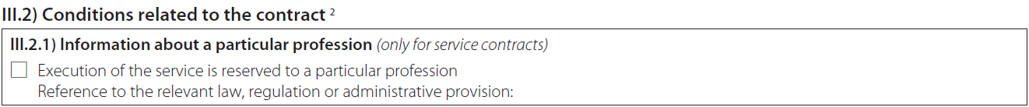
Complete if applicable. Avoid conditions that might unduly restrict participation.

Complete if applicable. Avoid conditions that might unduly restrict participation.

Select ‘yes’. Further explanation is provided in the section about the place of performance requirement in the PCP request for tenders.

Do not fill in. This is not a notice for a call for competition.

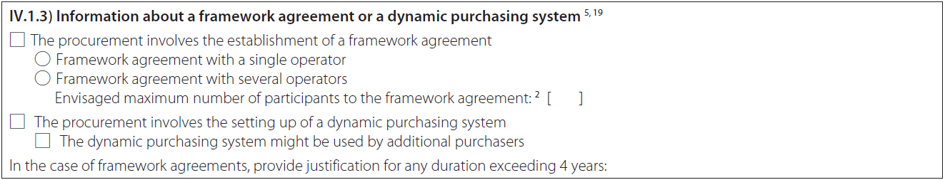
Select ‘Framework agreement with several operators’.
Do not fill in any number under ‘Envisaged maximum number of participants to the framework agreement’. In the free text field, state the minimum number of framework agreements that you plan to award (according to the request for tenders, there should be one per selected operator). For PCPs with lots, enter the total minimum number of framework agreements counted across all the lots.
Complete ‘The procurement involves the setting up of a dynamic purchasing system’ as applicable.

Select ‘no’.

Select ‘no’.

Do not fill in. This is not a notice for a call for competition.

Do not fill in. This is not a notice that is calling for tenders or requests to participate.

Enter the date.

Do not fill in. This is not a notice for a call for competition or a notice that aims at reducing time limits for receipt of tenders.

Use this text:
This procurement is exempted from the WTO Government Procurement Agreement (GPA), the EU public procurement directives and the national laws that implement them. This is because it concerns the procurement of R&D services where the benefits do not accrue exclusively to the contracting authority for its use in the conduct of its own affairs.
Publication of this contract notice in the EU Official Journal is not to be understood as a waiver of this exemption. Publication is made on a voluntary basis and the procurement will not follow the procedures under the EU public procurement directives, but rather the procedure described in the tender documentation.
This PIN is published to announce an open market consultation on a future procurement procedure. The PIN is not a commitment to procure.

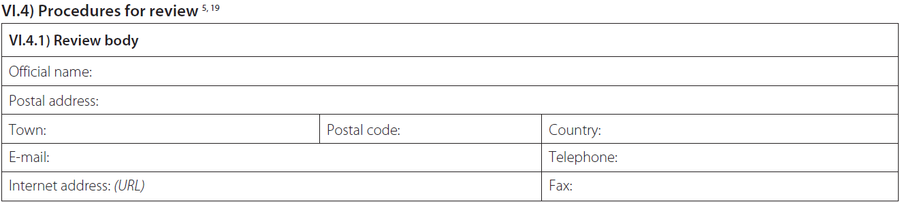
Do not fill in. This is not a notice for a call for competition or a notice that aims at reducing time limits for receipt of tenders.

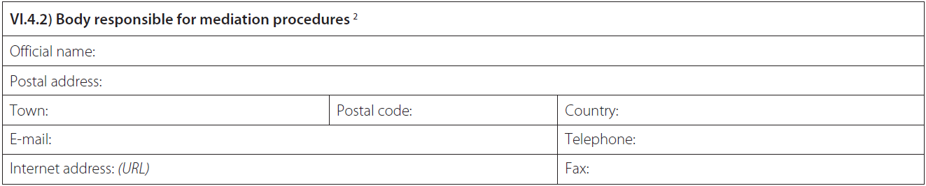
Do not fill in. This is not a notice for a call for competition or a notice that aims at reducing time limits for receipt of tenders.

Do not fill in. This is not a notice for a call for competition or a notice that aims at reducing time limits for receipt of tenders.

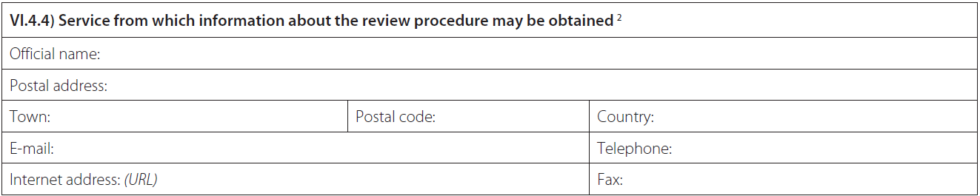
Do not fill in. This is not a notice for a call for competition or a notice that aims at reducing time limits for receipt of tenders.

Enter the date.

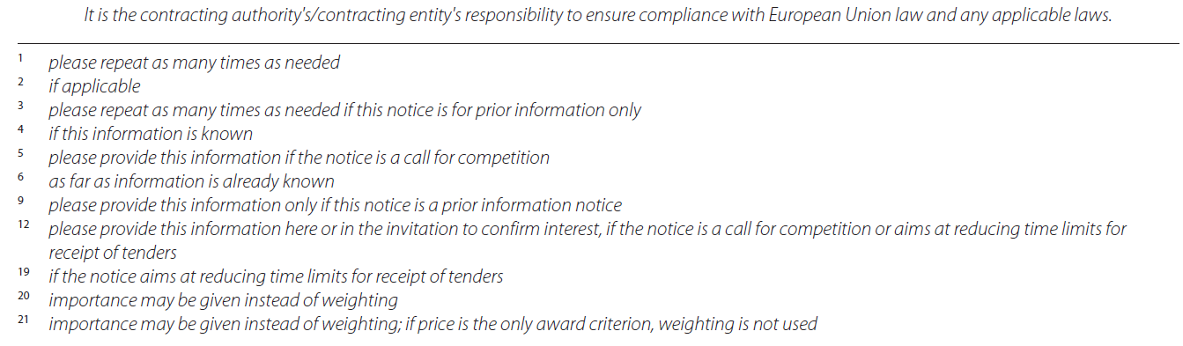

2. Request for tenders (RFT)

PCP REQUEST FOR TENDERS (RFT)

How does this document work?
- Instructions are in blue.
- Recommended text is in black.
- Options are in blue [in square brackets].
- Data to be added is shown in [grey in square brackets].

Since PCP requests do not fall under the EU public procurement directives, your normal templates may not work. You can use this document as a template (but please make sure that it works and complies with the applicable national law).

Disclaimer: This template is provided for information purposes only and is not intended to replace professional legal advice. It can be used as a starting point, but beneficiaries remain responsible for adapting it to their situation and checking compliance with national law.
Neither the European Commission nor its executive agencies and funding bodies (or any person acting on their behalf) can be held responsible for the use made of this template.

PCP REQUEST FOR TENDERS [Project acronym] — [full name of project]

Table of contents

1. General context & background 17
2. Tender profile: Services to be procured, tender closing time, procurers, contracting approach, budget, timetable and IPR 19
2.1 Description of services to be procured 19
2.2 Tender closing time 23
2.3 Procurer(s) [and other parties involved in the PCP] 23
2.4 Contracting approach 24
2.5 Total budget and budget distribution (per phase) 25
2.6 Time schedule 26
2.7 IPR issues 28
3. Evaluation of tenders 29
3.1 Eligible tenderers, joint tenders and subcontracting 29
3.2 Exclusion criteria 30
3.3 Selection criteria 30
3.4 Compliance criteria 31
3.5 Award criteria 35
3.6 Evaluation procedure: Opening of tenders & evaluation 37
4. Content & format of tenders 38
4.1 Format 38
4.2 Administrative section 38
4.3 Technical section 38
4.4 Financial section 39
5. Miscellaneous 40
5.1 Language 40
5.2 Tender constitutes binding offer 40
5.3 Unauthorized communication — Questions 40
5.4 Confidentiality 41
5.5 Contract implementation 41
5.6 Cancellation of the tender procedure 43
5.7 Procedures for appeal 43

Annex 1 Model framework agreement
Annex 2 Model specific contracts for phases 1, 2 and 3
Annex 3 Technical specification (optional; needed for example if the PCP challenge is too long to describe in the request for tenders or if there is a need to add specifications describing how the solutions to be developed in the PCP need to interact with the other systems/products/services at the procurers premises)
Annex 4 Templates for exclusion and on/off award criteria (if needed, e.g. declaration of honour for exclusion criteria, absence of conflict of interest and absence of incompatible other public financing)
Annex 5 Tender form (optional; only needed if the request for tenders does not specify the information requested from tenderers for each of the award criteria)
Annex 6 Template for reports or deliverables (optional; only needed if the request for tenders does not specify the minimum information contractors are required to submit in the reports or deliverables)

1. General context & background
Explain the general context:
This procurement is a pre-commercial procurement (PCP).
PCP means that public procurers challenge innovative players on the market, via an open, transparent and competitive process, to develop new solutions for a technologically demanding mid- to long-term challenge that is in the public interest and requires new R&D services.
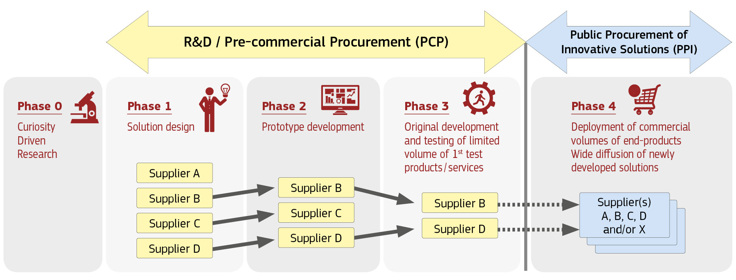

PCP is characterised by the following four features:
- Competitive development in phases to identify the solutions offering the best value for money
PCP targets situations that require radical innovation or R&D and for which there are typically no solutions on or close to the market yet. Different competing providers may have different ideas for solutions to the problem. As R&D is yet to take place, there is not yet any proof as to which of these potential alternative solutions would best meet customers' needs.
PCP therefore awards R&D contracts to a number of competing contractors at the same time, in order to compare different approaches to solving the problem. It thus offers innovators an opportunity to show how well their solution compares with others. It also allows a first customer test reference to be obtained from countries of the procurers that will test the solutions.
The R&D is split into 3 phases (solution design, prototyping, original development and testing of a limited set of ‘first’ products or services). Evaluations after each phase progressively identify the solutions that offer the best value for money and meet the customers’ needs. This phased approach allows successful contractors to improve their offers for the next phase based on lessons learnt and feedback from procurers in the previous phase. Using a phased approach with gradually growing contract sizes per phase also makes it easier for smaller companies to participate in the PCP and enables SMEs to grow their business step-by-step with each phase.
Depending on the outcome of the PCP, procurers may or may not decide to follow-up the PCP with a public procurement to deploy the innovative solutions (PPI).
- Public procurement of R&D services
PCP addresses mid- to long-term public procurement needs for which either no commercially stable solutions yet exist on the market, or existing solutions exhibit structural shortcomings that it requires further R&D to resolve. PCP is a way for procurers to trigger the market to develop new solutions that address these shortcomings. PCP focuses on specific identified needs and provides customer feedback to businesses from the early stages of R&D. This improves the likelihood of commercial exploitation of the newly developed solutions.
PCP is explained in the PCP communication COM/2007/799 and the associated staff working document SEC/2007/1668. The R&D services can cover research and development activities ranging from solution exploration and design, to prototyping, right through to the original development of a limited set of ‘first’ products or services in the form of a test series. Original development of a first product or service may include limited production or supply in order to incorporate the results of field-testing and demonstrate that the product or service is suitable for production or supply in quantity to acceptable quality standards. R&D does not include quantity production or supply to establish the commercial viability or to recover R&D costs. It also excludes commercial development activities such as incremental adaptations or routine or periodic changes to existing products, services, production lines, processes or other operations in progress, even if such changes may constitute improvements.
- Open, transparent, non-discriminatory approach — No large-scale deployments
PCP is open to all operators on equal terms, regardless of the size, geographical location or governance structure. There is, however, a place of performance requirement that they must perform a predefined minimum percentage of the contracted R&D services in EU Member States or Horizon 2020 associated countries.
Any subsequent public procurement of innovative solutions (PPI), for the supply of commercial volumes of the solutions, will be carried out under a separate procurement procedure. Providers that did not take part in this PCP (or were not chosen to go through as far as the last phase) will thus still be able to compete on an equal basis in any subsequent procurement looking for contractors to provide a solution on a commercial scale.
Note:
Please note that the minimum percentage should be set by the procurers so that at least 50% of the contracted R&D services are performed in EU Member States or Horizon 2020 associated countries.
- Sharing of IPR-related risks and benefits under market conditions
PCP procures R&D services at market price, thus providing contractors with a transparent, competitive and reliable source of financing for the early stages of their research and development. Giving each contractor the ownership of the IPRs attached to the results it generates during the PCP means that they can widely exploit the newly developed solutions commercially. In return, the tendered price must contain a financial compensation for keeping the IPR ownership compared to the case where the IPRs would be transferred to the procurers (the tendered price must be the ‘non-exclusive development price’). Moreover, the procurers must receive rights to use the R&D results for internal use and licensing rights subject to certain conditions.
For more information, see PCP on the Europa website.
- Exemption from EU public procurement directives, the WTO Government Procurement Agreement (GPA) and EU state aid rules
PCP procurements are exempted from the EU public procurement directives because the procurers do not retain all the benefits of the R&D (the IPR ownership stays with the contractors).
They are also exempted from the WTO Government Procurement Agreement (GPA) because this Agreement does not cover R&D services (the PCP being limited to such services — and any subsequent PPI procurements relating to commercial-scale supply of such solutions not being part of the PCP procurement).
PCP procurements do not constitute state aid under the EU state aid rules if they are implemented as defined in the PCP communication, namely by following an open, transparent, competitive procedure with risk- and benefit-sharing at market price. (The division of all rights and obligations (including IPRs) and the selection and award criteria for all phases must be published at the outset; the PCP must be limited to R&D services and clearly separated from any potential follow-up PPI procurements; PCP contractors may not be given any preferential treatment in a subsequent procurement for provision of the final products or services on a commercial scale.)
- Open market consultation
The start of this PCP procurement was preceded by an open market consultation (see summary and Q&A on [insert project website]).
- EU funding
This PCP procurement is part of a project that is funded by the European Union’s Horizon 2020 Research and Innovation Programme, under grant agreement No [insert number] — [insert project acronym] (see [insert project website]).
[OPTION if the procurement also receives funding from other EU programmes (e.g. if there are procurers in the buyers group whose financial contribution to the PCP budget is funded by other EU programmes, for example the European Structural and Investment Funds (ESIF) ): Moreover, it receives funding from the [OPTION for EU programmes: European Union’s [insert name of EU programme]][OPTION for national programmes co-funded by the EU (e.g. by Regional Funds, Agricultural Funds): [insert name of national programme] co-financed by the European Union]:
- [insert beneficiary name and grant agreement number and acronym].]
The contracts will therefore be subject to additional rules that come from the EU grant(s).
For more information, see ‘innovation procurement’ and ‘links to regional policy’ in the Funding & Tenders Portal Online Manual.
Attention: The EU is not participating as a contracting authority in this procurement.
Note:
It is not allowed for one and the same procurer to receive funding for his part of the PCP budget from different EU programmes (e.g. H2020 and ESIF). But it is possible for different procurers in the buyers group to receive funding from different EU sources.

2. Tender profile: Services to be procured, tender closing time, procurers, contracting approach, budget, timetable and IPR

2.1 Description of services to be procured

PCP challenge
Explain the common challenge to be addressed and the scope of the R&D services to be procured:
This procurement is for R&D services to develop solutions to tackle the following challenge: [specify briefly the subject and scope of this PCP, e.g. improving the energy efficiency of buildings] [OPTION for PCPs with sub-challenges: and the following sub-challenges: [specify the sub-challenges].]
This is a common challenge shared by all procurers in the buyers group. [OPTION for PCPs with sub-challenges: All sub-challenges are shared by all procurers in the buyers group.]
The main quality/efficiency improvements sought for: [indicate the target quality/efficiency and/or functionality/performance improvements, compared to the current best available solutions, e.g. 30 % energy efficiency improvement, interoperability]
[OPTION for PCPs that include the purchase of some of the R&D results: The PCP includes the purchase of a limited set of [prototype(s)] [and][or] [first test products or services] resulting from the R&D.
Explain clearly who is procuring which/how many prototypes/test products and where and when they need to be delivered.]
Explain the drivers behind the PCP (i.e. why the solutions are needed: to improve which aspects in the quality and efficiency of the public services that the procurer(s) is/are responsible for; to meet regulatory requirements and/or to meet a need for standardisation or certification). Explain also why current solutions don’t meet the need.
Note:
Ensure that the targets for the quality/efficiency improvements are set so that they clearly enable to make a step-change beyond what currently available solutions are able to deliver. Use functional or performance-based specifications that include technical minimum requirements that innovative solutions must meet, rather than prescribing a specific solution. Take into account your analysis on the shortcomings of solutions available on the market, the analysis of the needs of the procurers and the outcome of the open market consultation. Alert tenderers as far as possible to any specific requirements of the subsequent phases (e.g. for phase 2: local technical and safety conditions where prototype testing is planned to take place at one of the procurers' labs; for phase 3: local technical, ethics and safety/security requirements for field-testing). Provide the metrics or indicators that the procurers will use to evaluate and validate, at the end of each PCP phase, to what extent each competing solution has made progress towards reaching the targets.
For PCPs that include the purchase of a limited set of prototype(s) or first test products or services resulting from the R&D, specify why these are needed for R&D purposes (e.g. if the existing solution used by the procurers has to be destroyed in order to test the new solutions developed during the PCP and/or the procurers need to carry out further testing of the newly developed solutions after the PCP is finished). Specify which and how many prototypes or first products are to be procured.

Expected outcomes (per phase)
Describe the objectives, their associated output and results and the tasks to be carried out (milestones and deliverables) for each of the 3 phases (solution design, prototyping, original development and testing of a limited set of ‘first’ products or services):
Expected outcomes
Phase 1: Solution design
 | Objective: | Perform research to:  1. elaborate the solution design and determine the approach to be taken to develop the new solutions and  2. demonstrate the technical, financial and commercial feasibility of the proposed concepts and approach to meet the procurement need
 | Output and results:
 | Milestones and deliverables |  | By when? | How? | Output and results
 | Milestones: | M1.1) [milestone 1.1] | [dd.mm.yyyy] | [e.g.sent by email to lead procurer, on-site visit] | …
 |  | M1.2) [milestone 1.2] | … | … | …
 |  | …..
 | Deliverables: | D1.1)[deliverable 1.1]
 |  | D1.1a)[interim deliverable 1.1a]
 |  | D1.1b)[interim deliverable 1.1b]
 |  | D1.2)[deliverable 1.2]
 |  | D1.3)[deliverable 1.3]
 |  | D1.3a)[interim deliverable 1.3a]
 |  | D1.4)[deliverable 1.4]
 |  | …
Phase 2: Prototyping
 | Objective: | Develop, demonstrate and validate prototypes in lab conditions
 | Output and results:
 | Milestones and deliverables |  | By when? | How? | Output and results
 | Milestones: | M2.1) [milestone 2.1] | [dd.mm.yyyy] | [e.g.sent by email to lead procurer, on-site visit] | …
 |  | M2.2) [milestone 2.2] | … | …
 |  | …..
 | Deliverables: | D2.1)[deliverable 2.1]
 |  | D2.1a)[interim deliverable 2.1a]
 |  | D2.1b)[interim deliverable 2.1b]
 |  | D2.2)[deliverable 2.2]
 |  | D2.3)[deliverable 2.3]
 |  | D2.3a)[interim deliverable 2.3a]
 |  | D2.4)[deliverable 2.4]
 |  | …
 | Points to be addressed in report:
Phase 3: Development & testing
 | Objective: | Original development and field-testing of a limited set of first [products] [services] (the test series)
 | Output and results:
 | Milestones and deliverables |  | By when? | How? | Output and results
 | Milestones: | M3.1) [milestone 3.1] | [dd.mm.yyyy] | [e.g.sent by email to lead procurer, on-site visit]
 |  | M3.2) [milestone 3.2] | …
 |  | …..
 | Deliverables: | D3.1)[deliverable 3.1]
 |  | D3.1a)[interim deliverable 3.1a]
 |  | D3.1b)[interim deliverable 3.1b]
 |  | D3.2)[deliverable 3.2]
 |  | D3.3)[deliverable 3.3]
 |  | D3.3a)[interim deliverable 3.3a]
 |  | D3.4)[deliverable 3.4]
 |  | …
 | Points to be addressed in report:

Specify the tasks and expected outcomes of each milestone and deliverable in more detail:
M1.1)
M1.2) …
D1.1)
D1.2) …
Note:
Do not forget to include the following deliverables:
- for each end-of phase deliverable, a section that explains the IPR measures taken by the contractor to protect the results and lists the names and location of personnel that carried out the R&D activities
- at the start of phase 1, phase 1 project abstracts (in the format required by the EU for publication)
- at the end of phase 1, a summary of the main results achieved by each contractor and conclusions from phase 1 (in the format required by the EU for publication)
- at the start of phase 2, phase 2 project abstracts (in the format required by the EU for publication)
- at the end of phase 2, a summary of the main results achieved by each contractor and conclusions from phase 2 (in the format required by the EU for publication)
- at the end of phase 2, a demonstration to the EU of the prototypes developed during phase 2
- at the start of phase 3, phase 3 project abstracts (in the format required by the EU for publication)
- at the end of phase 3, a summary of the main results achieved by each contractor and conclusions from the PCP in the format required by the EU for publication)
- a deadline by which the contractors must agree on the text for the summary of overall lessons learnt and results achieved from the PCP, for publication
- at the end of phase 3, a final demonstration to the EU of the final products or services developed during the 3 phases.
For phase 2, specify whether prototype validation is expected to be done at the premises of the procurer(s) or the contractor. For PCPs with lots, clarify if there is a need for validating prototypes of contractors from different lots together (to test dependencies between lots and to ensure that building blocks developed in different lots will ultimately work together as expected).
For phase 3, provide information on the timing and the site(s) where the procurers will carry out the testing and validation of the test series. State clearly how many solutions each contractor is expected to develop for the limited test series. Specify whether contractors need to set aside resources for testing the solutions on the premises of all or only some procurers. Indicate whether they need to plan to have resources available to carry out testing sequentially or in parallel at the different sites. For PCPs with lots, clarify if there is a need for field testing of products/services developed by contractors in different lots together (to test dependencies between lots and to ensure that building blocks developed in different lots ultimately work together as expected).

2.2 Tender closing time
Tender closing time will be: [date and hour, e.g. 5 September 2017, 17.00h]

2.3 Procurer(s) [and other parties involved in the PCP]
Explain the procurer set-up:
This procurement relates to a joint PCP that will be carried out by the following lead procurer: [name and country of the lead procurer]
The lead procurer is appointed to coordinate and lead the joint PCP, and to sign and award the framework agreement and the specific contracts for all phases of the PCP, in the name and on behalf of the following buyers group:
- [name and country of the member 1 of the buyers group]
- [name and country of the member 2 of the buyers group]
- …
The lead procurer is [not] part of the buyers group.
The procurers in the buyers group have the following background/profile/responsibilities for:
- [name 1]: [insert responsibilities]
- [name 2]: [insert responsibilities]
- ……
Explain the responsibilities the procurers in the buyers group have in their respective countries with regards to setting the acquisition and/or regulatory strategy for the innovative solutions. (For example, a regional health procurer should explain here for how many hospitals in his region he is responsible to procure solutions, how many patients are served by these hospitals, how many of these patients are affected by the problem that the PCP aspires to solve etc. A regional ministry of health should explain for how many citizens (e.g. specific types of patients) it is defining regulations that affect the deployment of solutions in the healthcare sector in its region.)
[For PCPs with third parties providing in-kind contributions to the PCP, add: The following entities are not in the buyers group but participate as third parties giving in-kind contributions to the procurers for the purpose of carrying out the PCP:
- [name, country]
- [name, country]
- …
Provide a short description of the responsibilities of the third parties, the type of resources they will put at the disposal of the PCP, and the rights and obligations that the third parties will assume with respect to the PCP, e.g. the type of information they will have access to, and whether they will participate in certain parts of the PCP implementation such as testing. Explain that they will not have rights to results or IPRs.]
[For PCPs with preferred partners, add: The following entities are participating as preferred partners with an interest in the PCP, but without being part of the buyers group or giving in-kind contributions for carrying out the PCP:
- [name, country]
- [name, country]
- [name, country]
Explain briefly how the preferred partners will be kept informed about the PCP, what type of information concerning the PCP they will have access to and whether they will attend certain parts of the PCP implementation such as product demonstrations and testing. Explain that they will not have rights to results or IPRs.]
Note:
Use the roles that come from the H2020 grant agreement:
Lead procurer — Appointed by the buyers group to organise and lead the joint procurement; also part of the buyers group, if he contributes to the procurement budget.
Buyers group — The group of procurers that contribute to the procurement budget.
For procurers that participate in the EU grant as sole participants (i.e. entities representing several members, e.g. a central purchasing body, a European research infrastructure consortium or a European regional cooperation group), indicate which of the members contribute to the PCP procurement budget.
Third parties that provide in-kind contributions to the PCP — Entities that are neither lead procurer nor part of the buyers group, but that give in-kind contributions to the PCP.
Preferred partners — Entities that are neither lead procurer nor part of the buyers group nor third parties providing in-kind contributions, but that have a special interest in closely following the PCP (entities involved in the H2020 grant ‘related additional networking activities’; other potential buyers for the solutions that have expressed a special interest in the PCP).

2.4 Contracting approach
Explain the contracting approach:
The PCP will be implemented by means of a framework agreement with call-offs for specific contracts for each of the 3 R&D phases (altogether ‘contracts’).
Following the tendering stage, a framework agreement and a specific contract for phase 1 will be awarded to a minimum of [indicate number: minimum 3] contractors.
A call-off will be organised for phase 2, with the aim of awarding a minimum of [indicate number] phase 2 contracts. Only offers from contractors that successfully completed phase 1 will be eligible for phase 2. The procurers will validate the phase 2 prototypes [identify the site: in the procurer's labs or the contractors' lab].
A second call-off will be organised for phase 3, with the aim of awarding a minimum of [indicate number: minimum 2] phase 3 contracts. Only offers from contractors that successfully completed phase 2 will be eligible for phase 3. Phase 3 field-testing is expected to take place [insert where (e.g. at all the sites where procurers of the buyers group are based)].
The framework agreement will set all the framework conditions for the entire duration of the PCP (covering all the phases). There will be no renegotiation. The framework agreement will remain binding for the duration of all phases for which contractors remain in the PCP. Tenderers that are awarded a framework agreement will also be awarded a specific contract for phase 1 (evaluation of tenders for the framework agreement and phase 1 are combined). Tenderers are therefore asked not only to submit their detailed offer for phase 1, but also to state their goals, and to outline their plans (including price conditions) for phases 2 and 3 — thus giving specific details of the steps that would lead to commercial exploitation of the R&D results.
Provide a brief overview of the overall timing of the PCP (including the expected start and finish dates) and of the individual phases.
Indicate clearly (in this section and in the time schedule table below) if:
  - the offers for the next phase will be requested together with the end-of phase deliverables for the previous phase (In this case all contractors of the previous phase will be invited to make offers for the next phase, successful completion of the previous phase is evaluated before evaluating the offers for the next phase, to determine which offers are eligible to proceed to the evaluation of offers for the next phase)
or if
  - the offers for the next phase will be requested only after the end-of phase deliverables of the previous phase and after the contractors have been informed of successful completion of the previous phase (In this case only the contractors that successfully completed the previous phase will be invited to make offers for the next phase.)

2.5 Total budget and budget distribution (per phase)
Explain the budgetary set-up, specifying in particular:
- the total budget for the PCP
- the maximum budget per phase (and per lot, where applicable)
- the maximum budget per tender per phase (and per lot, where applicable)
- the ‘minimum’ number of contractors that are expected to be selected per phase (and per lot, where applicable)
- the maximum duration per phase.
Provide for the flexibility to transfer leftover budget from one phase to the next phase in case you receive offers with lower price than expected: For phases 1 and 2, contracts will be financed until the remaining budget is insufficient to fund the next best tender. The exact number of contracts finally awarded will thus depend on the prices offered and the number of tenders passing the evaluation. As leftover budget from the previous phase will be transferred to the next phase, the total budget available for phases 2 and 3 may eventually be higher than stated here (but the maximum budget per contractor for phases 2 and 3 will remain the same). The lower the average price of tenders, the more contracts can be awarded. However, the total value of the contracts awarded can also be lower than initially expected if there are fewer tenders than expected that meet the minimum evaluation criteria.
Note:
State the minimum instead of the maximum expected number of contractors, to allow more contracts than initially expected to be awarded if there are more high quality tenders at cheaper prices than expected.
Ensure that the budget distribution of the PCP:
- starts with minimum of 3 contractors and ends with a minimum of 2 contractors in the last phase
- contains a minimum of 3 phases that between them cover the entire PCP lifecycle: solution exploration; prototyping; initial development and testing of a limited set of first products or services. (If needed, each phase may be split up into more phases, e.g. in complex PCPs.)

2.6 Time schedule
Explain the planned time schedule:
Planned time schedule
Date | Activity
 | First tender procedure (framework agreement and phase 1 contracts)
[dd.mm.yyyy] | Publication of contract notice in TED
… | Deadline for requesting tender documents
 | Deadline for submitting questions about tender documents
 | Deadline for lead procurer to publish replies to questions (Q&A document)
 | Deadline for submission of tenders for the framework agreement and phase 1
 | Opening of tenders
 | Tenderers notified of decision on awarding contracts
 | Signing of framework agreements and phase 1 specific contracts
 | Publication of contract award notice in TED
 | Implementation of phase 1
 | Start of phase 1
 | Names of winning phase 1 contractors and their project abstracts to be sent to EU (template) and published on [insert acronym] PCP project website
 | Visit of phase 1 contractors to the premises(s) of the procurer(s) to learn about the operational boundary conditions governing the design of targeted solutions
 | Deadline for phase 1 interim milestone(s)/interim deliverable(s)
 | Visit(s) of the phase 1 supervisor/monitoring team to the contractor's premises to check completion of milestone(s)/interim deliverable(s)
 | Feedback from phase 1 supervisor/monitoring team on phase 1 interim milestone(s)/interim deliverable(s)
 | Interim payments (if applicable)
 | Deadline for phase 1 final milestone(s)/final report/deliverable(s)
 | Assessment of phase 1 final milestone(s)/final report/deliverable(s)
 | Phase 1 contractors notified as to whether they have completed this phase satisfactorily and successfully
 | End of phase 1
 | Summary of the results and conclusions achieved by each contractor during the phase sent to EU (template
 | Payment of balance for phase 1 to contractors that completed this phase satisfactorily
 | Second tender procedure (call-off for phase 2)
 | Launch call-off for phase 2 (only offers from contractors that successfully completed phase 1 are eligible)
 | Deadline for submitting questions on phase 2 call-off documents
 | Deadline for lead procurer to circulate replies to questions to phase 2 tenderers
 | Deadline for submitting phase 2 offers
 | Opening of phase 2 offers
 | Contractors notified of decision on awarding phase 2 contracts
 | Signing of phase 2 specific contracts
 | Implementation phase 2
 | Start of phase 2
 | Names of winning phase 2 contractors and their project abstracts to be sent to EU (template) and published on [insert acronym] PCP project website
 | Visit of phase 2 contractors to the premises(s) of the procurer(s), where applicable
 | Deadline for phase 2 interim milestone(s)/deliverable(s)
 | Visit(s) of the phase 2 supervisor/monitoring team to the contractor's premises to check completion of interim milestone(s)/deliverable(s)
 | Feedback from phase 2 supervisor/monitoring team on phase 2 interim milestone(s)/deliverable(s)
 | Interim payments (if applicable)
 | Lab testing of the prototype developed during phase 2
 | Feedback from phase 2 supervisor/monitoring team on lab testing of the prototype
 | Deadline for submission of phase 2 final milestone(s)/final report /deliverable(s)
 | Demonstration of prototype for the EU technical review of phase 2
 | Assessment of phase 2 final milestone(s)/final report/deliverable(s)
 | Phase 2 contractors notified as to whether they have completed this phase satisfactorily and successfully
 | End of phase 2
 | Summary of the results and conclusions achieved by each contractor during the phase sent to EU (template
 | Payment of balance for phase 2 to contractors that completed this phase satisfactorily
 | Third tender procedure (call-off for phase 3)
 | Launch call-off for phase 3 (only offers from contractors that successfully completed phase 2 are eligible)
 | Deadline for submitting questions about phase 3 call-off documents
 | Deadline for lead procurer to circulate replies to questions to phase 3 tenderers
 | Deadline for submitting phase 3 offers
 | Opening of phase 3 offers
 | Contractors notified of decision to award phase 3 contracts
 | Signing of phase 3 specific contracts
 | Implementation phase 3
 | Start of phase 3
 | Names of winning phase 3 contractors and their project abstracts to be sent to EU (template) and published on [insert acronym] PCP project website
 | Visit of phase 3 contractors to premises(s) of procurer(s), where applicable
 | Deadline for phase 3 interim milestone(s)/deliverable(s)
 | Visit(s) of the phase 3 /monitoring team to the contractor's premises to check completion of phase 3 interim milestone(s)/deliverable(s)
 | Feedback from phase 3 monitoring supervisor/monitoring team on phase 3 interim milestone(s)/deliverable(s)
 | Interim payments (if applicable)
 | Field-testing of products/services developed during phase 3
 | Feedback from phase 3 supervisor/monitoring team on field-testing of the products/services
 | Deadline for submission of phase 3 final milestone(s)/final report/ deliverable(s)
 | Final demonstration of products/services developed during phase 3 (including to EU representatives)
 | Assessment of phase 3 final milestone(s)/final report/deliverable(s)
 | Phase 3 contractors notified as to whether they have completed this phase satisfactorily and successfully
 | End of phase 3
 | Summary of the results and conclusions achieved by each contractor during the PCP sent to EU for publication purposes (template).
 | Payment of balance for phase 3 to contractors that completed this phase satisfactorily

2.7 IPR issues
Ownership of results (foreground)
Each contractor will keep ownership of the IPRs attached to the results they generate during the PCP implementation. The tendered price is expected to take this into account.
The ownership of the IPRs will be subject to the following:
- the buyers group has the right to:
  - access results, on a royalty-free basis, for their own use
  - grant (or to require the contractors to grant) non-exclusive licences to third parties to exploit the results under fair and reasonable conditions (without the right to sub-license)
- the buyers group has the right to require the contractors to transfer ownership of the IPRs if the contractors fail to comply with their obligation to commercially exploit the results (see below) or use the results to the detriment of the public interest (including security interests).
Commercial exploitation of results
[The market potential of the results is estimated at [insert available figures for the expected size and type of the potential total market size, i.e. beyond the PCP procurers].]
The contractors are expected to start commercial exploitation of the results at the latest [insert number of years (minimum of four years after the end of the H2020 grant)] years after the end of the framework agreement.
Provide information about:
- whether contractors are required to undertake specific activities beyond product development to commercially exploit the results, e.g. certification of solutions or contribution to standardisation
- activities that the procurers themselves plan to undertake to help remove barriers to the introduction onto the market of the solutions to be developed during the PCP (e.g. promotion of R&D results among other public procurers, contribution made by the demand side to regulation, standardisation, and certification).
The feasibility of the business plan to commercially exploit the R&D results will be assessed as part of the award criteria.
Declaration of pre-existing rights (background)
The ownership of pre-existing rights will remain unchanged.
In order to be able to distinguish clearly between results and pre-existing rights (and to establish which pre-existing rights are held by whom):
- tenderers are requested to list the pre-existing rights for their proposed solution in their offers
- procurers and contractors will be requested to establish a list of pre-existing rights to be used before the start of the contract.
[OPTION if already known that NO relevant background is held by lead procurer, buyers group and third parties providing in-kind contributions: The procurers [and third parties providing in-kind contributions to the PCP] do not hold any pre-existing rights relevant to the PCP contracts.]
[OPTION if already known that relevant background is held by lead procurer, buyers group or third parties providing in-kind contributions: The following pre-existing rights are already known: [list all pre-existing rights that tenderers should be aware about to prepare their offer — and specify those that are available for use and those that must be used to build upon for carrying out the R&D for the PCP].]
The framework agreement will contain a provision that describes in more detail the rights and obligations of the different parties regarding the pre-existing rights and results.
Note: The background meant here is not the same background as in the H2020 grant agreement (here it relates to the procurement; there it relates to the grant agreement).

3. Evaluation of tenders

3.1 Eligible tenderers, joint tenders and subcontracting
Explain that the call for tenders is open to all operators (companies or other type of legal entities):
Participation in the tendering procedure is open on equal terms to all types of operators from any country, regardless of their geographic location, size or governance structure.
Tenders may be submitted by a single entity or in collaboration with others. The latter can involve either submitting a joint tender or subcontracting, or a combination of the 2 approaches.

For joint tenders:
- explain that the group of tenderers must assume joint and several liability for the performance of the contract
- require that the group of tenderers must mandate one of them with the power to sign the framework agreement and specific contracts provide in their name and on their behalf (‘lead contractor’)

For subcontracting:
- specify if there are restrictions on the allowed amount(s) that can be subcontracted
- indicate the provisions of national law that apply to subcontracting
- explain that the tender must mention which parts of the contract will be subcontracted
- specify that the contractors remain fully liable to the procurers for the performance of the contract (and that this is the reason why subcontracts must reflect the rules of the H2020 grant agreement, including as relates to the place of performance, the definition of R&D services, confidentiality, results and IPRs, the visibility of EU funding, conflicts of interest, language, obligation to provide information and keep records, audits and checks by the EU, the processing of personal data, liability for damages and ethics and security requirements).
Participation in the open market consultation is not a condition for submitting a tender.
Attention:
There will, however, be a requirement relating to the place of performance of the R&D services (see below).
For phases 2 and 3, participation is limited to tenderers that successfully completed the preceding phase.

3.2 Exclusion criteria
List the exclusion criteria and the evidence to be provided that will be used for the evaluation of the tender.
The exclusion criteria are as follows:
Exclusion criteria | Evidence
Include conflict of interest and all mandatory (and if applicable, optional) exclusion criteria according to national law. | Specify the required evidence for each criterion.
A) Conflict of Interest | A) a declaration of honour for 'absence of conflict of interest'
B) …

Tenderers that do not comply with these criteria will be excluded.
Explain each exclusion criterion in more detail:
A) Conflict of interest
Tenderers that are subject to a conflict of interest may be excluded. If there is a potential conflict of interest, tenderers must immediately notify the lead procurer in writing.
A conflict of interest covers both personal and professional conflicts.
Personal conflicts are any situation where the impartial and objective evaluation of tenders and/or implementation of the contract is compromised for reasons relating to economic interests, political or national affinity, family, personal life (e.g. family of emotional ties) or any other shared interest.
Professional conflicts are any situation in which the contractor’s (previous or ongoing) professional activities affect the impartial and objective evaluation of tenders and/or implementation of the contract.
Attention: If an actual or potential conflict of interest arises at a later stage (i.e. during the implementation of the contract), the contractor must contact the lead procurer, who is required to notify the EU and to take steps to rectify the situation. The EU may verify the measures taken and require additional information to be provided and/or further measures to be taken.
B) …

3.3 Selection criteria
List the selection criteria and the evidence to be provided.
The selection criteria are as follows:
Selection criteria | Evidence
A) Ability to perform R&D up to original development of the first products or services and to commercially exploit the results of the PCP, including intangible results in particular IPRs | Description of the capacity, materials and equipment that are available to the tenderer for research, prototyping and limited production and supply of the first set of products or services  Description of the financial and organisational structures that are available to the tenderer for management, exploitation and transfer of IPRs and for generating revenue by marketing commercial applications of the results
B) …

Tenderers that do not comply with these criteria will be excluded.
Explain each selection criterion in more detail:
A) Ability to perform R&D up to original development of the first products or services and to commercially exploit the results of the PCP, including intangible results in particular IPRs
Tenderers must have:
- the capacity, tools, material and equipment to:
  - carry out research and lab prototyping
  - produce and supply a limited set of first products or services and demonstrate that these products or services are suitable for production or supply in quantity and to quality standards defined by the procurers
- the financial and organisational structures to
  - manage, exploit and transfer or sell the results of the PCP (including tangible and intangible results, such as new product designs and IPRs)
  - generate revenue by marketing commercial applications of the results (directly or through subcontractors or licensees).
B) …
Attention: Should there be any doubt as to any of these criteria, tenderers may be requested to provide additional information.
Note:
Avoid selection criteria that are based on disproportionate qualification and financial guarantee requirements (e.g. with regard to references from past customers, references for professional or technical qualifications and minimum turnover). Instead, use the business plan as one of the award criteria for deciding whether to award a contract (i.e. by requiring tenderers to show that they are able, during the PCP, to gradually build up sufficient financial capacity to successfully market their results).

3.4 Award criteria
There are 2 types of award criteria (on/off criteria and weighted criteria).

On/off award criteria
Explain that these are criteria that can only have value 0 or 1 and the score of the other award criteria must be multiplied by this value (so that the total score becomes 0 if a tender scores 0 on an on-off award criterion).
List the on/off criteria and the evidence to be provided. Explain that the offers for each phase will be evaluated against these criteria.
Tenders must comply with the following on/off award criteria:

On/off award criteria | Evidence
A) Compliance with the definition of R&D services
B) Compatibility with other public financing
C) Compliance with the requirements regarding the place of performance of the contract
D) Compliance with ethics requirements
E) Compliance with security requirements
Additional on/off award criteria for the call-off for phase 2
X) …
Additional on/off award criteria for the call-off for phase 3
X) …

Tenders that do not comply with these criteria will be excluded.
Explain each on/off criterion in more detail:
A) Compliance with the definition of R&D services
Tenders that go beyond the provision of R&D services will be excluded.
R&D covers fundamental research, industrial research and experimental development, as per the definition given in the EU R&D&I state aid framework. It may include exploration and design of solutions and prototyping up to the original development of a limited volume of first products or services in the form of a test series. Original development of a first product or service may include limited production or supply in order to incorporate the results of field-testing and to demonstrate that the product or service is suitable for production or supply in quantity to acceptable quality standards. R&D does not include quantity production or supply to establish commercial viability or to recover R&D costs. It also excludes commercial development activities such as incremental adaptations or routine or periodic changes to existing products, services, production lines, processes or other operations in progress, even if such changes may constitute improvements. The purchase of commercial volumes of products or services is not permitted.
The definition of services means that the value of the total amount of products covered by the contract must be less than 50 % of the total value of the PCP framework agreement.
Specify the evidence to be provided to demonstrate compliance with this criterion.
The following evidence is required:
- the financial part of the offer for the framework agreement must provide binding unit prices for all foreseeable items for the duration of the whole framework agreement
- the financial part of the offer for each phase must give a breakdown of the price for that phase in terms of units and unit prices for every type of item in the contract, distinguishing clearly the units and unit prices for items that concern products
- the offers for all 3 phases may include only items needed to address the challenge in question and to deliver the R&D services described in the request for tenders
- the offers for all 3 phases must offer services matching the R&D definition above
- the total value of products offered in phase 1 respectively phase 2 must be less than 50 % of the value of the phase 1 respectively phase 2 contract and the total value of products offered in phase 3 must be so that the total value of products offered in all phases (1,2 and 3) is less than 50% of the total value of the PCP framework agreement.
- …
Both percentages for the product value inside phase 1 and phase 2 must be set at less than 50 % to ensure that tenders that do not go through to phase 2 or 3 still satisfy the definition of an R&D services contract.
B) Compatibility with other public financing
Tenders that receive public funding from other sources will be excluded if this leads to double public financing or an accumulation of different types of public financing that is not permitted by EU legislation, including EU state aid rules.
Specify the evidence to be provided to demonstrate compliance with this criterion. Require for example a declaration of honour for absence of other incompatible public financing.
C) Compliance with requirements relating to the place of performance of the contract
Tenders will be excluded if they do not meet the following requirements relating to the place of performance of the contract:
- at least [add percentage — minimum 50 %] of the total value of activities covered by each specific contract for PCP phase 1 and 2 must be performed in the EU Member States or in H2020 associated countries. The principal R&D staff working on each specific contract must be located in the EU Member States or H2020 associated countries.
- at least [add percentage — minimum 50 %] of the total value of activities covered by the framework agreement (i.e. the total value of the activities covered by phase 1 + the total value of the activities covered by phase 2 + the total value of the activities covered by phase 3) must be performed in the EU Member States or H2020 associated countries. The principal R&D staff working on the PCP must be located in the EU Member States or H2020 associated countries.
The percentage is calculated as the part of the total monetary value of the contract that is allocated to activities performed in the EU Member States or in other countries associated to Horizon 2020. All activities covered by the contract are included in the calculation (i.e. all R&D and operational activities that are needed to perform the R&D services, e.g. research, development, testing and certifying solutions). This includes all activities performed under the contract by contractors and, if applicable, their subcontractors.
The principal R&D staff are the main researchers, developers and testers responsible for leading the R&D activities covered by the contract.
The countries associated to Horizon 2020 are those listed as associated countries in the Funding & Tenders Portal Online Manual.
Both percentages for phase 1 and phase 2 must be set at a minimum of 50 % to ensure that tenders that do not go through to phase 2 or 3 still satisfy the place of performance requirement.
Specify the evidence to be provided to demonstrate compliance with this criterion:
The following evidence is required:
- the financial part of the offer must provide binding unit prices for all foreseeable items for the duration of the whole framework agreement and give a breakdown of the price for the current phase in terms of units and unit prices (hours and unit price per hour), for every type of item in the contract (e.g. junior and senior researchers)
- a list of staff working on the specific contract (including for subcontractors), indicating clearly their role in performing the contract (i.e. whether they are principal R&D staff or not) and the location (country) where they will carry out their tasks under the contract
- a confirmation or declaration of honour that, where certain activities forming part of the contract are subcontracted, subcontractors will be required to comply with the place of performance obligation to ensure that the minimum percentage of the total amount of activities that has to be performed in the EU Member States or in countries participating in Horizon 2020 is respected
- …
D) Ethics and research integrity
Tenders will be excluded if they:
- do not comply with the following rules:
- ethical principles (including the highest standards of research integrity, notably as set out in the European Code of Conduct for Research Integrity, and, in particular, avoiding fabrication, falsification, plagiarism and other research misconduct)
- applicable international, EU and national law
- include plans to carry out activities in a country outside the EU if they are prohibited in all Member States or plans to destroy human embryos
- include activities whose aim is to:
  - carry out human cloning for reproductive purposes
  - modify the genetic heritage of human beings in such a way as could make such changes heritable (with the exception of research relating to cancer treatment of the gonads)
  - create human embryos solely for the purpose of research or for the purpose of stem cell procurement, including by means of somatic cell nuclear transfer
- include activities that do not focus exclusively on civil applications
  - [OPTION if H2020 grant agreement contains ethics requirements that affect the PCP contracts: do not comply with the following ethics requirements:
    - [insert the ethics deliverables from Annex 1 to the EU grant agreement]].
If the tender involves activities that raise ethical issues, the tenderer must submit an ethics self-assessment that:
- describes how the tender meets the legal and ethical requirements of the country or countries where the tasks raising ethical issues are to be carried out
- explains in detail how the tenderer intends to address the ethical issues identified, in particular as regards:
  - objectives (e.g. dealing with vulnerable populations and dual-use goods)
  - methodology (e.g. involvement of children and related consent procedure and protection of data collected)
  - the potential impact (e.g. issues relating to the dual use of goods, environmental damage, stigmatisation of particular social groups, political or financial retaliation, benefit-sharing and malevolent use of results).
For information on ethics issues, see the guidance for EU grant beneficiaries How to complete your ethics self-assessment.
Attention:
Call-offs for phases 2 and 3 may request that this information be updated in the offers submitted for these phases.
Before starting the particular task that raises ethical issues, contractors must provide a copy of:
- any ethics committee opinion required under national law; and
- any notification or authorisation for activities raising ethical issues required under national law.
The framework agreement contains a provision on ethics.
E) Security
Tenders will be excluded if they do not:
- comply with:
- EU, national and international law on dual-use goods or dangerous materials and substances
- [OPTION if H2020 grant agreement provides for a security classification that affects the PCP contracts: the security aspect letter (SAL) annexed to the H2020 grant agreement and Decision No 2015/444]
- [OPTION if H2020 grant agreement contains security recommendations that affect the PCP contracts: the following security recommendations:
  - [insert the security recommendations from Annex 1 to the H2020 grant agreement]]
Tenders themselves must not contain any classified information.
If the output of activities or results proposed in the tender raise security issues or uses EU-classified information, the tenderer must show that these issues are being handled correctly. In such a case, tenderers are required to ensure and to provide evidence of the adequate clearance of all relevant facilities. They must examine any issues (such as those relating to access to classified information or export or transfer control) with the national authorities before submitting their offer. Tenders must include a draft security classification guide (SCG), indicating the expected levels of security classification.
Attention:
If necessary for the tender procedure or for performing the contract itself, contractors will be requested to ensure appropriate security clearance for third parties (e.g. for personnel).
Call-offs for phases 2 and 3 may request that this security information be updated in the offers submitted for that phase.
Before starting the particular task that raises security issues, contractors must provide a copy of any export or transfer licences required under EU, national or international law.
The framework agreement and/or the specific contracts contain a provision on security.
For information on security, see the guidance for EU grant beneficiaries: Guidelines for the handling of classified information in EU research projects.
F)…
Attention: Should there be any doubt as to any of these criteria, tenderers may be requested to provide additional information.

Weighted award criteria
Specify the award criteria (and sub-criteria, where applicable), weightings and thresholds for each of the 3 phases (solution design, prototyping, original development and testing of a limited set of ‘first’ products or services):
Weighted award criteria | Maximum points | Thresholds | Weighting
Phase 1: Solution design
Technical quality criteria
A) [insert technical quality criterion 1]
B) [insert technical quality criterion 2]
C) [insert technical quality criterion 3]
D)…
Total technical quality criteria
Price
Phase 2: Prototyping
Technical quality criteria
A) [insert technical quality criterion 1]
B) [insert technical quality criterion 2]
C) [insert technical quality criterion 3]
D)…
Total technical quality criteria
Price
Phase 3: Development & testing
Technical quality criteria
A) [insert technical quality criterion 1]
B) [insert technical quality criterion 2]
C) [insert technical quality criterion 3]
D)…
Total technical quality criteria
Price

Explain each weighted award criterion in more detail:
A) …

B)…
Attention:
Additional sub-criteria may be added for the call-offs for phases 2 and 3, as a way of making the award criteria more precise, provided that they do not substantially change the existing criteria.
Should there be any doubt as to any of these criteria, tenderers may be requested to provide additional information.
Note:
The weighted award criteria must ensure that the procurer gets the best value for money. It is therefore not permitted to use either lowest price as the sole criteria, without taking quality into account, or highest quality as the sole criteria, without taking price into account.
Set the technical quality and price award criteria, weightings and thresholds so as to favour the most economically advantageous tenders. Define the thresholds per criterion and the total threshold.
Pay particular attention to the weighting given to price. It should be sufficiently high to avoid this criteria being neutralised in the evaluation. (For example, a weighting of less than 20 out of 100 for price is too low for it to have a significant effect on the result.)
State clearly whether all the award criteria will be evaluated by examining the written tender or whether some award criteria will be evaluated on the basis of hearings with or presentations to the evaluation committee.

3.6 Evaluation procedure: Opening of tenders & evaluation

Opening of tenders
Describe the composition of the opening committee, i.e. the number and type of members, without giving their names.
Specify which points will be checked during the opening of tenders, in particular in relation to compliance with the conditions on the content and format of the offer (see above).
State that tenders not complying with the formal requirements will be excluded from the tender evaluation.
Give the date for the opening of the tenders and explain how tenderers can participate.
For phases 2 and 3, explain any differences in the composition of the opening committee or in the procedure.

Evaluation
Describe the composition of the evaluation committee (and its panels, where applicable), i.e. specify:
- whether the evaluation committee is the same as the opening committee
- the number and type of members, without giving their names
- whether, in addition to the lead procurer and buyers group, there will be independent experts on the committee (e.g. technical experts on the subject, financial experts for evaluating the commercial viability of the solutions proposed or ethical or security experts).
The evaluation committee will evaluate the tenders, carrying out the following four steps:
Step 1 — Checking whether the tenderer is not in one of the situations covered by the exclusion criteria
Step 2 — For tenderers passing Step 1, assessing whether the tenderer has the capacities necessary to perform the contract, on the basis of the selection criteria
Step 3 — For tenderers passing Step 2, evaluating the tender based on the on/off award criteria
Step 4 — For tenders passing Step 3, evaluating the tender based on the weighted award criteria
Explain the tasks of the chair and the members (and the different panels, where applicable).
Specify which members will be involved in the different steps of the evaluation.
Describe how the committee (and its panels) will work (e.g. when and how they will meet), and explain the process to be used for making decisions at each of the different steps (e.g. decision by unanimity).
Explain the system for scoring, qualitative appraisal and ranking (e.g. starting from a first round of individual evaluations and concluding with a final agreed qualitative appraisal; the scoring for each tender and the final ranking list of all tenders agreed by the lead procurer and buyers group).
Specify the type of feedback tenderers will receive from the evaluation of their tender.
For phases 2 and 3, explain any differences in the composition of the evaluation committee or in the procedure (Highlight in particular that the evaluation of offers for phase 2 has only 2 steps: evaluating the offers based on the on/off and weighted award criteria.)
Note:
The buyers group and lead procurer must evaluate the tenders and offers for the call-offs for phase 2 and 3 jointly and must make a joint award decision.
Avoid potential conflicts of interest.
Don’t forget that, for each phase and each tender received, the evaluation documents must be submitted as deliverable under the H2020 grant agreement — at the end of the tender evaluation. (They should include: the final scores awarded, a qualitative appraisal per evaluation criterion, minutes of the evaluation meeting and the final ranking list)

4. Content & format of tenders

4.1 Format
Explain the formal requirements that tenders must meet (including the address for submission of the tender and requirements relating to the presentation of the offer and its packaging).
State that all tenders must:
- contain administrative, technical and financial sections
- indicate their minimum validity period (from submission)
- be signed.
Specify that tenders that do not comply with the formal requirements will automatically be rejected.
Explain that more detailed information about the final layout requirements for the phase 2 and 3 offers will be provided in the call-off.

4.2 Administrative section
List the information that must be included in this section of the tender (including the documentary evidence necessary to identify the tenderer and to evaluate the tender against the exclusion, selection and on/off award criterion B and — for joint tenders — the mandate for the lead contractor).
Mention that the lead procurer may request clarification or additional evidence where there is any doubt.
Explain that more detailed information for the phase 2 and 3 offers will be provided in the call-offs.

4.3 Technical section
Explain what the technical section of the tender must include:
Tenders must include a technical offer, containing:
- a technical plan that outlines: 1. the tenderer's idea for addressing all the requirements given in the PCP challenge description, relating both to functionality and performance; and 2. technical details of how this would be implemented
- a draft business plan that explains the proposed approach to commercially exploit the results of the PCP and to bring a viable product or service onto the market
- a list of the pre-existing rights (background) relevant to the tenderer's proposed solution, in order to allow IPR dependencies to be assessed
- a risk assessment and risk mitigation strategy
- a reply to the question "Does this tender involve ethical issues? (YES/NO)" and if YES, an ethics self-assessment, with explanations how the ethical issues will be addressed
- a reply to the question "Does this tender involve: activities or results that may raise security issues and/or EU-classified information as background or results? (YES/NO)" and if YES information on how these issues will be addressed
- …
Attention:
Tenders failing to meet these requirements will be excluded.
The technical part must provide a detailed technical offer for phase 1 (including an explanation of the methodology, a work plan and details of deliverables and milestones), and must specify the plans for and objectives of the subsequent phases 2 and 3 and beyond (including a plan for commercial exploitation of the results).
Explain how the technical section of the tender should be drafted (possibly by providing a template).
State that the information provided in the technical section of the tender will be used to evaluate the tenders, on the basis of the technical award criteria and the on/off award criteria A, D and E.
Explain that more detailed information for the phase 2 and 3 offers (in particular on the technical implementation plan, updated business plan and list of IPRs) will be provided in the call-offs.

4.4 Financial section
Explain what the financial section of the tender must include:
The tender must include a detailed financial offer specifying:
- binding unit prices for all items needed for carrying out phase 1 and for items that are expected to be needed for phases 2 and 3 (given in euros, excluding VAT but including any other taxes and duties)
- a fixed total price for phase 1 and an estimated total price for phases 2 and 3, broken down to show unit prices and the number of each unit needed to carry out phase 1 (given in euros, excluding VAT but including any other taxes and duties).
In addition, the financial section must include:
- a price breakdown that shows the price for R&D services and the price for supplies of products (to demonstrate compliance with the definition of R&D in on/off award criterion A)
- a price breakdown that shows the location or country in which the different categories of activities are to be carried out (e.g. x hours of senior researchers in country L at y euro/hour; a hours of junior developers in country M at b euro/hour) (to demonstrate compliance with the requirement relating to place of performance in on/off award criterion C)
- the financial compensation valuing the benefits and risks of the allocation of ownership of the IPRs to the contractor (i.e. IPRs generated by the contractor during the PCP), either:
  - [OPTION if the procurers choose ’ex ante’ valuation of the IPRs: by giving an absolute value for the price reduction between the price offered in the tender compared to the exclusive development price (i.e. the price that would have been quoted were IPR ownership to be transferred to the procurers)]
  - [OPTION if the procurers choose ‘ex post’ valuation of the IPRs: by confirming the tenderer's agreement with the chosen royalty scheme specified by the procurers, including the percentage of royalties that contractors will have to pay on sales/profits made from commercial exploitation of the IPRs]
in order to ensure compliance with the EU R&D&I state aid framework.
Attention: The unit prices quoted for each category of items (e.g. hourly rates for junior and senior researchers, developers and testers) remain binding for all phases (i.e. for the duration of the framework agreement).
Explain how the financial section of the tender should be written.
Explain whether and according to which formula unit prices can be indexed for phases 2 and 3.
Explain that the financial compensation for allocating IPR ownership to the contractor must reflect the market value of the benefits received (i.e. the opportunity that the IPRs offer for commercial exploitation) and the risks assumed by the contractor (e.g. the cost of maintaining IPRs and bringing the products onto the market). (Note that when the value of the risks equals or exceeds the value of the benefits, the financial compensation offered by vendors may be zero.)
State that the information provided in the financial section of the tender will be used to evaluate the tenders on the basis of the price award criteria and the on/off award criteria A and C.
Explain that more detailed information for the phase 2 and 3 offers will be provided in the call-off. The price for phase 2 and 3 offers must be based on the binding unit prices in the tender and the price conditions set out in the framework agreement. Where new units/unit prices (e.g. for new tasks or equipment) are subsequently added to the phase 2 or 3 offers, they will become binding for the remaining phases.
Similar price breakdowns will be requested for the call-offs for phase 2 and 3.
Note:

Indicate which VAT regime(s) apply. If all contractors will be paid by the lead procurer (centralised payments), it will be the VAT regime of the lead procurer. If the contractors will be paid by each procurer in the buyers group individually (pro rata to its contribution to the PCP procurement budget; decentralised payments), it will be the VAT regime for each procurer for its share of the payment.

5. Miscellaneous

5.1 Language
All communication (relating to either the tender procedure or the implementation of the contract) must be carried out in English [or [add additional language(s), if any]].
Tenders as well as offers for phase 2 and 3 call-offs must be submitted in English [and [insert additional language(s), if any]].
Deliverables must be submitted in English [and [insert additional language(s), if any]].
Note:
Indicate specific language requirements, if necessary (for example, if certain tasks need to be carried out in cooperation with third parties locally, e.g. for field-testing with end-users who may speak only the local language).

5.2 Tender constitutes binding offer
A signed tender will be considered to constitute a firm, irrevocable, unchangeable and binding offer from the tenderer.
The signature of an authorised representative will be considered as the signature of the tender (and will be binding on the tenderer or, for joint tenders, the group of tenderers).

5.3 Unauthorized communication — Questions
The Q&A from the open market consultation can be found on [indicate the website where the Q&A from the open market consultation phase can be found].
For further questions, you may contact [the lead procurer via email and/or by other means] in English [and any additional languages chosen by the lead procurer and buyers group] until [insert date].
The summary of all questions and answers will be presented in an anonymised Q&A document that will be published on [indicate the website where the Q&A will be uploaded] in English [and any additional languages chosen by the lead procurer and buyers group] (final version planned for [insert date]). For phases 2 and 3, the answers will not be published, but distributed to all contractors that successfully completed the previous phase.
Attention: All other contacts (or attempted contacts) will be considered unauthorised and may lead to the exclusion of your tender.

5.4 Confidentiality
Tenderers must keep confidential any information obtained in the context of the tender procedure (including EU-classified information).

5.5 Contract implementation
Successful tenderers will be requested to sign both a framework agreement and specific contracts for phases 1, 2 and 3 (see the models given in Annexes 1 and 2).

Monitoring
During each phase, contract implementation will be monitored periodically and reviewed against the expected outcomes (milestones, deliverables and output or results) for the phase.
Each contractor will be assigned a main contact person (their supervisor) from the monitoring team appointed by the procurers.
There will be regular monitoring meetings between contractor and the supervisor/monitoring team.
Explain how often they will take place, how they will be conducted (physical meetings or remote/online meetings), and what they will involve. The contractors could be asked to discuss the results achieved in the preceding period and present their updated work plan; the monitoring team or supervisor could visit the contractor’s premises to periodically monitor progress; the contractors could visit the procurer's premises (in particular at the start of a phase to get to know better the operational environment that solutions need to be designed for). Clarify that the contractor must cover its own costs and thus foresee personnel and travel budgets in its offer. In case of PCPs with lots, clarify if and when there will be meetings that involve contractors from the different lots to sort out dependencies between lots and to ensure that building blocks under development in different lots will ultimately work together as expected.
The monitoring team [or supervisor] will provide regular feedback to contractors after meetings or visits.
Explain how and when this will take place and how this will allow contractors to continuously improve the way in which their solutions address the problem set out in the PCP description.

Payments based on satisfactory completion of milestones and deliverables of the phase
Payments corresponding to each PCP phase will be subject to the satisfactory completion of the deliverables and milestones for that phase.
Satisfactory completion will be assessed by an assessment committee composed of [describe the composition of the assessment committee, without mentioning their names].
Satisfactory completion will be assessed according to the following requirements:
- if the work corresponding to that milestone / deliverable has been carried out
- if a reasonable minimum quality has been delivered
- if the reports have been submitted on time
- if the monies have been allocated to the planned objectives
- if the monies have been allocated and the work has been carried out according to the on/off award criteria (place of performance, public funding and R&D definition criteria)
and
- if the work has been carried out in compliance with the provisions of the contract (including in particular verification if the contractor has duly protected and managed IPRs generated in the respective phase).
‘Reasonable minimum quality’ of a report means that:
- the report can be read by somebody who is familiar with the topic, but not an expert
- the report gives insight in the tasks performed in and the results
- the report is made using the end of phase report form or (if applicable) the milestone report form and the requirements of this form have been met
- …
‘Reasonable minimum quality’ of a demonstration (for phase 2 or 3) means:
- the demonstration can be understood by somebody who is familiar with the topic, but not an expert (for instance, somebody with operational but not technical knowledge)
- the demonstration shows how the innovation works, how it can be used and (if applicable) how it is operated and maintained
- the demonstration is accessible to parties appointed by the procurers, unless these are direct competitors of the contractor
- ...
Satisfactory completion in each of the phases does not mean successful completion. (A PCP could, for instance, be satisfactorily completed even if it concludes that the innovation is not feasible.)
The assessment will consider the efforts made by contractors to take into account the feedback from the supervisor or the monitoring team.
Specify the terms of approval for deliverables (for reports and demonstrations respectively), in particular how many days the contractor has to approve/request modifications/reject deliverables, how many days the contractor has to resubmit deliverables.
Where the assessment committee judges the completion of deliverables or milestones to be unsatisfactory, [explain what happens, in particular the possible consequences in terms of reducing or withdrawing payments for that deliverable and/or terminating the contract].
Invoices must be submitted [to the lead procurer][pro-rata to each procurer in the buyers group].
[OPTION in case pro-rata payments are used: For every payment, the contractors must create [insert a number equal to the number of procurers in the buyers group] invoices which divide the amount according to the following distribution:
- [insert percentage that equals the ratio between the financial contribution of procurer X to the total PCP subcontracting cost (including the applicable VAT in country X) and the total PCP subcontracting cost (including VAT)] percent of the payment to be invoiced to [insert name of procurer X]]
- […] percent of the payment to be invoiced to [insert name of procurer Y]]
- …
Note: In an example of a buyers group with 3 procurers, each procurer must contribute the same amount (including VAT) to the total PCP subcontracting cost (i.e. for each payment 3 invoices equal to one third of the total payment amount; one invoice to each of the 3 procurers). ]
Contractors’ invoices must provide:
- a price breakdown showing the price for R&D services and the price for supplies of products (in order to demonstrate compliance with the definition of R&D in on/off award criterion A)
- a price breakdown showing the location or country in which the different categories of activities were performed (e.g. x hours of senior researchers in country L at y euro/hour, a hours of junior developers in country M at b euro/hour) (in order to demonstrate compliance with the requirement relating to the place of performance in on/off award criterion C).
Explain when payments will be made. Provide information on the amounts of the pre-instalments and interim payments (where applicable) and the payment of the balance.

Eligibility for the next phase based on successful completion of the phase
Eligibility for participation in the next phase will be subject to successful completion of the current phase.
Successful completion of a phase will be assessed by the assessment committee against the following requirements:
- if all milestones have been successfully completed
- if the R&D results meet the minimum functionality/performance requirements of the challenge description (i.e. the minimum quality/efficiency improvements which the procurers set forward for the innovative solutions to achieve)
- if the results of the R&D are considered to be promising
- …
‘Promising’ means:
- for phase 1, that the feasibility is convincing
- for phase 2, that the feasibility, the applicability in an operational setting and the potential impact of the product is convincing
Note: There is a difference between satisfactory completion (requirement for payment) and successful completion (prerequisite for passing from one phase to the next).

Finalisation of phase 3: Possible follow-up PPI procurements
Follow-up PPI procurements for a limited set of prototypes and/or test products developed during this PCP procurement (‘limited follow-up PPIs’) may be awarded by negotiated procedure (with invitation to at least 3 potential providers, including those that successfully completed this PCP).
Follow-up PPI procurements fora commercial volume of the innovative solutions developed in this PCP procurement will be subject to a new call for tenders.
If possible, please provide an indicative schedule for the procurement process that the buyers group would organise for deploying commercial volumes of the solutions, were the PCP to be completed successfully.

5.6 Cancellation of the tender procedure
The procurers may, at any moment, cease to proceed with the tender procedure and cancel it.
The procurers reserve the right not to award any contracts at the end of the tender procedure.
The procurers are not liable for any expense or loss the tenderers may have incurred in preparing their offer[, except for [insert if mandatory limits under national law]].

5.7 Procedures for appeal
Specify:
- the names of the appeal and mediation bodies foreseen under the national law applicable to the lead procurer and the time periods for filing a complaint and the different stages of dispute settlement.
Annex 1
PCP Framework Agreement
Disclaimer: This model contract is aimed at assisting H2020 PCP grant beneficiaries. It is provided for information purposes only and is not intended to replace professional legal advice. It can be used as a starting point, but beneficiaries remain responsible for adapting it to their situation and checking compliance with the applicable law. Neither the European Commission nor its executive agencies and funding bodies (or any person acting on their behalf) can be held responsible for the use made of this model.
In order to comply with the conditions of the H2020 grant agreement, the framework agreements should contain at least the following elements/provisions:
PREAMBLE
This is a framework agreement (“Agreement” or “Framework Agreement”) between the following parties:
on the one part,
the “lead procurer”, [insert details of the lead procurer],
acting in the name and on behalf of the [other] procurers in the buyers group (together with the lead procurer: “procurers”):
1. [insert the details of the procurers in the buyers group (NOT of preferred partners or third giving in-kind contributions to the PCP!)]
2.
and on the other hand, the “contractor”, [insert details of the contractor],
[OPTION for joint tenders: acting in the name and on behalf of the other members of group of tenderers:
1. [insert the details of the members of the group of tenderers]
2.
The members of the group of tenderers are hereafter collectively referred to as “the contractor” and will be jointly and severally liable vis-à-vis the lead procurer for the performance of this Framework Agreement and the Specific Contracts.]
The lead procurer, buyers group and the contractor(s) shall be referred to together as “parties”, unless otherwise specified.
By signing this Agreement the parties agree to implement the pre-commercial procurement in accordance with the Agreement and all the obligations it sets out.
The Agreement is composed of:
- Preamble
- Terms and Conditions
Annex 1 Request for tenders
Annex 2 Contractor's tender

TERMS AND CONDITIONS
In order to comply with the conditions of the H2020 grant agreement, the framework agreements should contain at least the following provisions:
Article 1 — Subject of the agreement
This Framework Agreement defines the general terms and conditions for the implementation of the PCP procurement of R&D services set out in Article XX and for the Specific Contracts that will be awarded for each of the 3 PCP phases.
Article XX — Duration
Define the duration for the framework agreement and starting and end date for the implementation of the tasks.
Specify that the period of execution of the tasks may be extended only with the express written agreement of the parties before the expiration of the period for execution of the tasks.
Article XX — R&D services to be provided
The contractor shall provide the R&D services (tasks, deliverables and milestones) to develop solutions to tackle the challenge set out in the tender and the Specific Contracts.
Article XX — Pricing, payment and accounting
The price for the R&D services to be implemented for each PCP phase will be set out in the Specific Contracts.
The prices shall be based on the binding unit prices in the tender and the following price conditions:
- if new units/unit prices are added to phase 2 or 3 offers, they shall become binding for the remaining phases
- … specify the other price conditions
Specify the payment and invoicing conditions that will apply. Ensure consistency with the request for tenders/tender (if needed via cross-references).
Article XX — Ownership of the results (foreground), pre-existing rights (background) and sideground (including intellectual and industrial property rights)
Include provisions that clarify the rights and obligations related to pre-existing rights (background), sideground and results (foreground) for:
- procurers,
- the contractor and
- its subcontractors (if any).
Provide definitions, notably for:
- ‘results (i.e. foreground)’ means any tangible or intangible output, such as data, knowledge or information, that is generated in the PCP, whatever its form or nature, whether or not it can be protected, as well as any rights attached to it, including intellectual property rights (‘attached IPRs’ or ‘IPRs attached to the results’)
- ‘pre-existing rights (i.e. background)’ means any data, know-how or information — whatever its form or nature (tangible or intangible), including any attached rights such as intellectual property rights (‘background IPRs’) — that is held prior to the signing of the framework agreement, identified by the parties involved in the PCP as background and needed to implement the PCP or exploit the results of the PCP
- ‘sideground’ means any data, know-how or information — whatever its form or nature (tangible or intangible), including any attached rights such as intellectual property rights (‘sideground IPRs’) — that is generated during the timespan of the PCP but not in the PCP and needed to implement the PCP or to exploit the results of the PCP
- ‘fair and reasonable conditions’ means appropriate conditions, including financial terms or royalty-free conditions, taking into account the specific circumstances of the request for access (for example, the actual or potential value of the results or background to which access is requested and/or the scope, duration or other characteristics of the exploitation envisaged)
- ‘Generated in the PCP’ means in activities described in the PCP framework agreement or specific contracts
- ‘Not generated in the PCP’ means not generated in activities described in the PCP framework agreement or specific contracts
Provide for the rights and obligations in relation to results. Specify:
- that each contractor that generates results owns the attached IPRs
- who will own results that are not IPRs (e.g. prototypes and first products resulting from the R&D, design, prototype and first product/service specifications, simulations, data models, drawings, source code)
- that each contractor is responsible for the management (including protection) of its IPRs and bears the costs associated with this
- that the procurers have the right to monitor the management of the IPRs
- that the contractor must inform the buyers group (via the lead procurer) of results that can be exploited, regardless of whether they can be protected or not, within [insert number] days from when they are generated. The information submitted to the lead procurer must include information about the contents of the results, the confirmation by the contractor to protect them and the planned timing for protection.
- that if a contractor does not seek protection for results that should be protected, the buyers group has the right to request (via the lead procurer) that the results are transferred to them
- that the contractor grants to the buyers group irrevocable, royalty-free, non-exclusive, world-wide access rights to use the results, for their own purposes (for IPRs: until their expiry date)
- that, for results that are an implementation of design specifications into simulations, prototypes, demonstrators or first products /services, those access rights are limited to a duration of [insert duration] years and to the following purposes for fulfilling the R&D objectives of the PCP: [specify those purposes for your PCP]
- that the EU and certain other third parties have special access rights
- that the buyers group has [the right to grant] [the right to require the contractor to grant — within a reasonable time period specified in the request —] non-exclusive licences to third parties to commercially or non-commercially exploit the results under fair and reasonable conditions, without the right to sub-license
- that the contractor may grant non-exclusive licences to third parties allowing them to exploit the results (or otherwise give the right to exploit them) — unless this impedes the access rights of the buyers group
- that the contractor may transfer ownership of its results — unless this is prohibited (or restricted) by the security obligations and provided that it ensures that its obligations (in respect of the results) apply to the new owner and that this new owner is obliged to pass them on in any subsequent transfer (e.g. by including a requirement to do so in their arrangements with the new owner)
You may foresee a right of first refusal for the buyers group to buy the results.
You should also foresee a procedure for transfers when there are procurers in the buyers group that still have (or may still request) access rights to the results (e.g. that the contractor must give them at least 45 days advance notice of its intention to transfer ownership of the results and that this notification must include sufficient information on the new owner to enable the procurers to assess the effects on their access rights. A procurer can object within 30 days of receiving notification, if it can show that the transfer would adversely affect its access rights. Should an objection be raised, the transfer may not take place until agreement has been reached between the parties concerned).
- whether the contractor is required to deposit copies of results (e.g. the source code and design specifications), for example, under an ESCROW agreement designed to guarantee the buyers group continued access to results in the case of financial bankruptcy of the contractor (or any of its subcontractors).
Provide for the rights and obligations concerning pre-existing rights (background) and sideground. Specify:
- rules regarding ownership of pre-existing rights and sideground (normally remains unchanged)
- that the parties must inform each other about the generation of/changes in pre-existing rights and sideground within [insert number] days from the generation /change
- that the contractor introducing background must within [define period e.g. 2 weeks] of the signing of the PCP framework agreement provide the lead procurer with a list of the pre-existing rights it holds and/or has access to (e.g. via its subcontractors) (at the date of the agreement) and a list of the software necessary for the operation of the prototype and first [products][services] that will be developed during the PCP, specifying which software is closed source software. An updated list (to the extent necessary) must be provided with each bid for the next phase
- the access that the parties must grant each other to each other’s pre-existing rights and sideground for carrying out the tasks assigned to them in the PCP, for exploitation of results generated in the PCP and for using the results for their own purposes (normally at least to the buyers group)
The conditions for access should be fair and reasonable to all parties, e.g. — if appropriate for your PCP —
- on a royalty-free, non-exclusive basis, access to each other’s background, for carrying out the tasks assigned to them in the PCP
- under fair and reasonable conditions and on non-exclusive basis, access to each other’s background, for exploitation of results generated in the PCP and for using the results for their own purposes
- under fair and reasonable conditions and on non-exclusive basis, access to each other’s sideground, for carrying out the tasks assigned to them in the PCP, for exploitation of results generated in the PCP and for using the results for their own purposes
Note:
If you use other definitions (allowed), make sure that they are compatible with your obligations under the H2020 grant agreement.
The limitation of the scope and duration of the access rights (to ‘what is needed by the buyers group to fulfil the R&D objectives of the PCP’) is needed for the PCP to remain an ‘R&D procurement’ where the ‘procurers do not retain all the benefits’ and thus be exempted from the WTO rules and the EU public procurement directives.
Don’t forget to foresee:
- rules that define third party rights and obligations with respect to the above points on results, pre-existing rights and sideground (in the Article on participation of preferred partners and third parties providing in-kind contributions)
- rules on subcontractor rights and obligations with respect to the above points on results, pre-existing rights and sideground (e.g. that the contractor must ensure that it complies with its obligations under the framework agreement and specific contracts if it uses subcontractors; that it must obtain all necessary rights (transfer, licences or other) from subcontractors, as if they were generated by itself; that it should refrain from using subcontractors if obtaining those rights is impossible)
Third parties providing in-kind contributions to the PCP and preferred partners should be covered in the Article on participation of preferred partners and third parties providing in-kind contributions.
Do not forget to include the special IPR provisions from the H2020 grant agreement into the PPI contracts (e.g. EU right to object to transfers or licencing of results; additional exploitation or dissemination obligations, access to research data etc).
You may specify additional intellectual property provisions, provided they:
- do not conflict with the obligations under the H2020 grant agreement and
- help the procurers or the contractor to implement the PCP as well as disseminate and exploit the results.
Article XX — Confidentiality
The parties shall keep confidential any data, documents or other material (in any form) that is identified as confidential at the time it is disclosed. This applies during the implementation of the Framework Agreement and Specific Contracts and up to [insert number of years (minimum 4 years after the end of the H2020 grant)] years after their end.
If information has been identified as confidential only orally, it shall be considered to be confidential only if this is confirmed in writing within 15 days of the oral disclosure.
The parties may disclose confidential information to their staff or to third parties involved in the PCP implementation only if:
- they need to be aware of this information in order to implement the PCP activities under the Framework Agreement and Specific Contracts; and
- they are bound by an obligation of confidentiality.
The procurers may disclose confidential information to the EU if required under their Horizon 2020 grant agreement.
The confidentiality obligations cease to apply if:
- the disclosing party agrees to release the other party from the obligation;
- the information was already known by the recipient or is given to him without obligation of confidentiality by a third party that was not bound by any obligation of confidentiality;
- the recipient proves that the information was produced without the use of confidential information;
- the information becomes generally and publicly available, without breaching any confidentiality obligation; or
- the disclosure of the information is required by EU or national law.
This does not change the security obligations, which still apply. Stricter confidentiality obligations apply for information that is EU-classified or subject to a security recommendation.
Note: If the duration of the H2020 grant agreement is longer than foreseen (i.e. if the action duration is extended), you must also extend the confidentiality obligation for the framework agreement (via an amendment).
Article XX — Promotion, publicity and communication
XX.1 The contractor shall undertake communication activities to create publicity about its participation to the procurement, and to promote the objectives and the results of the R&D carried out under the PCP (in particular to other potential customers with the objective to achieve commercial exploitation of the results; see Article XX – Commercial exploitation of results).
All communication activities shall comply with the applicable confidentiality and security restrictions.
During the implementation of the contract and for a period of [insert number] [years][months] after the end of the contract, the contractor shall inform the lead procurer [indicate number] days in advance of any (written or oral) publication or any other type of communication (in any media or form) relating to the services or results. Information on communication activities expected to have a major media impact shall be provided sufficiently in advance to allow the lead procurer to inform the EU.
All communication activities (including in electronic form and via social media) and infrastructure, equipment and major results financed by the PCP shall display the EU emblem and include the following text:
- for communication activities: ‘This is part of the [acronym of the H2020 grant] project that has received funding from the European Union’s Horizon 2020 Research and Innovation Programme’;
- for infrastructure, equipment and major results: ‘This [infrastructure][equipment][insert type of result] is part of the [acronym of H2020 grant] project that has received funding from the European Union’s Horizon 2020 Research and Innovation Programme’.
When displayed together with another logo, the EU emblem shall have appropriate prominence. The contractor may use the EU emblem without first obtaining approval from the EU. This does not, however, give the contractor the right to exclusive use. Moreover, the contractor may not appropriate the EU emblem or any similar trademark or logo, either by registration or by any other means.
All communication activities shall indicate that they reflect only the author’s views.
XX.2 The procurers may use, for the purposes of communication and publicity, all information relating to the PCP, documents (notably summaries) and deliverables, and any other material (such as pictures or audio-visual material) from the contractor (including in electronic form).
The procurers may, in particular, publish the names of the participating contractor and its project abstracts, the summaries of the main results from the R&D and the lessons learnt during the PCP (e.g. relating to the feasibility of the different approaches to meeting the procurers’ requirements that were explored, and the lessons learnt for potential future use of the solutions proposed).
This does not change the confidentiality obligations under Article XX.
Moreover, before publishing this information, the procurers shall consult the contractor, in order to avoid harm to legitimate business interests (e.g. regarding aspects of the solutions that could be IPR-protected) or distortion of competition.
XX.3 The EU may use, for the purposes of communication and publicity, information relating to the PCP, documents (notably summaries) and deliverables, and any other material (such as pictures or audiovisual material) from the contractor (including in electronic form).
If the EU’s use of these materials, documents or information would risk compromising legitimate interests, the contractor may, however, ask the lead procurer to request the EU not to use it.
The right to use the contractor’s materials, documents and information includes:
- use for its own purposes (in particular, making them available to staff working for the EU (including for the European Commission, EU executive agencies, other EU institutions, bodies, offices or agencies) or for EU Member State institutions or bodies; and copying or reproducing them in whole or in part, in unlimited numbers);
- distribution to the public (in particular, publication as hard copies and in electronic or digital format, publication on the internet, as a downloadable or non-downloadable file, broadcasting by any channel, public display or presentation, communicating through press information services, or inclusion in widely accessible databases or indexes);
- editing or redrafting for the purposes of communication and publicity (including shortening, summarising, inserting other elements (such as meta-data, legends, other graphic, visual, audio or text elements), extracting parts (e.g. audio or video files), dividing into parts or using in a compilation);
- translation;
- giving access in response to individual requests made under EU Regulation No 1049/2001, without the right to reproduce or exploit;
- storage in paper, electronic or other form;
- archiving, in line with applicable rules on document management, and
- authorising third parties to act on its behalf or sub-licensing the modes of use set out in points (b), (c), (d) and (f) to third parties if needed for the purposes of communication and publicity.
If the right of use is subject to rights of a third party (including the contractor's staff), the contractor shall ensure that it obtains the necessary approval from the third parties concerned.
Article XX — Commercial exploitation of results
The contractor shall, for at least [insert number of years (minimum 4 years after the end of the H2020 grant)] years after the end of the Framework Agreement and the Specific Contracts, take measures to ensure that its results are exploited commercially (directly or indirectly, in particular through transfer or licensing).
If the contractor fails to commercially exploit the results within this period (or uses the results to the detriment of the public interest, including security interests), the buyers group has the right to require that ownership of the results be transferred to them.
’Failure to commercially exploit results’ means not marketing a commercial application of the results (directly or indirectly, through a subcontractor or licensee).
Note:
Set the period of time allowed in such a way as to give the contractor a fair and reasonable amount of time to exploit the results in the relevant sector. This will ensure that the potential for marketing the product or service is valued correctly (an appropriate length of time would typically be longer than 4 years, e.g. 5 years). The period should take account of the fact that: 1. the contractor needs to start producing the good or service in quantity and to invest in large scale promotion activities; and 2. the potential first customers, public procurers, generally take time to prepare and launch a PPI after the PCP has been completed.
If the duration of the H2020 grant is longer than foreseen (i.e. if the action duration is extended), you must also extend the obligation on the commercial exploitation the framework agreement (via an amendment).
Article XX — Conflicts of interest
XX.1 The contractor shall take all measures necessary to prevent a situation arising where the impartial and objective implementation of the Framework Agreement or a Specific Contract is compromised for reasons involving economic interests, political or national affinity, family, personal life or any other shared interest.
The contractor shall also take all measures necessary to prevent a situation in which its (previous or ongoing) professional activities affect the impartial and objective implementation of the Framework Agreement or a Specific Contract.
XX.2 The contractor shall notify the lead procurer without delay of any situation constituting or likely to lead to a conflict of interest (including changes of ownership) and shall immediately take all steps necessary to rectify this situation.
The lead procurer may instruct the contractor to take specific measures to remedy the situation.
Article XX — Ethics and research integrity
XX.1 The contractor shall carry out the tasks assigned to it in the Framework Agreement and Specific Contracts in compliance with:
- ethical principles (including the highest standards of research integrity) and
- applicable international, EU and national law.
The contractor may not:
- carry out activities in a country outside the EU, if they are prohibited in all EU Member States or
- destroy human embryos.
The contractor may not carry out activities whose aim is to:
- carry out human cloning for reproductive purposes;
- modify the genetic heritage of human beings in such a way as could make such changes heritable (with the exception of research relating to cancer treatment of the gonads) or
- create human embryos solely for the purpose of research or for the purpose of stem cell procurement, including by means of somatic cell nuclear transfer.
The contractor may not carry out activities that do not focus exclusively on civil applications.
The contractor shall respect the fundamental principle of research integrity — as set out in the European Code of Conduct for Research Integrity.
This implies compliance with the following essential principles:
- reliability in ensuring the quality of research reflected in the design, the methodology, the analysis and the use of resources;

- honesty in developing, undertaking, reviewing, reporting and communicating research in a transparent, fair and unbiased way;

- respect for colleagues, research participants, society, ecosystems, cultural heritage and the environment;

- accountability for the research from idea to publication, for its management and organisation, for training, supervision and mentoring, and for its wider impacts

This and means that beneficiaries must ensure that persons carrying out research tasks follow the good research practices and refrain from the research integrity violations described in this Code.

XX.2 Before starting any activity that raises an ethical issue, the contractor shall submit to the lead procurer a copy of:
- any ethics committee opinion required under national law and
- any notification or authorisation for activities raising ethical issues required under national law.
[OPTION if the H2020 grant agreement contains ethics requirements that concern the PCP contracts: XX.3 In addition, the contractor shall comply with the following ethics requirements:
- [insert the ethics deliverables from Annex 1 to the H2020 grant agreement].]
Article XX — Security-related obligations
[OPTION if the contracts involve dual-use goods or dangerous materials or substances: XX.X Activities involving dual-use goods or dangerous materials and substances shall comply with applicable EU, national and international law.
Before starting the activity, the contractor shall provide the lead procurer with a copy of any export or transfer licences required.]
[OPTION if the H2020 grant agreement provides for a security classification that affects the PCP contracts: XX.X Classified information shall be treated in accordance with the security aspect letter (SAL) annexed to the H2020 grant agreement and EU Decision No 2015/544 until it is declassified.
Tasks involving classified information may not be subcontracted without prior written approval from the lead procurer.
The contractor shall inform the lead procurer of any changes relating to security and, if necessary, request an amendment.]
[OPTION if the H2020 grant agreement contains security recommendations restricting disclosure or dissemination that affect the PCP contracts: XX.X The following results may be disclosed or disseminated only if the contractor has first obtained written approval from the lead procurer:
- [insert the results subject to a security recommendation restricting disclosure or dissemination from Annex 1 to the H2020 grant agreement].]
[OPTION if the H2020 grant agreement contains other security recommendations that affect the PCP contracts: XX.X In addition, the contractor shall comply with the following security recommendations:
- [insert the security recommendations from Annex 1 to the H2020 grant agreement].]
Article XX — Processing of personal data
The contractor shall process personal data in compliance with the applicable EU and national law on data protection (including as relates to authorisations and notification requirements).
The contractor may grant its staff access to data only in so far as is strictly necessary for implementing, managing and monitoring the Framework Agreement and Specific Contracts.
The contractor must inform the staff whose personal data are collected and processed by the procurers and/or the EU. For this purpose, the contractor must provide them with the privacy statements of the procurers and the EU, before transmitting their data. If explicit prior consent from the data subjects is needed, the contractor must obtain such consent.
Article XX — Obligation to provide information and keep records
XX.1 The contractor must, at any time during the implementation of the Framework Agreement and Specific Contracts or afterwards, provide any information requested by the procurers in relation to the Agreement or Contracts.
XX.2 The contractor must keep, for a period of up to [insert number of years (minimum 5 years after the end of the H2020 grant agreement)] years after the end of the Framework Agreement and Specific Contracts, records and other supporting documentation relating to their implementation.
This obligation includes records and other supporting documentation on scientific and technical implementation (in line with the accepted standards in the field) and on the price charged and the costs incurred by the contractor.
The contractor must keep the original documents. Digital and digitalised documents are considered originals if they are authorised under national law.
Should there be ongoing checks, reviews, audits, investigations, litigation or other pursuits of claims (including claims by a third party against the procurers), the contractor must keep all records and other supporting documentation until the end of these procedures.
Article XX — EU checks, reviews, audits and investigations
Should the EU (including the European Court of Auditors or the European Anti-Fraud Office (OLAF)) decide to carry out a check, review, audit or investigation, the contractor must make available all information, records and other supporting documents relating to the implementation of the Framework Agreement and Specific Contracts.
Should there be an on-the-spot visit, the contractor must allow access to its premises and must ensure that the information requested is readily available.
Article XX — EU impact evaluation
Should the EU carry out an impact evaluation (of its grant to the procurers), the contractor must make available all information, records and other supporting documents relating to the implementation of the Framework Agreement and Specific Contracts.
Article XX — Breach of contract
Set out the consequences in case of breach of contract (in line with the law applicable to the contract).
Don’t forget provisions on partial/improper implementation of tasks and breach of other obligations.
Include a section on liability for damages:
XX.1 The contractor must compensate the procurers if they are held liable by the EU for damage sustained as a result of the implementation of the Framework Agreement or a Specific Contract (or because it was not implemented properly).
XX.2 The EU cannot be held liable for any damage caused to the contractor or caused by the contractor in connection with the implementation of the Framework Agreement or a Specific Contract.
[OPTION in case there are preferred partners and third parties providing in-kind contributions to the PCP: Article XX — Participation of preferred partners and third parties providing in-kind contributions to the PCP)
Complete as applicable to the specificities of the PCP. Name the preferred partners and third parties providing in-kind contributions to the PCP and explain the boundary conditions for their participation, i.e. the rights and responsibilities under the agreement and specific contracts.
Pay particular attention to clearly set out the rules for participating in testing/monitoring/evaluation of results, confidentiality, processing of personal data and communication.
Specify also clearly the IPR-related rights (e.g. access rights to results needed to follow the implementation of the PCP) and obligations of preferred partners and third parties providing in-kind contributions to the PCP (e.g. access rights to pre-existing rights, sideground or results (foreground) needed by contractors to implement the PCP or exploit its results).]
Article XX — Amendments
Include a provision on amendments. Specify that they must be made in writing.
Include a clause that the amendment may not have the purpose or the effect of making changes to the contracts which might call into question the decision awarding the contracts or result in unequal treatment of tenderers.
Article XX — Interpretation
Include a provision specifying that the terms set out in the framework agreement have precedence over those in annexes and that the terms set out in Annex 1 (request for tenders) have precedence over those set out in Annex 2 (contractor's tender).
Specify that the same applies to the specific contracts.
Article XX — Applicable law and dispute settlement
Choose:
- the law applicable to the framework agreement and to the specific contracts
- the dispute settlement mechanisms, in particular the competent court or other dispute settlement mechanisms (e.g. arbitration or mediation, if allowed under national law) and the deadlines to respect.
Article XX — Entry into force
Define the entry into force (e.g. upon signature of the last party)

SIGNATURES
The lead procurer signs for the buyers group and — in case of joint tenders — the lead contractor for the group of contractors.

Annex 2
PCP Specific contract for phase [1][2][3]
Disclaimer: This model contract is aimed at assisting H2020 PCP grant beneficiaries. It is provided for information purposes only and is not intended to replace professional legal advice. It can be used as a starting point, but beneficiaries remain responsible for adapting it to their situation and checking compliance with the applicable law. Neither the European Commission nor its executive agencies and funding bodies (or any person acting on their behalf) can be held responsible for the use made of this model.
Specific contracts must contain at least the following elements/provisions:
PREAMBLE
Similar set-up as the framework agreement: Lead procurer concludes and signs in in the name and on behalf of the buyers group.
Annex the contractor’s offer.

TERMS AND CONDITIONS
Article 1 — Subject of the contract
This Specific Contract defines the specific terms and conditions for the implementation of the PCP procurement of R&D services set out in Article XX — for the [1st][2rd][3rd] PCP phase.

Article XX — Duration
Specify the duration of the specific contract and starting and end date for the implementation of the tasks.
Specify that the period of execution of the tasks may be extended only with the express written agreement of the parties before the expiration of the period for execution of the tasks.
Article XX — R&D services to be provided
The contractor shall provide the R&D services (tasks, deliverables and milestones) set out in the offer for this phase.
Specify the scope of the specific contract (i.e. which phase and which lot, if any).
Specify the individuals in charge of carrying out the R&D activities for the specific contract and their location (country where they carry out the R&D activities).
Article XX — Price and payment arrangements
The price to be paid by [the lead procurer][the procurers in the buyers group] for the R&D services set out in Article XX shall be [EUR][other currency] [amount in figures and in words].
Specify the amounts of pre-instalments and interim payments (if applicable) and final payment in figures and words. In case of pro rata payments by the procurers in the buyers group, split the amount pro rata per procurer according to their contribution to the total PCP subcontracting cost (with and without VAT).
Specify which invoice for which payment x the contractor has to send to whom (lead procurer or buyers group) after approval of deliverable x. Specify how many days after receipt of the invoice payment(s) have to be made to the contractor.
Specify the contractor's bank account details and the currency in which payments will be made.
Article XX — Security related obligations
Add a provision on security if specifically needed for the phase and not already covered by the provision in the framework agreement.
Article XX — Entry into force
Specify the entry into force date.
SIGNATURES
Same as for framework agreement: The lead procurer signs for the buyers group and — in case of joint tenders — the lead contractor for the group of contractors.

3. Contract notice

PCP CONTRACT NOTICE

How does this document work?
- Instructions are in blue.
- Recommended text is in black.
- Options are in blue [in square brackets].
- Data to be added is shown in [grey in square brackets].

The contract notice has to be filled out online on the TED — tenders electronic daily website.
Use the English version of the simap standard form that is most appropriate for your type of organisation:
- for lead procurers in the public sector: ‘Contract notice’
- for lead procurers in the utilities sector: ‘Contract notice — utilities’
- for lead procurers in the field of defence and security: ‘Contract notice for contracts in the field of defence and security’
In addition to English, you may publish the contract notice (or a summary) in any other language(s).
Do not forget that a copy of the contract notice must be submitted as a deliverable to the EU at the latest 30 days before publication of the notice (i.e. 30 days before the date of dispatch of the contract notice — see Article 19 H2020 PCP-PPI MGA).

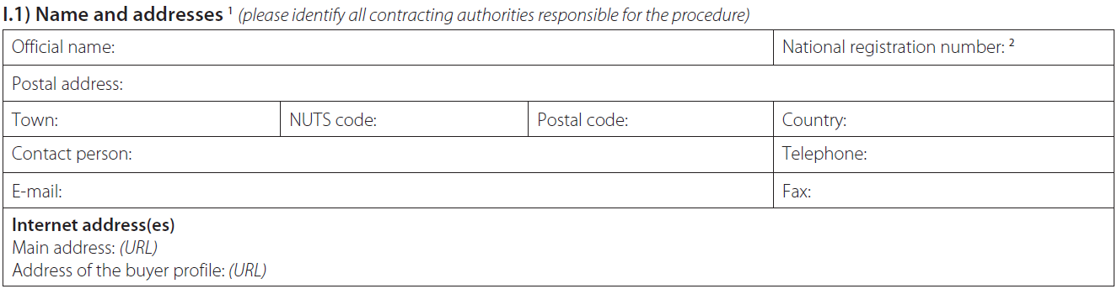
In the contact points section, give the contact details of the lead procurer.
In the internet addresses section, give the project website if you do not want to use the general website of the lead procurer. Use the address of the lead procurer’s buyer profile.

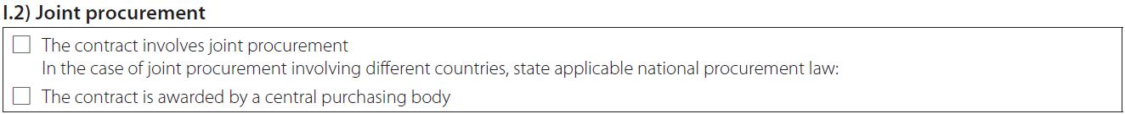
Select ‘yes’ for the first question, i.e. this contract involves joint procurement.
Insert the following text in the free text field for 'in the case of joint procurement involving different countries, state applicable national procurement law': ‘This pre-commercial procurement (PCP) is carried out by [insert name of the lead procurer] who was appointed as lead procurer to coordinate and lead the joint procurement in the name and on behalf of the buyers group listed in I.1. The applicable national procurement law is [insert the applicable national procurement law of the lead procurer]’.
Only select ‘yes’ for the second question, i.e. the contract is awarded by a central purchasing body, if this is the case for your PCP.

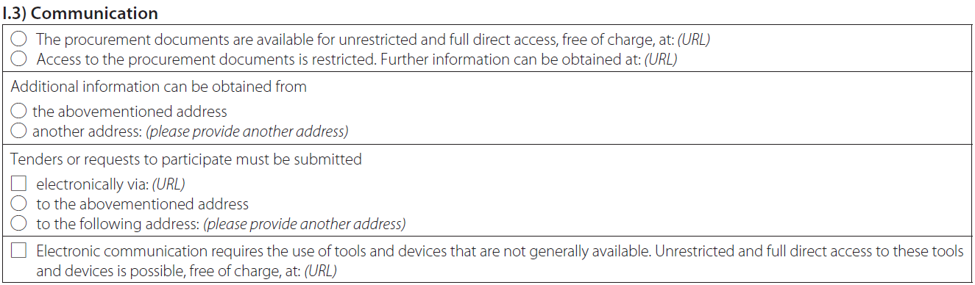
Select the applicable options to clarify how interested tenderers can obtain the procurement documents and additional information and how they must submit their tenders.

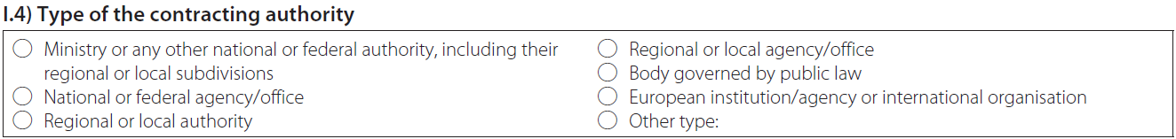
This section is to be filled in ONLY if the lead procurer is a contracting authority (i.e. NOT a contracting entity).

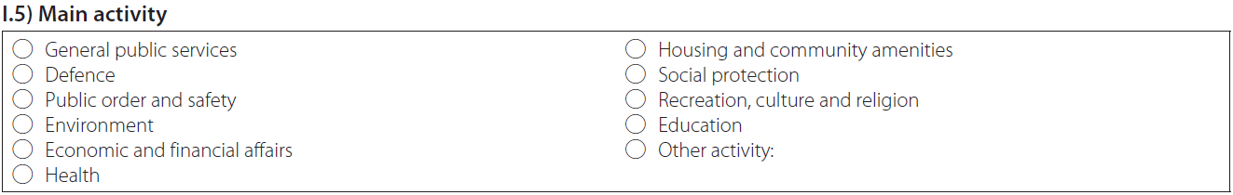
Select the lead procurer's main activities.

Use this title: ‘Pre–commercial procurement (PCP) to buy R&D (research and development) services to [specify in a few words the subject and scope of this PCP e.g. improving the energy efficiency of buildings]’.

Use CPV 73100000 for R&D services and additional other CPVs, if relevant to the object of the contract (e.g. CPV for medical equipment if the PCP is for medical equipment-related R&D, CPV for software development services if software-related R&D is needed).

Select ‘Services’ (not ‘Supplies’ or ‘Works’; PCP is an R&D services contract).

This contract notice invites interested operators to submit tenders to a procurement.
The procurement aims to trigger new solutions to be developed and tested to address the following challenge: [specify briefly the subject and scope of this PCP e.g. improving the energy efficiency of buildings].
[OPTION for PCPs with lots: As the common challenge exists of a number of sub-challenges, the procurement will be divided into the following lots, each corresponding to one sub-challenge:
- lot 1: [insert name of the sub-challenge to which the lot corresponds]
- lot 2:
- …]
The main technical challenges to be addressed [per lot] are: [indicate the main target quality/efficiency and/or functionality/performance improvements compared to the current state-of-the art technology — per lot, if applicable — e.g. 30 % energy efficiency improvement, 20% cost reduction, etc].
This PCP procurement is a joint procurement by different procurers across Europe that are all facing the same common challenge and are thus looking for similar solutions (so-called ‘buyers group’).
Provide any other relevant information. If needed to cope with the character-limit in the forms, distribute text also over ‘II.2.4) Description of the procurement’ and ‘II.2.14) Additional information’.

Give the total estimated value of the PCP framework agreement in euros/other currency (excluding VAT).

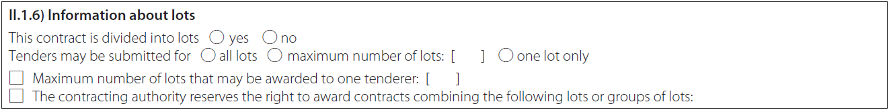
For PCPs with lots select ‘yes’. Consider carefully the consequences of restricting the number of lots that tenders may be submitted for, if applicable.

Only fill in if lots are used. Fill in the title and number of each lot.

Only fill in if lots are used. Use the CPV codes for each lot.

Do NOT fill out the fields ‘NUTS code’ and ‘main site or place of performance’. (The place of performance meant here is a specific place; it has nothing to do with the place of performance requirement under the H2020 grant agreement (i.e. to do at least 50% of the contracted R&D services in EU Member States or Horizon 2020 associated countries).

Provide any further relevant information on differences in scope per lot.
Use this text to describe the procurement:
The procurement will take the form of a pre-commercial procurement (PCP) under which R&D service contracts will be awarded to a number of R&D providers in parallel in a phased approach. This will make it possible to compare competing alternative solutions.
Each selected operator will be awarded a framework agreement that covers 3 R&D phases.
The 3 phases are:
- R&D up to solution design
- R&D up to a prototype
- R&D up to original development, validation and testing of a limited set of first products or services.
After each phase, intermediate evaluations will be carried out to progressively select the best of the competing solutions. The contractors with the best-value-for-money solutions will be offered a specific contract for the next phase. [OPTION for PCPs with lots: The phased approach with parallel contracts and intermediate evaluations will be followed within each lot.]
Testing is expected to take place in [add the locations where testing is expected to take place, in particular test locations of the procurers and other additional test locations]. This testing may also serve as a first customer test reference for the contractors. The procurement is expected to start in [add expected starting date of the PCP] and end in [add expected completion date of the PCP].
The selected operators will retain ownership of the intellectual property rights (IPRs) that they generate during the PCP and will be able to use them to exploit the full market potential of the developed solutions i.e. beyond the procurers. [The market potential is estimated at [insert available figures about the potential total market size, i.e. beyond the procurers].]

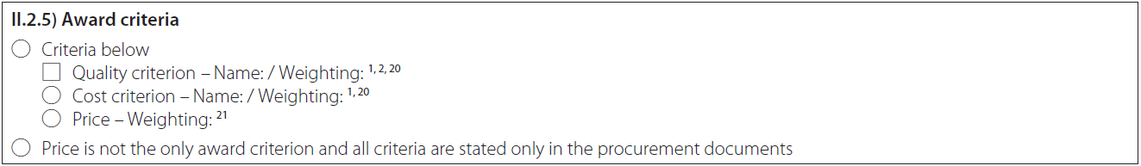
Select one of the 2 options (‘the criteria below’ OR ‘price is not the only award criterion and all criteria are stated only in the procurement documents’).
If you select the first option (‘the criteria below’), you must indicate all the criteria and their weighting.

Only fill in if lots are used.

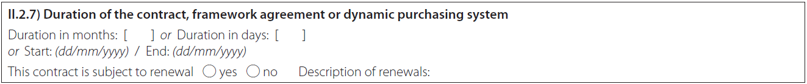
Enter the duration.

Do not fill in.

Select ‘No’. In PCP, the use of variants is not necessary, since the PCP approach inherently supports the development of several alternative solutions in parallel.

Complete if applicable.

Complete as applicable. Avoid conditions that might unduly restrict participation.

Select ‘yes’.
Use this text:
This procurement receives funding from the European Union’s Horizon 2020 Research and Innovation Programme, under grant agreement No [insert number] — [insert project acronym] (see [insert project website]).
[OPTION if the procurement also receives funding from other EU programmes (i.e. if there are procurers in the buyers group whose financial contribution to the PCP budget is funded by other EU programmes, for example the European Structural and Investment Funds (ESIF)): The procurement also receives funding from the [OPTION for EU programmes: European Union’s [insert name of EU programme]][OPTION for national programmes co-funded by the EU (e.g. by Regional Funds, Agricultural Funds): [insert name of national programme] co-financed by the European Union]:
- [insert beneficiary name and grant agreement number and acronym].]
The EU has given a grant for this procurement, but is not participating as a contracting authority in the procurement.
Note that it is not allowed for one and the same procurer to receive funding for his part of the PCP budget from different EU programmes (e.g. H2020 and ESIF). But it is possible for different procurers in the buyers group to receive funding from different EU sources.

Use this text:
Participation in the open market consultation that was held as part of the preparation for this procurement is not a prerequisite for submitting a tender.
This procurement is exempted from the WTO Government Procurement Agreement (GPA), the EU public procurement directives and the national laws that implement them. This is because it concerns the procurement of R&D services where the benefits do not accrue exclusively to the contracting authority for its use in the conduct of its own affairs.
Publication of this contract notice in the EU Official Journal is not to be understood as a waiver of this exemption. Publication is made on a voluntary basis and the procurement will not follow the procedures under the EU public procurement directives, but rather the procedure described in the tender documentation.
The [open][negotiated] procedure was chosen in Section IV.1.1) ‘Procedure’ for formal reasons only. This is because it is not possible to publish a contract notice without selecting one of the listed procedures.
Offers may be submitted in English [and [insert additional language(s), if any]]. All communication (before, during and after the procurement) can be made in English [and [add additional language(s), if any]].
More information:
See:
- the project website (see [insert address])
- the open market consultation Q&A (see [insert address])
- PCPs on the Europa website (see https://ec.europa.eu/digital-single-market/innovation-procurement)
or contact:
- [insert email address or interactive web address]
Provide other additional information (if applicable).
Please ensure that interested operators can ask questions about the procurement and tender documents and give them sufficient time to do so.

Complete as applicable. Avoid conditions that might unduly restrict participation.
You can refer to the tender documents for further information.

Complete as applicable. Avoid conditions that might unduly restrict participation (in particular disproportionate financial guarantee requirements e.g. minimum turnovers).
You can refer to the tender documents for further information.

Complete as applicable. Avoid conditions that might unduly restrict participation (in particular disproportionate qualification requirements e.g. references from past customers).
You can refer to the tender documents for further information.

The options for reserved contracts do not apply.

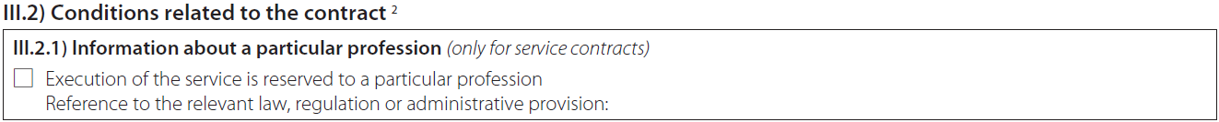
Complete if applicable. Avoid conditions that might unduly restrict participation.

Complete if applicable. Avoid conditions that might unduly restrict participation.

Select ‘yes’. Further explanation is provided in the section about the place of performance requirement in the PCP request for tenders.

For lead procurers in the public or utilities sector: select ‘open’.
For lead procurers in the defence and security sector: select ‘negotiated’.
In Section VI.3 Additional information, you will have to state that this procurement is exempted from the EU public procurement directives and the national laws that implement them (i.e. it is not an open and negotiated procedure subject to the EU public procurement directives; the choice here must be made for formal reasons only, because it is mandatory for filling out the form).

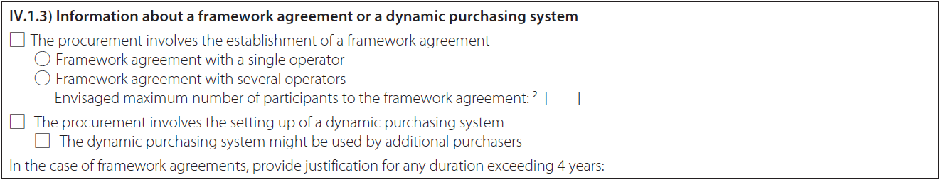
Select ‘Framework agreement with several operators’.
Do not fill in any number under ‘Envisaged maximum number of participants to the framework agreement’. In the free text field, state the minimum number of framework agreements that you plan to award (according to the request for tenders, there should be one per selected operator). For PCPs with lots, enter the total minimum number of framework agreements counted across all the lots.
Complete ‘The procurement involves the setting up of a dynamic purchasing system’ if applicable.

Select ‘No’.

Do not fill in.

Select ‘No’.

Select ‘No’.

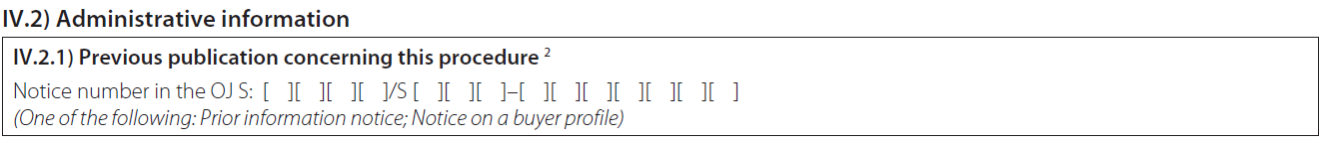
Provide information on the PIN announcing the open market consultation.
Provide information on other previous publications (if applicable).

Enter date and time.

Do not fill in. Tendering is not restricted to selected tenderers or candidates.

Select at least ‘English’ and add additional languages, if any.

Complete as applicable.
Complete as applicable.

Select ‘No’.

Complete as applicable.

Provide any other additional relevant information.

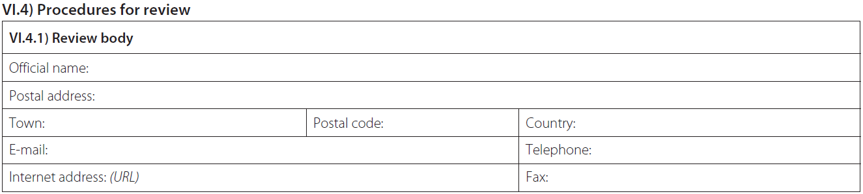
Give the names of the review bodies (also called ‘appeal bodies’) foreseen under the national law applicable to the lead procurer.
Depending on the country, this may or may not be the same body that is competent when the EU public procurement directives do apply.
Do NOT leave this section blank (otherwise you risk multiple complaints procedures in different countries).

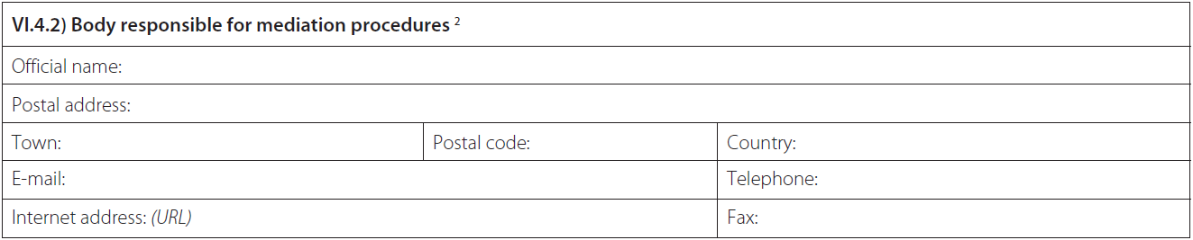
Give the names of the mediation bodies foreseen under the national law applicable to the lead procurer.
Depending on the country, this may or may not be the same body that is competent when the EU public procurement directives do apply.
Do NOT leave this section blank (otherwise you risk multiple complaints procedures in different countries).

Use the following text:
The procurement is exempted from the EU public procurement directives (including the EU procurement remedies directives 89/665/EEC and 92/13/EEC — see above) and the national laws that implement them.
Publication of this notice in the Official Journal is not to be understood as a waiver of this exemption by the contracting authority.
The deadlines for the review procedures at the bodies for review and mediation, mentioned in IV.4.1) and IV.4.2) are: [complete].

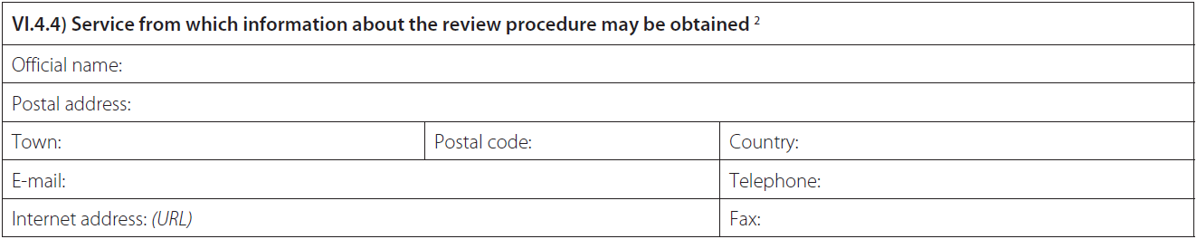
Give the contact details of a contact person at the lead procurer.
Make sure that this contact person has sufficient information about the context and background of the procurement.

Enter date.
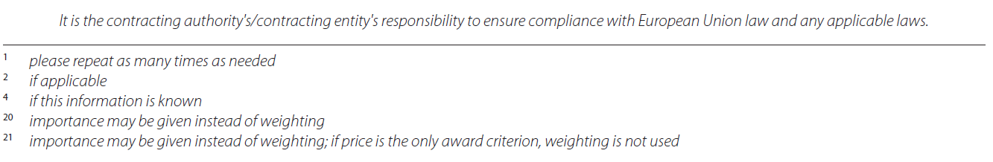

4. Contract award notice

PCP CONTRACT AWARD NOTICE

How does this document work?
- Instructions are in blue.
- Recommended text is in black.
- Options are in blue [in square brackets].
- Data to be added is shown in [grey in square brackets].

Since framework agreements are used, verify whether national law requires publishing separate contract award notices for each contract based on the agreement (or grouped notices on a quarterly basis).
The contract award notice has to be filled out online on the TED — tenders electronic daily website.
Use the English version of the simap standard form that is appropriate for your type of organisation:
- for lead procurers in the public sector: ‘Contract award notice’
- for lead procurers in the utilities sector: ‘Contract award notice — utilities’
- for lead procurers in the field of defence and security: ‘Contract award notice for contracts in the field of defence and security’
In addition to English, you may publish the contract award notice (or a summary) in any other language(s).
Do not forget that a copy of the published contract award notice should be submitted to EU as part of the deliverables at the end of the tender evaluation (see Article 19 H2020 PCP-PPI MGA).

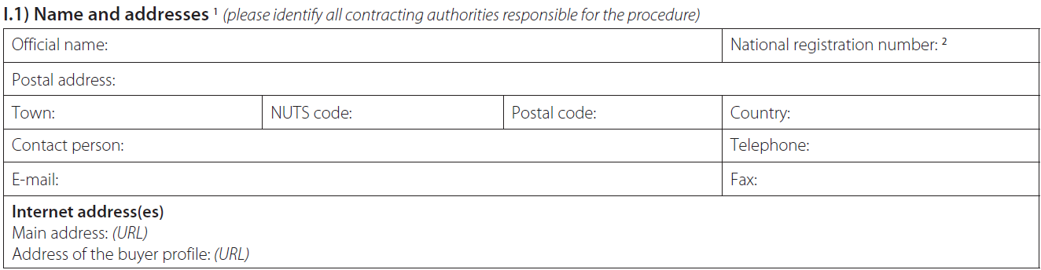
In the contact points section, give the contact details of the lead procurer.
In the internet addresses section, give the project website if you do not want to use the general website of the lead procurer. Use the address of the lead procurer’s buyer profile.

Select ‘yes’ for the first question, i.e. this contract involves joint procurement.
Insert the following text in the free text field for 'in the case of joint procurement involving different countries, state applicable national procurement law': ‘This pre-commercial procurement (PCP) is carried out by [insert name of the lead procurer] who was appointed as lead procurer to coordinate and lead the joint procurement in the name and on behalf of the buyers group listed in I.1. The applicable national procurement law is [insert the applicable national procurement law of the lead procurer]’.
Only select ‘yes’ for the second question, i.e. the contract is awarded by a central purchasing body, if this is the case for your PCP.

This section is to be filled in ONLY if the lead procurer is a contracting authority (i.e. NOT a contracting entity).

Select the lead procurer's main activities.

Use this title: ‘Pre–commercial procurement (PCP) to buy R&D (research and development) services to [specify in a few words the subject and scope of this PCP e.g. improving the energy efficiency of buildings]’.

Use CPV 73100000 for R&D services and additional other CPVs, if relevant to the object of the contract (e.g. CPV for medical equipment if the PCP is for medical equipment-related R&D, CPV for software development services if software-related R&D is needed).
Select ‘Services’ (not ‘Supplies’ or ‘Works’; PCP is an R&D services contract).

Use the following text:
This contract award notice informs interested operators about the outcome of a tender.
On [enter date of the publication of the contract notice], a contract notice was published as part of the EU project [insert project acronym] to purchase R&D services from a number of R&D providers in parallel (PCP procurement).
The PCP procurement compared competing alternative solution approaches to address the following challenge: [specify briefly the subject and scope of this PCP e.g. improving the energy efficiency of buildings].
[OPTION for PCPs with lots: As the common challenge exists of a number of sub-challenges, the procurement is divided into the following lots, each corresponding to one sub-challenge:
- lot 1: [insert name of the sub-challenge to which the lot corresponds]
- lot 2:
- …]
The main technical challenges to be addressed [per lot] are: [indicate the main target quality/efficiency and/or functionality/performance improvements compared to the current state-of-the art technology – per lot, if applicable - e.g. 30 % energy efficiency improvement, 20% cost reduction, etc].
This PCP procurement is a joint procurement by different procurers across Europe that are all facing the same common challenge and are thus looking for similar solutions (so-called ‘buyers group’).
Provide any other relevant information. If needed to cope with the character limit in the forms, distribute text also over ‘II.2.4) Description of the procurement’ and ‘II.2.14) Additional information’.

Provide any other relevant information. If needed to cope with the character limit in the forms, distribute text also over ‘II.2.4) Description of the procurement’ and ‘II.2.14) Additional information’.

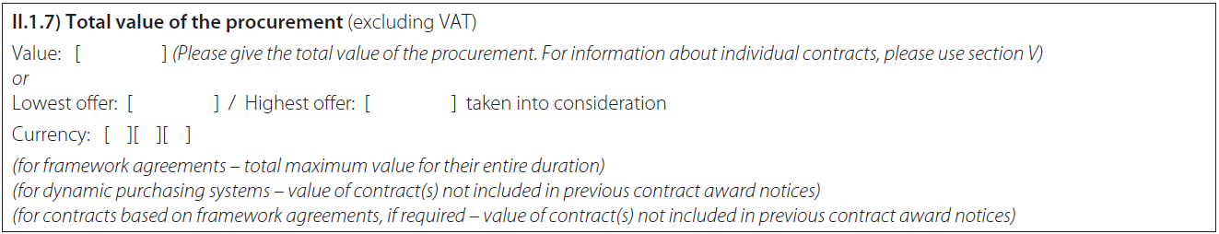
Indicate the total final value of all contract(s)/agreement(s) awarded (and not already included in previous contract award notices), across different specific contracts and across all lots (if applicable), in euros/other currency.
Details on the value of the individual contracts must be given in Section V. ‘Award of contract’.

Only fill in if lots are usedFill in the title and number of each lot.
Only fill in if lots are used. Use the CPV codes for each lot.

Do NOT fill out the fields ‘NUTS code’ and ‘main site or place of performance’. (The place of performance meant here is a specific place; it has nothing to do with the place of performance requirement under the H2020 grant agreement (i.e. to do at least 50% of the contracted R&D services in EU Member States or Horizon 2020 associated countries).

Use this text:
The procurement was announced in the form of a pre-commercial procurement (PCP) with a phased approach, i.e. a framework agreement covering 3 R&D phases:
- R&D up to solution design
- R&D up to prototype
- R&D up to original development and validation and testing of a limited set of first products or services.
After each phase, intermediate evaluations are carried out to progressively select the best competing solutions. The contractors with the best-value-for-money solutions will be offered a specific contract for the next phase.
A total budget of [enter the total estimated budget for the PCP that was announced in the contract notice] was earmarked for awarding the contracts to a minimum of:
- [enter minimum number of R&D providers that were expected to start phase 1 as announced in the contract notice] contractors for phase 1
- [enter minimum number of R&D providers that were expected to start phase 2 as announced in the contract notice] contractors for phase 2 and
- [enter minimum number of R&D providers that were expected to start phase 3 as announced in the contract notice] contractors for phase 3.
[OPTION if the procurement is started:
[OPTION if the award of contracts proceeded as planned: Sufficient amount of good quality tenders were received to award the planned amount of contracts [for lot x] (see section V for more information).]
[OPTION if the award of contracts proceeds with less contracts as planned: The PCP is started with fewer contracts than initially planned [for lot x] because [insert reason: e.g. insufficient amount of good quality tenders were received] (see section V for more information).]
The abstracts of the winning tenders are available on [insert project website].
The PCP is expected to start in [enter expected start date for phase 1] and end in [add expected completion date for phase 3]. ]
[OPTION if the procurement will not be started: [Lot x of] the PCP will not be started because [insert reason: e.g. insufficient amount of good quality tenders were received [for lot x]] (see section V for more information).]
If needed to cope with the character limit in the forms, distribute text also over ‘II.1.4) Description of the procurement’ and ‘II.2.14) Additional information’.

Specify the award criteria that were used and their weighting.
Complete if applicable.

Select ‘yes’.
Use this text:
This procurement receives funding from the European Union’s Horizon 2020 Research and Innovation Programme, under grant agreement No [insert number] — [insert project acronym] (see [insert project website]).
[OPTION if the procurement also receives funding from other EU programmes (i.e. if there are procurers in the buyers group whose financial contribution to the PCP budget is funded by other EU programmes, for example the European Structural and Investment Funds (ESIF)): This procurement receives also funding from the [OPTION for EU programmes: European Union’s [insert name of EU programme]][OPTION for national programmes co-funded by the EU (e.g. by Regional Funds, Agricultural Funds): [insert name of national programme] co-financed by the European Union]:
- [insert beneficiary name and grant agreement number and acronym].]
The EU has given a grant for this procurement but is not participating as a contracting authority in the procurement.
Note that it is not allowed for one and the same procurer to receive funding for his part of the PCP budget from different EU programmes (e.g. H2020 and ESIF). But it is possible for different procurers in the buyers group to receive funding from different EU sources.

Add any other relevant additional information.

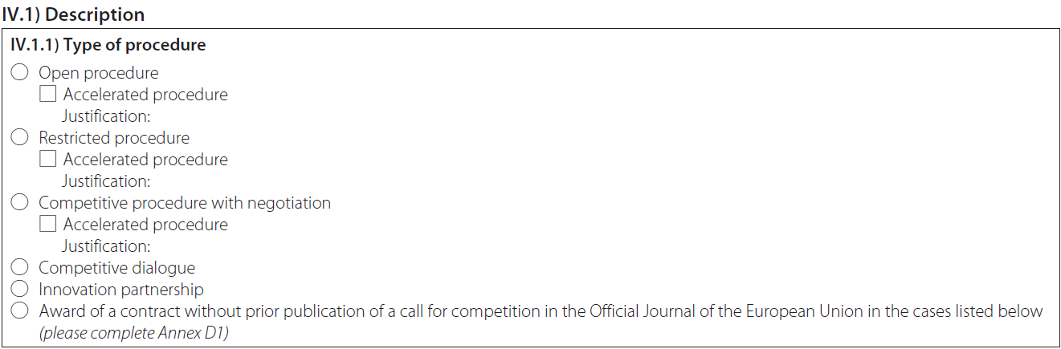
For lead procurers in the public or utilities sector: select ‘open’.
For lead procurers in the defence and security sector: select ‘negotiated’.
In Section VI.3 Additional information, you will have to state that this procurement is exempted from the EU public procurement directives and the national laws that implement them (i.e. it is not an open and negotiated procedure subject to the EU public procurement directives; the choice here must be made for formal reasons only, because it is mandatory for filling out the form).

Complete if applicable.

Select ‘No’.

Select ‘No’.

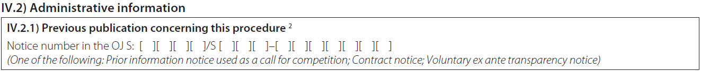
Provide information on the PIN announcing the open market consultation and the contract notice.
Provide information about other previous publications, if applicable.

Complete if applicable.

Do not fill in. This does not concern the termination of a call for competition via a prior information notice.

This section must be filled out as many times as needed, i.e.
- in case lots are used, for every lot and every contractor that was awarded a contract for that lot
- for every contractor that was awarded a framework agreement and/or specific contracts
- for all the contracts that were awarded and not already announced in previous contract award notices.

Complete for every framework agreement and for every specific contract.
Complete for every lot, if applicable.

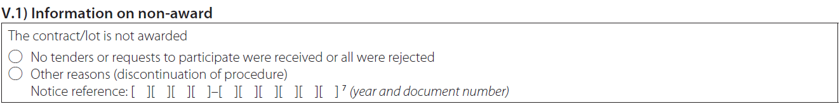
Complete as applicable in case of non-award.

Enter date.
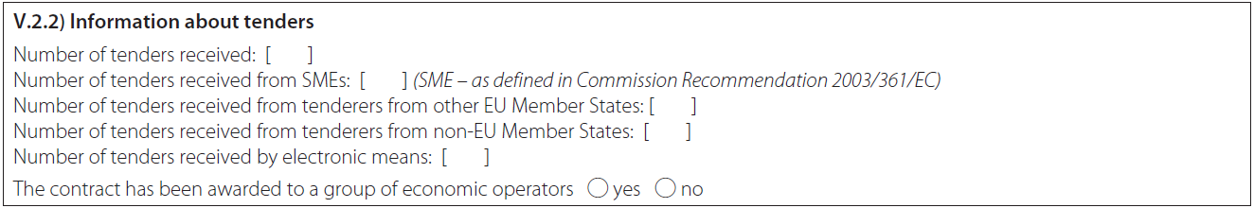
Complete as applicable per awarded specific contract (and per lot, if applicable) that was not already included in previous contract award notices.

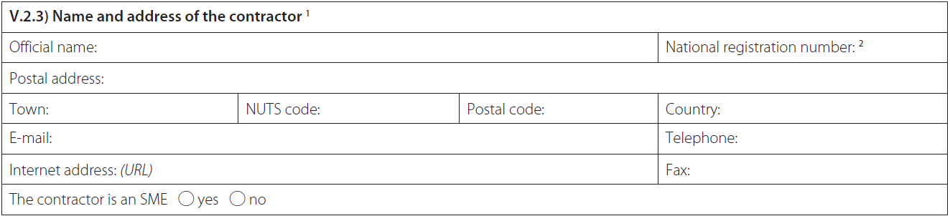
Give the name and address of the operator that won the contract in question per awarded specific contract (and per lot, if applicable) that was not already included in previous contract award notices.

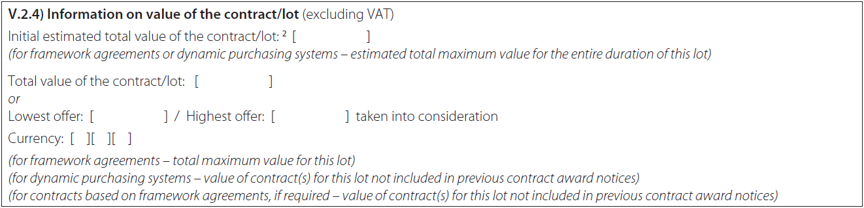
Complete as applicable per awarded specific contract (and per lot, if applicable) that was not already included in previous contract award notices.

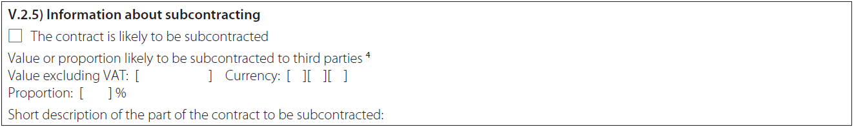
Complete as applicable per awarded specific contract (and per lot, if applicable) that was not already included in previous contract award notices.

Complete if applicable.

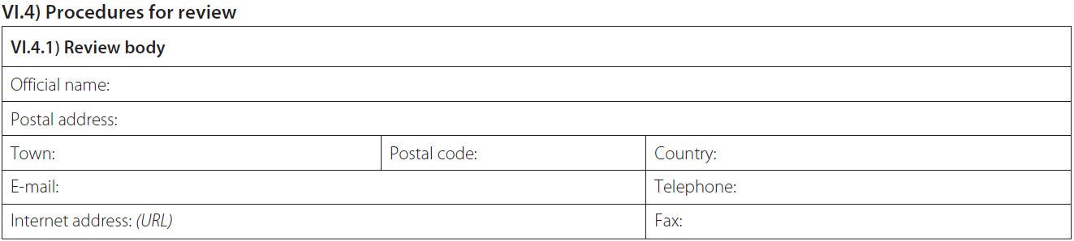
Give the names of the review bodies (also called ‘appeal bodies’) foreseen under the national law applicable to the lead procurer.
Depending on the country, this may or may not be the same body that is competent when the EU public procurement directives do apply.
Do NOT leave this section blank (otherwise you risk multiple complaints procedures in different countries).

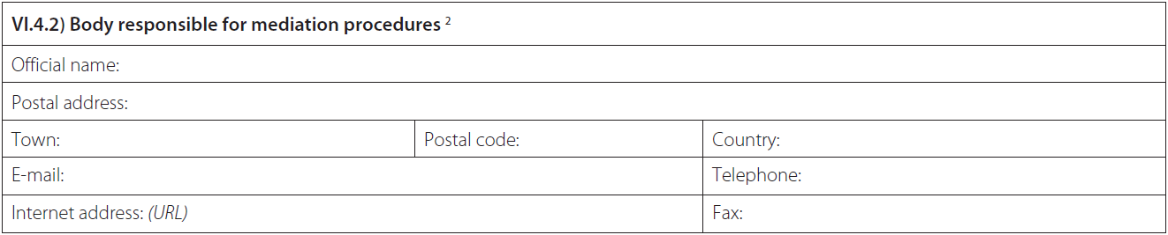
Give the names of the mediation bodies foreseen under the national law applicable to the lead procurer.
Depending on the country, this may or may not be the same body that is competent when the EU public procurement directives do apply.
Do NOT leave this section blank (otherwise you risk multiple complaints procedures in different countries).

Use the following text:
The procurement is exempted from the EU public procurement directives (including the EU procurement remedies directives 89/665/EEC and 92/13/EEC — see above) and the national laws that implement them.
Publication of this notice in the Official Journal is not to be understood as a waiver of this exemption by the contracting authority.
The deadlines for the review procedures at the bodies for review and mediation, mentioned in IV.4.1) and IV.4.2) are: [complete].
Give the contact details of a contact person at the lead procurer.
Make sure that this contact person has sufficient information about the context and background of the procurement.

Enter date.

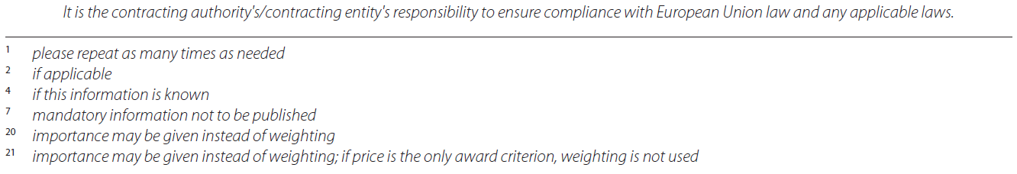

Do not complete. Not applicable.
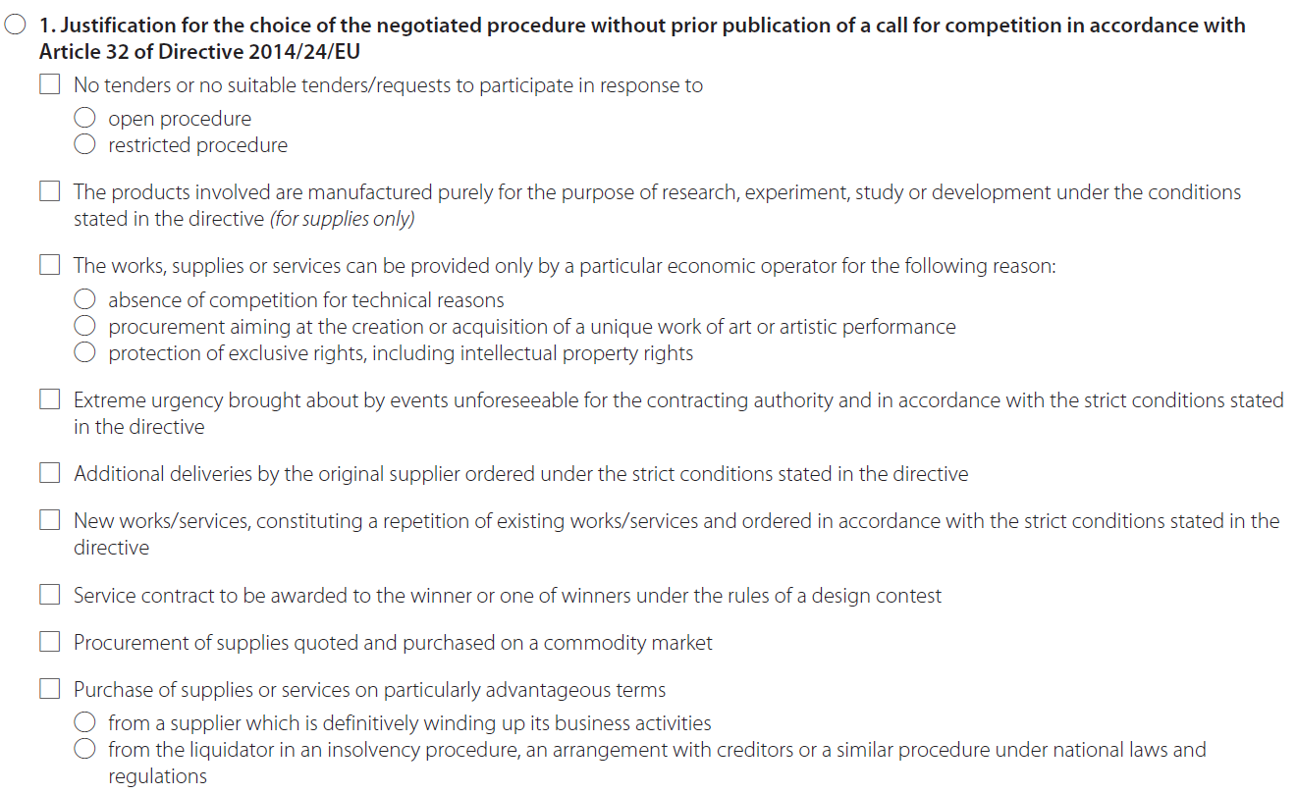

Do not complete. Not applicable.

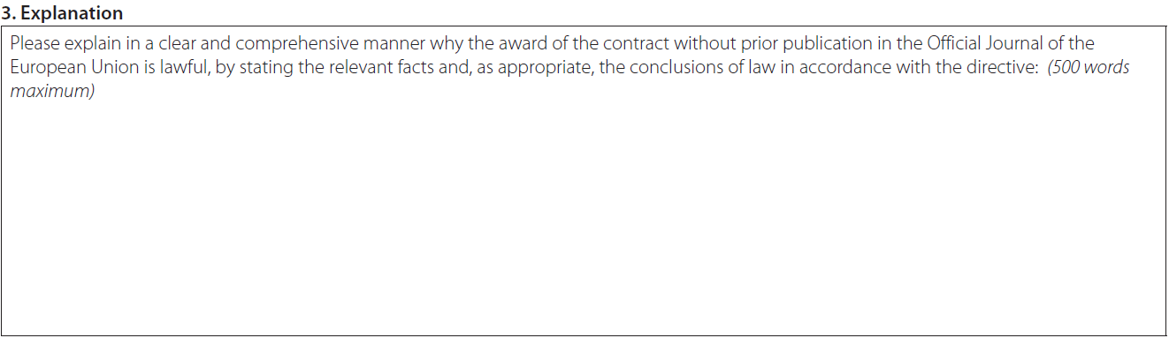
Do not complete. Not applicable.

See also Article XV(1)(e) WTO GPA 1994 and the Article XIII(1)(f) of the revised WTO GPA 2014.
See Article 16(f) of Directive 2004/18/EC (Article 14 of Directive 2014/24/EU), Article 24(e) of Directive 2004/17/EC (Article 32 of Directive 2014/25/EU) and Article 13(f)(j) of Directive 2009/81/EC.
See the EU’s Annex IV of Appendix I to the WTO GPA.
See Point 33 of the Commission Communication on a framework for state aid for research and development and innovation (C(2014) 3282).
Commission Communication: Pre-Commercial Procurement: driving innovation to ensure sustainable, high quality public services (COM(2007) 799) and PCP staff working document (SEC(2007)1668).
See Point 15 of the Commission Communication on a framework for state aid for research and development and innovation (C(2014) 3282).
See Article XV(1)(e) WTO GPA 1994 and the Article XIII(1)(f) of the revised WTO GPA 2014.
List of H2020 associated countries.
The European Code of Conduct for Research Integrity of ALLEA (All European Academies).
See Article 2(1) EU Export Control Regulation No 428/2009.
Commission Decision 2015/444/EC, Euratom of 13 March 2015 on the security rules for protecting EU classified information
See Decision 2015/444/EC, Euratom on the provisions on security of EU-classified information.
Commission Decision 2015/444/EC, Euratom of 13 March 2015 on the security rules for protecting EU-classified information.
Regulation (EC) No 1049/2001 of the European Parliament and of the Council of 30 May 2001 regarding public access to European Parliament, Council and Commission documents, OJ L 145, 31.5.2001, p. 43.
The European Code of Conduct for Research Integrity of ALLEA (All European Academies) and ESF (European Science Foundation) of March 2011. http://www.esf.org/fileadmin/Public_documents/Publications/Code_Conduct_ResearchIntegrity.pdf
Commission Decision 2015/444/EC, Euratom of 13 March 2015 on the security rules for protecting EU-classified information.

