**Reflections on financial structure and financial stability**

In December 2009 the publication of the Basel proposals on liquidity caused a shock in the Danish financial system. The proposals - if implemented - would have resulted in a major retrenchment of the Danish financial sector as there was an insufficient amount of Danish government bonds available. Government bonds had become an endangered species because of many years of fiscal surpluses. Outstanding amounts were way insufficient relative to the liquidity requirements for the Danish banks. The Danish banks had for many years instead used DKK-denominated covered bonds as the main instrument for managing their liquidity. In turn the Danish mortgage system had been a source of stable credit to the Danish economy, generating more than half of all credit, and a rock of financial stability in the Danish financial system. During the financial crisis, the bid-offer spreads of Danish covered bonds were on a par with or lower than those of government bonds, proving their reliability as liquid instruments. The emphasis on government bonds in the proposed Basel liquidity standards and the relegation of covered bonds to a Tier 2 liquidity status were both unwarranted and would have destroyed the Danish financial structure.

This paper has three objectives. First, as a minimum, it should contribute to avoiding that the Danish financial system is once again subject to a proposal with potentially devastating consequences because we have not adequately explained how our system works. Second, it may contribute to an understanding of aspects of the regulatory framework that are counterproductive. Third, a more ambitious objective is to provide input to discussions on how our financial structure can provide some inspiration for how to structure financial systems in order to make them more stable.

The paper proceeds as follows. It starts by outlining a very simple model of a bank that illustrates both the growth generating potential of banks and the possible instability. The model is subsequently used to illustrate how structural changes can enhance financial stability. The Danish mortgage system is one example of how this can be done. The recent increase in issuance of covered bonds has led to concerns about structural subordination, and it is shown where these concerns are valid and where they are not. It is also shown how regulation inadvertently contributes to both structural subordination and increased liquidity risks. More generally, it is argued that regulations need to be set taking into consideration not only the objective to create greater stability in a part of the financial system, but also any potential repercussions in other parts of the financial system, as well as the need for the financial system to take on risk in order to support growth in the economy. Thus, the objective should not be to create a risk free system, but to create a system, where risk is allocated in a smart way.

***Financial intermediation through banks***

Financial intermediation can be illustrated by a balance sheet of a very simplified bank that has deposits and capital as liabilities and loans and liquid assets as assets, cf Fig 1. This balance sheet can illustrate the benefits and risks, the externalities associated with bank failure, and a number of different ways to contain these risks, including – but not limited to – increases in capital requirements and the introduction of liquidity requirements.

*Figure 1: A simplified bank balance sheet*

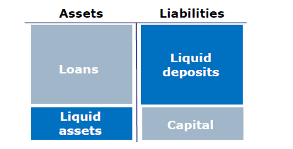

Banks create welfare by paying interest on liquid deposits and by making loans available at comparably low rates because of the maturity transformation and credit transformation banks perform. Banks rely on the fact that normally the withdrawals and deposits more or less cancel each other out. The liquidity of deposits can thus under normal circumstances be maintained at low cost. Furthermore, banks' skill set and scale give them a comparative advantage as monitors of credit quality.

As described by Bagehot in 1873 and modelled 110 years later by Diamond and Dybvig,this is not a stable equilibrium. If a run starts, there is an incentive to be among the first that get out. Or in a slight rephrasing of Mervin King's statement, while it is not smart to start a bank run, it is definitely smart to be among the first in the pack running. The reason is that a bank is worth much more as a going concern than in a forced liquidation. The first that get out get paid from the liquid assets. At some stage the less liquid loans have to be sold. In a market under pressure, that is likely to happen at prices below par. Thus the capital of the bank will be reduced. When the capital is gone, there is not enough assets left to pay the remaining depositors. A depositor with perfect foresight thus has an incentive to be among the first that get out.

The failure of a bank is costly also for others than those who have contributed capital and deposits. There are negative externalities.

Most countries have deposit insurance schemes that protect ordinary depositors. The deposit insurance entails costs for those that finance the payouts. This creates negative externalities. The case for deposit insurance is twofold. One, banks' accounts are opaque, and the ordinary depositor has little chance of understanding them. Two, deposit insurance reinserts some stability into the unstable banking model by lessening the incentive to run.

Bank failures also have social costs as a result of credits being cut and projects abandoned. Other banks have difficulties in stepping in as new lenders because of the informational asymmetries, or in banker's language the lack of credit history. In some cases, the forced liquidation of assets depresses the valuation of assets owned by other banks and starts a financial accelerator effect. Bernanke describes in his work on the Great Depression how the financial accelerator drove falling collateral values and declining overall capacity of banks to lend. This, much more than losses on counterparty exposures, was a main driver of the recent financial crisis, cf Hansson et al and Shleifer and Vishny.

The fact that the negative externalities can both be associated with the liability side of a financial intermediary and the asset side is very important for the design of financial regulation. It may not be a trivial exercise to handle the negative externalities arising from the liability side. However, it is much more complex to deal with the negative externalities arising from the asset side, cf. the EU Commission's paper on shadow banking. While the regulatory perimeter is fairly well defined in relation to the liability side, ie deposit takers (banks), it is much wider and less well defined in relation to the asset side, the funding of the economy.

It is very important to be clear on which externalities should be addressed. Measures that address the externalities associated with the liability side could unintentionally shift activity to the unregulated funding industry. The end result could be that, while we have a safe banking system, non-banks dominate funding, which becomes very volatile.

The relation between solvency and liquidity is a difficult one. Economists think of solvency as a question of whether there is any equity left. Lawyers think of solvency as a question of whether you can be expected to meet your obligations, ie more as a question of liquidity. Prior to this crisis, many economists – but not Rochet and Vives- thought that illiquidity reflected insolvency. Thus, there was deep scepticism about whether Bagehot's old advice on lending to illiquid but solvent institutions was lending to the empty set. This crisis has shown that illiquidity can lead to insolvency not only for one institution, but also through fire sales for other institutions.

Thus, central banks acting as lenders of last resort and standing ready to provide liquidity against illiquid assets, is another way of safeguarding the system. Bagehot as well as Diamond and Dybvig described this avenue. It can be argued that lender of last resort liquidity support creates moral hazard in a similar general manner as deposit insurance. With the notable exception of the Bank of England in the early phase of the financial crisis, most central banks have seen the moral hazard issue in relation to liquidity support as a second order issue. It may play a role that the social costs of liquidity support are much lower than the costs of deposit insurance.

Supervisors have traditionally focused on capital buffers that could cover losses on the loans, cf Fig 2. In the most recent proposals for a new regulatory framework, international liquidity standards are introduced for the first time. Liquid assets protect a bank from having to do forced selling and thereby serve as a buffer to capital.

*Figure 2: Banking regulation 101*

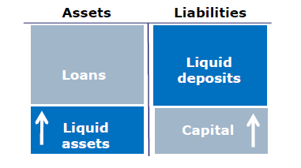

***Structural measures***

There are many ways to address the inherent risks of banks. Looking at the simplified balance sheet, there are more handles that can be adjusted than are usually being considered.

Narrow banking is another possibility, cf Fig 3. In narrow banking the assets of banks are restricted; in the most restrictive version to short-term government bonds, ie there are no loans in the simplified balance sheet, and these will have to be granted by other institutions. In less restrictive versions, only certain assets or activities are "no go". The Volcker rule and the recommendations of the Independent Commission on Banking (Vickers Commission) are examples of such less restrictive versions. Both the Volcker rule and the recommendations of the Vickers Commission face difficult delineation issues. What constitutes proprietary trading and what is retail banking? Presumably the latter will include mortgages and their financing and thereby the very significant maturity transformation associated with mortgages.

*Figure 3: Narrow banking*

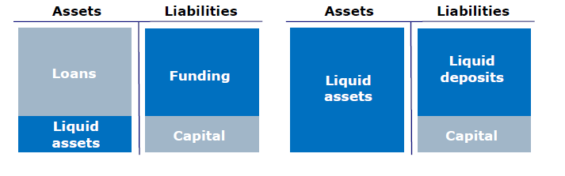

The risks can also be reduced by changing the deposit contract, cf Fig 4. The deposit contract can be made similar to mutual funds, as earlier proposed by others, where you have the right to a share of the pie rather than a fixed amount. The practical difficulty is to value the pie. The run on the mutual funds during the financial crisis and the stigma associated with breaking the buck also suggest that the model was not as watertight as some thought. However, valuing the assets could be left to the markets if there is no possibility of redemption, ie if it is a closed fund.

*Figure 4: The mutual fund model*

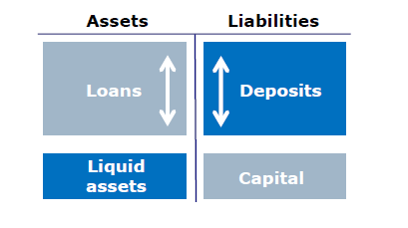

The riskiness of the bank structure also depends on the more general design of the surrounding economy. If creditor protection is limited, defaults on loans are more likely and the costs in case of default will be higher. Similarly, a social safety net lowers risks of default and costs. *LaP*orta et alare among those who have worked on these aspects.

***The specialised mortgage banks***

The specialised mortgage system that exists in a number of European countries, including Denmark, combines some of these features with a balance principle that makes it a very "dull" system, cf Fig 5. These days, "dull" is a plus word as it implies safe.

*Figure 5: The specialised mortgage bank*

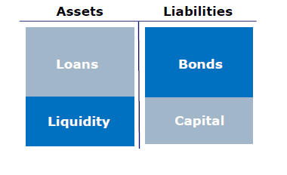

The Danish mortgage system is a pass through system, where payments on loans pass through to bondholders. Bondholders cannot withdraw their funds as depositors can. There is no maturity transformation, and the intermediary is not exposed to interest rate risk[1]. Credit risk is contained through personal liability as opposed to the no recourse loans that caused so many problems in the US. The legal system ensures that foreclosure is unusually quick, around six months, and the social safety net means that in most parts of the country families can service their debt with one family member unemployed. Originate to hold as opposed to originate to distribute results in sharp credit assessments.

The result is that despite house price falls similar to those in the US, delinquencies have been a small fraction of those in the US, cf Fig 6. Financial markets are aware of this, and spreads and volatility have been on a par with those of many government bonds, if not better, as has liquidity, cf Buchholst et al.

*Figure 6: House price developments and delinquencies in Denmark and the USA*

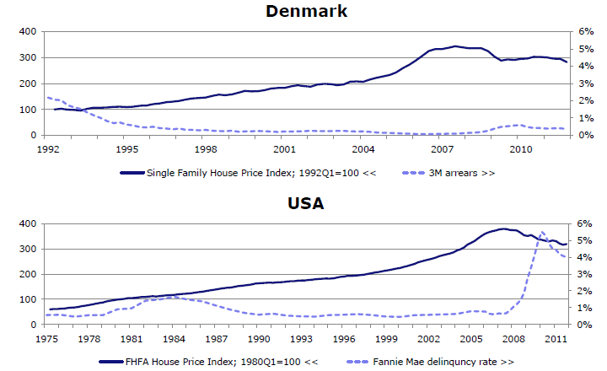

Source: Association of Danish Mortgage Banks, FHFA and Fannie Mae

*Figure 7.a: Developments in bid-offer spreads of short-term covered bonds and government bonds in Denmark*

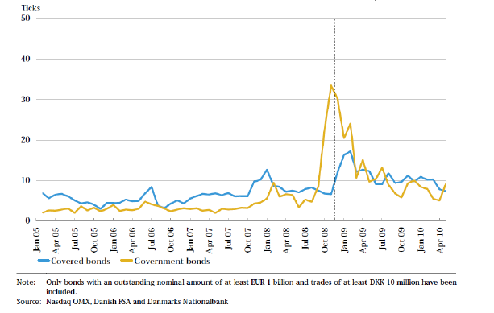

*Figure 7.b: Developments in bid-offer spreads of long-term covered bonds and government bonds in Denmark*

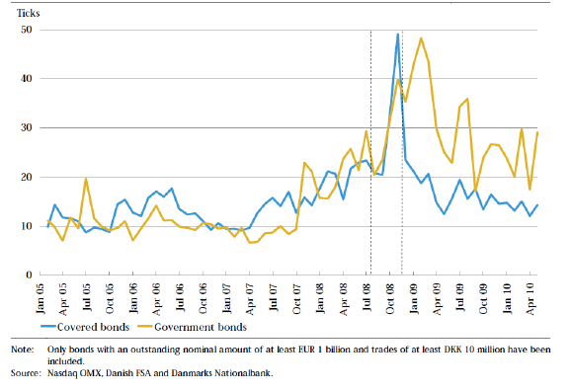

Nevertheless, the Basel standards as originally formulated could have made the Danish mortgage system a casualty of not the war but the peace. This applied in particular to the new liquidity standards, eg the idea that government bonds are all Tier 1 liquidity, while covered bonds are all Tier 2 liquidity. The new measures were obviously not formulated with the Danish system in mind. Fortunately, the EU version of the new regulations allows for a better fitting and less of a cookie cutter approach.

In fact, the EU should make use of the opportunity to build on the unique European instrument that covered bonds are to create a housing finance system in Europe that would share the best features of the best systems. A system that next time around will give all the citizens of Europe continued access to housing finance, even when a financial hurricane is raging. In Denmark, growth in covered bond finance even limited the effect on the economy of the fall in bank credit to industry and trade, cf Fig 8.

*Figure 8: Growth in mortgage lending and bank lending to non-financial corporations*

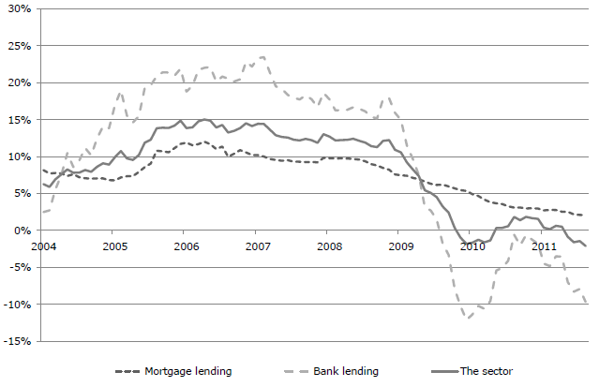

Source: Danmarks Nationalbank

***Covered bonds and structural subordination***

Covered bonds have been criticised for creating structural subordination of depositors as assets are set aside for covered bond holders. It is important to note that such structural subordination by definition does not apply to specialised institutions that do not take deposits. Here, any other creditors are consenting adults who do not rely on deposit insurance.

In institutions that do take deposits, the structural subordination created by covered bond issuance depends on the overcollateralisation of the covered bonds, cf Fig 9. The more assets reserved for covered bonds, the less available for depositors, and the larger the potential bill for the deposit insurance scheme, and in the worst case the tax payers, if a bank is bailed out by the government.

*Figure 9: Structural subordination of depositors*

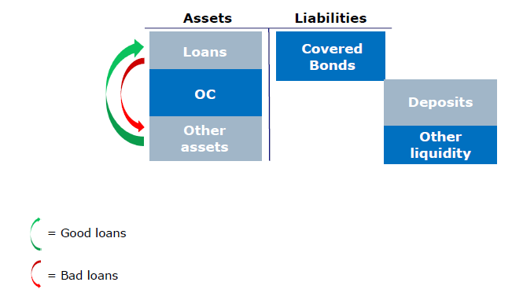

Thus, there is a case for limiting overcollateralisation. Canada in fact recently introduced legislation to limit overcollateralisation. The argument was partly structural subordination, and partly that the combination of limits on overcollateralisation and the need to uphold a decent rating required lenders to maintain much higher credit standards.

Limits to overcollateralisation would also make stand alone systems more stable, as overcollateralisation introduces a liquidity risk in such systems, cf Fig 10.

*Figure 10: Overcollateralisation and liquidity risk*

**

In this context, it is important to note that overcollateralisation is a result not only of the requirements of rating agencies, but also of the requirement in CRD/CRR that covered bonds maintain an LTV below certain limits on a continuous basis on each mortgage. The Danish mortgage system functioned for almost 200 years without a single default with LTV limits that only applied to loans at origination. There are many different ways of making a covered bond system even more robust and among these, revising the rule on continuous LTV compliance for each property should definitely be considered.

The continuous LTV requirement is a good example of a requirement that on the surface makes sense in relation to the objective of setting aside adequate capital for the risk of holding the bonds. Covered bonds of lesser regulatory quality, so called UCITS compliant bonds where the LTV is only observed at issuance, carry double the risk weight of CRD compliant covered bonds. However, from the perspective of the risk of the issuer, this creates an incentive to issue CRD compliant bonds, which increases the risk of structural subordination of deposit taking issuers and the liquidity risks of both deposit taking and non-deposit taking issuers. Thus, when you look at the financial system as a whole, it is not clear whether the regulatory framework in this area contributes to financial stability.

***Where should all the risk go***

The regulatory reforms are an understandable reaction to the financial crisis. Each of the initiatives aims to reduce the risks that financial instability poses to society. In addition to the initiatives undertaken in relation to credit institutions, major reforms are under way in relation to the life insurance industry in the form of Solvency II. These initiatives are undertaken at a time when a number of economies are faced with historical fiscal retrenchment, economic growth is anaemic at best and the foundation of the Economic and Monetary Union is under pressure.

Two questions deserve to be posed. One, are we at risk of overloading the reform agenda with the economy at large as the casualty? Two, even under better circumstances, growth and prosperity require risk taking, and have we in our eagerness to reduce risks forgotten to consider where that risk is best located?

Returning to Bagehot, in "Lombard Street" he describes how industry and trade in the UK developed and how it was supported by banks. Part of the price was a number of banking crises. However, the UK economy developed a lot earlier than the economies of Germany and France, where the legal framework was not supportive of banking, and where savers were likely to see their savings go into the public coffers – an early version of financial repression.

This is not an argument against reform of the financial system and the regulatory framework, but it is an argument in favour of taking a more holistic approach to the reforms.

The models outlined above are models of individual institutions and the issue of their interaction has only been touched on briefly, cf the discussion on the formulation of LTV restrictions. On the one hand, limiting risks in one area may not limit overall risks, eg if risks are shifted to a part of the financial system that is more vulnerable. On the other hand, building institutions that are safer may require that risks are increased in other parts of the system.

A more holistic approach should also take into consideration the fundamental changes that have happened in the financial industry over the last decades. For example, since the mid to late 1970s, Denmark has seen not only exponential growth in banks' balance sheets relative to GDP, but also a very significant increase in the role of other financial intermediaries, such as life insurance and pension funds as well as investment associations (MFIs), cf Fig 11[2]. Qualitatively similar developments can be seen in other EU countries, cf the ECB's Report on Financial Structures*.*

Figure 11: Financial balance sheet developments relative to GDP in Denmark

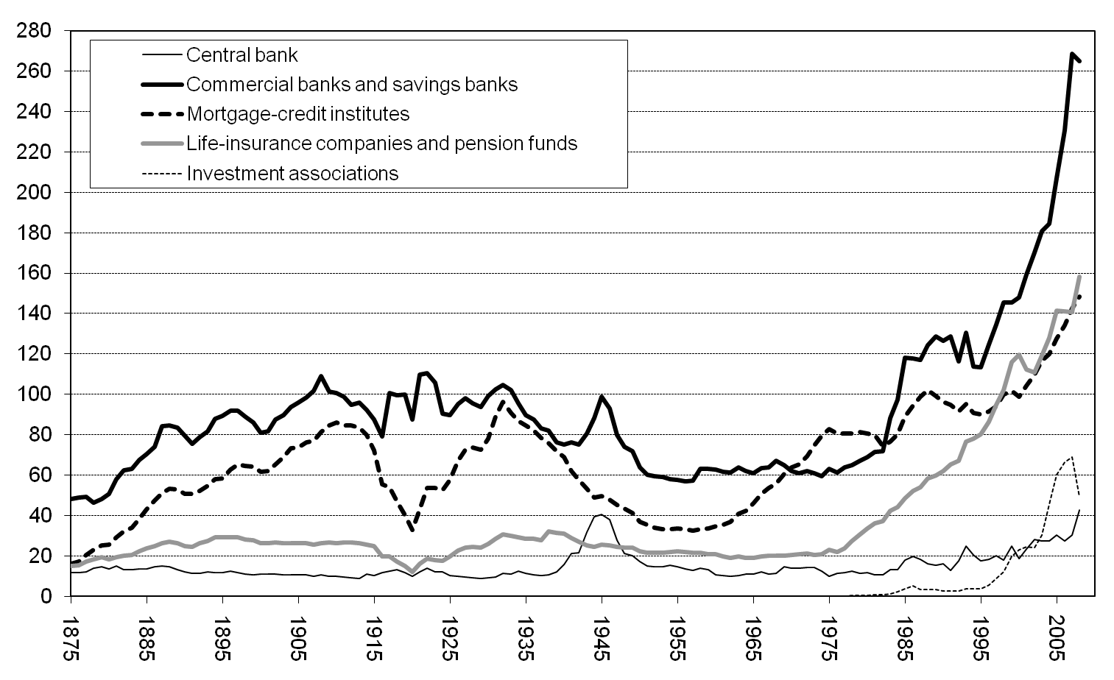

Source: Abildgren

The increase in life insurance, pension fund and investment association savings constitutes an increase in savings that are less subject to run risk, if at all subject to such risk. This should allow some movement of long-term finance from banks to these other intermediaries. However, in this larger context, Solvency II may inhibit life insurers from taking on their natural role, given the large capital requirements imposed on credit risk in Solvency II.

It is noteworthy that mortgage banks' balance sheets, which are dominated by mortgages on the asset side and covered bonds on the liability side, in most years far exceed the balance sheets of life insurers, pension funds and investment associations. Even today, the aforementioned institutions would have to spend an excessive amount of their resources were they to buy all outstanding covered bonds. Thus, banks, households, corporates and foreigners have bought and still buy the bulk of covered bonds, cf Fig 12.

*Figure 12: Investor distribution of Danish covered bonds*

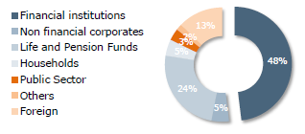

Source: Danmarks Nationalbank

The business model of mortgage banks is well suited to continue to play a significant role in longer-term finance, and with the increased role of longer-term institutional investors, there are more natural investors in long-term assets. However, even with the growth in longer-term investors, it is unlikely that there will be enough investors for whom 30-year covered bonds are the natural habitat. Thus, maturity transformation and its associated risks will still be part of the financial system. The question is, where should we place it?

The regulatory environment for mortgage finance has to reflect both the objective of matching the natural habitats and creating habitats where they do least harm to financial stability. This applies to the treatment of covered bonds as investments for both credit institutions under the CRD/CRR and life insurance companies under Solvency II.

EU regulators have wisely gone far in this direction both in the CRD/CRR and in Solvency II. The qualities of covered bonds are recognised both in terms of capital weights and liquidity. However, further adjustments may be warranted in order to reach the full potential of what covered bonds can contribute to financial stability.

*References:*

Abildgren: Kvantitative studier af Danmarks monetære og finansielle historie. Danmarks Nationalbank, Copenhagen, 2010.

Bagehot: Lombard Street: A Description of the Money Market. Henry S. King & Co, London 1873.

Bernanke: Essay on the Great Depression. Princeton University Press, 2004.

Buchholst, Gyntelberg and Sangill: Liquidity of Danish Government and Covered Bonds – Before, During and After the Financial Crisis – Preliminary Findings. Danmarks Nationalbank, 2010.

Diamond and Dybvig: Bank Runs, Deposit Insurance and Liquidity. Journal of Political Economy, 1983.

ECB: Report on Financial Structures. Frankfurt, 2002.

EU Commission: Green Paper on Shadow Banking. Brussels, 2012.

Hanson, Kashyap and Stein: A Macroprudential Approach to Financial Regulation. Journal of Economic Perspectives, 2011.

Independent Commission on Banking: Final Report Recommendations. London, 2011 (Vickers Commission).

Isaksen, Lassenius Kramp, Funch Sørensen and Vester Sørensen: Household Balance Sheets and Debt – an International Country Study, Monetary Review, Danmarks Nationalbank, 2011 IV.2.

LaPorta, Lopez-de-Silanes, Shleifer, and Vishny: Law and Finance. Journal of Political Economy, 1998.

Rochet and Vives: Coordination Failures and the Lender of Last Resort:

Was Bagehot Right After All? Journal of the European Economic Association, 2004.

Shleifer and Vishny: Fire Sales in Finance and Macroeconomics, Journal of Economic Perspectives, 2011.

1. It is sometimes mentioned that the Danish version of adjustable-rate mortgages (ARMs) creates a liquidity risk. Traditionally, Danish mortgage loans were 20 or 30-year fixed-rate mortgages with a prepayment option should interest rates fall. The bonds issued to finance the mortgages matched the loans in terms of maturity, interest rate and prepayment option. In the 1990s ARMs were introduced where interest rates were reset from once a year to once every ten years. The ARM loans are financed by auctioning mortgage bonds compatible with the interest rate reset. Thus, the mortgage banks are exposed to a liquidity risk should they be unable to sell the bonds. However, that risk is much more limited than in systems where the interest rate reset on mortgages is not aligned with the refinancing. In the Danish system, mortgage banks are obliged to pass on the rate set at the auctions to the borrowers. Therefore, they are never left with an interest rate risk that in turn can create a liquidity risk, if buyers of the bonds are reluctant to acquire bonds issued by institutions that are potentially at risk in the event of increases in interest rates.
2. The growth in balancesheets since the mid to late 1970s partly reflect that tax incentives to build up gross balances, cf. Isaksen et al.