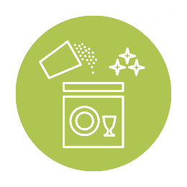
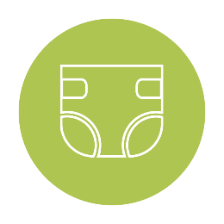
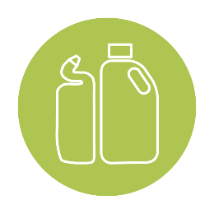
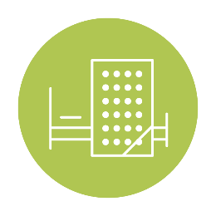
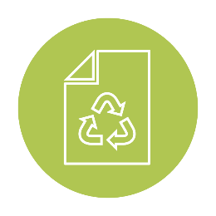

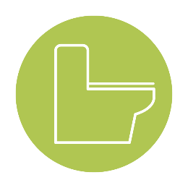
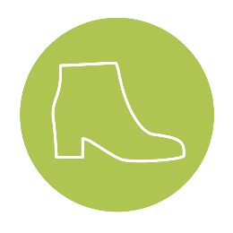
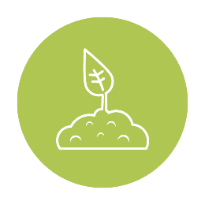
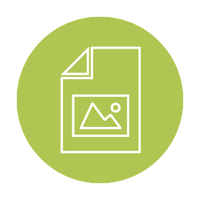

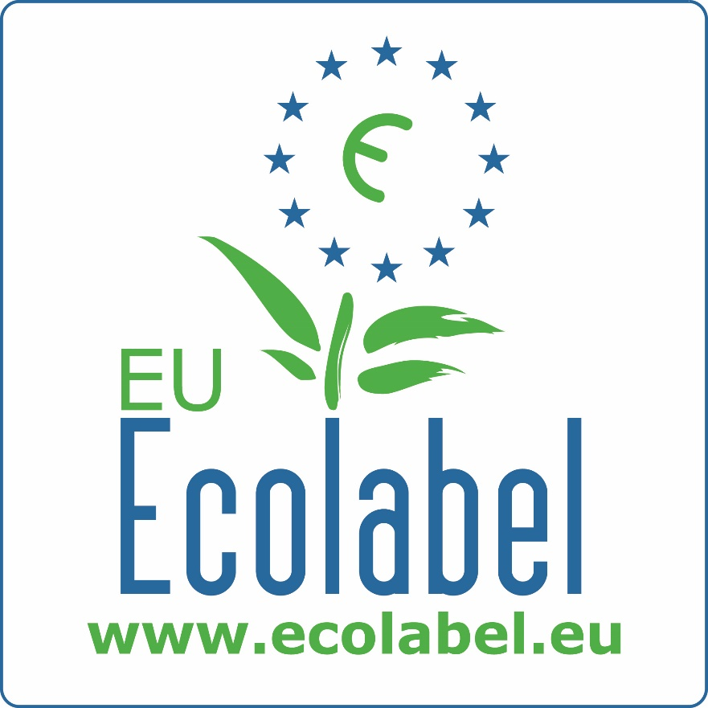
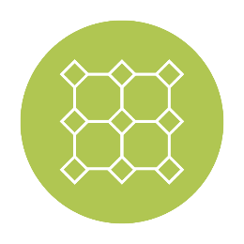
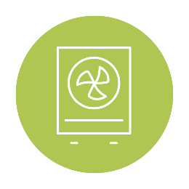
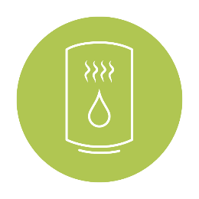

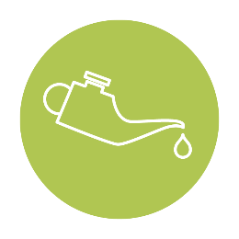
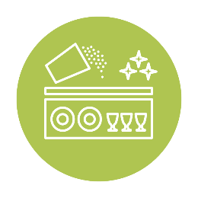

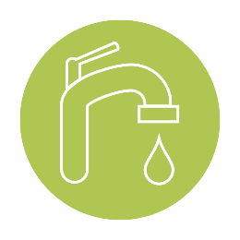
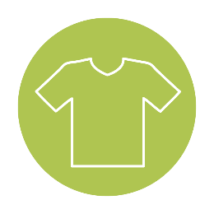
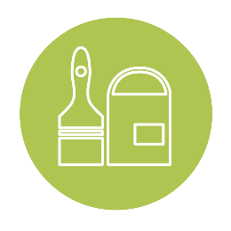
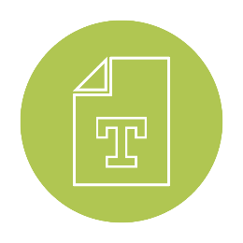
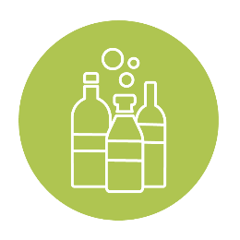
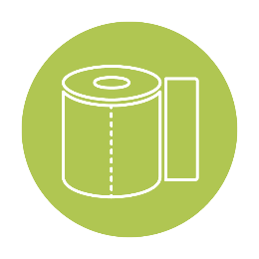
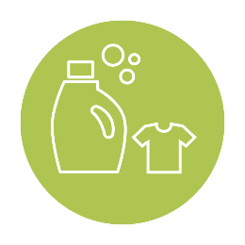
EU Ecolabel
NETWORK TOOLKIT
MARCH
TEXTILE

Network Toolkit

Textiles - March 2018

Dear all,

In this document, you will find Twitter, Facebook and LinkedIn posts and hashtags that you can publish directly on your respective social media pages. Feel free to copy-paste, translate or edit these posts when publishing them (page 4 to 8). You may also communicate on events going on throughout the month of March and April (page 9).

You also have access to three articles (pages 10 to 15) which can be copy pasted and shared across your website and social media pages we encourage you to share this content with your partners like NGOs, journalists or sustainability and lifestyle bloggers or any other media outlets available in your country.

Please make sure to tag other stakeholders when publishing any posts if you find it relevant to do so. You will find Competent Body social media and contact information in the Excel file we sent to you.

Finally, make sure to follow and tag the EU Ecolabel social media pages when publishing on social media, so that we retweet and share posts on our pages.

Please find the EU Ecolabel contact information below:

EU Ecolabel Helpdesk
Tel: +33 (0)1 40 88 70 88
Email: ecolabel@bio.deloitte.fr
Twitter: @EMAS_EUEcolabel
Facebook: https://www.facebook.com/EMAS.EUEcolabel/?modal=composer
Linkedin: EU Ecolabel
Site: http://ec.europa.eu/environment/ecolabel/index_en.htm

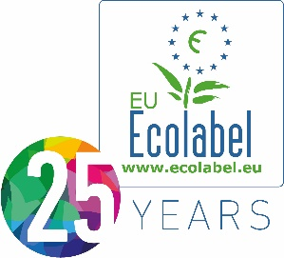
Best wishes,
The EU Ecolabel Helpdesk Team
EU Ecolabel Helpdesk
Tel : +33 (0)1 40 88 70 88
www.ecolabel.eu
E-Catalogue: http://ec.europa.eu/ecat

Contents

I. Social media posts 4
1) Denim industry 4
2) EU Ecolabel Showroom 6
3) EU Ecolabel Ambassador: Neutral 8
4) Fast fashion 10
5) Upholstery textiles 12
II. Events in March 14
III. Articles 15
1) Denim industry 15
2) Upholstery textiles 18
3) EU Ecolabel Success Story: Neutral 21

Social media posts

Denim industry

Feel free to copy-paste, translate or edit these posts when publishing them.

Twitter | #DidYouKnow: Production of #denim pollutes the planet through excessive use of dyes and chemicals. @ISKODENIM is the first company to receive the #EUEcolabel for its denim products, prohibiting substances that are harmful to health and environment.
- Facebook  - LinkedIn | From the production of genetically modified cotton to the use of toxic substances, producing jeans causes a lot of strain on the environment. Fortunately, the rise in environmentally conscious consumers is pushing brands to engage in eco-friendly initiatives. Concerns such as water use, dye impact, soil health, labor issues and fair trade are now at the heart of brand initiatives.  The European Commission encourages these transitions in the supply chain through the EU Ecolabel. The certification aims to improve the production of textiles through a large range of scientifically based criteria that encompass environmental and social concern and analyses the full life cycle of jeans. Many future-looking brands have found that the EU Ecolabel aligns with their sustainability values. For example, the Turkish brand ISKO known for its innovative spirit is the first denim brand to certify some of its B2B products with the EU Ecolabel.
- Suggested tags | #EUEcolabelTextiles  #SustainableFashion  #CircularEconomy  #SustainableChoices  #EEB  #BEUC
- Relevant social media links | ISKO Twitter  ISKO Facebook  ISKO LinkedIn  EU Ecolabel Twitter  EU Ecolabel Facebook  EU Ecolabel LinkedIn
- Visuals  (available on the PowerPoint) | 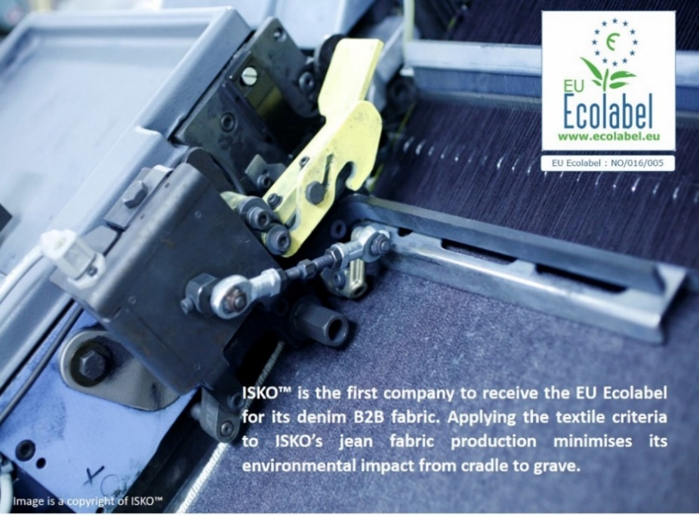

EU Ecolabel Showroom

Feel free to copy-paste, translate or edit these posts when publishing them.

Twitter | Last week around 65 thousand visitors were able to discover a selection of the best #EUEcolabel products, and have a chat with @ZeroWasteFR and @PikPik92 at the #EUEcolabelShowroom in Paris.
- Facebook  - LinkedIn | From the 12th to the 16th of March 2018, the #EUEcolabel SHOWROOM opened its doors at the La Défense square. Around 6500 people were able to discover a selection of the best EU Ecolabel products and services, with a particular focus on French EU Ecolabel products.  During these five days, The Showroom also hosted conferences and presentations by experts, consumer associations, producers and public actors involved and engaged with the environment and circular economy. Discussions and debates on responsible purchasing, consumption and the daily actions that we can do to take better care of our environment, were open to everyone free of charge. Workshops organized by @ZeroWasteFrance and @pikpikenvironnement focused on limiting waste and leading a zero waste lifestyle.
- Suggested tags | #EUEcolabelShowroom  #CircularEconomy  #SustainableChoices
- Relevant social media links | Zero Waste France Facebook  Zero Waste France Twitter  PikPik Twitter  PikPik Facebook  EU Ecolabel Twitter  EU Ecolabel Facebook  EU Ecolabel LinkedIn
  - Visuals
(available on the PowerPoint)

EU Ecolabel Ambassador: Neutral

Feel free to copy-paste, translate or edit these posts when publishing them.

Twitter | #DidYouKnow: The #EUEcolabel considers the health of both workers and consumers. Revision of the criteria on chemicals led #Neutral and its suppliers to innovate by removing carcinogenic, mutagenic, and toxic dyes.
- Facebook  - LinkedIn | Neutral acquired the EU Ecolabel ten years ago in 2008, at a time when few products were environmentally certified, especially in the textile industry. The owners of Neutral particularly appreciated the regenerative design strategy chosen by the EU Ecolabel, which analyses the complete lifecycle of products.  Furthermore, the EU Ecolabel’s dynamism and progressive approach towards updating and strengthening the criteria every 3-5 years aligns with the Neutral’s values. Indeed, the EU Ecolabel pushes Neutral to innovate constantly to reach an even more sustainable production. For instance, when the EU Ecolabel changed the criteria for chemicals used in the dyeing process, Neutral had to develop completely new dyestuffs together with their suppliers to meet the revised standard. This meant removing any dyes that are carcinogenic, mutagenic, toxic for reproduction or have metal complexes. Neutral also sources its products from 100% organic cotton farmers who use biological fertilizers (earthworms) and natural pesticides such as sugar water, which attracts ants who defend the cotton plant.
- Suggested tags | #EUEcolabelAmbassador  #SustainableFashion  #CircularEconomy  #SustainableChoices
- Relevant social media links | Neutral LinkedIn account  Ecolabelling Denmark LinkedIn  Ecolabelling Denmark Facebook  EU Ecolabel Twitter  EU Ecolabel Facebook  EU Ecolabel LinkedIn
- Visuals  (available on the PowerPoint) | 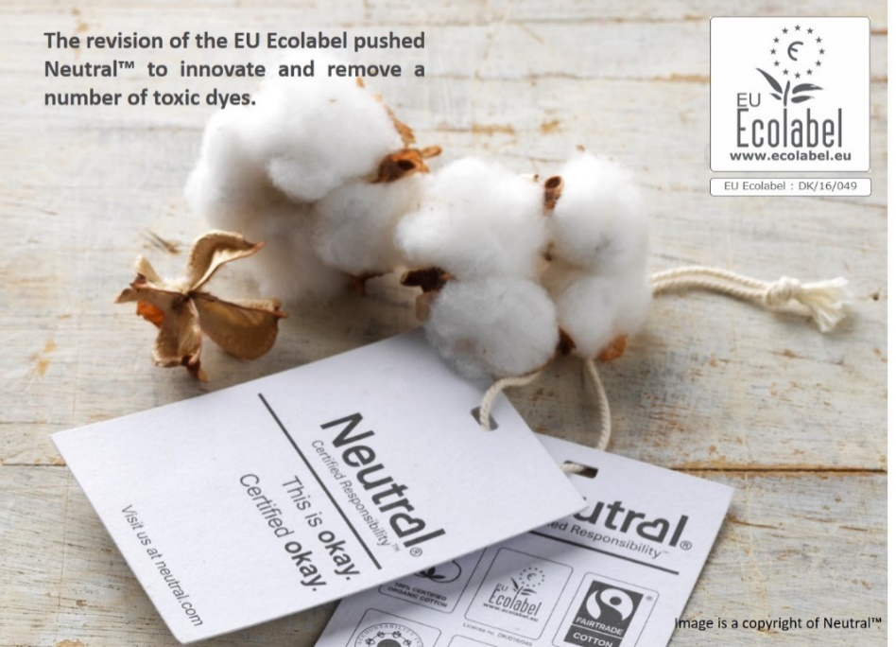

Fast fashion

Feel free to copy-paste, translate or edit these posts when publishing them.

Twitter | #DidYouKnow: The manufacturing of textiles is often the source of environmental degradation. The #EUEcolabel aims to counter this reality with strict controls on fibres and dyes to ensure durable fabrics.
- Facebook  - LinkedIn | From hazardous substances to water waste, the manufacturing of textile is often the source of environmental degradation. The EU Ecolabel aims to counter this reality with durability requirements and strict controls on fibres, dyes and waste.  From the production of the fibre, to the dyeing, washing and final assembly of the product, the EU Ecolabel sets minimum requirements in place that companies must comply with to receive the certification. Some requirements ensure that natural fibres are either organic or use a minimum amount of pesticides during their production. Other criteria forces wastewater to be treated in order to remove the presence of toxic substances. The focus of these criteria is to have a direct impact on preserving the environment and to ensure the well-being of the workers and communities surrounding the production plant.
- Suggested tags | #EUEcolabelTextiles  #SustainableFashion  #CircularEconomy  #SustainableChoices
- Relevant social media links | EU Ecolabel Twitter  EU Ecolabel Facebook  EU Ecolabel LinkedIn
- Visuals  (available on the PowerPoint) | 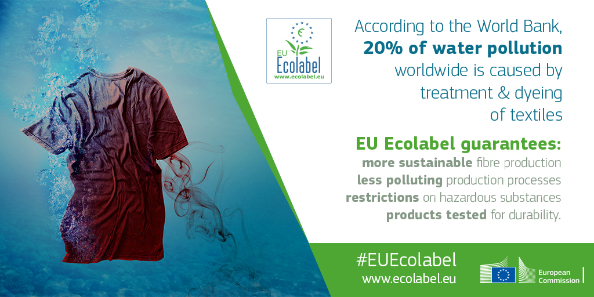

Upholstery textiles

Feel free to copy-paste, translate or edit these posts when publishing them.

Twitter | #DidYouKnow: 10-50% of #dyes are lost during conventional textile manufacturing. By using high-quality raw material @Gabriel, an #EUEcolabel certified company, limits the use of chemical treatments responsible for toxic waste.
- Facebook  - LinkedIn | From organic cotton and eco-friendly wool to recycled polyester, the upholstery fabrics industry is transitioning towards more eco-friendly practices. It is no secret that textile manufacturing degrades the environment due to toxic wastewater.  Acquiring and keeping up with third party ecolabels such as EU Ecolabel guarantees products that are environmentally friendly, of high quality and ethically sourced. The EU Ecolabel certified Danish company Gabriel is one of the industry leaders in eco-friendly upholstery fabrics and particularly in materials such as environmentally certified polyester and wool for the B2B market. The EU Ecolabel criteria on wool fibre, polyester and dyes that Gabriel must comply with is particularly stringent. For example, strict limits on wool ectoparasiticide concentrations (compounds used to treat external parasites) in raw wool prior to scouring must be respected. Dyes that are carcinogenic, mutagenic, toxic for reproduction or have metal complexes must also be removed. In order to respect these criteria, Gabriel has committed to a long-term partnership with Wools of New Zealand, which guarantees high-quality raw materials, good conditions for the sheep and less necessity for dyes.
- Suggested tags | #EUEcolabelTextiles  #SustainableTextiles  #CircularEconomy  #SustainableChoices
- Relevant social media links | Gabriel LinkedIn  EU Ecolabel Twitter  EU Ecolabel Facebook  EU Ecolabel LinkedIn
- Visuals  (available on the PowerPoint) | 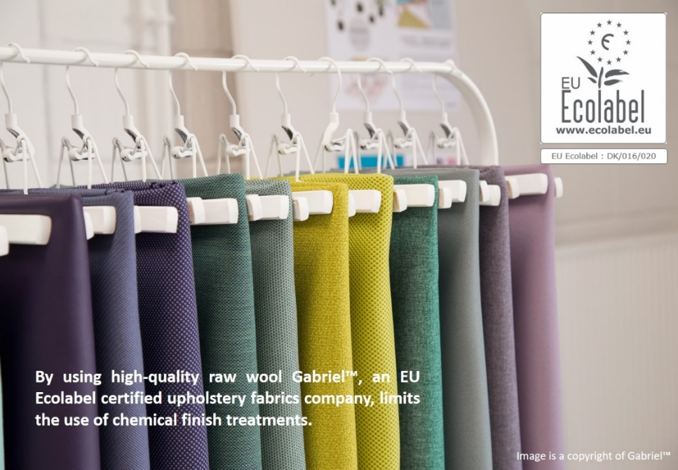

Events in March

22nd of March | World water day: World Water Day, on 22 March every year, is about focusing attention on the importance of water. The theme for World Water Day 2018 is ‘Nature for Water’ – exploring nature-based solutions to the water challenges we face in the 21st century: http://worldwaterday.org/
22nd of March 2018 | Circular Regions on the Way - A vision on Cohesion Policy Beyond 2020 : RETRACE Interreg Europe Project Politecnico di Torino: https://circulareconomy.europa.eu/platform/en/news-and-events/all-events/circular-regions-way-vision-cohesion-policy-beyond-2020
27th to 29th of March 2018 | AFNOR will be present at EUROCOAT 2018 taking place in Paris at la Porte de Versailles. They will communique on EU Ecolabel paints and varnished: http://www.eurocoat-expo.com/

Articles

Denim industry

We encourage you to share this content with your partners like NGOs, journalists or sustainability and lifestyle bloggers or any other media outlets available in your country.

The Environmental Impact of the Denim Industry

From the production of genetically modified cotton to the use of toxic substances, producing jeans causes a lot of strain on the environment. The EU Ecolabel certifies companies who take conscious steps in improving the sustainability of their production.
Although cotton plants cultivated for traditional jean production represent 2.5% of all agricultural land, they use 10% of the pesticides and 25% of the insecticides consumed worldwide. Furthermore, up to 29,000 litres of water are required to produce 1 kg of cotton. This cotton then goes through a series of dye baths (usually around 5 baths) in order to achieve the iconic pigment of a blue jean. This toxic indigo pigment is often dumped into neighbouring rivers, turning them blue. Finally, some pairs of jeans go through a discolouring phase in order to achieve a ‘distressed’ look. Overall, the amount of water wasted through this dying and discolouring process can go up to 150 litres per pair of jeans, and the number of chemicals used is extremely high.
Fortunately, the rise in environmentally conscious consumers is pushing brands to engage in eco-friendly initiatives. Finding alternative solutions is crucial if a brand wants to survive in this competitive industry. Indeed, using organic, recycled and pesticide-free cotton is becoming more profitable for companies. Adriana Galijasevic, one of G-Star’s sustainability and research heads explains that: ‘using organic cotton, saves 91 percent of the water as opposed to conventional cotton organic cotton doesn’t use any pesticides that are unnatural, synthetic or chemical which in the end take away from the soil richness and makes the crop water intensive.’ Concerns such as water use, dye impact, soil health, labour issues and fair trade are now at the heart of brands’ initiatives.
The European Commission encourages these transitions in the supply chain through the EU Ecolabel. The certification aims to improve the production of textiles through a large range of scientifically based criteria that encompass environmental and social concern and analyses the full life cycle of jeans. For example, companies must either use 95% of organic cotton in their production of jeans or 60% of cotton that complies with ‘Integral Pest Management’; a systematic plan developed as a way to control pests without relying solely on pesticides.
Furthermore, sandblasting, a technique used to achieve distressed denim is prohibited by the EU Ecolabel. This method consists of blasting abrasive materials such as silica sand (crystalline) which creates harmful dust and causes silicosis, lung cancer and other breathing problems in exposed workers. The use of hazardous substances in the dyeing, printing and finishing is also strictly controlled by the certification. The EU Ecolabel ensures the quality of its certified products through consumer test requirements, which determine how quickly the jeans will fade and thin out.
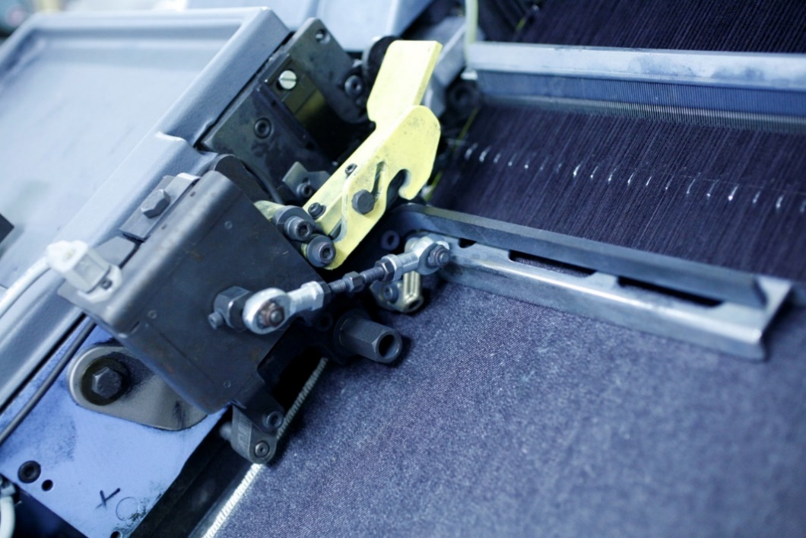

Images are copyrights of ISKO™
Many future-looking brands have found that the EU Ecolabel aligns with their sustainability values. For example, the Ingredient Brand ISKO™, known for its innovative spirit, is the first denim mill to certify a selection of products with the EU Ecolabel. Water savings, as well as reduced energy and chemical consumption, are key issues reflecting the brand’s approach to production. Seeing as 23% of the water consumption throughout the life of a pair of jeans comes about during consumer care, ISKO™ key innovations ensure the highest quality standards, and guarantee garments that retain their shape wear after wear, limiting the need for frequent washes.
Responsible innovation, excellence and sustainability go hand in hand in ISKO™’s approach. ISKO Earth Fit™, made with eco-friendly raw materials like organic cotton, Better Cotton, pre-consumer recycled cotton and post-consumer recycled polyester from PET bottles, forms an integral part of ISKO™’s responsible innovation platform. Becoming EU Ecolabel-certified was a rewarding step along ISKO™’s road to sustainability. Alongside receiving the prestigious Nordic Swan Ecolabel, it affirmed ISKO™ as the only denim mill in the world to have obtained the most stringent certifications for its outstanding sustainability, now attributed to all the articles that are part of the ISKO Earth Fit™ platform. This commitment is shared within the industry and, with jean consumers through educational and cultural projects, seminars and workshops dedicated to the global fashion system.

Sources:
http://ec.europa.eu/environment/ecolabel/green_week/stories/isko_textiles_turkey.pdf
http://eur-lex.europa.eu/legal-content/EN/TXT/?uri=CELEX%3A32014D0350
https://www.forbes.com/sites/rebeccasuhrawardi/2018/02/15/disrupting-the-game-g-star-raw-launches-the-most-sustainable-denim-ever/#5c622f475a75
https://issuu.com/michaelhooper/docs/gen34_final_with_links
https://www.lesechos.fr/18/12/2015/LesEchosWeekEnd/00012-009-ECWE_la-conversion-ecolo-de-l-industrie-du-jean.htm

Upholstery textiles

We encourage you to share this content with your partners like NGOs, journalists or sustainability and lifestyle bloggers or any other media outlets available in your country.

EU Ecolabel: Reducing the Ecological Impact of Textile Dyeing

From organic cotton and eco-friendly wool to recycled polyester, the upholstery fabrics industry is transitioning towards more eco-friendly practices. The EU Ecolabel is an efficient solution for companies seeking to adopt these good practices.
It is no secret that textile manufacturing degrades the environment through toxic wastewater. If we look at dyes alone, up to 200,000 tons of textile dye are discharged as liquid waste every year due to inefficiencies during the dyeing process (almost 10-50% of colourants are lost). Most of these dyes do not go through a controlled wastewater treatment process, instead remaining in the environment for long lengths of time due to their high resistance to light, temperature and most natural and chemical substances. Furthermore, these toxic and mutagenic losses are responsible for destroying aquatic ecosystems through a decrease of light penetration, photosynthetic activity and ultimately oxygen.
Acquiring and keeping up with third party labels such as the EU Ecolabel guarantees products that are environmentally friendly, of high quality and ethically sourced. Indeed, the EU Ecolabel is one of the most efficient tools in Europe to ensure products that contribute to the circular economy and are sustainable throughout their entire value chain – from extraction of raw material to production, use and disposal. The EU Ecolabel certified Danish company Gabriel is one of the industry leaders in eco-friendly upholstery fabrics and particularly in materials such as environmentally certified polyester and wool. Gabriel’s business model also focuses on creating products with the most sustainable life cycles possible.

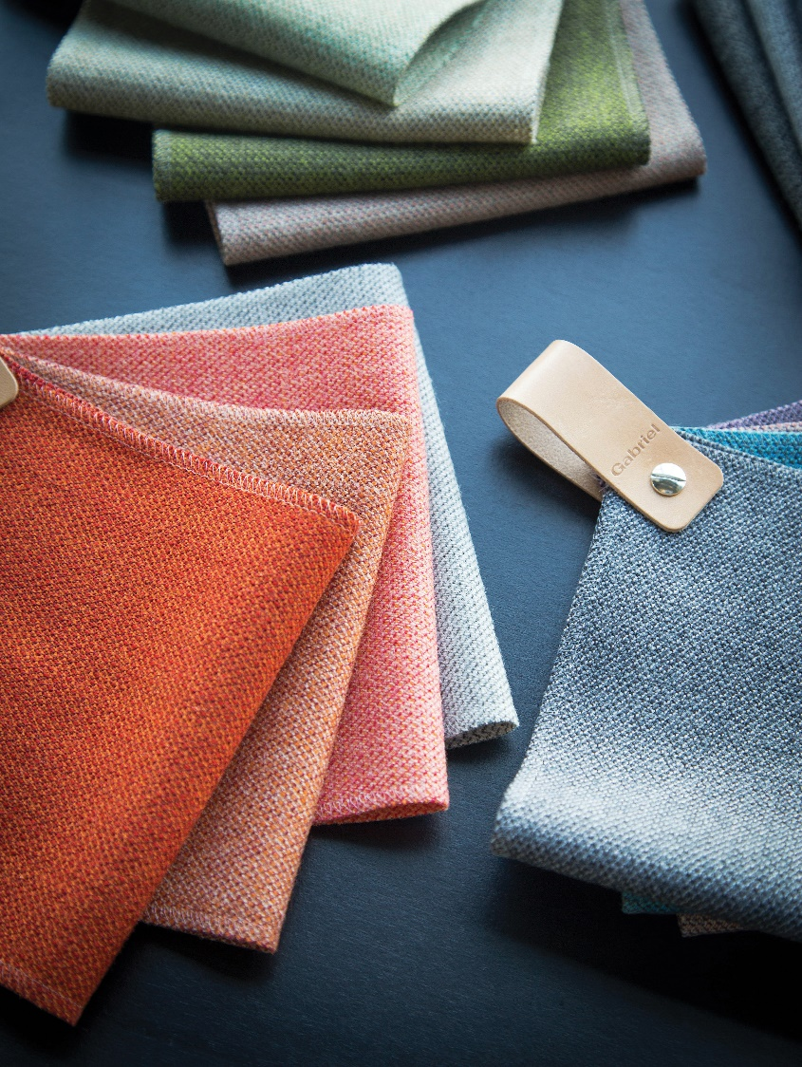

Image is a copyright of Gabriel™
The EU Ecolabel criteria on wool fibre, polyester and dyes that Gabriel must comply with is particularly stringent. Strict limits on wool ectoparasiticide concentrations in raw wool prior to scouring must be respected. COD values for the final discharge of effluent from wool scouring must not go over 25 g/kg for coarse wool and 45 g/kg for fine wool. Wool scourers must also follow measures to recover value from either oxidised grease, fibre, suint or sludge arising from the scouring site used for the EU ecolabelled wool products. These can take the form of transformation of these substances into chemical feedstock, compost or liquid fertiliser and building material. Products with polyester fibre must not have more than 260 ppm of antimony present. Producers should also either manufacture the polyester using a minimum of content of recycled PET (50% for staple fibre and 20% for filament fibre) or control the emissions of VOCs during polyester production. Finally, dyes that are carcinogenic, mutagenic, toxic for reproduction or have metal complex must be removed.
Amongst other practices, in order to respect these criteria, Gabriel has committed to a long-term partnership with Wools of New Zealand, which guarantees high-quality raw materials and good conditions for the sheep. This type of wool possesses unique dyeing properties where the dye is easily absorbed into the fibre. By using high-quality raw wool, Gabriel can forego customary chemical finish treatments, since the desired characteristics are already inherent in the type of raw material sourced. Gabriel also controls the use of dyes and toxic substances through the installation of electronic measurements.
Compliance with EU Ecolabel also requires Gabriel to demonstrate implementations of ‘Best Available Techniques’ in energy efficiency such as the installation of heat recovery systems, efficient burner systems and replacement of overflow washing with drainage/inflow washing. This pushed the company to shift most of its energy-heavy production to use more renewable energy to lessen climate impacts and reduce the water and energy consumption per unit produced. Finally, by using fewer chemicals, Gabriel has been able to reduce both its use of water and electricity by about a third.

Source:
Technology » Textile Technology » "Eco-Friendly Textile Dyeing and Finishing", book edited by Melih Günay, ISBN 978-953-51-0892-4, Published: January 16, 2013, under CC BY 3.0 licence. © The Author(s).

EU Ecolabel Success Story: Neutral

We encourage you to share this content with your partners like NGOs, journalists or sustainability and lifestyle bloggers or any other media outlets available in your country.

EU Ecolabel Success Story: Neutral
Environmental Certifications
Neutral’s array of certificates which includes the EU Ecolabel cover all social, ethical and environmental aspects of clothing manufacturing and provide an external guarantee that Neutral clothing is amongst the most eco-friendly in the market. Neutral acquired the EU Ecolabel ten years ago in 2008, at a time when few products were environmentally certified, especially in the textile industry. Collaborating with international standards such as GOTS and Fairtrade, and searching for the most reliable labels such as the EU Ecolabel was Neutral’s solution to being the most sustainable possible. The co-founders of Neutral particularly appreciated the regenerative design strategy chosen by the EU Ecolabel, which analyses the complete lifecycle of products.

The EU Ecolabel’s Dynamic Approach
Neutral believes that having a separate unit deciding the criteria and third parties controlling the certification makes the label particularly trustworthy. Furthermore, the EU Ecolabel’s dynamism and progressive approach towards updating and strengthening the criteria every third year aligns with the company’s values. Indeed, the EU Ecolabel pushes the brand to innovate constantly to reach an even more sustainable production. For instance, when the EU Ecolabel changed the criteria for chemicals used in the dyeing process, Neutral had to develop completely new dyestuffs together with their suppliers to meet the revised standard.

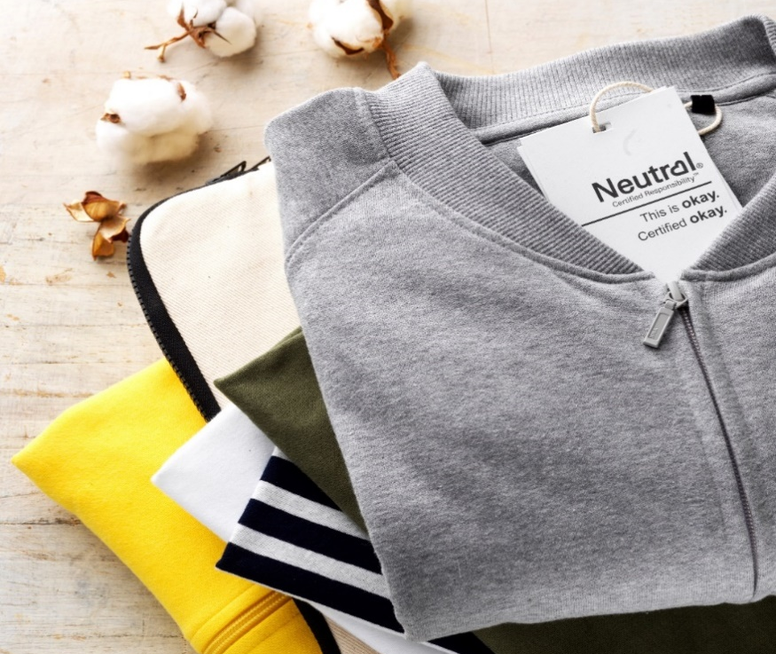
Image is a copyright of Neutral™

Impact on Neutral’s Value Chain
Acquiring environmental certifications forces all actors involved in the value chain to comply with strict regulations. In turn, this helps develop and transform new norms across different aspects of the production chain such as the farming of organic cotton and the dyeing of fibre with less toxic chemicals. Neutral has long lasting partnerships with their suppliers who are eager and willing to take the required steps to comply with the certification due to the company’s proven commitment to sustainable production methods.
Neutral has found that the EU Ecolabel’s impact is increasingly felt when selling and communicating their B2B products. Christina Larsen, Neutral’s co-founder, explains that the credibility the label has gained from other sectors and products makes it easier to communicate its value in the clothing industry, where supply chain complexity makes it practically impossible to tell customers the full story.
Neutral’s purpose is to make the most sustainable clothing possible. This is why the company became EU Ecolabel certified ten years ago, appreciating the way the standard pushes them to constantly search for new materials, measures and methods of production. These combined efforts have been rewarded by The Ministry of Foreign Affairs of Denmark, which awarded Neutral® the CSR Abroad Prize 2015 dedicated to companies promoting social responsibility and sustainable growth in the developing world.

EU Ecolabel Criteria Roadmap
ORGANIC COTTON & REDUCTION OF CHEMICALS
Neutral products are sourced from 100% organic cotton, which complies with the EU Ecolabel’s minimum threshold (95% organic cotton for t-shirts, women’s tops, casual shirts, sleepwear and undergarments). Indeed, Neutral cotton farmers use biological fertilisers (earthworms) and natural pesticides such as sugar water, which attracts ants who defend the cotton plant. This means cleaner rivers, a richer biodiversity and toxic free handpicking by the farmers.

ECO-FRIENDLY DYES
Upon the revision of the EU Ecolabel criteria on chemicals, Neutral and its suppliers had to innovate to meet the revised standard. This meant removing any dyes that are carcinogenic, mutagenic, and toxic for reproduction or have metal complexes. Printing pastes cannot contain more than 5% volatile organic compounds and chlorine bleaching is prohibited. Fabric softeners used by Neutral must also be biodegradable.

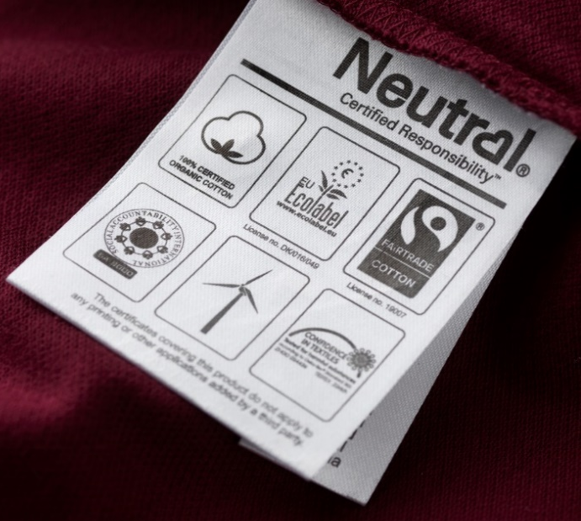

Image is a copyright of Neutral™

WASTE & WATER MANAGEMENT
Neutral treats and reuses wastewater according to the highest industry requirements demanded by the EU Ecolabel (wastewater discharges must not exceed 20 g COD/kg textile). A set of Best Available Techniques proposed by the EU Ecolabel must also be respected, such as the use of cooling water as process water or ‘smart’ rinsing technologies with water flow controls and counter currents.

ENERGY & AIR POLLUTION
The EU Ecolabel requires Neutral to demonstrate evidence of an energy and carbon dioxide emissions management system with a minimum number of Best Available Techniques, for example: sub-metering, the insulation of pipework, valves and flanges or the installation of heat recovery. Furthermore, the total emissions of organic compounds from textile printing and finishing production sites used to manufacture EU Ecolabel products must not exceed 100 mg C/Nm³.

PRODUCT DURABILITY
The strict durability criteria enforced by the EU Ecolabel provide a third-party guarantee of product quality. The EU Ecolabel uses international testing methods such as ISO 105 C06 and ISO 105 E04 (tests for colour fastness) to ensure that Neutral products have long life spans.

https://www.lesechos.fr/18/12/2015/LesEchosWeekEnd/00012-009-ECWE_la-conversion-ecolo-de-l-industrie-du-jean.htm
https://www.forbes.com/sites/rebeccasuhrawardi/2018/02/15/disrupting-the-game-g-star-raw-launches-the-most-sustainable-denim-ever/#5c622f475a75
http://eur-lex.europa.eu/legal-content/EN/TXT/?uri=CELEX%3A32014D0350
Ibid
Technology » Textile Technology » "Eco-Friendly Textile Dyeing and Finishing", book edited by Melih Günay, ISBN 978-953-51-0892-4, Published: January 16, 2013, under CC BY 3.0 licence. © The Author(s).

