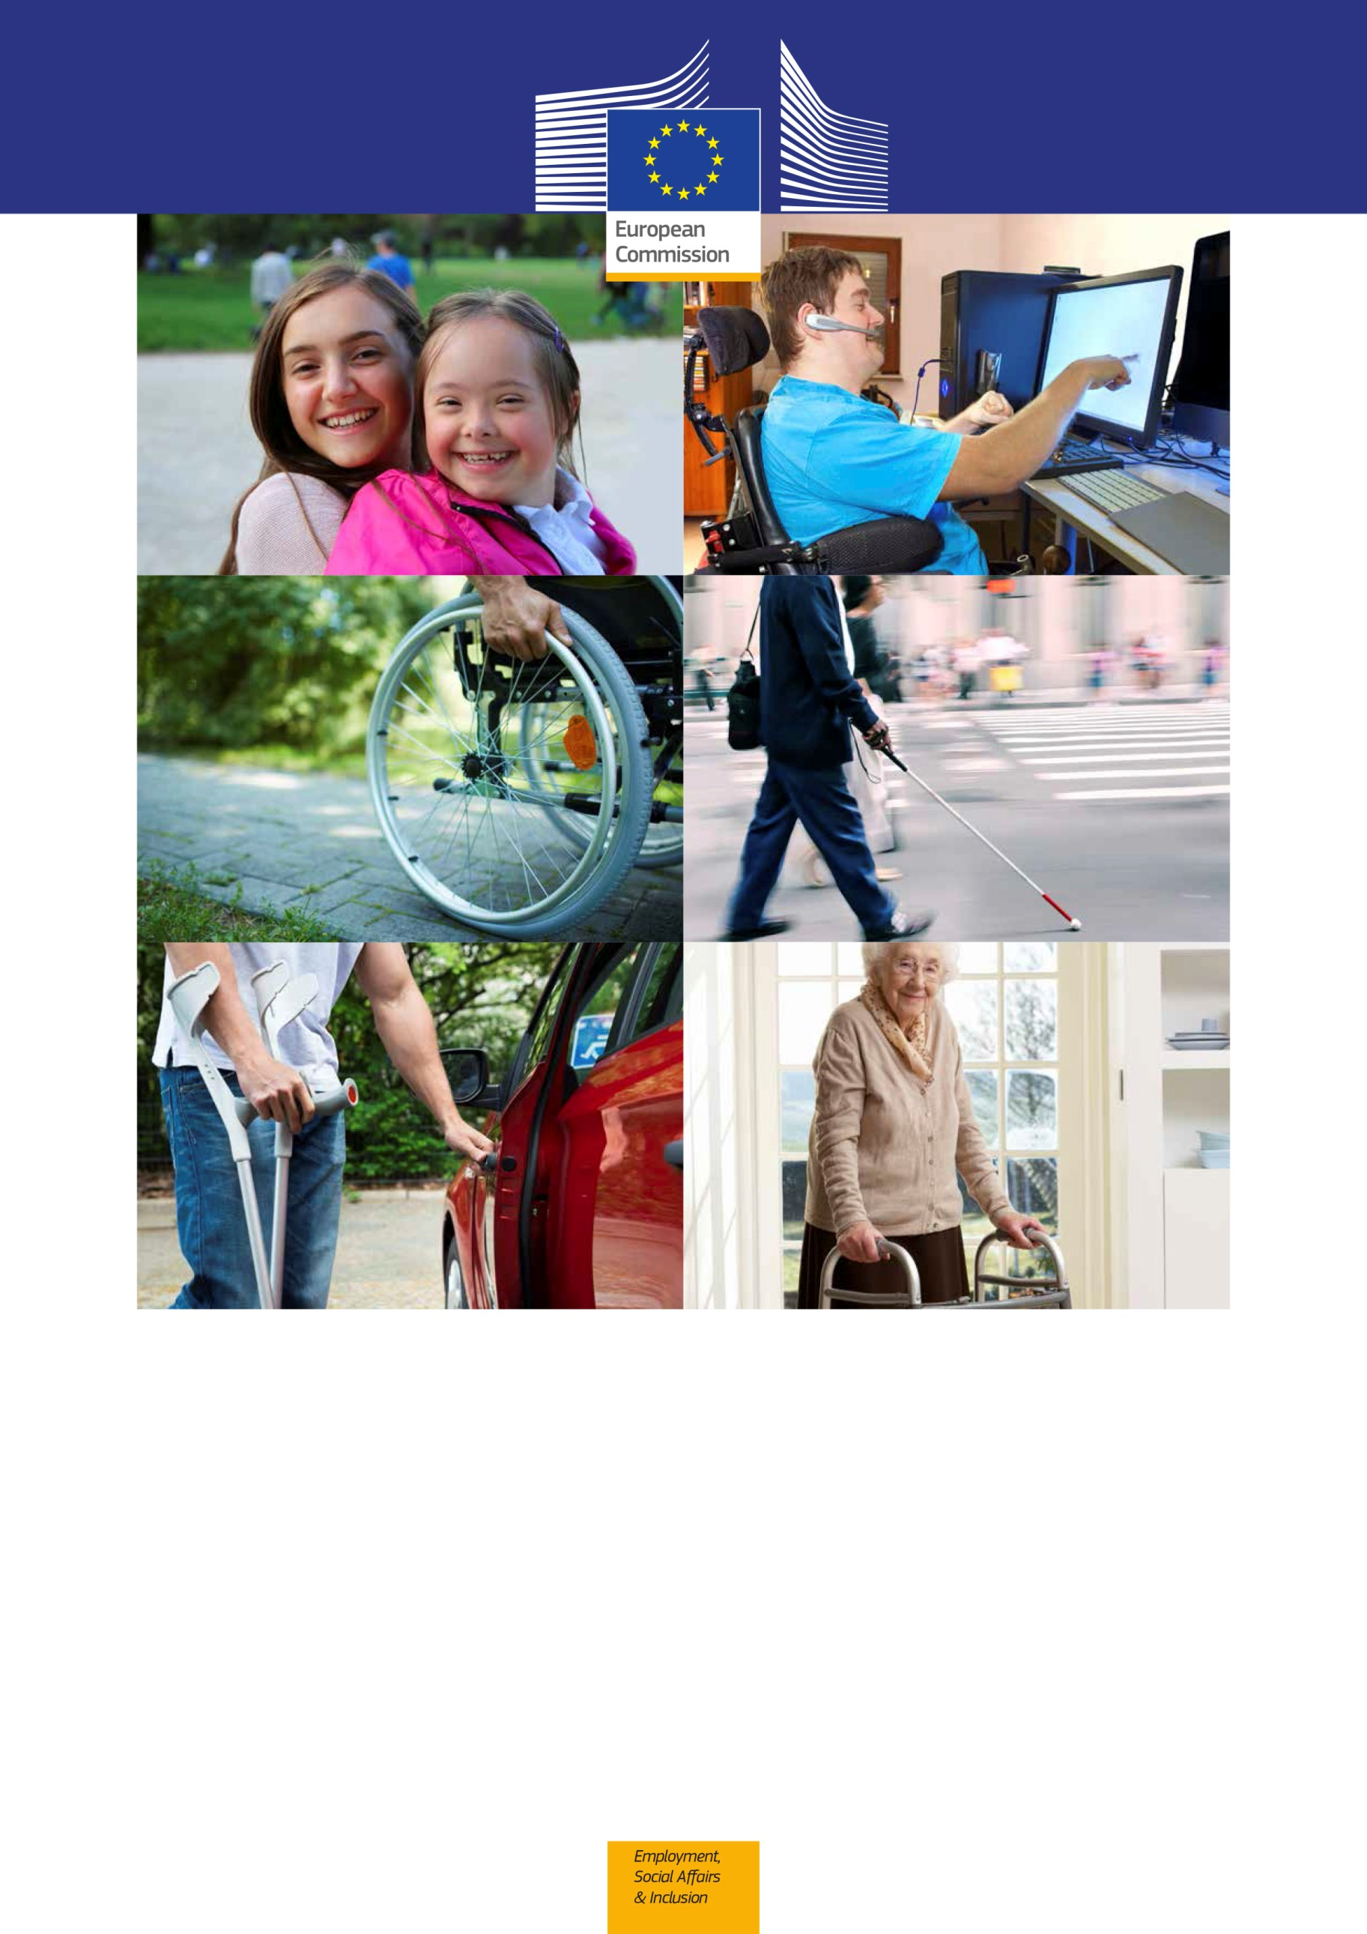

EUROPEAN ACCESSIBILITY ACT

IMPROVING THE ACCESSIBILITY OF PRODUCTS
AND SERVICES IN THE SINGLE MARKET

Why a European Accessibility Act?
Around 80 million people in the EU are affected by a disability in some degree. Accessibility is a precondition to ensure their full and equal participation in society. The European Accessibility Act (EAA) aims to improve the functioning of the internal market for accessible products and services by removing barriers created by divergent legislation.
The EU and most of the Member States have ratified the UN Convention on the Rights of Persons with Disabilities (UN CRPD). As such they have committed to create a legislative framework for accessibility in line with Article 9 of the Convention. Accessibility is considered as a wide concept that includes the prevention and elimination of obstacles that pose problems for persons with disabilities in using products, services and infrastructures.
Member States have started to legislate on accessibility independently, increasing regulatory fragmentation. The Commission table the Accessibility Act to help dismantle barriers between Member States due to different national accessibility requirements that are emerging. The Accessibility Act will establish European-wide functional requirements. This means requirements establishing accessibility principles instead of prescribing the detailed technical solutions.

What will it cover?
The European Accessibility Act will cover the following products and services:
- computers and operating systems
- ATMs, ticketing and check-in machines
- telephones and smartphones
- TV equipment related to digital television services
- telephony services and related equipment
- audiovisual media services, such as television broadcast and related consumer equipment
- services related to air, bus, rail and waterborne passenger transport
- banking services
- e-books
- e-commerce

What will it do and what it will not do?
The Directive will tell "What" needs to be accessible in terms of functional requirements but will not impose detailed technical solutions telling "How" to make it accessible, allowing for innovation.

- uses a set of common accessibility requirements at EU level for a number of products and services
- creates an obligation for Member States to ensure that the selected products and services placed in the market after the transitional period comply with accessibility requirements
- uses the same accessibility requirements to define the accessibility obligation laid down in existing EU law, in particular in the areas of public procurement, Structural & Investment Funds and transport
- supports Member States implementation of the UN Convention on the Rights of Persons with Disabilities
- ensures that all products and services complying with accessibility requirements will circulate freely in the internal market
- does not prescribe to the level of technical details how to render a product or service accessible. However, it provides for the development of standards or technical implementing measures wherever more detail is needed
- does not set obligations for all manufacturers and service providers, but only for those working on a selected list of products and services
  - does not impose burdensome requirements by providing safeguards on disproportionate burden and fundamental alteration
- does not amend existing EU sectorial legislation on accessibility

What will be the impact of the EAA?

For EU citizens
The EAA is a step forward in reducing barriers for people with disabilities within the EU: better accessibility of products and services that citizens use every day, such as phones, transport or banking services, will help people with disabilities to be able to fully participate in society on an equal basis with others, to have better access to education and to enter more easily the open labour market. Accessibility is also necessary for older people to maintain an active role in society, including extending their working lives. In general, accessibility is beneficial to all EU citizens. For example, people trying to hear travelling information in noisy environments like train stations, or trying to get money from ATMs on a sunny day, or employees working with enlarged documents to avoid eye strain will also greatly benefit from further accessibility.

7 in 10 Europeans believe better accessibility of products and services would very much improve the lives of people with disabilities, the elderly and others with accessibility needs:
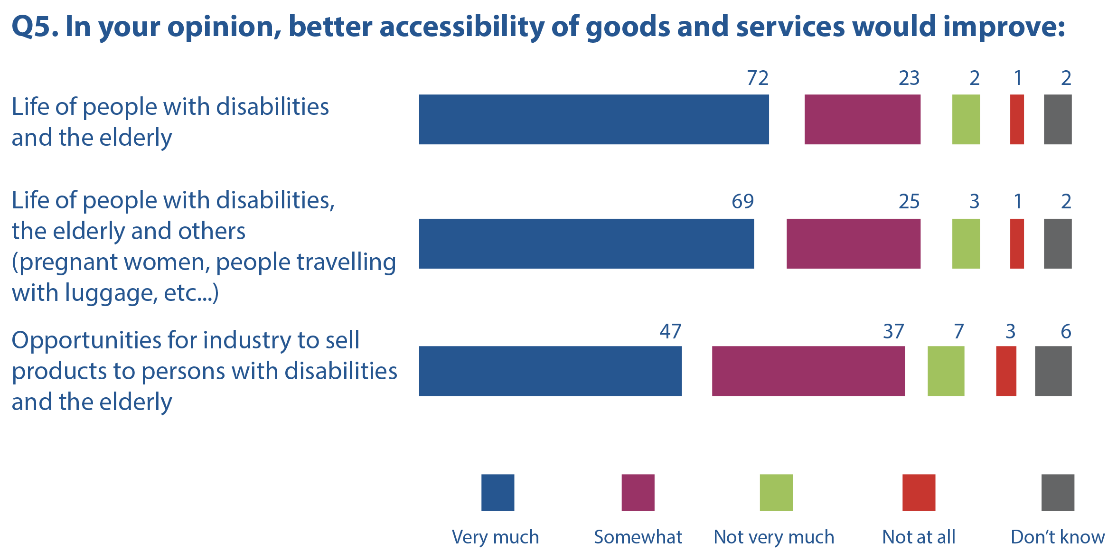
Source: Eurobarometer on Accessibility (2012).
Croatia is not included as it was not an EU Member State at the time of the survey.

For businesses
Businesses – and in particular SMEs - will benefit from the elimination of barriers caused by a fragmented market thanks to the creation of a single set of requirements. Cross-border trade will thus be easier for them. The market costs for companies and Member States due to divergent requirements are estimated at € 20 billion in 2020. The proposed EU action is estimated to reduce it by 45% to 50%. The extra production costs introduced with the EAA will be very low or even non-existent. The potential benefits are expected to be higher than the potential accessibility-related costs for all economic operators.

SMEs are generally favourable to the introduction of EU-level accessibility requirements:

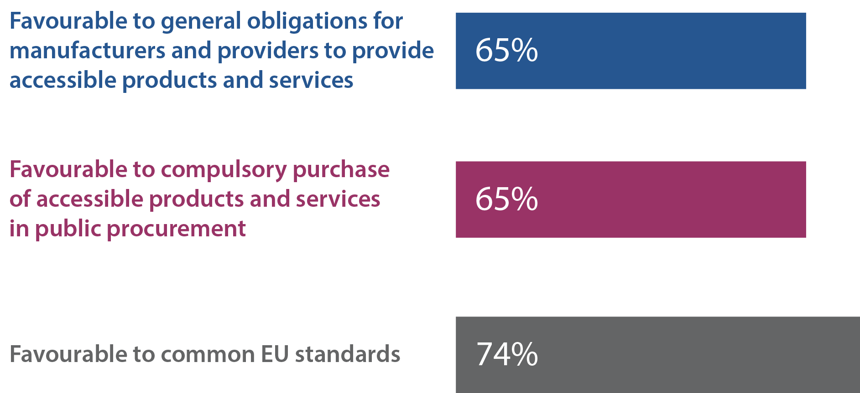
Source: SME Panel conducted by Enterprise Europe Network
78% of Europeans think that having common rules on accessibility in the EU will make it easier for companies to operate in another EU country:
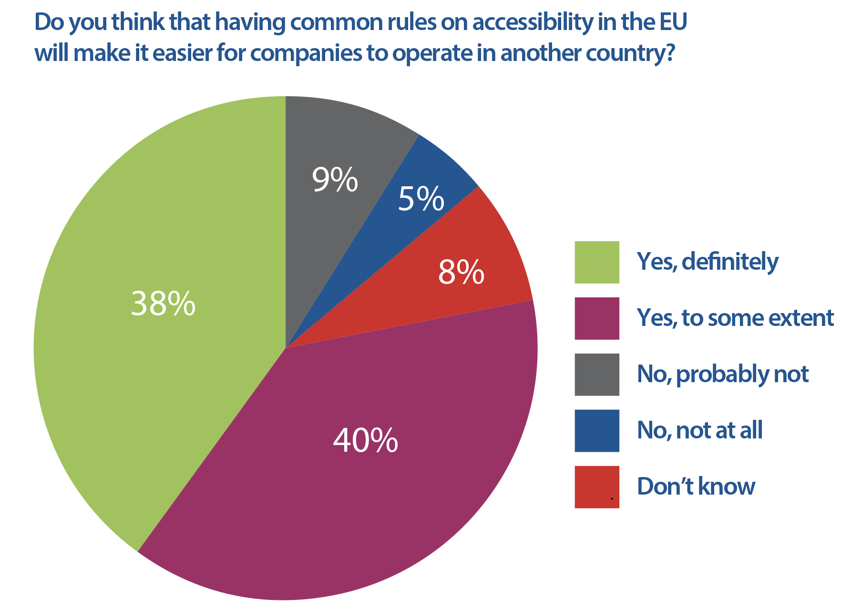
Source: Eurobarometer on Accessibility (2012).

