

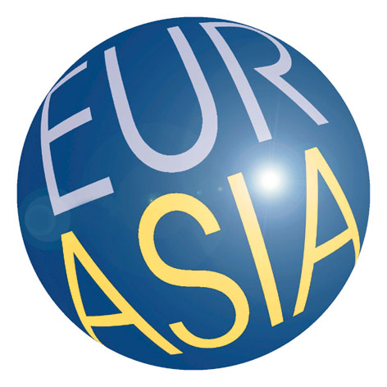EIAS

"Regionalism and Reform of the Global Monetary & Financial System

What Role for Europe and Asia?"

Conference organised by the Asian Development Bank Institute, the European Institute for Asian Studies and the European Commission

Directorate General for Economic and Financial affairs

Brussels, 4 February 2010

Please fill in information as appears on your passport (required for entry to Commission building)
Mr/Mrs/Ms
Title
First name / given name
Last name / surname
Nationality
Passport number
Passport expiry date
Date of birth
Function / Designation
Organisation
Address
Address 2
Postal code
City
Country
E-mail
Tel.
Fax

Completed application forms should be sent by email to:

ECFIN-EIAS-ADBI-Conference@ec.europa.eu

Deadline for registration: 15 January 2010
For further details please liaise with Mr. Gertjan Driessen, European Commission, either by phone +32 2 295 09 50 or by email gertjan.driessen@ec.europa.eu.

